Fish, Forests, Fungi: Soils in the ‘Salmon Forests’ of British Columbia
by

Allen Thomas Larocque

B.Sc., The University of British Columbia, 2006
M.Sc. McGill University, 2011

A DISSERTATION SUBMITTED IN PARTIAL FULFILLMENT OF
THE REQUIREMENTS FOR THE DEGREE OF

DOCTOR OF PHILOSOPHY
in
THE FACULTY OF GRADUATE AND POSTDOCTORAL STUDIES
(Forestry)

THE UNIVERSITY OF BRITISH COLUMBIA
(Vancouver)
April 2022

© Allen Larocque, 2022
The following individuals certify that they have read, and recommend to the Faculty of Graduate and Postdoctoral Studies for acceptance, the dissertation entitled:
Fish, Forests, Fungi: Soils in the ‘Salmon Forests’ of British Columbia

submitted by | Allen Larocque | in partial fulfillment of the requirements for
the degree of | Doctor of Philosophy
in | The Faculty of Graduate and Postdoctoral Studies

Examining Committee:
Dr. Suzanne Simard, Professor, Forestry, UBC
Supervisor
Dr. Robert Guy, Professor, Forestry, UBC
Supervisory Committee Member
Dr. John Reynolds, Professor, Biology, Simon Fraser University
Supervisory Committee Member

Dr. Les Lavkulich, Professor Emeritus, Land and Food Systems, UBC
University Examiner
Dr. Gordon Holtgreive, Assistant Professor, Aquatic and Fishery Sciences, U. Washington

University Examiner

Additional Supervisory Committee Members:
Dr. William Mohn, Professor, Microbiology & Immunology, UBC
Supervisory Committee Member
Dr. Thomas Reimchen, Adjunct Professor, Biology, University of Victoria
Supervisory Committee Member

Abstract
In this thesis, I examine the effects of returning salmon on riparian soils in Heiltsuk traditional territory, near the community of Bella Bella on the Central Coast of British Columbia, Canada. My main objectives were to: 1) quantify how salmon affect forest soil chemistry; 2) use nitrogen stable isotopes to measure salmon contributions to fungi, soil, and litter nitrogen metabolism; 3) quantify how salmon affect soil fungal communities; 4) quantify how salmon affect soil bacterial communities; and 5) test the role of fungi in plant ammonium uptake by disrupting fungal metabolism. To achieve objectives 1 through 4, I used two observational approaches: the first examined watersheds along a natural gradient of salmon density; and the second used sites where waterfalls block salmon migration, allowing for within-watershed comparisons above and below these barriers. To achieve objective 5, I employed a nitrogen stable-isotope addition experiment. I found that salmon affected soil chemistry, with impacts on concentrations of nitrogenous compounds, exchangeable cations, phosphorus, and metals, as well as differences in pH. I found that δ¹⁵N was greater in sporocarps when salmon were present, and interpreted this as evidence fungi acquire salmon nutrients. Using next-generation environmental sequencing, I found salmon inputs impact fungal relative abundance, soil fungal β- and α- diversity, but did not affect phylogenetic dispersion. In general, symbiotrophic fungi were affected by salmon inputs more than saprotrophs. Soil bacterial communities had fewer correlations with salmon inputs. Finally, I found that disruption of fungal metabolism slowed the uptake of ammonium by riparian shrubs. These results show that salmon are important in structuring riparian soil chemistry and microbial ecology, and support the hypothesis that fungi play an important role in salmon nutrient uptake by plants.

Lay Summary
Salmon, at the end of their lives, swim back to the streams of their birth to spawn and die. In doing so, they bring with them the nutrients stored in their flesh. Their coming is eagerly awaited by all sorts of animals, including bears, wolves, and humans. These organisms leave urine, feces, and salmon carcasses distributed throughout the forest; over time, these decompose and the nutrients are metabolized in soil and plants. In this thesis I looked at the effect of salmon nutrients on streamside soils, plants, and fungi. I showed the ways salmon inputs affect soil chemistry; how they influence the number and types of fungal and bacterial species living in the soil; and showed that salmon nutrients occur ‘in the mushrooms’. In total, these findings show that understanding how salmon affect the ‘salmon forest’ requires that we understand how they affect forest soils.

Preface
The research presented in this dissertation was developed and carried out by Allen Larocque under the supervision of Dr. Suzanne Simard and with the advisement of the committee members. All background research, experimental conceptualization and design, fieldwork, laboratory work, data analysis and manuscript preparation was performed by Allen Larocque unless otherwise noted. Dr. Suzanne Simard helped throughout to secure funding, conceptualize and plan the project, and during manuscript preparation.
The first three years of my PhD was funded through a MITACS program partnered with the Brinkman Group, and the second three years was funded with the help of the Donner Foundation Canada.
This project began with my thoughts and observations over a summer studying bird populations in Heiltsuk traditional territory near Bella Bella on the British Columbia Central Coast with PhD student Marlene Wagner and Dr. John Reynold’s laboratory at Simon Fraser University.
Chapter 1 was researched and written by Allen Larocque with edits by Dr. Suzanne Simard.
Chapter 2 was designed, executed, analyzed, and written by Allen Larocque. Dr. Suzanne Simard helped in experimental design and manuscript preparation. Dr. Bianca Eskelson provided minor statistical advice.
Chapter 3 was likewise designed, executed, analyzed, and written by Allen Larocque, with manuscript preparation help by Dr. Suzanne Simard. Vegetation data were provided by Dr. Morgan Hocking and Dr. John Reynolds. Logistical support was provided by Dr. John Reynold’s Research Group, Allison Dennert, and the Heiltsuk Integrated Resource Management Department.
Chapters 4, 5 and 6 were designed, executed, analyzed, and written by Allen Larocque with experimental design and manuscript preparation help by Dr. Suzanne Simard.
Chapters 2, 3, 4, and 5 made use of salmon density measurements provided by Dr. John Reynold’s research group and the Heiltsuk Integrated Resource Management Department.

Table of Contents
Abstract ii
Lay Summary iii
Preface iv
Table of Contents vi
List of Tables xiii
List of Symbols and Abbreviations xix
Acknowledgements xx
Chapter 1: Fish, Forest, Fungi: literature review, context, and research questions 1
1.1 Introduction 1
1.2 The fish: salmon in context 2
1.3 Salmon streams and salmon lakes: aquatic effects of marine-derived nutrients 5
1.4 Salmon forests: terrestrial effects of MDN 10
1.4.1 From stream to forest 10
1.4.2 Effects on animals 11
1.4.3 Effects on terrestrial plants 13
1.4.4 Effects on soils 15
1.5 Soil metabolism 18
1.5.1 Mycorrhizal Fungi 20
1.5.2 Common Mycorrhizal Networks 22
1.6 Summary and motivation 24
1.7 Main Questions and approach 25
1.8 Thesis outline 26
1.9 Tables and Figures 29
Chapter 2: The effects of marine-derived nutrients on soil chemistry 34
2.1 Introduction 34
2.2 Materials and Methods 39
2.3 Results 46
2.3.1 Aggregate soil chemistry (Figure 2-1) 46
2.3.2 Nitrogenous compounds (Figure 2-2) 47
2.3.3 Organics (Figure 2-3) 47
2.3.4 Exchangeable cations (Figure 2-4) 48
2.3.5 Metals (Figure 2-5) and Ergosterol (Figure 2-6) 48
2.3.6 Exploratory analysis (Figure 2-7) 49
2.3.7 Calcium to aluminum ratio and regional comparisons 49
2.4 Discussion 50
2.5 Conclusion 57
2.6 Tables and Figures 58
Chapter 3: Sporocarp ¹⁵N natural abundance along a gradient of salmon density 82
3.1 Introduction 82
3.2 Materials and Methods 87
3.3 Results 92
3.4 Discussion 94
3.4.1 Nitrogen Isotopes as indicators of N-cycling 94
3.4.2 Effects of MDN on Nitrogen Concentrations 98
3.4.3 Effects of MDN on Carbon Cycling 100
3.4.4 ¹⁵N and sporocarp taxonomic identity: 101
3.5 Conclusion 101
3.6 Tables and Figures 104
Chapter 4: Salmon density influences soil fungal microbiome diversity and community composition 114
4.1 Introduction 114
4.2 Materials and Methods 118
4.2.1 Study sites 118
4.2.2 Soil sampling 119
4.2.3 Plant Community and Watershed Size 120
4.2.4 Salmon density data 121
4.2.5 Molecular analysis 122
4.2.6 Bioinformatics 122
4.2.7 Statistical Analysis 123
4.3 Results 126
4.3.1 Sequencing and community composition 126
4.3.2 Community metrics 128
4.3.2.1 Relative Abundance 128
4.3.2.2 Species richness 128
4.3.2.3 Shannon diversity 129
4.3.2.4 Phylogenetic Dispersion 130
4.3.3 Beta diversity 131
4.3.4 Compositional changes along salmon gradient 131
4.4 Discussion 132
4.4.1 Fungal communities of the central coast 132
4.4.2 Responses to MDN 133
4.4.2.1 Relative abundance 133
4.4.2.2 α-diversity 133
4.4.2.3 Phylogenetic dispersion 134
4.4.2.4 Β diversity 135
4.4.2.5 Genus-level differential responses 135
4.5 Conclusion 137
4.6 Tables and Figures 139
Chapter 5: Soil bacteria diversity and community composition changes along salmon density gradients 161
5.1 Introduction 161
5.2 Materials and Methods 164
5.2.1 Study sites 164
5.2.2 Soil sampling 165
5.2.3 Plant Community and Watershed Size 166
5.2.4 Salmon density data 167
5.2.5 Molecular analysis 168
5.2.6 Bioinformatics 168
5.2.7 Statistical Analysis 169
5.3 Results 171
5.3.1 Sequencing and community composition 171
5.3.2 Community metrics 172
5.3.2.1 Species Richness 172
5.3.2.2 Shannon diversity 172
5.3.2.3 Phylogenetic Dispersion 173
5.3.3 Beta diversity 173
5.3.4 Compositional changes along salmon gradient 174
5.4 Discussion 174
5.4.1 Bacteria communities of the Central Coast 174
5.4.2 Responses of bacterial communities to MDN inputs 175
5.5 Conclusion 177
5.6 Tables and Figures 178
Chapter 6: Fate of artificial MDN addition 188
6.1 Introduction 188
6.2 Materials and Methods 190
6.2.1 Study site 190
6.2.2 Experimental design 191
6.2.3 Analysis: 194
6.3 Results 195
6.3.1 Rate and distance of uptake 195
6.4 Discussion 196
6.5 Tables and Figures 198
Chapter 7: Conclusion and summary 204
7.1 Summary 204
7.2 Synopsis of Chapter 2 204
7.3 Synopsis of Chapter 3 206
7.4 Synopsis of Chapter 4 207
7.5 Synopsis of Chapter 5 208
7.6 Synopsis of Chapter 6 209
7.7 Research strengths and limitations 210
7.7.1 Design strengths and limitations 210
7.7.1.1 Regional salmon density gradient design 210
7.7.1.2 Above and below waterfall design 211
7.7.1.3 Common limitations to both designs 211
7.7.2 Molecular characterization of fungal and bacterial communities: from sequences to function 212
7.8 Next steps 213
7.8.1 Next steps for salmon forest soil chemistry and ecosystem functioning 213
7.8.2 Next steps for soil community ecology 214
7.9 Implications for local people and the Heiltsuk Nation 215
7.10 Conclusion 216
Bibliography 219
Appendix A : Study Sites 295
A.1 The Central Coast of British Columbia 295
A.2 Regional Geology 296
A.3 Regional Soils 297
A.4 Site details 298
A.5 Watershed size indices 298
Appendix B Salmon Density 303
Appendix C Vegetation summer 2017 313
C.1 Vegetation measures 313
C.2 Dimension reduction (PCA) 314
C.3 Vegetation Autumn 2017 327
Appendix D Nutrient Addition Calculations 333

List of Tables
Table 1-1: Published studies on the effects of salmon on soil. 29
Table 1-2: Outline of motivating questions, scientific hypotheses, response variables investigated, and predictions investigated in this thesis. 31
Table 2-1: Chemical groups examined in this study, as well as correlations with fertility and predictions with response to salmon nutrient inputs. 58
Table 2-2: ANOVA table summary for above/below waterfall paired Wilcoxson tests. 75
Table 2-3: Summary of salmon-soil chemistry results. 79
Table 3-1: ANOVA table for salmon density regressions. 106
Table 3-2: Pairwise comparisons of intercepts and slopes for salmon density regressions. 107
Table 6-1: Regression table for the LM translated log δ¹⁵N ~ day * distance * treatment. 202

Table A-1: Correlation matrix of watershed size measures with salmon density (biomass per m of stream reach) for reference. 301
Table A-2: Loadings of the four principle components of the ordination in Figure A-3. 301
Table B-1: Average mass at spawning for different salmon species used in salmon density calculations. 309
Table B-2: Correlation table between salmon-density indices. 310
Table B-3: Four principal components of biomass and the three density indices. 312
Table C-1: Species observed and identified in this thesis 316
Table D-1: Nutrients, their molar masses and their proportion by mass of a salmon carcass. 334
Table D-2: Compound salts used in Drake 2006 and in this study. 334
Table D-3: Amount of each compound added. 334

List of Figures
Figure 2-1: Canonical correspondence ordination for aggregate soil chemistry. 61
Figure 2-2: Nitrogen GLM results for regional gradient data and boxplots for above/below waterfall data. 64
Figure 2-3: pH and organic substance GLM results for regional gradient data and boxplots for above/below waterfall data. 67
Figure 2-4: Exchangeable cations GLM results for regional gradient data and boxplots for above/below waterfall data. 69
Figure 2-5: Metal GLM results for regional gradient data and boxplots for above/below waterfall data. 73
Figure 2-6: Ergosterol GLM results for regional gradient data and boxplots for above/below waterfall data. 74
Figure 2-7: Random forest model response for all chemical response variables as a function of an extended set of explanatory variables. 77
Figure 2-8: Calcium to aluminum ratio along the salmon regional gradient and above and below waterfalls. 78
Figure 2-9: A comparison of forest floor and organic soil values from across a regional gradient of salmon density for pH, cation exchange capacity (CEC), total soil organic carbon (SOC), soil organic nitrogen (SON) and the C:N ratio for forest floor soil from this study (FF), organic soil from this study (O) and regional averages 80
Figure 3-1: A: Conceptual outline of N and ¹⁵N transfer, with expectations of isotopic enrichment in pools highlighted green and depletion in red. Expectations of fractionation factors associated with flows are in brackets. B: Expectations of ¹⁵N discrimination between belowground and aboveground compartments due to i. increases in mycorrhizal transfer rate; and ii. increasing salmon inputs. 104
Figure 3-2: δ¹⁵N, %N, δ¹³C, %C, and C:N ratio as a function of salmon density (p in axes and titles denotes percent). 105
Figure 3-3: Averaged standardized GLM coefficients for all explanatory variables (EVs) in the linear models δ¹⁵N_{sample type} ~ EVs (first column) and %N_{sample type} ~ EVs (second column). 108
Figure 3-4: Averaged standardized GLM coefficients for all explanatory variables (EVs) in the linear models δ¹³C_{sample type} ~ EVs (first column) and %C_{sample type} ~ EVs (second column) and C_{sample type} : N_{sample type} ~ EVs (third column). 109
Figure 3-5: Heatmap of random forest model importance for mushroom, litter, and soil response variables. 110
Figure 3-6: δ¹⁵N as a function %N, with sample type denoted by colour. 111
Figure 3-7: Isoplot of δ¹⁵N vs. δ¹³C for vegetation, litter, and mushroom samples. 112
Figure 3-8: δ¹⁵N measures by genus. 113
Figure 4-1: Heat trees of ITS relative abundance agglomerated to genus for the regional gradient data for forest floor (A) and organic (B) soils 139
Figure -2: : Heat trees of SSU relative abundance agglomerated to genus for the regional gradient data for forest floor (A) and organic (B) soils 140
Figure 4-3: Relative read abundance for ITS (A-D) and SSU (E-H) amplicons for forest floor soil (first and third row) and organic soil (second and fourth row) 142
Figure 4-4: Species richness for ITS (A-D) and SSU (E-H) amplicons for forest floor soil (first and third row) and organic soil (second and fourth row) 144
Figure 4-5: Shannon diversity for ITS (A-D) and SSU (E-H) amplicons for forest floor soil (first and third row) and organic soil (second and fourth row) 146
Figure 4-6: Phylogenetic dispersion index (PDI) for ITS (A-D) and SSU (E-H) amplicons for forest floor soil (first and third row) and organic soil (second and fourth row) 148
Figure 4-7: Standardized model-averaged coefficients for ITS GLMs for three taxonomic groups 150
Figure 4-8: Standardized model-averaged coefficients for SSU GLMs for three taxonomic groups 152
Figure 4-9: Heatmap of ITS random forest model importance coefficients for community metrics across the regional salmon density gradient. 153
Figure 4-10: SSU random forest model importance coefficients for community metrics over the regional salmon density gradient. 155
Figure 4-11: ITS beta diversity NMDS plots (2-axis) standardized Bray-Curtis distance over three community subsets (columns): ‘all reads’, ‘symbiotrophs’, and ‘saprotrophs’. 157
Figure 4-12: SSU beta diversity NMDS plots (2-axis) using weighted unifrac distance over three community subsets (columns): ‘all reads’, ‘symbiotrophs’, and ‘saprotrophs’. 158
Figure 4-13: ITS differential analysis coefficients. 159
Figure 4-14: SSU differential abundance effect coefficients. 160
Figure 5-1: Heat trees of 16S relative abundance agglomerated to genus along gradient forest floor (A) and organic (B) soils; and above/below forest floor (C) and organic (D) datasets. 178
Figure 5-2: Community species richness for forest floor soil (top row) and organic soil (bottom row) 179
Figure 5-3: Community Shannon diversity for forest floor soil (top row) and organic soil (bottom row) 181
Figure 5-4: Community phylogenetic dispersion index (PDI) for forest floor soil (top row) and organic soil (bottom row) 182
Figure 5-5: Standardized GLM model-averaged coefficients for four community measures 184
Figure 5-6: Heatmap of 16S random forest model importance coefficients for community metrics 185
Figure 5-7: 16S beta diversity NMDS plots 186
Figure 5-8: 16S differential abundance analysis coefficients. 187
Figure 6-1: Time series of δ¹⁵N values per plant 198
Figure 6-2: Time series of log δ¹⁵N values per plant 199
Figure 6-3: log transformed δ¹⁵N values as a function of days since application. 200
Figure 6-4: 3-D plots of translated log δ¹⁵N values for the three treatment groups as a function of distance from the center of the plot and days since application. 201
Figure 6-5: Estimated V_{max} and K_{M} values from Michaelis-Menten function fits of the closest plant for each treatment group. 203

Figure A-1: Map of study sites on the Central Coast examined in this thesis. Sites with waterfalls are indicated by a (W). 299
Figure A-2: PCA biplot of four watershed size indices 302
Figure B-1: Salmon density (kg of salmon/m of accessible stream reach) for all streams used in this study. 306
Figure B-2: Salmon density (kg of salmon/m of accessible stream reach) for all streams used in this study. 307
Figure B-3: Salmon biomass (metric tons) by year over all streams used in this thesis. 308
Figure B-4: Histogram of the distribution of salmon density (kg/m) across streams for all years. Note the skew-right distribution and gap between 20 and 40 kg/m (high density streams are Neekas and Clatse). 309
Figure B-5: PCA biplot of density indices. 311
Figure C-1: Heatmap of observed moss percent cover by watershed 319
Figure C-2: Heatmap of observed herb and fern percent cover by watershed 320
Figure C-3: Heatmap of observed shrub volume by watershed 321
Figure C-4: Heatmap of observed tree basal area by watershed 322
Figure C-5: PCA loadings for moss. 323
Figure C-6: PCA loadings for herbs. 324
Figure C-7: PCA loadings for the shrub influence index. 325
Figure C-8: PCA loadings for tree influence index. 326
Figure C-9: PCA loadings for moss, fall 2017. 329
Figure C-10: PCA loadings for herbs, fall 2017. 330
Figure C-11: PCA loadings for shrubs, fall 2017. 331
Figure C-12: PCA loadings for trees, fall 2017. 332

List of Symbols and Abbreviations
δ – delta, used to denote the difference between measured sample isotopic concentrations and that of standardized reference materials. Positive values indicate enrichment, negative values depletion.
‰ – per mil. Amount per thousand.
ITS – Internal Transcribed Spacer
MDN – Marine derived nutrients.
MN – Mycorrhizal network
NGS – Next Generation Sequencing
SDN – salmon derived nutrients.
SSU – Small Subunit (rRNA)

Acknowledgements
This work involved the labour, care, and help of more people than I can name.
Thanks to the Heiltsuk First Nation and the Heiltsuk Integrated Research Management Department for allowing me to conduct this research in their unceded, traditional, ancestral, and current territory, as well as to live in your community while doing so. I was honoured to work with you on your lands.
Specific thanks to Kelly Brown for his trust and his stories; Darryl Easterbrook for being a fantastic captain; Carrie Easterbrook for community introductions; Tamara and Chris Powell for being gracious hosts; Howard Humchitt for introducing me to the land and for keeping a watchful eye on our little expeditions; and Walter Campbell for both riding and carrying shotgun.
Thanks to Allison Dennert, without whom this work would have been not only prohibitively expensive but also much less fun. Working with you these last years has been the best field seasons of my life.
Thanks to all my direct and indirect field assistants: Suzanne Simard, Bill Heath, Robyn Simard, Gabriel Orrego, Huamani Orrego, Lindsi Kruczko-Orrego, Ernest Wu, Leah Walker, Jessica Walsh, Nicola Rammel, and Lindsey Ogston. Thanks to Zac de Moor and Joey Timmermans for laboratory assistance. I could not do this work alone, and without all of you and your hard work it would have been impossible.
Thanks to Dr. Alice Chang, Dr. Mina Momayyezi and especially Dr. Shannon Guichon for help designing, executing, troubleshooting and interpreting my isotopic data. Thanks to Dr. Shannon Guichon for help doing the same with my molecular results, teaching me bioinformatics, and for being an incredible laboratory manager.
Special thanks to my committee members: Dr. Rob Guy, Dr. William Mohn, Dr. Thomas Reimchen and Dr. John Reynolds. You all contributed in your own ways to the success of this dissertation.
Dr. John Reynolds in particular worked with me at many stages of this project and whose questions, collaborations, and thoughts have always been motivating and meaningful. Thanks also to the myriad folks in the Reynolds Research Group - without the Keta and the Cannery this work would have been a very different project.
Deep thanks to my various granting agencies, NGO groups and scholarships that made this work possible. Thanks to Brinkman Associates Inc. for funding this research for the first three years. Your interest, flexibility, and faith are what made this thesis possible. Deep thanks also to the Donner Canadian Foundation, without whom the final two years of research would have been impossible. It is through your generous support that experiments have been conducted, movies filmed, and papers written.
Thanks to my lab mates: Julia Amerongen-Maddison, for deep talks and sympathetic ears; Matt Zustovic, for blazing trail; Dr. Monika Gorzelak, who’s example has always been an inspiration; Dr. Brian Pickles, who’s curiosity, passion and example is exceeded only by his wife; Amanda Asay, Camille DeFrenne, Katie McMahon, Eva Snyder and Laura Super, for being my sisters in arms. Thanks to Deon Louw for friendship, advice, and much-needed faith and encouragement.
Deepest thanks to Dr. Suzanne Simard: your heart, support, and brains constantly amaze me. You are the Mother Tree of this project, and it would have remained only an idea at the back of my mind if not for you.

Dr. Teresa Ryan: your guidance, encouragement, and example lifted me up and pushed me along. Thank you.
Deepest love and thanks to Mom and Dad. Without your financial and emotional support I would have been more hungry and less happy.
Finally, thank you Lindsey. Your patience and love continue to astound me. I promise you won’t have to put up with this again.

For my Grandmother, Lucy Lech

Not the kind of doctor you wanted, but the doctor you’re going to get.

Fish, Forest, Fungi: literature review, context, and research questions

Introduction
Central to 'ecological thought' is interconnection (Morton, 2010). This interconnection is evident in everything ecologists do: in the traditional tripartite division of community, population, and ecosystem ecology; in our consideration of systems - whether land, sea, soils or air; in time, at all scales; and between and within organisms. This thread of interconnection - what is it, when does it matter, its structure - is the central theme of this thesis. In particular, I tie together three threads – fish, forests, and fungi - to look at the interconnection between land and sea, between aboveground and belowground processes and between different ecological network participants. The system where I’ll investigate this – salmon forests – has a long history of importance to coastal First Nations (Colombi & Brooks, 2012), coastal communities (National Research Council, 1996), and industry, and has garnered considerable recent attention in the media and popular consciousness (J. Turner & Turner, 2015; Underwood, 2001). At the same time, salmon forests are sites of contestation where different visions, traditions, and assertions of sovereignty collide. Current and historic colonial-industrial exploitation of the sea- and land-scape has left salmon populations and timber stocks both diminished and changed; contemporary struggles over fishing rights, tourism and timber drive diplomacy and discussion; and the inevitable accidents associated with active shipping lanes in dangerous waters make national headlines. At the same time, ongoing climate change continues to inexorably disrupt traditional and ecological relationships as well as introduce novel connectivity. Contemporary efforts in British Columbia to create land- and sea-management plans such as the Great Bear Rainforest (M. Smith et al., 2016) and the Marine Plan Partnership for the North Pacific Coast (Diggon et al., 2020) seek, to varying success, to balance and find compromises between sovereignties and political and economic interests. Meanwhile, against this evolving backdrop of human activity, salmon continue their six million year old migration (Waples et al., 2008) into quiet coastal rainforests to pass their genes on to the next generation.

The fish: salmon in context
There are seven species of salmon (Oncorhynchus sp.) in the Pacific. Five anadromous species occur in the Pacific Northwest of North America (Groot & Margolis, 1991): Chinook (O. tshawytscha), chum (O. keta), coho (O. kitsutch), pink (O. gorbuscha), and sockeye (O. nerka). In addition, there are landlocked sockeye (Kokanee) and occasionally-anadromous steelhead (O. mykiss). While the details of their lifecycle vary by species and population (Crisp, 2000; Quinn, 2018), salmon are usually born in fresh water, swim out to sea where they spend the majority of their adult lives, and then return to their natal sites to spawn and die. When they return home to spawn, they can do so in small or great numbers: runs can span several orders of magnitude from individuals to millions.
Salmon and humans share a long history of interaction. Indigenous oral histories record harvest and management of salmon since time immemorial (Ignace, 2009; J. E. Taylor, 2009). Archeological evidence points to human presence and occupation on the Central Coast for at least 14,000 years (McLaren et al., 2018), and village sites such as Namu have been continuously occupied for at least 6000 years (Duffield, 2017). Tidal stone fish traps are found in the majority of streams in this region (Pomeroy, 1980; Smethurst, 2014; White (Xanius), 2006). Further south, in traditional K'ómoks territory near Comox, Vancouver Island, wooden stakes preserved in marine mud flats have been dated to ~700 CE and indicate that large-scale intertidal fisheries continuously operated over the last 1300 years (Greene et al., 2015). Similar fisheries operated in Haida Gwaii and the south coast of Alaska (Moss & Cannon, 2011), as well as in the Salish Sea and Puget Sound (Murray, 2008). These salmon fisheries were managed through a diverse mixture of cultural, spiritual, and institutional practices, including selective fishing technologies, harvest techniques, and sophisticated systems of tenure management (Atlas et al., 2021; Ryan, 2014), all of which co-evolved with salmon over a long period of direct observation and led to sustainable practices lasting thousands of years.
Around the Pacific Rim, these productive fisheries were encountered by early colonial explorers and salmon quickly became a resource of major international interest. Cederholm et al. (1999a) cite observations from the Russian explorer V.K. Arseniev from 1906 visits to streams around the Sea of Japan, and colonial histories from the Salish Sea document sophisticated large-scale fisheries that became foci of colonial settlement (Morin, 2021). Colonialism and the triple innovations of canning, rail and steamship dispossessed first peoples of these resources and connected salmon fisheries to both global markets and global capital (C. Harris, 2001, 2004). With the emergence of a booming global trade in Pacific salmon flesh, canneries spread up and down the coast (McKervill, 1992), and over a century-long period this industry drove many stocks to extinction or close to it (Lichatowich & Lichatowich, 2001). Changing political economies of the 20th century led to a process of industry consolidation (Haas et al., 2016; Hayward, 1981; Millerd, 2004) and globalization (W. W. Taylor & Leonard, 2007); the resultant ‘managed decline’ (Walters et al., 2019) of salmon populations propelled a shift from wild fishing to Atlantic salmon (Salmo salar) aquaculture (Naylor et al., 2003), an industry which has further stressed wild salmon populations (Cubitt et al., 2008; Ford & Myers, 2008).
Today salmon are a diminishing resource whose exploitation is subject to negotiation and contestation between Russia, Canada, the United States, Japan, China, and other nations (Noakes et al., 2005). At a regional level, First Nations, commercial fishers, and sport fishermen contend with declining fisheries stocks (Powell, 2012; J. C. Walsh, Connors, et al., 2020). The outlook of these stocks is mixed – in southern regions of their range (California to northern BC) populations generally have been extirpated or are declining due to cumulative impacts of timber exploitation, urbanization, and agriculture. In addition, there has been a reduction of spawning area due to hydropower development and dam construction; and in the open sea there has been overexploitation of both salmon populations and their forage fish (e.g. herring) (Gustafson et al., 2007). Disease and parasites from salmon farms reduce fitness along migration routes in British Columbia (Krkošek et al., 2011), and global heating inexorably brings warmer waters less amenable to both deep-sea survival and stream spawning success (Isaak et al., 2015). In these southern locations the prognosis for salmon is grim and it is unlikely that the situation is a sustainable one without considerable change (Lackey, 2003; Schoen et al., 2017). Data to assess the status of the majority of salmon conservation units in British Columbia are sparse (Connors, Jones, Honka, et al., 2018), and Canada and BC have largely failed in their responsibility to monitor and manage wild salmon populations, ignoring calls to action by the Cohen commission, the Wild Salmon Policy, and other groups (Fisheries and Oceans Canada, 2005; M. H. Price et al., 2017).
In places without these stressors however, salmon may be doing well, and in northerly regions their range is expanding. The Arctic Ocean, the McKenzie river system, and Siberian river systems are all attracting spawning populations (Carothers et al., 2019; Nielsen et al., 2013). The Bristol Bay fishery continues to be well-managed and is seemingly sustainable (Cunningham et al., 2019; Donkersloot et al., 2020), and the outlook is positive as long as development and exploitation impacts are kept low (resisting, for example, continued attempts to develop Pebble Mine and oil exploration in the Arctic Wildlife Refuge; (Snyder, 2014)). Challenges are emerging in the north as well however, and as the Arctic warms declines are being reported in the Yukon river watershed related to heat stress and overexploitation (Bowen et al., 2020; Loring & Gerlach, 2010; von Biela et al., 2020).
Despite their social, economic and ecological importance, there remain important gaps in our understanding of salmon biology and ecology (Connors, Jones, Honka, et al., 2018; J. C. Walsh, Connors, et al., 2020). Their ocean life in particular remains obscure (Augerot et al., 2005; Groot & Margolis, 1991), and new discoveries reveal unexpected interconnections and biological challenges - for example, there has been acute mortality observed to be induced in coho salmon by the chemical 6PPD-quinone, a common rubber tire additive (Z. Tian et al., 2021). Knowledge gaps of such stressors hamper conservation efforts, as do challenges in reconciling international and local interests and management objectives. Land-use change, inappropriate salmon fishing and farming practices, and political resistance stymie efforts at legislative change. And as the future of salmon remains uncertain, so too does the future of aquatic and terrestrial systems that will be affected by their loss.

Salmon streams and salmon lakes: aquatic effects of marine-derived nutrients
Early observations of salmon runs led to speculation about their importance to maintaining the productivity of spawning lakes and rivers. As early as the 1930s, sockeye salmon were found to increase soluble phosphorus and nitrogen compounds in lakes and streams on Kodiak Island, Alaska (Juday et al., 1932). A more systematic study in California found that stream water nitrogen, phosphorus, algae production, periphyton production, and stream metabolism were higher downstream than upstream of spawning salmon, and higher in high-salmon run years compared to years with lower runs (Richey et al., 1975). This led to a rich literature focused on intergenerational effects between returning salmon populations and their offspring, which found that presence of salmon carcasses in natal streams was associated with higher growth rates in juvenile salmon (Wipfli et al., 2003). This suggested the possibility of a reinforcing feedback loop whereby reduced marine derived nutrient (MDN) inputs lead to smaller salmon fry and hence reduced fitness, which in turn leads to lower runs in future years (Cederholm et al., 1999b; Larkin & Slaney, 1997). This concern, as well as evidence of increased primary production in benthic algae associated with salmon carcass decomposition (Narver, 1967), led to efforts to measure the broader suite of salmon impacts on host lakes and streams.
One of the most commonly used correlates to measure MDN inputs has been nitrogen stable isotope ratios (δ¹⁵N). Biogeochemically, ¹⁵N is higher in marine relative to terrestrial environments; in addition, it bioaccumulates in trophic webs so that predators show elevated δ¹⁵N relative to herbivores (Fry, 2007). Since salmon are predators of marine origin, elevated δ¹⁵N has been used as a measure of MDN contributions to the nitrogen budgets of recipient systems, and as a tracer of the flow and fate of MDN through trophic webs.
The arrival of salmon directly affects stream and lake water chemistry. Their presence increases stream nitrogenous compounds (primarily NH₄⁺, but also NO₃⁻ and dissolved organic nitrogen (DON)) and phosphorus compounds (PO₄⁻; soluble reactive phosphorus (SRP)) (Hood et al., 2019; Minakawa & Gara, 1999; Mitchell & Lamberti, 2005). Some variability has been reported in stream carbon and dissolved organic matter (DOM) content, with some studies documenting increases with salmon (Hood et al., 2007; Sarica et al., 2004) and others finding no effect (Hood et al., 2019). These changes in water chemistry are likely due to a combination of excretion, egg production, decomposition, and the effects of salmon behaviour. Comparisons between live salmon, salmon carcasses, and artificial fertilizers indicate that there are different effects on water chemistry among these nutrient source pathways, and indicated that excretion from live salmon is a major pathway of NH₄ deposition in the water column (S. F. Collins et al., 2016; K. Wheeler et al., 2015).
These increases in dissolved nutrients significantly affect stream primary producers, particularly those in biofilms and periphyton. Salmon have been shown to increase periphyton and plankton biomass (S. F. Collins et al., 2016; Marcarelli et al., 2014), and these effects were recently reviewed by Collins et al. (2015). However, spawning salmon also disturb the streambed during migration and redd construction, resulting in some cases in reduced algal biomass as periphyton and biofilms are dislodged by bioturbation and washed downstream (Holtgrieve & Schindler, 2011; Moore et al., 2007; Rüegg et al., 2020; Verspoor et al., 2010). Hence salmon can either increase or decrease biofilm and periphyton abundance (J. N. Harding et al., 2014; Rüegg et al., 2012) depending on the environmental context and the time of year that measurements are being taken. These effects are mediated by sediment size and presence of large woody debris (LWD), which in turn are affected by logging intensity that can shift the net effect of salmon on aquatic biofilm from positive to negative (P. S. Levi et al., 2011; Tiegs et al., 2008).
Marine derived nutrients have also been shown to affect benthic invertebrates (Sato et al., 2016; Verspoor et al., 2011). Benthic invertebrate diversity increased and their community composition changed with MDN (Piorkowski, 1995), and multiple studies provide isotopic evidence for the incorporation of MDN into these organisms (Claeson et al., 2006; Monaghan & Milner, 2008; Wipfli et al., 1998). Benthic invertebrate communities display complex responses depending on their ecological role, with some taxa (e.g., filterers) increasing with MDN and others decreasing or remaining the same (e.g., scrapers) (Rinella et al., 2013). In addition to negative MDN effects occasionally arising due to increased disturbance, it has also been suggested that the negative effect of salmon on stream benthic invertebrate densities might be due to a trophic cascade arising from MDN subsidization of higher (i.e. predator) trophic levels (J. N. Harding & Reynolds, 2014).
Finally, MDN has been found to affect lake and stream vertebrates, including other fish species. In addition to positive growth rates observed in juvenile salmon noted earlier (Bilby et al., 1996; Hicks et al., 2005; Wipfli et al., 2003), isotopic evidence revealed exploitation of MDN by other fish species including sculpins, sticklebacks, rainbow trout and Arctic char (Mathisen et al., 1988). On the Central Coast, Coastrange sculpin increased in number, showed improved body condition, and shifted their diet when salmon were present (Swain et al., 2013; Swain & Reynolds, 2015). Live salmon also have wide-ranging indirect effects via changes to aquatic foodwebs and changes to fish behaviour by shifting dominance hierarchies among stream fish communities (Bailey et al., 2019; Bailey & Moore, 2020). These changes demonstrate that salmon affect not only stream-water chemistry, but also primary producers and secondary and tertiary consumers.
These findings motivated a re-analysis of historical salmon runs in order to estimate the decline of MDN subsidies to aquatic and terrestrial ecosystems (Gresh et al., 2000; Larkin & Slaney, 1997), which showed that widespread stock declines were potentially detrimental to the fertility of recipient sites. Given this possibility, early ideas to artificially fertilize lakes to stimulate production (Huntsman, 1948) were further developed, and a large literature emerged around attempts to fertilize lakes and streams to improve salmon production and to hedge against the possibility of a reinforcing feedback loop of salmon decline. Work on the Keogh and Salmon rivers of Vancouver Island (Johnston et al., 1990) showed that fertilization with P and N increased periphyton biomass, stream-water nutrient concentrations, and doubled the growth rates of juvenile salmon (Johnston et al., 1990; Manley et al., 2005; Stockner & MacIsaac, 1996). A review of 24 studies done in Alaska, BC, and Idaho found consistent increases in sockeye individual weight, total biomass, and survival rates when lakes were fertilized (Hyatt et al., 2004). A contemporary review indicates that whole-lake fertilization can be a useful tool in the restoration ecologist’s toolbox (Gerwing & Plate, 2019), but cautions that results may be unpredictable and robust monitoring (often neglected) is needed to evaluate results. This echoes earlier reflections on the success (and lack of it) of the Salmon Enhancement Program in Canada (Hilborn & Winton, 1993), which concluded that while lake and stream fertilization could offset some of the impacts of diminishing salmon runs, they could not replace ecosystem functions that require live fish (e.g. excretion).
Hence returning salmon represent a unique and irreplaceable phenomenon that has pervasive ecological effects on recipient streams and lakes. Water chemistry, primary producers, benthic consumers, and salmonid and other fish species all show responses to salmon presence. These effects are mediated by stream conditions, species identity, salmon behaviour, land use, and other environmental factors. Carcasses are retained by woody debris, stream channel complexity, and the presence of deep pools (Cederholm et al., 1997; Cederholm & Peterson, 1985). Woody debris in particular is a pathway through which forests feed into these processes, which in turn are changed by past and current logging and the clearing of stream debris and log jams (B. D. Collins & Montgomery, 2002; P. S. Levi et al., 2011). All of this indicates a consistent but complicated network of impacts by salmon on aquatic communities, with net effects emerging from inputs mediated by environmental and ecological context.

Salmon forests: terrestrial effects of MDN

From stream to forest
Some of the marine-derived nutrients brought into aquatic settings are destined to end up back in the sea. For example, relative to materials imported by salmon, Alaskan streams exported a net of 189% of biomass, 60% of P and 55% of N (Moore et al., 2007). These net effects included outputs from bioturbation from salmon redd digging and migration (Holtgrieve & Schindler, 2011), diffusion, eventual out-migration of smolts (Moore & Schindler, 2004), and the outwashing of carcasses (Reimchen, 2017). Similar numbers were found in import/export mass-balance calculations in a central Idaho Chinook system (Kohler et al., 2013).
Remaining nutrients are either retained in aquatic systems or moved to terrestrial sites via three main pathways: insect emergence, hyporheic flow, and consumption and displacement by terrestrial animals. Emergence of aquatic insects represents a small but measurable vector of MDN movement from streams to terrestrial sites, estimated in Alaska to account for 0.03% of total salmon-imported MDN (T. B. Francis et al., 2006). The hyporheic zone (lit. ‘below flow’) is a saturated zone of rapid fluid exchange between surface water and groundwater (Boano et al., 2014) that underlies rivers and riparian landscapes. Hyporheic zones are larger in flatter floodplains, and higher flows are associated with more complex and meandering stream channels (Schindler & Smits, 2017). Through these subsurface flows, dissolved nutrients can be transferred and stored in riparian soil by adhesion to soil particles, microbial fixation, and direct root access by riparian vegetation and fungi (Marmonier et al., 2012). Net transfer of MDN to terrestrial sites via hyporheic flow has been shown in a southwestern Alaskan creek, where NH₄⁺ and P were shown to be rapidly immobilized within meters of the stream-soil interface, whereas NO₃⁻ travelled as far as 60 m or more (O Keefe & Edwards, 2003). Another study at the same site using a tracer-addition approach demonstrated that NO₃-N was taken up over a period of 1-2 hours, and that this uptake was primarily mediated by plant and microbial communities (Pinay et al., 2009). The net importance of these exchanges are hard to measure, but they could be quite high given the topography of most salmon spawning streams and the propensity for salmon to choose high-hyporheic flow sites for spawning (here gas exchange conditions are more amenable to egg survival) (Harrison et al., 2019).

Effects on animals
The third and most significant vector for MDN movement to terrestrial sites is consumption by terrestrial animals, which in turn transfer MDN via urine, feces, and carcass displacement (Gende et al., 2002; Reimchen, 2017). Observations of animal behaviour (Cederholm et al., 1989; Reimchen, 1994, 2017; Willson & Halupka, 1995) found over 80 vertebrate species interacting with salmon remains (Cederholm et al., 1999b). These included wolves (Darimont et al., 2003, 2008), mink (Ben-David et al., 1997), otters (Ben-David et al., 1998; Dolloff, 1993) and various small rodents (T. Levi et al., 2020; Shakeri et al., 2018). Birds included ravens, gulls, eagles, and diverse passerines (Christie & Reimchen, 2005, 2008; Wagner & Reynolds, 2019). A recent study used camera traps, bait stations, and genetic analysis of hair samples to quantify these interactions (Shardlow & Hyatt, 2013), and this affirmed previous conclusions that bears (Ursus americanus and U. arctos) are by far the dominant salmon predators at these sites (Reimchen, 2000; Shuman, 1950). Salmon can constitute an important component of bear annual caloric intake, and the timing of runs are frequently at the same time bears are putting on weight for their winter hibernation (Hilderbrand et al., 1996; Willson & Halupka, 1995). Bear predation can account for significant amounts of the salmon run: for example, at two central coast sites, 16-48% of the total salmon run was predated upon by bears (Hocking & Reimchen, 2006). Direct observation on Haida Gwaii found total capture rates by bears to range between 58-92% (Reimchen, 1994, 2000, 2017), and similar numbers were found at Alaskan sites (Quinn et al., 2009). Of flesh consumed by bears, approximately 96% of salmon-N is excreted as urine, with the remainder assimilated or expelled as feces (Hilderbrand et al., 1999).
Bears often leave large proportions of their kills behind; when salmon are in excess bears preferentially consume only high-energy body parts such as ovaries and eggs (Gende et al., 2001; Lincoln & Quinn, 2019). Leftover carcasses can then be distributed throughout the riparian zone, sometimes across hundreds of meters (Hocking et al., 2009; Quinn et al., 2009; Reimchen, 2000, 2017). On the Central Coast of British Columbia, this movement has been shown to be affected by bear species identity, salmon spawning behaviour and species identity, and year-to-year variation in salmon density (J. M. S. Harding et al., 2019), with bear-chum interactions dominating in the forest, and wolf-pink and bear-pink interactions dominating in estuaries and lower reaches. In years with lower salmon runs, fewer salmon are transferred to the forest. This results in a patchy distribution of salmon carcasses in time, with variance both between and within years (i.e., seasons). They are also patchily distributed in space: on a regional scale, carcasses are concentrated around streams with high salmon runs (Adams et al., 2017), and within-stream variation is both systematic (higher closer to the stream, behind large trees) and idiosyncratic (simply the favoured spot of individual bears) (J. M. S. Harding et al., 2019; Reimchen, 2000).
Once abandoned by bears, carcasses are rapidly exploited by insects and other invertebrates. Over 60 species of insects have been found feeding on salmon (Hocking et al., 2009), with biomass dominated by larval blowflies (Hocking & Reimchen, 2006; Meehan et al., 2005). Stable isotope analysis of these taxa reveal high proportions of MDN in their diets, with some parasitoid wasps having equivalent isotopic signatures to killer whales (Hocking et al., 2013). Consumption of carcasses by colonizing maggots can be very rapid: in Alaskan streams, entire carcasses are consumed in ~5 days (Meehan et al., 2005). This consumption results in pronounced ecological effects on insect populations (Hocking et al., 2013), with downstream trophic effects on avian insectivores (Wagner & Reynolds, 2019). Finally, the flesh of decaying carcasses supports unique bacterial communities, which are likely spread via insect intermediaries (Pechal et al., 2019; Pechal & Benbow, 2016).

Effects on terrestrial plants
Evidence has also accumulated showing pervasive evidence of MDN uptake by riparian plants. N-isotopes of marine origin were noted in foliage by Bilby (Bilby et al., 1996) and Piorkowski (Piorkowski, 1995) in Alaskan riparian vegetation. In later studies, these were found in shrubs and both white and Sitka spruce (Helfield & Naiman, 2001; Hilderbrand et al., 1999), riparian herbs, shrubs, and trees (Feddern et al., 2019; Hocking & Reynolds, 2011; Reimchen et al., 2003), and horsetail (Rinella et al., 2013). An above/below waterfall study on the central coast also showed increased δ¹⁵N and %N in mosses, liverworts, and vascular plants below falls, as well as near carcass microsites and bear trails (C. E. Wilkinson et al., 2005). In a carcass addition experiment, nitrogen was shown to be taken up by plants over the fall, winter, and following spring as evidenced by increased foliar %N and δ¹⁵N after eight months (Hocking & Reynolds, 2012). These and other studies support a widespread ¹⁵N signal in vegetation that is consistent with MDN uptake.
Ecological effects of MDN on plants include community shifts to nitrophyllic indicator plant assemblages (Hocking & Reynolds, 2011; Mathewson et al., 2003; C. E. Wilkinson et al., 2005), and lower plant diversity and larger phylogenetic dispersion within communities (Hocking & Reynolds, 2011; Hurteau et al., 2016). MDN also affect plant phenology, such that flowering plants time their blooming to coincide with the proliferation of flies that both serve as pollinators and feed on salmon (Lisi & Schindler, 2011). Physiological effects include decreased foliar C:N ratios, usually driven by increases in N content (Hocking & Reynolds, 2012), which has been interpreted to indicate an amelioration of plant physical condition (but see Vizza et al., 2017, who found no relationship between C:N ratios and salmon presence). This amelioration of plant condition is also supported by observations of increased stomatal density in salmonberry (Rubus spectabilis), which is an indicator of N fertilization (van den Top et al., 2018), as well as increased fruit number (Siemens et al., 2020).
Investigations of MDN effects on mature trees are more difficult to carry out, but a 20-year salmon displacement study in Alaska has shown increased tree growth rates on the bank receiving salmon relative to the side donating carcasses (Quinn et al., 2018). In Alaska, both white (Picea glauca) and Sitka spruce (Picea sitchensis) were found to grow faster when associated with MDN (Helfield, 2001). Uptake has also been demonstrated using isotopic tracers in western red cedar (Thuja plicata) trees, whose roots grow throughout the winter (Drake et al., 2006). Due to the tracing of MDN via ¹⁵N natural abundance, it was suggested that time series of the densities of past salmon runs might be reconstructed via ¹⁵N analysis of tree cores (Drake et al., 2002). Despite significant methodological challenges associated with this approach (Drake et al., 2011), it has been successfully applied in Sitka spruce trees in Haida Gwaii and on coastal BC (Reimchen & Arbellay, 2018; Reimchen & Fox, 2013), where seasons with wider growth rings were correlated with historical salmon runs.
Taken together, the combination of isotopic, ecological, and physiological changes observed in plants associated with salmon indicate widespread nitrogen uptake and a general shift to more nutrient-rich soil conditions with MDN inputs.

Effects on soils
Soils are affected directly by salmon presence through carcass deposition, indirectly through increased bear activity and urine deposition, and through multiple indirect feedbacks via changes in plants and vegetation communities. On an elemental level, salmon carcasses directly deposit N, P, K, S, Ca, Mg, Fe and Mn to soils (Drake et al., 2005). Nitrogen, phosphorus, and sulfur are in salmon flesh which decomposes relatively quickly (days), while calcium and the other elements reside in bones and cartilage and take longer to be released (months to years) (Drake et al., 2005). Nitrogen deposited via bear urine is primarily in ureic substances (Singer, 2002), which are highly labile and generally metabolized quickly by soil organisms (Du et al., 2014; Orwin et al., 2009).
To my knowledge, only 13 studies have directly investigated the effects of salmon on soils (summarized in Table 1-1), and these have used various approaches (regional gradients, above/below barriers, carcass placement) and various soil layers (forest floors, organic, and mineral soil). The most consistently measured variables in these studies have been nitrogen, nitrogenous compounds (NH₄ and NO₃), and ¹⁵N. Total nitrogen increased with salmon presence in 8/9 studies, with the final study finding no change (Table 1-1), and nitrate and ammonium increased in 4/5 studies with the final study also showing no change. δ¹⁵N ratios increased with salmon in 7/9 studies, with one of the studies showing no change and the other a decreasing relationship. Nitrous oxide (N₂O) gas efflux from soil increased with salmon addition, but only when bears were also present (Holtgrieve et al., 2009). Nitrification rates on terrestrial sites have been reported twice, both studies showing increases in nitrification rates with MDN (Feddern et al., 2019; Perry et al., 2017). Finally, it has been noted that undeveloped soils (Regisols) processed salmon-N differently than more developed Podzols (D’Amore et al., 2011, 2020), a point often overlooked in this literature but consistent with soil science’s understanding that different soil types have different nutrient dynamics. Collectively these studies demonstrate that nitrogen is associated with salmon carcass presence, but questions remain about the details of nitrogen cycling within soils, its form (NH₄, NO₃, dissolved organic nitrogen, efflux as N₂O, etc.), and its fate (immobilized in the soil, leached, or volatilized); as well as the interactions of these factors with soil physical and biological context. Understanding the effects of MDN ultimately requires an understanding of nitrogen stocks and flows; this understanding has implications not only for N budgets but also for isotopic fractionation factors, without which interpretation of stable isotope data remains difficult (A. E. Morris et al., 2005a). Because of this, we cannot confidently interpret stable isotope values without firmly understanding of the underlying soil chemistry in salmon-forest sites.
Other important macronutrients and parameters have been rarely measured in soils influenced by salmon. pH, a ‘master variable’ in determining soil characteristics (Strawn et al., 2020), has only been reported in a single study (Perry et al., 2017) where mineral soil pH was found to increase with MDN. Phosphorus, a potentially limiting or co-limiting nutrient in forest systems, has only been measured in four studies, where it was found to increase with MDN in two studies (D’Amore et al., 2020; Drake et al., 2005), not change in one (Bartz & Naiman, 2005), and decrease in another (Perry et al., 2017). Carbon is another ‘master variable’ in driving soil chemistry (Tiessen et al., 1994), but its relationship with MDN has only been measured in three studies. At two drier sites in Idaho, MDN increased soil carbon (T. A. Wheeler et al., 2014; T. A. Wheeler & Kavanagh, 2017), while sites along a series of dams in coastal Washington showed mixed results (Perry et al., 2017). Potassium has only been reported in two studies, where it was found to increase with MDN in one study (Drake et al., 2005) and decrease in another (Perry et al., 2017). Sulfur has only been reported once (Drake et al., 2005) and was positively correlated with MDN. These findings show that there remain large gaps in our knowledge of soil macronutrients that are important drivers of salmon-forest soil chemistry and plant health.
Even larger gaps remain in our understanding of the effects of salmon on soil micronutrients that are important for soil fertility. Cations (Ca²⁺, Mg²⁺, Na⁺) are strongly associated with both soil fertility and nitrogen dynamics (Perakis et al., 2006), but have only been reported twice, showing no change with MDN (Drake et al., 2005) or an increasing tendency (Perry et al., 2017). Manganese has important implications in soil microbiome community structure (Kranabetter, 2019) but has only been reported once where it increased with MDN (Drake et al., 2005). Finally, soil fertility is also impacted by the concentrations of certain metals, particularly aluminum and iron, and particularly in low-pH forest soils associated with conifer forests (Bojórquez-Quintal et al., 2017; X. Q. Zhao et al., 2014). These elements frequently interact with soil nitrogen cycling and organic matter content (X. Q. Zhao & Shen, 2018), and hence may co-vary with MDN loading. Despite this, the effects of salmon on soil aluminum have never been reported in the literature and iron only once, where it was correlated with MDN addition (Drake et al., 2005).
An often-neglected aspect of salmon nutrient subsidy is the concentration and transportation of persistent organic pollutants (POPs, including brominated flame retardants (PBDRs), diclorodiphenyltrichloroethanes (DDTs), and polychlorinated biphenyls (PCBs), among others) (Krümmel et al., 2003). POPs have been found to be deposited by salmon in Alaska (Ewald et al., 1998), the Fraser basin (Kelly et al., 2007), and have been associated with sockeye hatcheries in BC (Kelly et al., 2008). Evidence of POP contamination via salmon pathways has been found on the BC Central Coast in American dippers (Morrissey et al., 2012), and these bio-accumulating pollutants may have detrimental effects on predators at higher trophic levels such as bears (Christensen, 2008) and killer whales (Cullon et al., 2009). These pollutants are important to quantify not only for the management of animal and human health, but they may also be (somewhat perversely) leveraged as chemical tracers to complement stable-isotope inferences of MDN ecosystem contributions (O’Neill et al., 2020).
Finally, soil chemistry is deeply influenced by vegetation, through litterfall, root exudates, and mycorrhizal and bacterial communities (Prescott, 2002; Prescott & Grayston, 2013). To my knowledge, no study has investigated the role of indirect effects of MDN deposition on salmon-forest soils due to known changes in vegetation community structure (Hocking & Reynolds, 2011; Hurteau et al., 2016). This may be particularly salient given the importance of mycorrhizal fungi and soil bacterial communities in soil N cycling, retention, and distribution (Jin et al., 2012; Simard et al., 2015).

Soil metabolism
Soils are perhaps the most complex environments on the planet (Baldrian, 2017; Binkley & Fisher, 2019; Coleman, 2008). They have solid, liquid, and gaseous phases; consist of a wide diversity of chemical elements and compounds; and vary considerably in space and time. Fluctuating water tables, changing oxygen conditions, and reactions with soil parent material create a highly variable redox environment that drives many important soil processes (Strawn et al., 2020). Biologically, soils are home to a multitude of micro- and macro-biota: bacteria, archaea, protists, fungi, plants, and animals all interact to change the physical and chemical environments around them. These organisms interact holistically to perform chemical and physical work and nutrient transformations (Vandenkoornhuyse et al., 2015). These multi-faceted processes lead to emergent behaviour and novel chemical pathways, able to process complex molecules in multi-step transformations that are beyond the capabilities of individual species (Baveye et al., 2018; Saleem et al., 2019; B. Wang & Allison, 2019).
Recent development of next-generation sequencing technologies has allowed for the quantification and identification of cryptic soil communities. These innovations have revealed an incredible density and diversity of organisms (Delgado-Baquerizo et al., 2018; Thakur et al., 2020). On global and continental scales, microbiome diversity is driven by latitude, pH, temperature, and water availability (Delgado-Baquerizo et al., 2018). On regional scales topography, site history, and soil stoichiometry are important (Delgado‐Baquerizo et al., 2017), and on single sites diversity can vary on spatial scales as small as a few µm in response to chemical and physical factors (Bach et al., 2018). Neighbouring vegetation is important, as litterfall and root exudates interact with soil communities (Prescott & Grayston, 2013; Tedersoo et al., 2020; Vries et al., 2012). In turn, these factors on community composition feed-back to influence ecosystem function (Wagg et al., 2014).
Particularly important for soil nitrogen metabolism in forest soils are fungi. Fungi are often separated by ‘trophic mode’ – primarily parasitic, endophytic, saprophobic, or mycorrhizal (i.e. symbiotrophic) (Nguyen et al., 2016). Saprobes play important roles in recycling nutrients from wood, litter, and animal carcasses to labile forms that are easily taken up by plant roots and microbial communities (Buée et al., 2007; M. S. Foster et al., 2004). Mycorrhizal fungi lack the genetic capacity to degrade lignin and cellulose (Miyauchi et al., 2020), but nevertheless are important drivers of soil organic matter dynamics (Bunn et al., 2019; Frey, 2019).

Mycorrhizal Fungi
Mycorrhizal fungi grow in symbiotic relationship with plant roots. This relationship is an old one, with the oldest land plant fossils showing evidence of mycorrhizal colonization (Redecker et al., 2000). This has led to a very long period (at least 460 million years) of coevolution, resulting in an entanglement of form, function and diversity that has led biologists to call the fungi-plant pair a ‘holobiont’ – an association which must be looked at together as a whole in order to understand its functioning (Vandenkoornhuyse et al., 2015). The ancestral association takes diverse physical manifestations of growth form known as endomycorrhizal (EM), where the hypha of the fungi penetrate the cell walls of plant roots, setting up networks of branching hyphae which present large surface areas for substance exchange. Endomycorrhizal forms have further been divided into arbuscular, arbutoid, ericoid, monotropoid and orchid mycorrhiza; each associates with different guilds of hosts and have had different physiological and evolutionary trajectories (Peterson, Massicotte, and Melville 2004). Approximately 100-200 million years ago (Cairney, 2000), ectomycorrhizal growth forms emerged (ECM), where the fungi formed a woven mantle outside the root cells (Finlay, 2008). Modern DNA sequencing techniques are adding to and will continue to change this picture (Veneault-Fourrey & Martin, 2013).
Many hypotheses have been proposed regarding the advantages conferred to each partner in the mycorrhizal association. Some of these are well known: mycorrhizal fungi trade phosphorus, nitrogen, water, and other metabolites with the plant for sugars, produced via photosynthesis, in exchange (Courty et al., 2010; S. E. Smith & Read, 2008). From the plant’s perspective, the hyphal growth form of fungi is much thinner than plant roots; this allows fungi to explore a much greater volume of soil for a given amount of invested matter and energy. This more ‘cost effective’ approach allows for greater efficiency in nutrient scavenging, and through trade it is thought that all partners benefit from this increased efficiency. In addition, the complexity of fungal saprophytic exudates may allow plants access to nutrients of sources different than those they can access directly, particularly from recalcitrant organic sources (Lindahl & Tunlid, 2015). Mycorrhizae also confer tolerance to stressful environments, helping plants to deal with high levels of heavy metals, salts, pollutants (Schechter & Branco, 2014), and even radioactive materials (Djedidi et al., 2014). They are also able to influence plant immune responses to pests and pathogens (Pozo et al., 2010, 2015), and through common hyphal networks act as communication channels between plants (Gorzelak et al., 2015; Newman, 1988; Simard, 2018; Song et al., 2010, 2015). Through coevolution, organismal boundaries have become blurred: pheromones and other chemical signals induce physiological, developmental and adaptive changes in both the plant and the fungi that are necessary for proper maturation, functioning and evolution (S. E. Smith & Read, 2008).
From the fungi’s perspective, access to a plant’s photosynthates represents an energy source exogenous to the belowground environment which acts as an ecosystem subsidy, promoting the decomposition and acquisition of soil nutrients. In forests, host plants regularly invest up to 30% of their primary production belowground, with variable amounts partitioned to the fungal partner; this represents an enormous source of energy and material for the fungus. Fungal fidelity to particular plant hosts is complex: many fungi are specialized on single or related groups of hosts while others are generalists (Bruns et al., 2002, 2002; Molina et al., 1992). The timing of these subsidies is variable in time; there is a pronounced resource pulse in the late summer and fall as trees and other plants remobilize nutrients and energy from their leaves to their roots for the winter (Millard & Grelet, 2010). This pulse coincides with the fall flush of fruiting fungi, which also coincides with the beginning of salmon spawning season (Quinn, 2018).

Common Mycorrhizal Networks
Originally conceived to be simply a two-way exchange partner, exchanging nutrients scavenged from the soil for carbon fixed by the plant, it is now clear that mycorrhizal fungi also act as multifunctional linking agents in a common mycorrhizal network (CMN), serving as active participants in shuttling carbon, phosphorus, nitrogen, water and other metabolites between plants and across the rhizosphere (Newman, 1988; Selosse et al., 2006; Simard et al., 2003, 2015). Early evidence of CMN came from stable isotope enrichment and autoradiography studies, which demonstrated that molecules of water (Brownlee et al., 1983), carbon (R. Francis & Read, 1984), nitrogen (Bethlenfalvay et al., 1991) and phosphorus (Newman & Eason, 1993) moved from plant to plant. They also spread informational molecules (‘infochemicals’) through the network (Barto et al., 2012), and evidence from greenhouse models of tomato plants and conifer seedlings has shown that signals carried through CMNs upregulate anti-herbivore compounds in ‘receiver’ plants (Song et al., 2010, 2015). On top of older work showing orchid and other ‘parasitic’ plants obtaining the entirety of their carbon budget from the mycelial network (S. Smith, 1967), contemporary ideas conceptualize understory plants as spanning a continuum from completely autotrophic (all carbon obtained through photosynthesis) to ‘mycoheterotrophic’ (all carbon obtained through mycelial networks), to ‘mixotrophic’ (points in between) (Selosse et al., 2006). These transfers also occur between heterospecific trees (paper birch and Douglas fir) in field conditions (Simard et al., 2012), and trees with overlapping ectomycorrhizal species distributions have higher carbon transfer rates (Rog et al., 2020). Birch obtain more carbon from the network than Douglas-fir in the spring and fall when their photosynthetic rates are minimal, while Douglas fir obtains more carbon from paper birch in the summer when they are relatively less productive (Philip et al., 2010). Hence the intriguing possibility emerges of the MN acting in an adaptive fashion, allocating carbon and nutrients dynamically to network participants (Simard et al., 2013).
There remain many important questions on the functional effects of common mycorrhizal networks (Selosse et al., 2006), with important implications in forestry, agriculture, and pasture systems, particularly in the context of a shift from high-input agro-ecological systems (fertilizers and pesticides) to more sustainable, permaculture-based paradigms where fungal symbionts remain important in accessing nutrient sources (Simard et al., 2013). The mechanisms and dynamics of these processes remain poorly understood; in particular, the temporal dynamics of MN processes, including the effects of shifting seasonal and life-cycle shortages and surpluses of network participants. The currently dominant model for modelling nutrient flow in MNs is a source-sink mass-flow model (Finlay & Read, 1986; Simard e=t al., 2012); in this case nutrients and water are thought to flow from regions of high concentration and pressure to regions of low concentration and pressure, similar to mass-flow phloem transport. Diffusion is a sensible initial hypothesis, and the source-sink model can be laid upon structural models of hyphal and root architectures where resources move about the network in a structurally directed manner while still following diffusion gradients. Major questions remain in this field regarding the degree to which host specificity and colonization rates impact nutrient flows and allocation; and whether or not more complex network models are called for than implied by source-sink flows.
These questions are particularly relevant in salmon forests, where isotopic evidence implies widespread distribution of salmon-derived nitrogen, but inputs are highly clustered in both space and time. Given the likely role of mycorrhizal fungi in facilitating nutrient uptake, the possibility emerges of their playing a role not just in accessing MDN, but also as active distributors and intermediaries in plant-to-plant exchange (Rog et al., 2020). This would have implications not only for MDN dynamics in salmon forests, but also for carbon, information, and other plant metabolites.

Summary and motivation
Salmon migrate from the sea to freshwater systems, where they affect aquatic chemistry, primary producers, and secondary and tertiary consumers. From aquatic environments, marine-derived nutrients are displaced to terrestrial sites mainly through hyporheic flow and the activity of animal consumers, for whom salmon may account for large proportions of their annual protein budget. Once ashore, abandoned carcasses are consumed by flies and other insects, as well as a succession of microbial communities. Carcass exudates enter the soil, where we see a succession of changes in soil chemistry in salmon-carcass ‘hot spots’ over a period of approximately a year. From the soil MDN enters the plant community where it affects plant diversity, physiology, and ecology. Flows through all these compartments are evidenced by ¹⁵N signals, which permeate all biotic and abiotic environments in salmon-associated systems.
Despite an extensive body of literature, relative to isotopic evidence less is known about physiological and ecosystem-level effects and MDN addition (J. C. Walsh, Pendray, et al., 2020), and little consideration has been given to how nutrients are cycled (or lost) once inside the terrestrial ecosystem. Almost all research has focused on nitrogen, and although phosphorus has received some attention, other nutrients remain understudied. Salmon forest soils, the most important sites for nutrient transformation and retention, remain relatively understudied despite evidence that soil taxonomy is important in mediating MDN outcomes (D’Amore et al., 2011). The most important organisms in mediating these soil processes are fungi and bacteria, and thus evidence of changes due to MDN subsidy may be expected to be observable in microbial community composition and diversity.
This thesis is motivated to address some of these gaps by continuing the accumulation of scientific investigation into salmon nutrient subsidies and their journey from the ocean to aquatic and terrestrial settings by ameliorating our understanding of salmon-forest soils.

Main Questions and approach
The main question of this thesis is: “how do salmon-derived nutrients change soils in salmon forests?” In particular, I wanted to investigate the effects of MDN on soil chemistry and fungal and bacterial microbial communities.

Hence, with regards to MDN subsidy this thesis aims to answer:
- How do salmon inputs affect forest soil chemistry?

- How do salmon inputs affect mushroom sporocarp nutrient levels?

- How do salmon affect forest soil-fungi-vegetation nitrogen dynamics?

- How do salmon affect soil fungal communities?

- How do salmon affect soil bacterial communities?

- Do mycorrhizal fungi take up MDN, and if they do, do they play an active role in distributing these resources to neighbouring vegetation?

In addition, this thesis also addresses some secondary questions:
- Since they have never been surveyed, what are the soil fungal and bacterial communities in British Columbia Central Coast soils?

- What environmental covariates affect salmon forest soil chemistry and biotic communities?

To do this, I employed two observational gradients in salmon density on the Central Coast of British Columbia that have often been used as a model ‘salmon forest’ (Appendix A). The first gradient was composed of 23 streams, representing a regional gradient of salmon density (see Appendix B for a discussion of salmon inputs and salmon density metrics). The second gradient comprised a subset of four of these streams where waterfalls blocked salmon migration, providing a sharp discontinuity in MDN inputs. Soil cores were collected for these comparisons during a single summer field season in 2017 (Chapters 2, 4, 5) and mushroom sporocarps collected in late fall (Chapter 3). A combination of chemical analysis, stable isotope analysis, and next-generation environmental genetic sequencing were used to answer the above questions. The fundamental hypothetical-deductive logic (Lawson et al., 2008) of this natural-gradient approach is: if salmon subsidies affect soil characteristics, then along regional salmon density gradients and/or through above and below waterfall comparisons we predict variation in these characteristics. For details on each hypothesis, see Table 1-2 and each individual chapter.

Thesis outline
Chapter two asks ‘what are the effects of salmon inputs on soil chemistry’, and is intended to set the stage for the biotic investigations in remainder of the thesis. I measured a suite of chemical characteristics, including pH, exchangeable cations, metals, and nitrogen concentrations as well as ergosterol as a measure of fungal biomass. It contains both regional and above/below waterfall data, and serves to provide a baseline for understanding the soil chemistry of these hypermaritime forests and to place salmon nutrient additions in context. It extends the limited treatment that soil chemistry has received in the literature, particularly for non-nitrogenous elements, and is to my knowledge the most comprehensive analysis of salmon-forest soil chemistry to date.
Chapter three asks ‘how do salmon inputs affect mushroom sporocarps’, and uses these data to make inferences on forest nitrogen metabolism. It adds measures of %N, ¹⁵N, %C, and ¹³C of mushroom sporocarp, forest floor, and organic soil layers to data previously collected on riparian vegetation at these sites (Hocking & Reynolds, 2011), and leverages differences in ¹⁵N between these compartments to make inferences regarding nitrogen stocks and flows between soil, fungi, and riparian plants.
Chapter four asks ‘what is the effect of MDN on soil fungal communities’, and uses next-generation environmental sequencing on the same samples as Chapter 2 to quantify variation in fungal diversity and community composition along salmon density gradients. This complements the stable isotope analysis in chapter 3, and adds a ‘community-level’ analysis that heretofore has been rare in the literature.
Chapter five asks ‘what is the effect of MDN on soil bacterial communities’, and follows similar methods as chapter 4.
Chapter six is an experimental manipulation at a single site and uses stable isotope tracers in a ‘fake salmon addition’ experiment to trace nitrogen uptake in riparian plants. It uses a fungicide treatment to test if fungi play a role in ammonium uptake.
Finally, Chapter 7 summarizes the thesis and its main findings, places it in the context of current understanding in the literature, and makes suggestions for future research.

Tables and Figures
Table 1-1: Published studies on the effects of salmon on soil.
Green indicates positive correlation with MDN; orange no change; and red negative correlations; pink indicates no data. Where relevant, “FF” refers to forest floor, “O” refers to organic soil layers and “M” to mineral soil layer.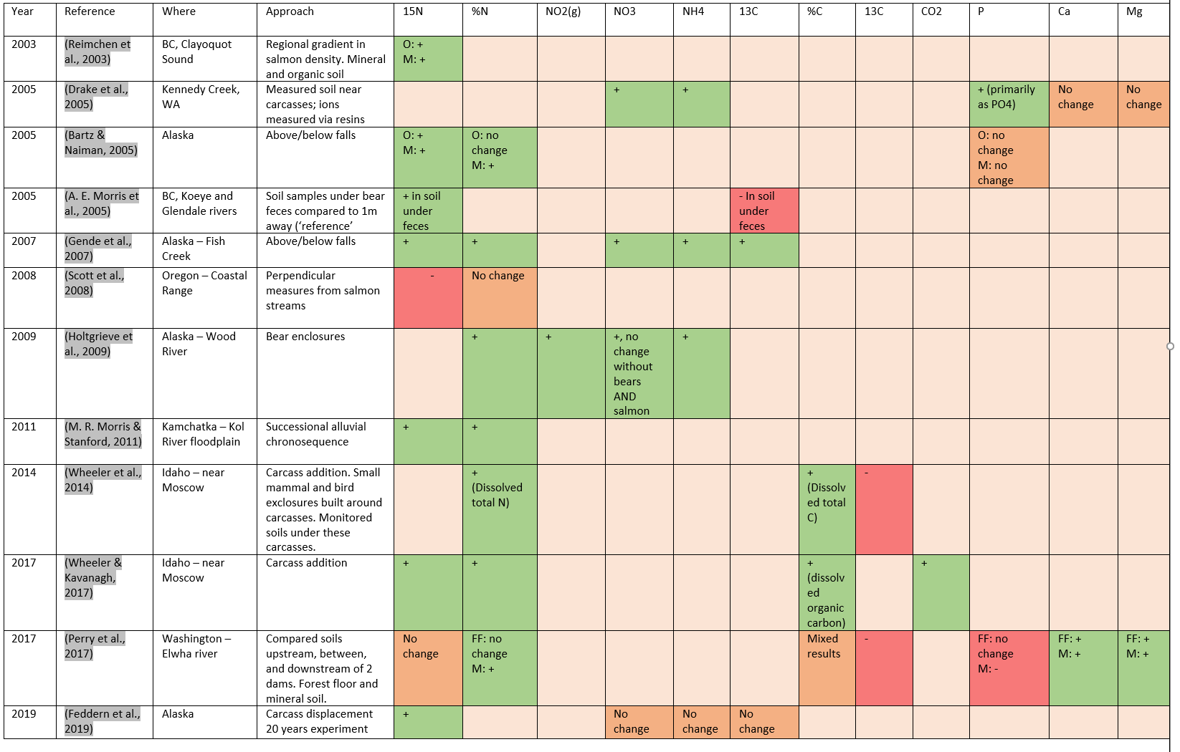
Table 1-1 (cont):
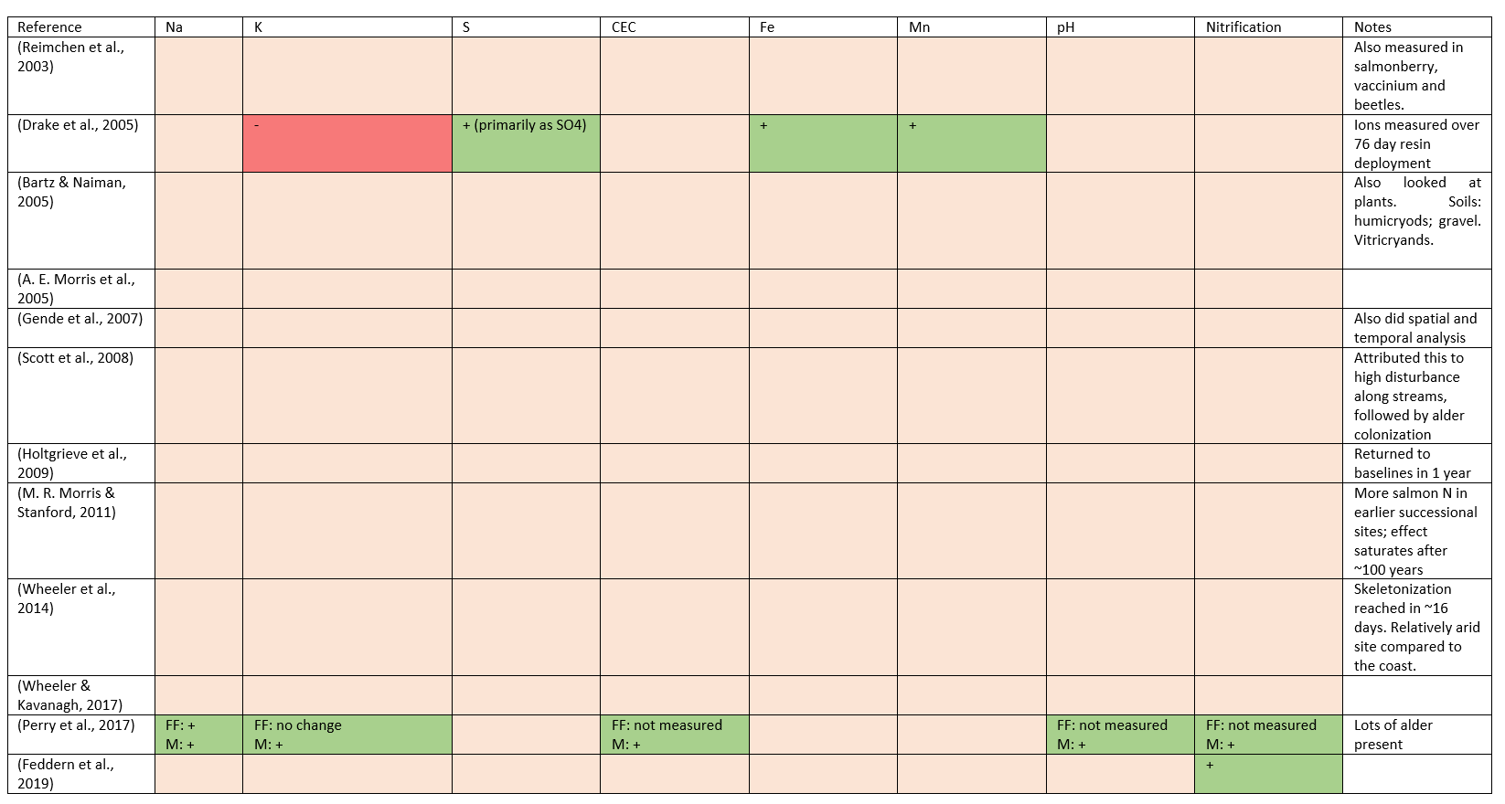

Table 1-2: Outline of motivating questions, scientific hypotheses, response variables investigated, and predictions investigated in this thesis.
Question | Hypothesis | Response variable | Prediction with SDN | Chapter
How does SDN change soil chemistry? | SDN increases soil fertility | Total N | Increases | 2
 |  | NH₄ | Increases | 2
 |  | NO₃ | Increases | 2
 |  | P | Increases | 2
 |  | C | Increases | 2
 |  | K | Increases | 2
 |  | S | Increases | 2
 |  | Ca | Increases | 2
 |  | Mg | Increases | 2
 |  | Na | No hypothesis | 2
 |  | CEC | Increases | 2
 |  | Mn | Increases | 2
 |  | Al | Decrease | 2
 |  | Fe | Increase or decrease | 2
 |  | Cu | No hypothesis | 2
 |  | Zn | No hypothesis | 2
 |  | B | No hypothesis | 2
 | SDN acidifies soil | pH | Increases or decreases | 2
Does SDN change soil metabolism? | Fungi take up SDN | Sporocarp ¹⁵N | Increases | 3
 | Vegetation takes up SDN | Vegetation ¹⁵N | Increases | 3
 | Soil takes up SDN | Forest floor ¹⁵N | Increases | 3
 |  | Organic soil ¹⁵N | Increases | 3
Do fungal communities react to SDN? | SDN increases fungal biomass | Ergosterol | Increases | 2
 | SDN increases mycorrhizal diversity | Mycorrhizal NGS diversity | Increases | 4
 | SDN decreases saprobe diversity | Saprobe NGS diversity | Decreases | 4
 | SDN changes community structure | NGS reads | Increased representation of nitrophiles | 4
 |  | Fungal NGS phylogenetic dispersion | Increases | 4
Do bacterial communities react to SDN? | SDN decreases bacterial diversity | Bacterial NGS diversity | Decreases | 5
 | SDN changes community structure | Bacterial NGS community | Increased representation of nitrophiles | 5
 |  | Bacterial NGS phylogenetic dispersion | Increases | 5
Do fungi promote uptake of SDN? | Fungi aid plants in MDN uptake | Addition experiment | Uptake decreases w/ fungal inhibition | 6

The effects of marine-derived nutrients on soil chemistry

Introduction
Every autumn, migratory pacific salmon (Oncorhynchus spp.) return to their native streams to spawn and die. In coming home, they carry with them a lifetime’s accumulation of nutrients stored in their flesh; this high-protein, high-fat material represents an ecosystem subsidy of marine-derived nutrients (MDN) from the ocean to riparian zones. These nutrients permeate stream water environments, increase stream nutrient loads (P. S. Levi et al., 2013), biofilm and plankton biomass (S. F. Collins et al., 2015), and impact fish biomass, numbers, and spawning success (S. F. Collins et al., 2016; Swain & Reynolds, 2015). Salmon presence has also been shown to affect surrounding forests, including increased abundance of nitrophyllic plant species (Hocking & Reynolds, 2011; Mathewson et al., 2003), plant growth (Quinn et al., 2018; Sayer, 2008; Siemens et al., 2020), and bird diversity and abundance (Christie & Reimchen, 2008; Wagner & Reynolds, 2019). They also provide food for numerous terrestrial insects and large mammals such as bears and wolves (Hocking et al., 2009; Reimchen, 2017). These myriad effects have contributed to salmon being identified as keystone species in these forests (Helfield & Naiman, 2006; J. C. Walsh, Pendray, et al., 2020).
Marine-derived nutrients pass from streams to terrestrial environments through three main pathways: 1. Direct uptake by plants, either from the stream itself or through diffusion into the hyporheic zone (O Keefe & Edwards, 2003; Pinay et al., 2009); 2. Emergence of aquatic insects (T. B. Francis et al., 2006); and 3. Direct consumption and distribution by terrestrial animals (Cederholm et al., 1989; Reimchen, 2017). Direct consumption and distribution by terrestrial animals is the largest vector by mass (Reimchen, 2017), and salmon carcass remnants, animal urine and animal feces represent three chemically distinct vectors of nutrient transfer to terrestrial environments (Cederholm et al., 1999b). Urine contributes mostly nitrogen in ureic form, while salmon carcasses contain large amounts of N, P, K, Ca, and S, as well as smaller amounts of Mg, Fe, Mn and other substances (Drake et al., 2005).
Ultimately, these nutrients accumulate in, are transformed by, and pass through the soil. The effects of MDN on soils has been examined using a variety of experimental approaches, including assessing soil nutrients across regional salmon gradients (Hocking & Reynolds, 2011; Reimchen et al., 2003), above and below barriers to salmon migration (waterfalls or dams) (Bartz & Naiman, 2005; Gende et al., 2007; Perry et al., 2017), and in carcass addition or displacement experiments (Drake et al., 2005; Feddern et al., 2019; T. A. Wheeler et al., 2014; T. A. Wheeler & Kavanagh, 2017). In other studies, soils have been sampled perpendicular to streams (Scott et al., 2008); across chronosequences of alluvial deposits (D’Amore et al., 2011, 2020; M. R. Morris & Stanford, 2011); and inside and outside bear exclosures (Holtgrieve et al., 2009). Due to being predators and of marine origin, salmon flesh is isotopically enriched in ¹⁵N, and these diverse methodologies have often used nitrogen isotopic signatures as a primary response variable. This has shown increased δ¹⁵N (Bartz & Naiman, 2005; Feddern et al., 2019; Gende et al., 2007; A. E. Morris et al., 2005b; M. R. Morris & Stanford, 2011; Reimchen et al., 2003; T. A. Wheeler & Kavanagh, 2017), decreased δ¹⁵N (Scott et al., 2008), or no change (Perry et al., 2017) along gradients of salmon nutrient inputs. In addition, MDN have been shown to be associated with increased total soil N (Bartz & Naiman, 2005; Gende et al., 2007; Holtgrieve et al., 2009; M. R. Morris & Stanford, 2011; Perry et al., 2017; T. A. Wheeler et al., 2014; T. A. Wheeler & Kavanagh, 2017), nitrate (Drake et al., 2005; Gende et al., 2007; Holtgrieve et al., 2009), ammonium (Drake et al., 2005; Gende et al., 2007; Holtgrieve et al., 2009), and NO₂ (gas) (Holtgrieve et al., 2009) concentrations, although others have also found no effects of MDN on total N (Scott et al., 2008), or nitrate and ammonium (Feddern et al., 2019).
Despite over two decades of attention, soil characteristics other than nitrogen have been rarely studied in salmon forest soil assessments. Phosphorus, critical for the health of plant proteins, nucleic acids, and photosynthesis (Maathuis, 2009), has been found to have variable responses to MDN addition, and studies have found it to increase (Drake et al., 2005), not change (Bartz & Naiman, 2005) or decrease (Perry et al., 2017) in response to increased salmon inputs. Calcium, potassium, and other exchangeable cations (sodium, magnesium, and aggregate cation exchange capacity) are also important for plant cell signaling, photosynthesis, and the structuring of cell walls (Maathuis, 2009). The two studies where cations were examined showed conflicting reports of both increases and decreases in response to salmon inputs (Drake et al., 2005; Perry et al., 2017). These same studies showed that salmon inputs were correlated with increases in sulfur, iron, manganese and pH. pH has rarely been reported in the salmon forest literature, despite being a ‘master variable’ in driving both soil chemistry (Strawn et al., 2020) and microbial community composition (Delgado-Baquerizo et al., 2018), and its response to salmon inputs has only been reported in a single study where it was found to increase with salmon below migration-blocking dams (Perry et al., 2017). Carbon is increasingly being recognized as another soil ‘master variable’ which serves to mediate all other soil functions (Schmidt et al., 2011; Solly et al., 2020), and which has received considerable attention in recent years as a mediator of soil redox potential that positively correlates with soil fertility (Diacono & Montemurro, 2011; Jiang et al., 2018; Schmidt et al., 2011). Three studies have examined soil carbon with regards to salmon inputs, and two found that soil carbon stocks increased and CO₂ flux decreased with salmon inputs (T. A. Wheeler et al., 2014; T. A. Wheeler & Kavanagh, 2017), and one showed mixed results of both increases and decreases of soil carbon along a series of salmon-blocking dams (Perry et al., 2017).
Due to the release of hydrogen ions from the oxidation of ammonium (NH₄⁺), decreases in pH are often associated with high rates of ammonium application (W. Gao et al., 2015; D. Tian & Niu, 2015). This nitrogen-driven acidification has important implications for soil fertility, as lower pH is associated with higher aluminum toxicity (Fenn et al., 2006; X. Q. Zhao & Shen, 2018) and decreased stocks of exchangeable cations such as calcium due to nitrate-assisted co-leaching (Brady & Weil, 2016; Perakis et al., 2013). Higher soluble aluminum and iron concentrations may be indicative of an ongoing process of nitrogen-mediated acidification, but metals have never been investigated in soils along salmon gradients. In agricultural and forest settings, this type of soil acidification can be caused by nitrogen deposition at similar or lower deposition rates than those estimated for MDN inputs (D. Tian & Niu, 2015). If occurring at these sites, this process would predict a decrease in pH, an increase in soluble aluminum concentrations, and decreased exchangeable cation concentrations with higher salmon inputs. This phenomenon could be ongoing even as salmon directly deposit nitrogen, phosphorus, and calcium to riparian systems, and potentially offset fertility gains from direct deposition.
Soil fertility is a integrative concept that accounts for nutrient availability, water conditions, soil aeration and physical stability, and the absence of substances that can inhibit plant growth (Fisher et al., 2012; Nicolodi & Gianello, 2014; Patzel et al., 2000). Temperate rain forests are considered nitrogen-limited (Edmonds et al., 1989; LeBauer & Treseder, 2008), and for this reason studies focused on marine-derived nitrogen (MDN-N) dynamics have been thought to be most salient on west-coast rainforest sites (Oliver et al., 2017). However, phosphorus (Kranabetter et al., 2005; Richardson et al., 2004), calcium (Perakis et al., 2013; Trant et al., 2016), and co-limitations of calcium with nitrogen (Hynicka et al., 2016; Kranabetter et al., 2020; Perakis et al., 2006; Prescott et al., 2013), and phosphorus with nitrogen (Blevins et al., 2006a), have also been implicated in limiting productivity in these forests. Assessments of soil fertility should treat soil as a complex system (Nicolodi & Gianello, 2014), and consider a suite of soil nutrients and physical characteristics that support plant growth. Soil fertility is generally associated with high nitrogen, phosphorous, and exchangeable cation concentrations (primarily Ca²⁺, K⁺, and Mg⁺); moderate pH; high soil organic matter; and low iron and aluminum concentrations (Dick & Culman, 2017). A compound measure suggested to correlate with stress in forest ecosystems is the calcium : aluminum ratio (Cronan & Grigal, 1995), and this measure may be relevant in reference to these soils. In addition, higher soil fertility can also be indicated by shifts in plant, soil bacterial, and mycorrhizal fungal communities (Ceska & Scagel, 2011); and especially a shift from fungal-dominated to bacterial-dominated soils (Phillips et al., 2013; Wallenstein et al., 2006). Thus, the effects of MDN on soil fertility ought to be evaluated through an integrative measurement of chemical and biological characteristics along salmon gradients.
The goal of this study was to examine the effects of salmon density on forest soil chemistry in migratory salmon rivers of the Central Coast of British Columbia, Canada. My broad objectives were to: 1) assess whether salmon inputs are important drivers of soil chemical properties; 2) evaluate the degree to which salmon inputs affect soil fertility, and 3) establish baselines of soil chemical properties for riparian salmon forests in the BC Central Coast region and compare these with other forests in the PNW. To do this, I measured 22 soil chemical properties at two soil depths (forest floor and organic soil) in 23 well-studied watersheds that represent a gradient of salmon density (Hocking & Reynolds, 2011). In four of these watersheds, I compared soil properties below and above waterfalls that block salmon migration, representing a sharp discontinuity in MDN addition. I predicted that 1.) soil fertility would increase along the regional salmon density gradient; and 2.) soil fertility would be higher below than above falls. In evaluating this, I assume that salmon associated soil fertility is correlated with higher soil nitrogen concentrations (total N, NH₄⁺, NO₃⁻); higher exchangeable phosphorus (P) concentrations; higher exchangeable cation concentrations (K⁺, Mg²⁺, Na⁺, CEC), with particular importance attached to calcium (Ca²⁺); lower exchangeable metal concentrations, especially aluminum (Al³⁺) and iron (Fe); higher soil carbon; higher sulfur (total S and exchangeable S) concentrations, higher pH, and higher Ca : Al ratios (Table 2-1). In addition, I predicted that fungal biomass would decline with salmon inputs as nitrogen becomes increasingly accessible and as the soil community shifts from fungal-dominated to bacterial-dominated. This study thus assesses a complex of soil properties in order to evaluate the contribution of marine-derived salmon inputs to soil fertility in the Pacific Northwest.

Materials and Methods
Study sites
The study was conducted in Heiltsuk Nation traditional territory in the Central Coast Regional District of British Columbia, Canada, near the town of Bella Bella (Appendix A). The study sites are in the Central variant of the Very Wet Hypermaritime subzone of the Coastal Western Hemlock biogeoclimatic zone (CWHvh2) (MFLNRORD, 2018). Dominated by a cool maritime climate with high rainfall, the landscape is a mosaic of highland bogs where water is stagnant, and forested slopes where water sheds (Lamb & Megill, 2003). The forested riparian zones are a mix of western hemlock (Tsuga heterophylla), western red cedar (Thuja plicata), Amabilis fir (Abies amabilis), and Sitka spruce (Picea sitchensis), with red alder (Alnus rubra) appearing in disturbed sites. The understory includes huckleberry and blueberry species (Vaccinium parvifolium, V. alaskensae, and V. ovalifolium), false azalea (Menziesia furruginea), salal (Gaultheria shallon), salmonberry (Rubus spectabilis), and devil’s club (Oploplanax horridus).
Regional soils are dominated by alkaline and peralkaline geochemistry (Souther, 1986), and recent glacial dynamics imply that soil formation has occurred only in the last ~14,000 years (Eamer et al., 2017). Ferro-Humic Podzols dominate the region, extending from northern Vancouver Island to Prince Rupert. The Central Coast is characterized by a narrow coastal band of Folisols that encompass the study sites (Carpenter et al., 2014). The soils found at the study sites were primarily Humic and Lignic Folisols (Organic order, Folisol great group), with the occasional Ferro-Humic Podzol (Podzolic order, Ferro-Humic great group) (n=4) (C. A. Fox et al., 1987).
A total of 23 streams were included in the study, representing a gradient of salmon density (0 – 67 kg salmon per meter of stream reach per year). These streams have been well studied previously (Hocking & Reynolds, 2011) and have ongoing long term (12+ years) salmon density measurements. Four of the 23 streams had waterfalls, which were utilized for above/below waterfall comparisons. This study was intentionally conducted in July and August to be as distant annually from the salmon run as possible, and in order to emphasize long-term and legacy effects of salmon deposition.
Soil sampling
Two soil cores were collected from each stream, with an additional two cores above waterfalls in the four watersheds where they occurred. Samples were taken from microsites of flat, deep soil (>50 cm), within 100 m of the stream mouth, and within 50 m perpendicular to the stream. At each microsite, a small soil pit was dug to 50 cm depth and the soil profile described and photographed, and the location, distance from the stream mouth, and distance to the closest bank recorded. In the soil pit, horizons were identified, and soil texture and percent lignic matter were estimated. The litter layer was removed and the top 5 cm collected as a single sample (“forest floor”). The underlying 10-15 cm of organic soil was collected as a second sample (“organic”).
Forest floors were generally dominated by decomposing moss and conifer needles. Deeper soils were found to match soil maps and were almost exclusively Lignic and Humic Folisols (Drw) (C. A. Fox & Tarnocai, 2011), with homogenous organic composition down to gravel or bedrock.

Plant Community
At each core, the closest large tree (the “focal tree”) was identified to species; and had its distance from the core, azimuth from the core, and diameter at breast height (dbh) measured, and its height estimated. Mosses and herbs, and trees and shrubs, were recorded with a two-tiered nested approach (Appendix C). First, a 1 m² plot was centered on the soil core where percent cover of each moss and herb species j were visually assessed. This resulted in an estimate for each moss and herb species j in each plot.
Second, a 5 m radius circular plot was centered on the soil core and shrubs with height >1 m were identified to species and their aboveground volume estimated by measuring their cubic volume ($h x l x w$). Their distance and bearing to the core were measured, and these figures combined to estimate the effect of each shrub on the soil core as a “shrub influence index”, calculated as:
$i_{shrub}=\frac{shrub volume}{distance to soil core}$.
Similarly, every tree with dbh > 1 cm in the 5 m radius plot was recorded. Tree species identity, circumference, distance and azimuth from the core were measured. To estimate the effect of each tree on the soil core, a “tree influence index” was calculated as:
$i_{tree}=\frac{circumference}{distance to soil core}$.
For each tree and shrub species j the influence indices of all individuals at each plot were summed, giving an estimate of the aggregate effect of species j on each soil core.
Dimensionality of these four vegetation indices (mosses, herbs, shrubs and trees) were reduced via principal component analysis (PCA) for downstream use as explanatory variables. In each vegetation PCA, the variation explained and major loading for the first principal axis was: moss (36% of variation explained; positive direction - lanky moss); herbs (35%; positive – salal, deer fern; negative – false lily of the valley, spiny wood fern); shrubs (34%; positive – salal; negative – false azalea, Vaccinium); trees (39% of variation; negative – cedar) (Appendix C).
Soil analyses
Soil chemical analyses were carried out by the British Columbia Ministry of Environment & Climate Change Strategy Analytical Laboratory in Victoria, British Columbia, Canada. Total C, N, and S were volatilized via combustion and analyzed using a Thermo Flash 2000 elemental analyzer. Nitrate and ammonium were extracted with a 2N KCl extraction (Carter & Gregorich, 2007) and analyzed using an Astoria Pacific A2 auto-analyzer. Loss on ignition (LOI) was calculated via complete combustion in an ashing furnace and measured using an analytical balance, and pH using an ion meter and a 1:1 dilution with distilled water. Ergosterol was extracted using an EtOH protocol and analyzed using a Waters 2690 HPLC (F. Martin et al., 1990). All other elements were extracted using a 0.1N Barium Chloride Extraction (Hendershot & Duquette, 1986) and/or a Mehlich III extraction (Mehlich, 1984) and analyzed with a Teledyne Leeman Prodigy ICP-OES. Soil tests, units, and methods are summarized in Table 2-2.

Salmon density data
Annual fish count data were contributed by the Reynolds lab at Simon Fraser University, Department of Fisheries and Oceans, and the Heiltsuk First Nation. Detailed description of these data are found in Appendix B. Salmon biomass for year t at site j was calculated by multiplying annual salmon escapement estimates of site j by the average biomass of the corresponding species i at spawning time $({estimated biomass}_{tj}=\sum_{i=1}^{4}{{escapement}_{tji}*{average individual biomass at spawning}_{ i}}$). Four salmon species are found in these study sites: Chum (Oncorhynchus keta), Pink (O. gorbusha), Coho (O. kisutch), and Sockeye (O. nerka); biomass estimates at spawning for Chum and Pink were taken from previous values at these sites (Hocking & Reynolds, 2011), and Coho and Sockeye were taken from the literature (Shaul et al., 2007). Chum and Pink accounted for the vast majority of salmon at the sites (>95% of total biomass). Annual biomass measures for each stream j were averaged over the last three years on record prior to sampling (2014-2016). From these biomass estimates, density indices were calculated by dividing estimated biomass by the length of spawning reach of each watershed $(density=\frac{estimated biomass}{length of spawning reach} )$ and is henceforth referred to as “salmon density”. Its units are thus $\frac{(kg of salmon)}{(m of stream reach)(year) }$.
Data Analysis
Two interconnected data sets were analyzed: a regional gradient of salmon density at 23 sites (“regional gradient data”), and an above and below waterfalls comparison at four of these sites (“above/below waterfall data”). Regional gradient data was analyzed through three methodologies: a multivariate approach using canonical correspondence analysis (CCA); hypothesis testing using a generalized linear modelling approach; and an exploratory approach using random forest models on a wider set of explanatory variables. Above/below waterfall data was summed within watershed and analyzed using paired Wilcoxon tests due to lack of normality and sensitivity of the mean to extreme values. All statistical analyses were performed in R (R Core Team, 2019).
Given we had strong a-priori hypotheses (Table 2-1), canonical correspondence analysis (CCA) (Legendre & Legendre, 2012) was appropriate to test the relationships between explanatory variables and aggregate soil chemistry. All chemical variables were used (k=22) and the ordination was constrained by salmon density, soil type (2 levels: forest floor and organic), dominant tree species (4 levels: Sitka spruce, Amabilis fir, Western redcedar, and Western hemlock), and the first axes of each vegetation PCA. Chi-square distances were used and all variables were scaled to zero with unit variance. P-values represent the marginal effects of each term after all other effects are included in the model and calculated over 1000 permutations using pseudo-F statistics for comparison (Legendre et al., 2011).
A generalized linear model averaging approach was used for hypothesis testing (Burnham & Anderson, 2003). Forest floors and organic soil were analyzed separately, and a separate model was built for every response variable k. Boron in organic soil was excluded as it had negligible concentrations. This resulted in $\left(2x22\right)-1=43$ separate models. The full model equation was:
${Response vaiable}_{k} \sim salmon density+soil type+ dominant tree species+moss PCA1+herb PCA1+shrub PCA1+tree PCA1$.
All explanatory variables associated with each response variable were tested for collinearity before modelling (Cade, 2015) and multicollinearity assessed via inspection of variance inflation factors (VIFs) with respect to the full model; multicollinearity between explanatory variables was minimal in all selected models (VIFs < 2). All explanatory variables were scaled before model fitting. Model assumptions were visually assessed via diagnostic plots, and either Gaussian or Gamma distributions were used as the model family with either identity, inverse, or log-link link functions based on data range and which best met model assumptions. Predictions from the global model were used to generate marginal predictions and confidence intervals visualized in scatterplots in Figure 2-2 to Figure 2-6.
To compare the relative importance of explanatory variables, model-averaged standardized coefficients and confidence intervals were calculated and visualized in forestplots in Figure 2-2 to Figure 2-6; this methodology calculates coefficients for all subsets of the global model, sorts them by AICc, and averages all coefficients weighted in proportion to their AICc values (Barton, 2020; Burnham & Anderson, 2003). This results in a single ‘averaged’ model coefficient for each explanatory variable. Coefficients were averaged only across the models in which they occur (‘conditional’ rather than ‘full’ averaging) (Galipaud et al., 2014), and model selection tables were manually inspected to assess coefficient stability among averaged models,.
Above and below waterfall data was visualized with box-and-whisker plots (Figure 2-2 to Figure 2-6, last facet in each row); for hypothesis testing data was pooled by taking the mean within site and then compared via two-sided Wilcoxon paired-rank tests (
Table 2-4), with samples above and below randomly paired within sites.
To test a broader set of explanatory variables, random forest models were used in an exploratory analysis with a broader set of explanatory variables with the R caret and randomForest packages (Kuhn, 2008; Liaw & Wiener, 2002). Standardized importance coefficients of these explanatory variables were then visualized with a heatmap (Figure 2-7).
Finally, to place these soils in context they were compared with regional averages for nearby coastal temperate rainforest, as catalogued in a recent meta-analysis (Carpenter et al., 2014). Data density curves for their data were reassembled (Figure 2-9) and compared with both forest floors and organic soils measured in this study. We assumed a bulk density of 0.15 (similar to regional Folisols) and projected to 1 m depth in order to match the scales used in the regional meta-analysis.

Results

Aggregate soil chemistry (Figure 2-1)
Salmon density was found to affect aggregate soil chemistry; in the regional gradient data CCA, salmon density, soil depth, dominant tree, moss PCA1 and shrub PCA1 all had significant (P < 0.05) correlations with aggregate soil chemistry (Figure 2-1 & Table 2-3). 57% of the inertia was accounted for by the explanatory variables, and adjusted R² for the model was 0.40 and VIFs amongst explanatory variables was low (<3.5).

Nitrogenous compounds (Figure 2-2)
Total nitrogen, ammonium and nitrate were all predicted to increase with salmon inputs (Table 2-5). Total N did not change with salmon density across the regional gradient, but was higher below falls than above falls (Figure 2-2). Ammonium was also higher below falls than above falls, and had an increasing, but only moderately significant (P<0.1), tendency with respect to salmon density in forest floor soil, and an increasing tendency in organic soil. Nitrate increased with salmon inputs both along the regional gradient and below falls.

Organics (Figure 2-3)
I found a decreasing tendency in pH below waterfalls, and this was significant in organic soil but not in forest floors (Figure 2-3); however, this increase was not reflected in the modelling results.
Exchangeable phosphorus was predicted to increase with salmon inputs, and was higher below than above falls in both soil types (Figure 2-3). However, there were no significant trends in the modelling results or the waterfall analysis.
Similarly, carbon was predicted to increase with salmon inputs, but was unaffected by salmon inputs in the gradient data and was higher, but not significantly so, in organic soil below falls. Loss-on-ignition (LOI, Figure 2-3 p.2) was dominated by carbon content and had similar results.
Total sulfur (Figure 2-3 p.2) was predicted to increase with salmon inputs, and there was an increasing tendency in both soil layers below waterfalls. It showed, however, no significant tendency in the modelling results. Similarly, exchangeable sulfur was also expected to increase with salmon inputs, but showed a decreasing but not significant trend both between waterfalls and along gradients.

Exchangeable cations (Figure 2-4)
Cation exchange capacity (CEC) was predicted to increase with salmon inputs, but showed no change along the salmon density gradient in either soil type (Figure 2-4), and similarly no significant differences between waterfall sites.
Calcium was also predicted to increase with salmon inputs, and showed positive but only moderately-significant (0.5<P<0.1) tendencies in the regional modelling analysis and positive but not significant differences below falls.
Magnesium was predicted to increase with salmon inputs, but was found instead to decrease along the regional salmon gradient. Between waterfall sites, there was no relationship in forest floors and an increasing tendency in organic soil.
Potassium (Figure 2-4, p.2) was also predicted to increase with salmon inputs, but showed no significant relationships but decreasing tendencies in any these comparisons.
While no predictions were made for sodium, it behaved similarly to magnesium and decreased in the modelling results but was higher, or had no change, in the waterfall comparisons.

Metals (Figure 2-5) and Ergosterol (Figure 2-6)
Turning to the metals, aluminum was predicted to decrease with salmon inputs. It showed mixed responses across these analyses (Figure 2-5), with no change along the regional salmon density gradient in forest floor soils but a moderately significant (p=0.055) increase in organic soils (this result, however, was sensitive to two extreme values). Among waterfall sites it showed no significant relationships, but tended to be lower below than above falls.
Total and exchangeable iron were both predicted to decrease with salmon inputs, and showed similar lack of a response in the regional density gradient models. Despite being lower below falls in all soil types none of these differences were significant.
No predictions were made for copper, but it was found to increase with salmon density in organic but not forest floor soil (Figure 2-5, p.2). Zinc, since it is a component of salmon flesh, was predicted to increase with salmon inputs; however, it showed no significant responses among our comparisons but had an increasing tendency below falls. No predictions were made for either manganese or boron, and similar to zinc these elements showed no significant responses among the various analyses.
Various alternative hypotheses were made for ergosterol, but it was found to not change either along the regional salmon gradient or between waterfall sites (Figure 2-6).

Exploratory analysis (Figure 2-7)
In the random forest model analysis, explanatory variables of high importance were soil layer type, the two moss percent cover PCA axes, and the first shrub index PCA axis (Figure 2-7). Salmon density and distance from the stream were also of relatively high importance for the various nitrogenous compounds, phosphorus, total sulfur, calcium, magnesium, and zinc.

Calcium to aluminum ratio and regional comparisons
Ca:Al ratios were predicted to increase with salmon inputs, and were found to be higher in forest floors than organic soil (Figure 2-8). Ca:Al was U-shaped in forest floors as a function of salmon density, although this was highly sensitive to the two highest salmon-density sites. Wilcoxon tests indicated that while variable, Ca:Al ratios were significantly higher below waterfalls than above (P < 0.05).
Compared with regional values, the soils in this study were more acidic and had higher cation exchange capacity, carbon, and nitrogen contents (Figure 2-9). C:N ratios were greater than regional soils, reflecting the Folisol order found at these sites (C. A. Fox et al., 1987).

Discussion
The first goal of this study was to assess whether salmon inputs influenced soil chemistry. I found that salmon inputs along a gradient of salmon density were significantly correlated to aggregate soil chemical profiles, which is consistent with an important role for salmon inputs in shaping soil dynamics in these riparian sites.
The second goal was to evaluate if these changes were consistent with higher soil fertility, as indicated by a suite of characters including increased nitrogenous compounds, higher pH, increased exchangeable cation concentrations, and lower aluminum concentrations. The prediction regarding increased nitrogen loading was mostly confirmed, and in particular ammonium and nitrate increased both with increasing salmon inputs and was higher below waterfalls. The observed lack of response in total nitrogen to increased salmon inputs along regional gradients may be due to total N including recalcitrant N, consisting of both difficult to access organic-N in needles and wood and mineral-stabilized nitrogen in the soil. These are impacted by complex feedbacks between nitrogen availability and vegetation community composition (F. Gao et al., 2020; Marty et al., 2017), an interpretation supported by the significance of the shrub community in forest floors. Given that salmon-derived nitrogen is primarily delivered in soluble ammonium and nitrate form (Drake et al., 2005), the stronger response in these chemicals is consistent with expectations from salmon inputs. The net increase in nitrogenous compounds found here supports previous findings along these streams which showed shifts in plant communities to nitrophyllic assemblages with increasing salmon density (Hocking & Reynolds, 2011). Assuming that nitrogen is a limiting nutrient in this system (LeBauer & Treseder, 2008), these results provide partial support to the first expectation that there would be an increase in fertility along salmon gradients.
pH is perhaps the most important single soil character for determining soil fertility (Bohn et al., 2001), and here the goal was to assess evidence for acidification resulting from high nitrogen loading from salmon inputs. There was no observed change in pH with increased salmon inputs along regional density gradients, mainly due to a few high values with high leverage at the high-salmon density sites Neekas and Clatse. Without these points there is a declining tendency in pH with increasing density, and lower pH was found below waterfalls in both soil layers (Figure 2-3). These data thus partially support the hypothesis of nitrogen-driven acidification occurring at these sites which, combined with the observation that relative to regional soils the pH of these soils was very low (Figure 2-9), suggests that low pH is characteristic of these low-lying riparian sites and salmon inputs may be a primary driver.
Exchangeable phosphorus was higher below than above falls (Figure 2-3), which matched its tendency to increase with salmon density. Given that P is directly deposited in soils by salmon carcasses (Drake et al., 2005) and has been found associated with salmon inputs in previous studies (D’Amore et al., 2020; Drake et al., 2005), this is likely due to direct P deposition. This finding is important because phosphorus by mass is the second most important plant nutrient next to nitrogen (Bohn et al., 2001) and is important in plant enzymatic, nucleic acid, and photosynthetic health (Maathuis, 2009). This finding supports the expectation that phosphorus would increase with salmon inputs and, to the degree that phosphorus limitation is important in these forests, increase site fertility. Exchangeable phosphorus in acidic soils is often deactivated via complexation with Al³⁺, and it has been suggested that organic-P amendments, such as those found in salmon carcasses, are particularly effective in increasing plant-available P in these environments (Y. Chen et al., 2018). Because of this, organic P is likely the dominant form of phosphorus in these soils, and organic-P has been suggested as the driver of tree fertility (S. F. Collins et al., 2015; Kranabetter et al., 2020). This study however did not measure total or organic P, only exchangeable P, and hence we cannot assess the importance of organic-P fractions; not measuring organic P may be missing an important dynamic in these soils and should be addressed in future studies. Despite this limitation, the increase in exchangeable-P shown here is consistent with a promotion of soil fertility.
Total C and loss-on-ignition (LOI) were unaffected by salmon inputs along regional gradients (Figure 2-3), but there was a tendency for soil C to be higher below waterfalls in organic-layer soils. This likely reflects topological, edaphic, and hydrological factors rather than salmon inputs, as the flatter and wetter below-falls sites would accumulate soil carbon faster than above falls. However, the total amounts of soil carbon found here were extremely high relative to regional soils (~600 Mg C/ha; Figure 2-9) and emphasizes the importance of these coastal rainforests as high-priority carbon sinks (Buotte et al., 2020; Post et al., 1985). Regardless of any effects due to salmon inputs, there is ample organic matter in the soil and inputs are unlikely to qualitatively change soil chemistry.
Sulfur is another essential macronutrient for plant function, and is necessary for protein synthesis and important in the production of phytochelators which detoxify metals and metalloids (Maathuis, 2009) which are important in buffering plant function in acidic soil (X. Q. Zhao et al., 2014, p. 201). Here there was no change in exchangeable sulfur, but total sulfur was higher below waterfalls relative to above (Figure 2-3). Sulfur is directly deposited by salmon carcasses (Drake et al., 2005), and while this finding suggests a possible importance of salmon inputs in driving soil sulfur concentrations at these sites it may be confounded with topological factors. Given that sulfate is the stable oxidation state and reservoir of exchangeable S in aerobic soils, and both retention and plant availability of sulfate anions is generally high in acidic soil environments (Bohn et al., 2001), I believe sulfur deficiency to be unlikely at these sites.
Cation exchange capacity (CEC) was unaffected by salmon inputs in either analysis, but calcium was also positively associated with salmon inputs. Calcium is important in maintaining plant structural integrity and cellular messaging, and has been suggested to be a limiting nutrient in coastal systems (Trant et al., 2016), in particular for western redcedar and associated plants. Ca²⁺ is intimately associated with N cycling (Hynicka et al., 2016; Perakis et al., 2006) and generally shows an inverse relationship with NO₃⁻ addition, with co-leaching of NO₃⁻ anions and Ca²⁺ cations the most commonly suggested mechanism (Bohn et al., 2001). The positive relationship shown here suggests either there is no loss as a result of salmon inputs, or that any potential leaching as a result of excess nitrate addition is compensated by direct Ca deposition from salmon carcass bones and cartilage.
Salmon carcasses also deposit magnesium and potassium (Mg⁺, K⁺), but do so in lower concentrations than calcium. Magnesium has a central role in the chlorophyll molecule, and is also important as a enzymatic cofactor in both transcription and translation (Maathuis, 2009). Magnesium declined with salmon inputs along regional gradients, but showed the opposite tendency in organic soils below waterfalls, where it was higher below falls than above (Figure 2-4). Potassium, meanwhile, is important in maintaining plant turgor pressure, cellular signalling, and the activation of numerous enzymes (Maathuis, 2009), and is considered the third most important macronutrient in plants (Pandey et al., 2020). Potassium followed a similar pattern to magnesium, and had a decreasing trend with salmon inputs along regional gradients. Sodium, the final exchangeable cation we examined, followed a similar pattern to magnesium and potassium and decreased with salmon inputs along our gradient, but similar to magnesium was higher below waterfalls than above waterfalls in forest floor soil. Since few of these relationships were significant, these data suggest minimal effect of salmon inputs on exchangeable cations. Considered together, however, Mg²⁺, K⁺, and Na²⁺ had decreasing tendencies along the salmon density gradient, while Ca²⁺ increased; given full consideration, there may be evidence for the idea of nitrogen-assisted cation leaching in these soils, with the caveat that calcium is either not being leached or is being replaced by carcass deposition or another process at similar or higher rates. If it is occurring, mediation of cation leaching due to nitrogen-mediated acidification by calcium inputs suggests particular importance in these systems for large old-growth cedar trees, which act as calcium pumps and recycle calcium from deeper soil layers (D’Amore et al., 2009), as well as reflecting the importance of anthropological soil amendments from shellfish harvesting (Cox et al., 2020; Trant et al., 2016).
Soluble aluminum and both iron measurements had no significant responses to changes in salmon inputs (Figure 2-5), but all tended to be lower below falls. This rejects the idea that high nitrogen loads would lead to higher levels of aluminum toxicity, and supports the idea that salmon inputs improve fertility at these sites.
Zinc, manganese, and boron also showed no responses to salmon inputs, but copper showed significant increases with salmon inputs in organic soils. Given the lack of predictions regarding copper, the lack of difference between waterfall sites, and the large number of comparisons in this study, I interpret this finding with suspicion and believe that there are limited impacts of salmon inputs on the metal concentrations at these sites.
Contrary to expectations, I found no evidence for changes in ergosterol, a proxy for fungal biomass, over the salmon density gradient or between above and below waterfall sites. Ergosterol is a membrane lipid found exclusively in fungal cells, and is the most common sterol in many fungal lineages (Wallander et al., 2013). It has been commonly used for quantification of ectomycorrhizal biomass, but may be of questionable use in quantifying ericoid fungi (Olsrud et al., 2007), which are one of the dominant fungal guilds at these sites (Chapter 4). Given these data, I interpret this as not supporting the prediction that soils would shift to a more bacterial-dominated state at higher salmon inputs, and conclude instead that fungal biomass remains relatively unchanged by salmon deposition.
Recent years have seen a revision in the understanding of CEC, metal, and nitrogen dynamics in acidic soils (Ross et al., 2008; X. Q. Zhao et al., 2014; X. Q. Zhao & Shen, 2018). The emerging model of acidic soil chemistry is one dominated by organic acids and humic materials (Jiang et al., 2018), and which is thus intimately tied to fungal and root exudates, plant litter, and microbial interactions (Ross et al., 2008). Given the light soil colour, its lignic origin (Ogner & Schnitzer, 1971), and abundance of Vaccinium spp. (Ciarkowska & Miechówka, 2019) at our sites, I hypothesize that the organic acid fraction is dominated by fulvic acids which form strong soluble complexes with Fe⁺, Al³⁺ and Cu; this removes them from plant-accessible soil fractions, promotes their leaching from the site, and both reduces their toxicity and indirectly increases P availability (Yang et al., 2013). This process may explain the lack of relationship between salmon-mediated nitrogen inputs and soluble aluminum concentrations, as organic acids buffer the system from aluminum toxicity due to nitrogen-driven acidification (X. Q. Zhao et al., 2014). Fulvic and humic acids, and their association with plant community shifts associated with MDN inputs, should be directly measured at these sites to clarify the best conceptual model for these soils.
One indicator suggested to be representative of forest stress is the calcium : aluminum ratio (Cronan & Grigal, 1995), which is negatively correlated with plant stress and positively correlated with fertility, and may play a role in stabilizing soil organic matter (Rowley et al., 2018), reversing forest decline (Battles et al., 2014), and promoting fungal growth (Jackson & Heath, 1993). I found Ca : Al ratios to be unchanged in organic soils with increasing salmon inputs along the regional gradient, and higher ratios (i.e., less stressed) below waterfalls than above (Figure 2-8). However, I found a distinct U-shaped curve in forest floor soils along the salmon gradient, where the minimum is consistent with higher leaching of calcium from forest floors to deeper soils, and the increasing trend at very high-salmon input sites consistent with increased nutrient loading in the larger, flatter floodplains at these sites. Given that there was no change observed in organic soils, and the potential for organic acids to control aluminum dynamics, I believe this ratio to be of minimum importance to the long-term fertility of these sites.
This study was conducted in the late summer in order to be as distant in the annual round from the salmon run as possible. This was in line with my intention to focus on the medium- and long-term legacy effects of salmon inputs, but a tradeoff of this choice is the potential influence of seasonal effects, particularly late-summer drought, on these results. It is also probable that by this time many of the soluble nutrients deposited by salmon have already been taken up by plants or leached from the system entirely. These findings should thus be regarded as a baseline to which soil conditions at times more proximate to the salmon run may be compared.

Conclusion
Generally, the above and below waterfall comparison agreed with the regional salmon density gradient modelling. There are advantages and disadvantages to each approach (Chapter 7), as the above and below waterfall methodology better controls for regional and watershed-level effects, but confounds salmon inputs with topographical and edaphic factors. In general, I have highest confidence where the two methodologies agree: salmon inputs likely increase ammonium and nitrate concentrations. Where regional trends match the above/below waterfall analysis, I have medium confidence in the results: salmon likely increase exchangeable phosphorus and calcium concentrations. In other cases, I would view these results as preliminary evidence that necessitates further study. In total consideration, these findings support the hypothesis that salmon inputs improve the fertility of recipient sites. Salmon increased nitrogenous compounds, likely increased phosphorus and calcium, and did not consistently lower pH or increase aluminum and iron concentrations.
It is likely that organic amendments are processed differently than inorganic amendments in forest soils (Y. Chen et al., 2018), and hence agricultural models of soil health are inappropriate in acidic and organic-rich forest soils. The increased fertility in response to salmon density observed in this study is comparable to fish silage fertilization experiments in cedar-hemlock forests from Northern Vancouver Island (Blevins et al., 2006b; Weetman & Prescott, 2000), where additions of fish silage resulted in positive growth responses in western redcedar, western hemlock and Amabilis fir; these responses were similar or superior to inorganic fertilizer application (Prescott, 1997). Our understanding of these processes may be enhanced by improved general understanding of how acidic organic soils work, and by directly measuring deposition and uptake of salmon amino acids (Metcalfe et al., 2011), organic phosphates, and lipids (Dinel et al., 1990).
This study adds a suite of soil characteristics to the growing list of ‘salmon-sensitive’ ecological features that include changes in plant community composition (Hocking & Reynolds, 2011) and physiology (Siemens et al., 2020; van den Top et al., 2018), as well as studies on direct effects on forest soils (Drake et al., 2005) (Chapter 1). These findings confirm in particular previous findings of increased nitrate and ammonium from salmon inputs, and are consistent with general net fertility gains from salmon inputs at these sites.

Tables and Figures
Table 2-1: Chemical groups examined in this study, as well as correlations with fertility and predictions with response to salmon nutrient inputs.
Group | Chemical | Correlation with fertility* | Predicted correlation with salmon | Predicted mechanism | Representative reference
Nitrogen compounds | N (tot) | positive | increase | Carcass deposition | (Drake, 2005)
 | NH₄+ | positive | increase | Carcass deposition | (Drake, 2005)
 | NO₃⁻ | positive | increase | Carcass deposition | (Drake, 2005)
Organics | P (ex) | positive | increase | Carcass deposition | (Drake, 2005)
 | pH | positive | decrease | Nitrogen-associated acidification | (D. Tian & Niu, 2015)
 | C (tot) | positive | increase | Litter from increased fertility | (Knorr et al., 2005)
 | LOI | positive | increase | Litter from increased fertility | (Knorr et al., 2005)
 | S (tot) | positive | increase | Carcass deposition | (Drake, 2005)
 | S (ex) | positive | increase | Carcass deposition | (Drake, 2005)
Exchangeable cations | CEC | positive | increase | Carcass deposition | (Drake, 2005)
 | Ca (ex) | positive | Increase | Carcass deposition | (Drake, 2005)
 | Mg (ex) | positive | increase | Carcass deposition | (Drake, 2005)
 | K (ex) | positive | increase | Carcass deposition | (Drake, 2005)
 | Na (ex) |  | none
Metals | Al (ex) | negative | increase | N-associated acidification | (D. Tian & Niu, 2015)
 | Fe (tot) | negative | increase | N-associated acidification | (D. Tian & Niu, 2015)
 | Fe (ex) | negative | increase | N-associated acidification | (D. Tian & Niu, 2015)
 | Cu (ex) |  | none
 | Zn (ex) |  | none
 | Mn (ex) |  | none
 | B (ex) |  | none
Ergosterol |  | negative | decrease | Lower fungal biomass with increased fertility | (Wallenstein et al., 2006)

Table 2-2: Chemical compounds measured, their units, preparation methods, analytical methodology, and type of measurement. All tests were conducted by the British Columbia Ministry of Environment analytical laboratory.
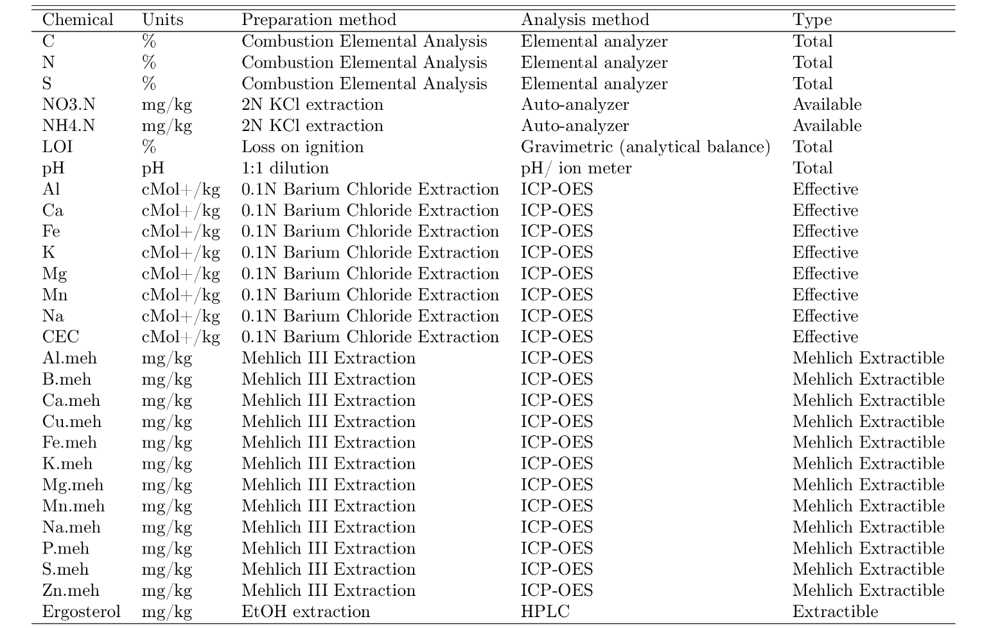

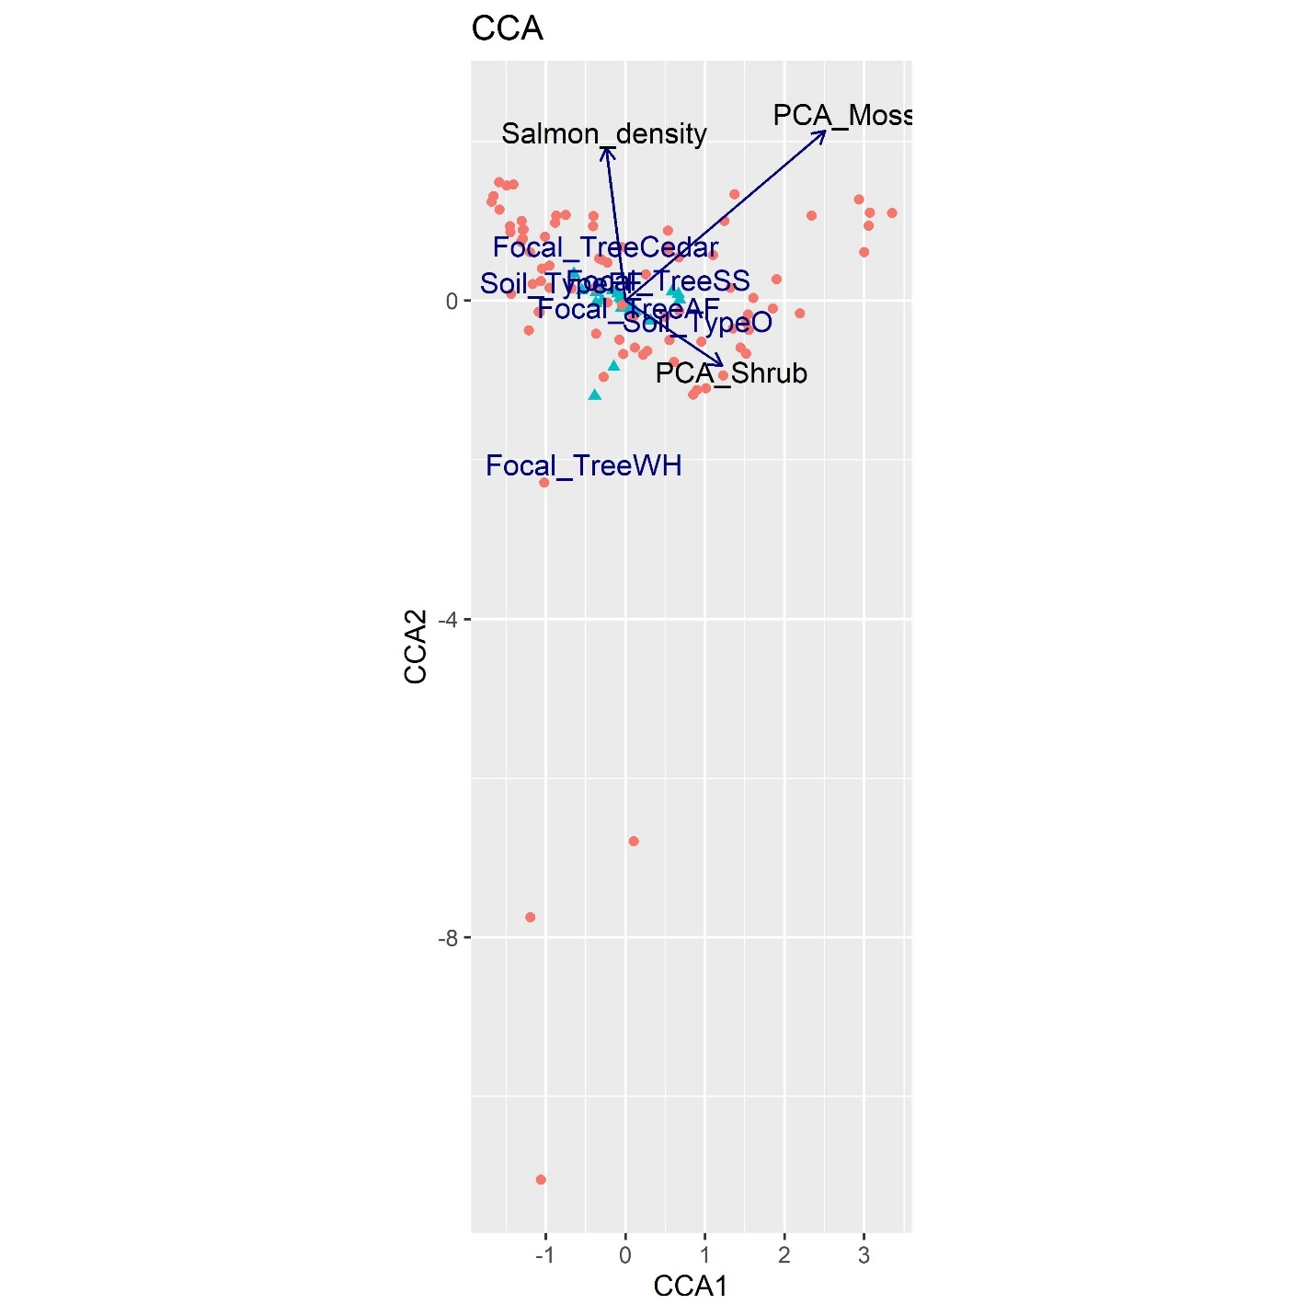
Figure 2-1: Canonical correspondence ordination for aggregate soil chemistry.
The initial set of chemical variables was constrained by salmon density, focal tree species, soil type, and the four vegetation PCA axes; the first tree PCA axis and the first herb PCA axis were not significant in initial models and dropped in the model shown here. 57% of the inertia was captured by the explanatory factors. Adjusted R² for the whole model was 0.40 and VIFs amongst explanatory variables was tolerable (<3.2).

Table 2-3: Summary table of the canonical correspondence analysis parameters. Salmon density, soil type, focal tree, the first moss PCA and the first shrub PCA were significant at a P < 0.05 threshold. The first tree PCA axis and the first herb PCA axis were not significant in initial models and dropped here. F-values are “pseudo-F values” sensu Legendre & Legendre 2012, and P-values are based on distributions generated from 1000 random permutations.
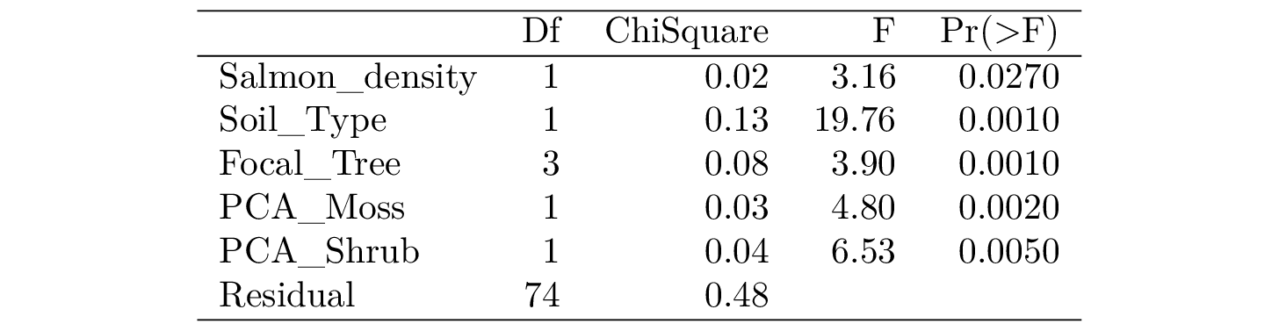

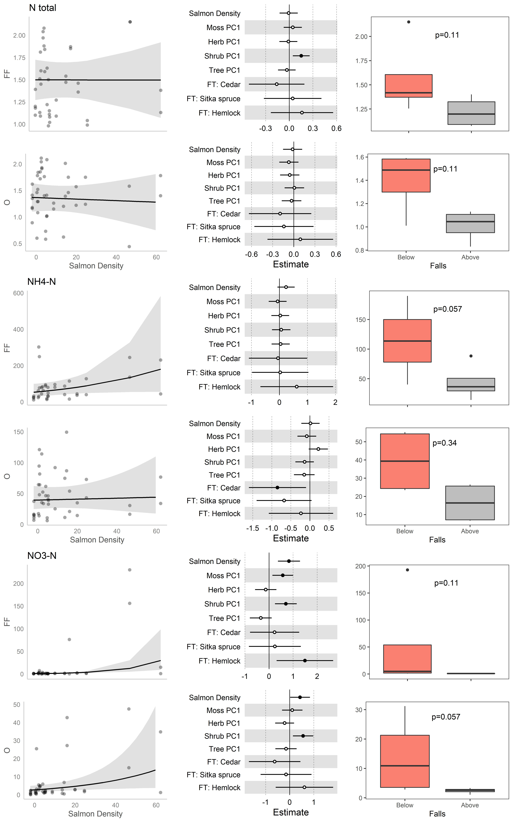

Figure 2-2: Nitrogen GLM results for regional gradient data and boxplots for above/below waterfall data.
The top row of each chemical are forest floors (0-5 cm) and second row are organic soil (10-15 cm). The first column are scatterplots for the global model of each chemical as a function of salmon density, with prediction lines and 95% confidence intervals indicating marginal responses to salmon density keeping all other explanatory variables at their mean values. The middle column indicates model-averaged standardized coefficient values for each explanatory variable, with significant (p<0.05) values indicated by filled dots. Contrasts for focal tree coefficients (FT: Cedar, FT: Sitka Spruce, and FT: Hemlock) indicate differences relative to Amabilis Fir. The rightmost columns are boxplots of above falls (AF; grey coloured box) and below falls (BF; salmon coloured box) data, with P-values indicated for paired Wilcoxon tests. Top and bottom of each box denote 75th and 25th quantiles respectively; whiskers show 1.5*IQR; dark central line indicates median values.
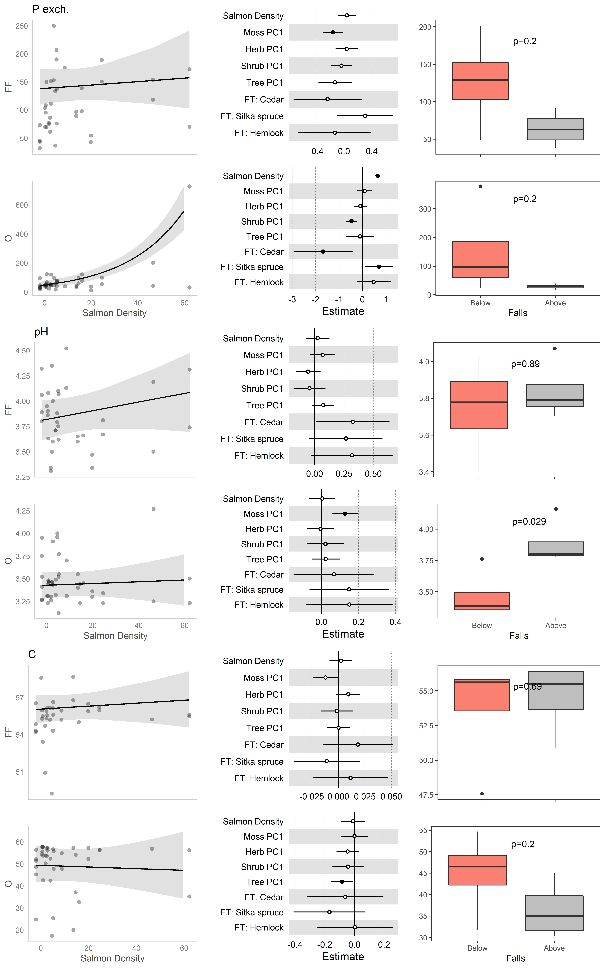
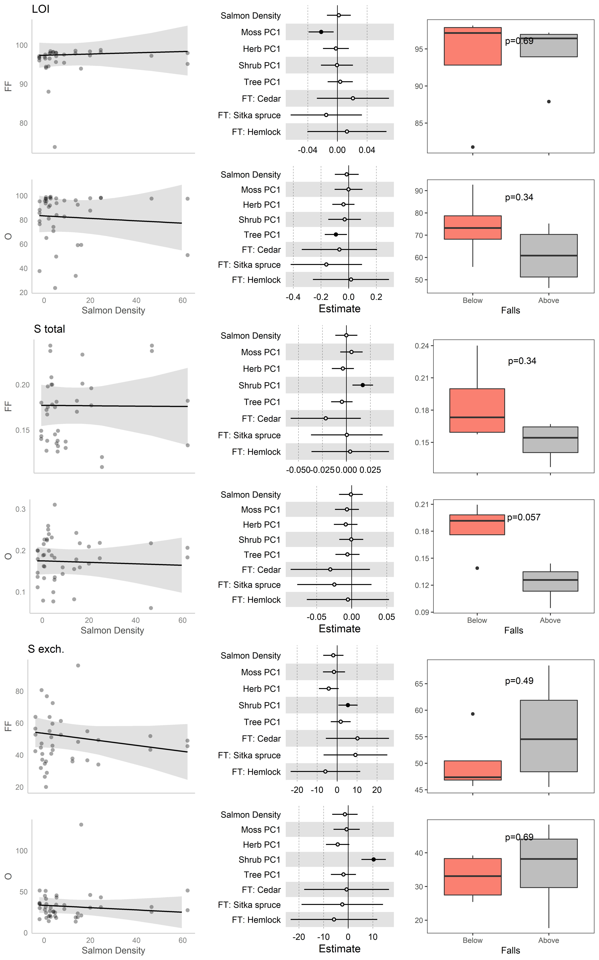

Figure 2-3: pH and organic substance GLM results for regional gradient data and boxplots for above/below waterfall data.
The top row of each chemical are forest floors (0-5 cm) and second row are organic soil (10-15 cm). The first column are scatterplots for the global model of each chemical as a function of salmon density, with prediction lines and 95% confidence intervals indicating marginal responses to salmon density keeping all other explanatory variables at their mean values. The middle column indicates model-averaged standardized coefficient values for each explanatory variable, with significant (p<0.05) values indicated by filled dots. Contrasts for focal tree coefficients (FT: Cedar, FT: Sitka Spruce, and FT: Hemlock) indicate differences relative to Amabilis Fir. The rightmost columns are boxplots of above falls (AF; grey coloured box) and below falls (BF; salmon coloured box) data, with P-values indicated for paired Wilcoxon tests. Top and bottom of each box denote 75th and 25th quantiles respectively; whiskers show 1.5*IQR; dark central line indicates median values.

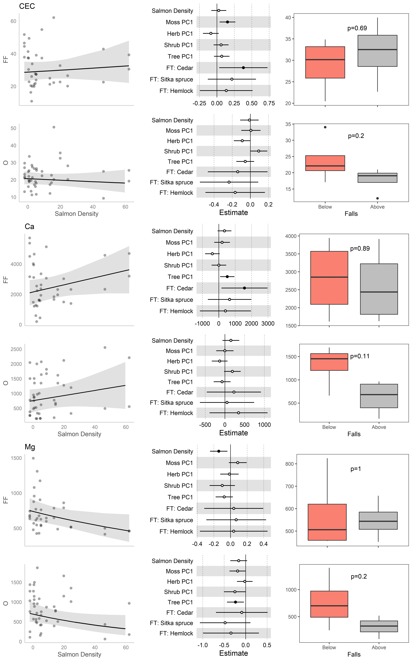
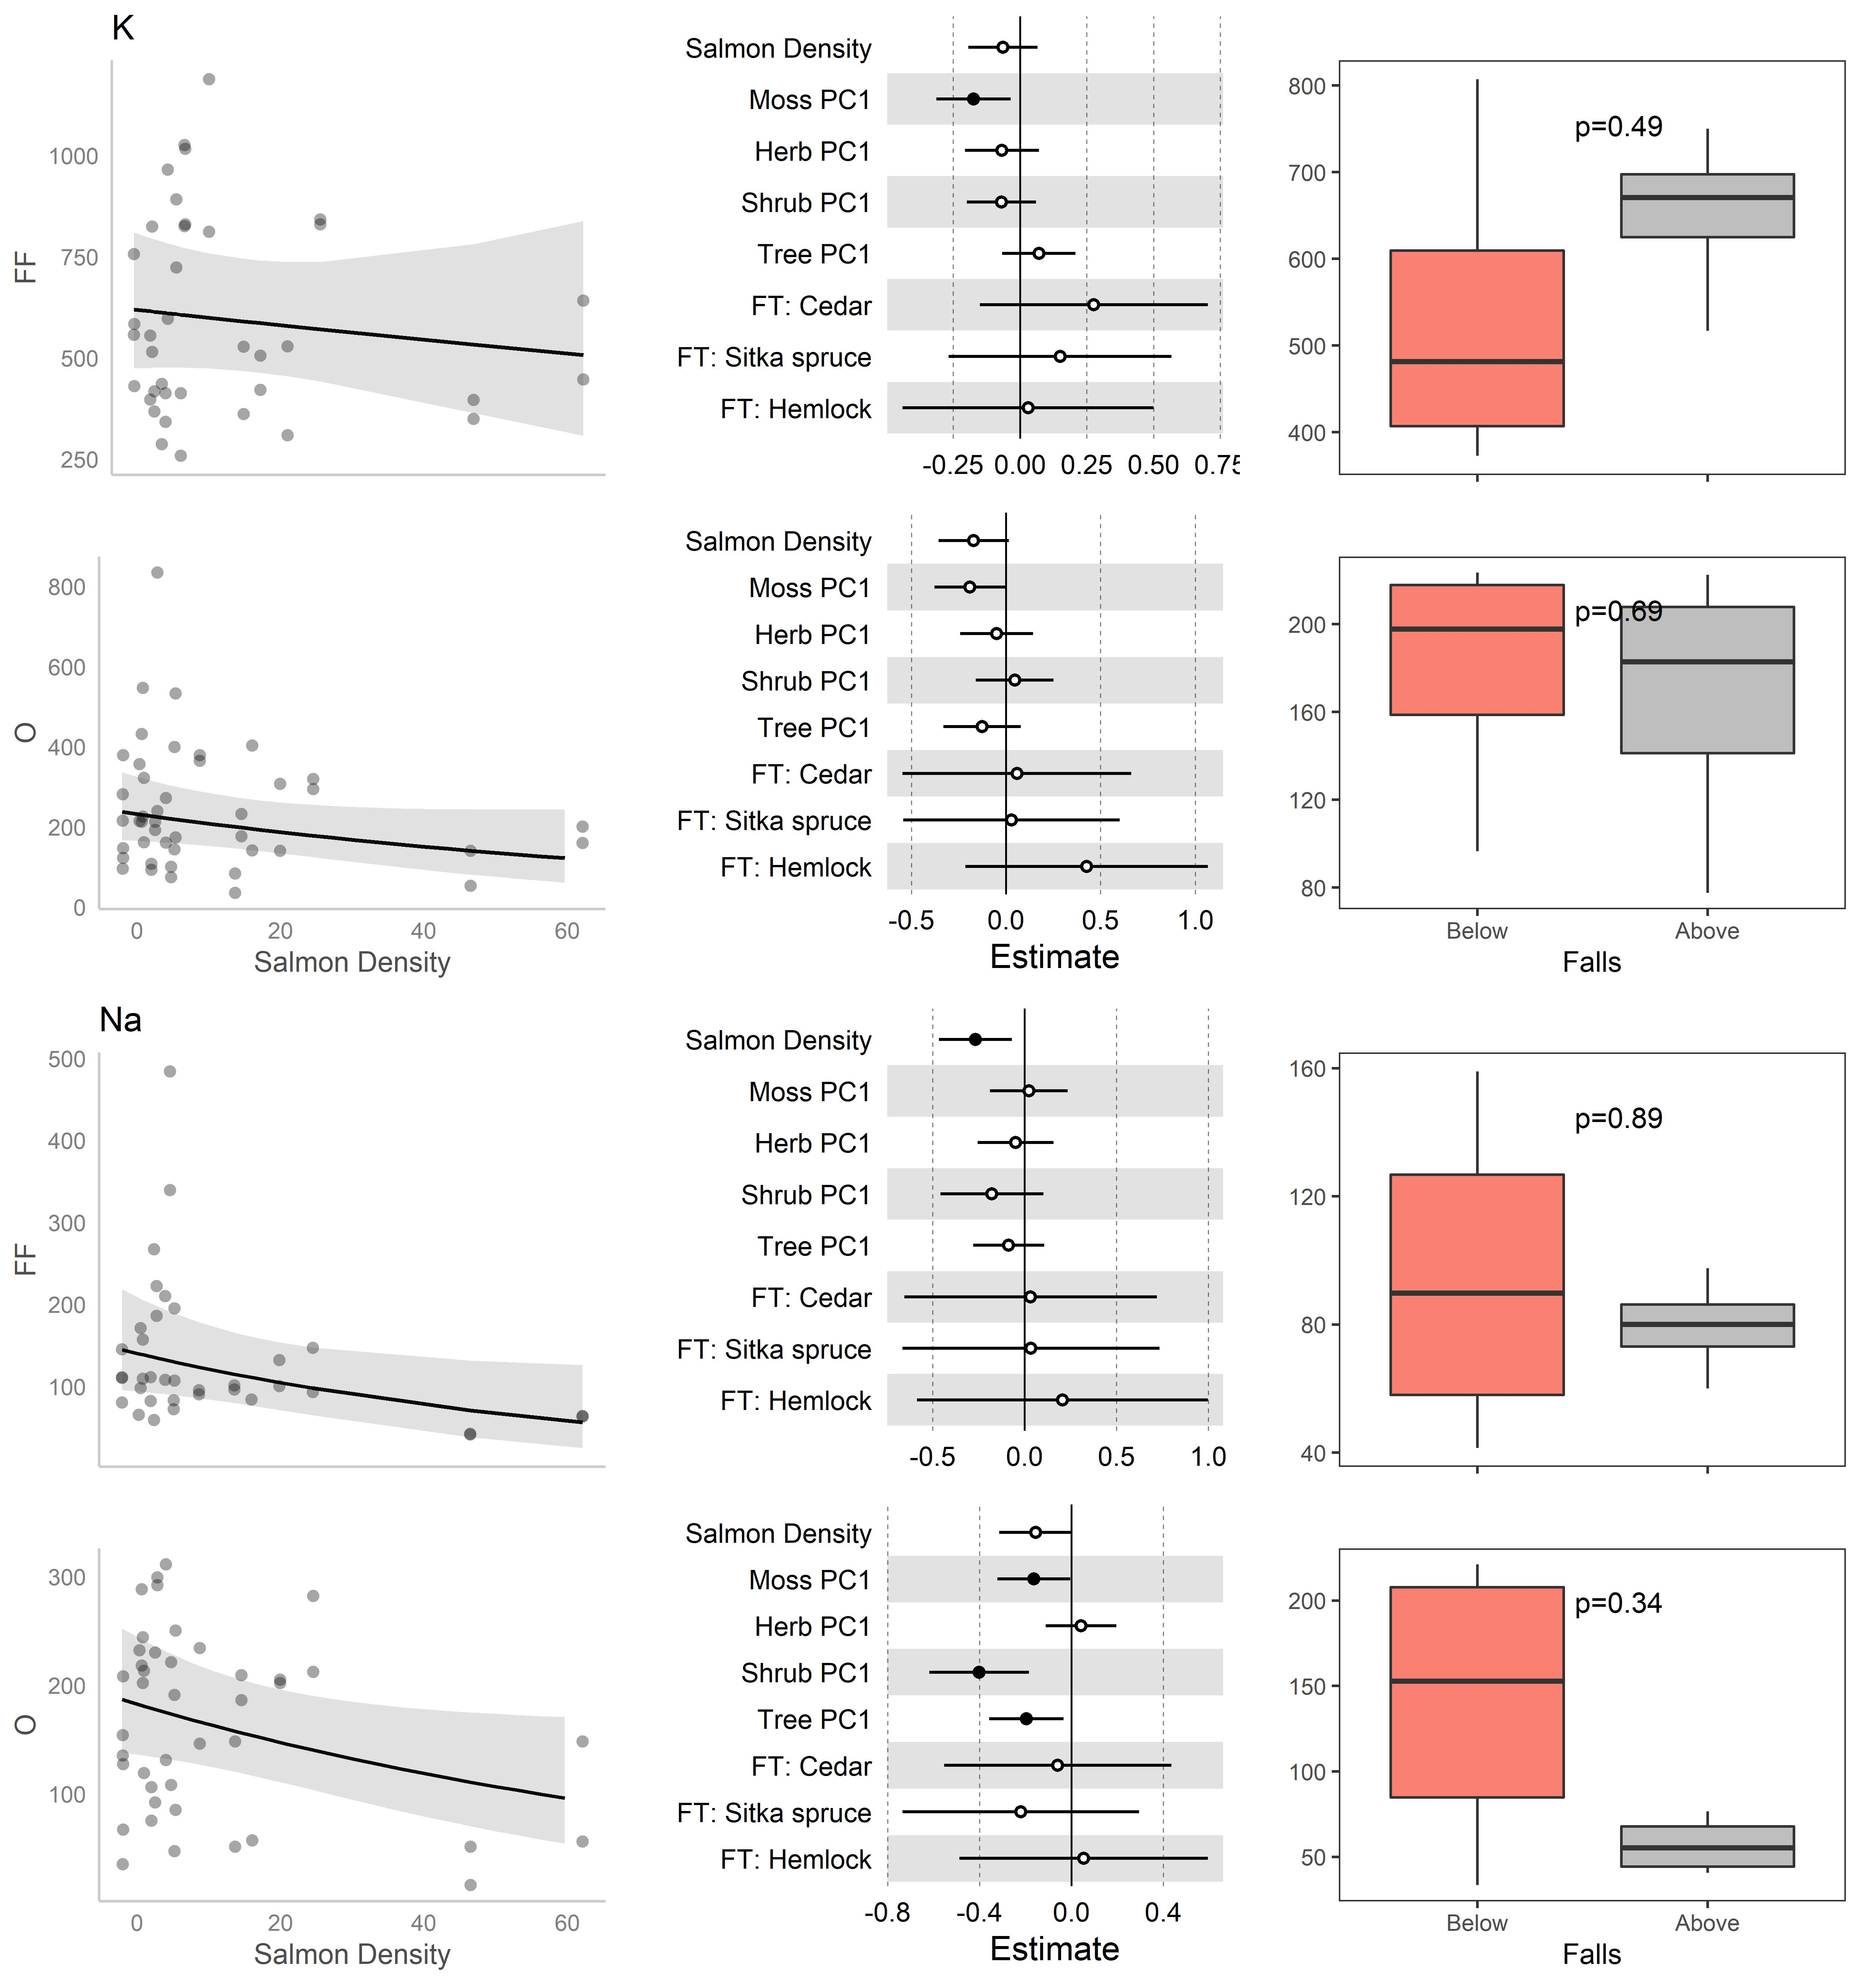
Figure 2-4: Exchangeable cations GLM results for regional gradient data and boxplots for above/below waterfall data.
The top row of each chemical are forest floors (0-5 cm) and second row are organic soil (10-15 cm). The first column are scatterplots for the global model of each chemical as a function of salmon density, with prediction lines and 95% confidence intervals indicating marginal responses to salmon density keeping all other explanatory variables at their mean values. The middle column indicates model-averaged standardized coefficient values for each explanatory variable, with significant (p<0.05) values indicated by filled dots. Contrasts for focal tree coefficients (FT: Cedar, FT: Sitka Spruce, and FT: Hemlock) indicate differences relative to Amabilis Fir. The rightmost columns are boxplots of above falls (AF; grey coloured box) and below falls (BF; salmon coloured box) data, with P-values indicated for paired Wilcoxon tests. Top and bottom of each box denote 75th and 25th quantiles respectively; whiskers show 1.5*IQR; dark central line indicates median values.
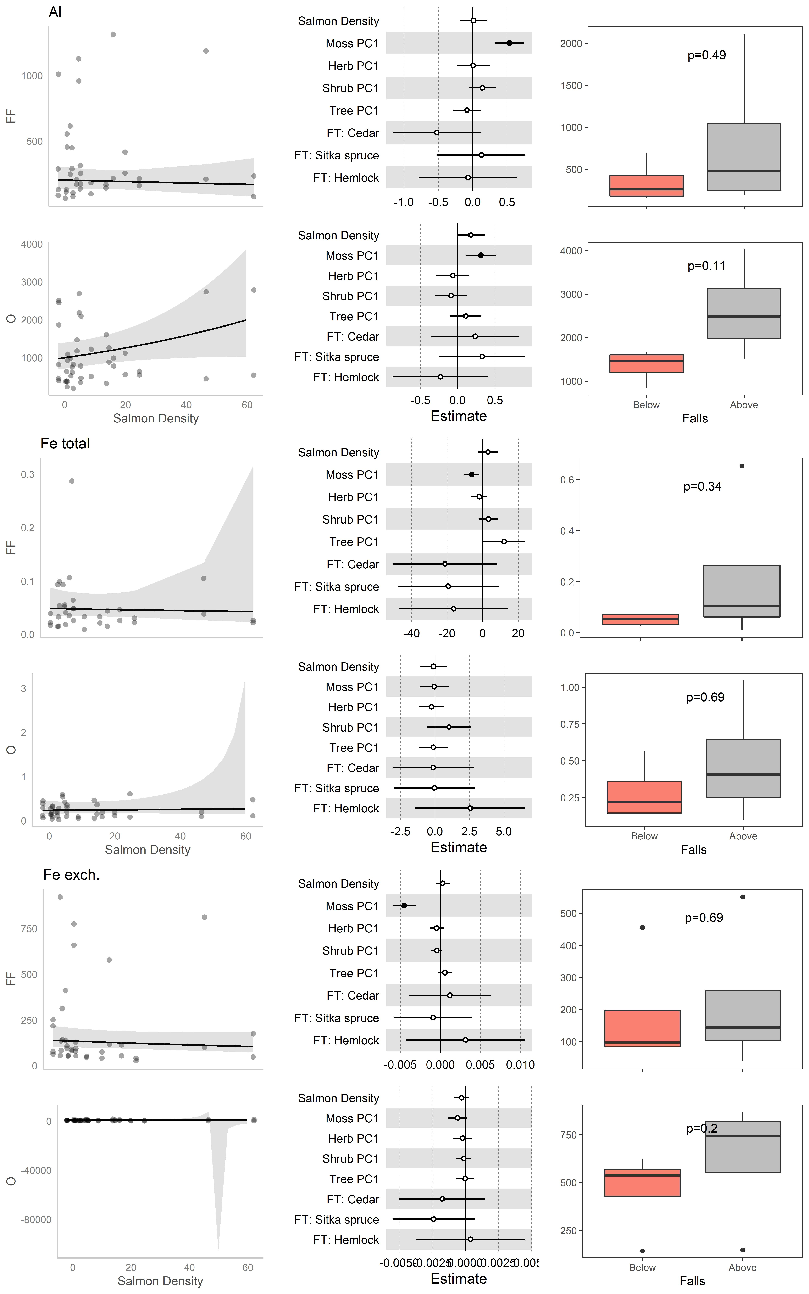

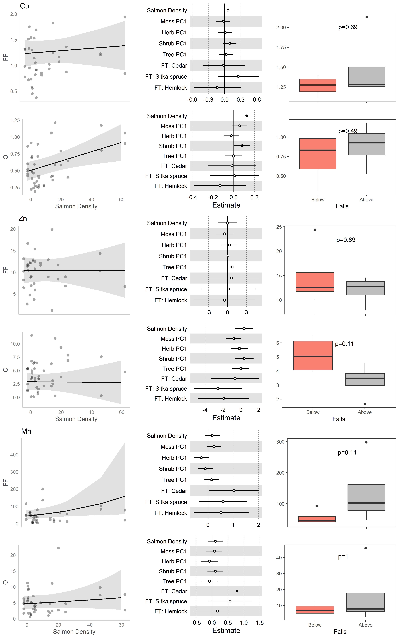
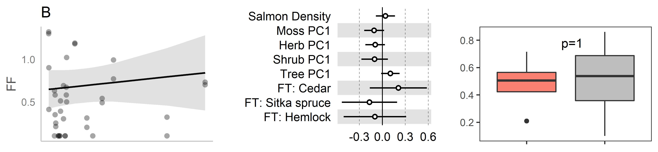
Figure 2-5: Metal GLM results for regional gradient data and boxplots for above/below waterfall data.
The top row of each chemical are forest floors (0-5 cm) and second row are organic soil (10-15 cm). The first column are scatterplots for the global model of each chemical as a function of salmon density, with prediction lines and 95% confidence intervals indicating marginal responses to salmon density keeping all other explanatory variables at their mean values. The middle column indicates model-averaged standardized coefficient values for each explanatory variable, with significant (p<0.05) values indicated by filled dots. Contrasts for focal tree coefficients (FT: Cedar, FT: Sitka Spruce, and FT: Hemlock) indicate differences relative to Amabilis Fir. The rightmost columns are boxplots of above falls (AF; grey coloured box) and below falls (BF; salmon coloured box) data, with P-values indicated for paired Wilcoxon tests. Top and bottom of each box denote 75th and 25th quantiles respectively; whiskers show 1.5*IQR; dark central line indicates median values.

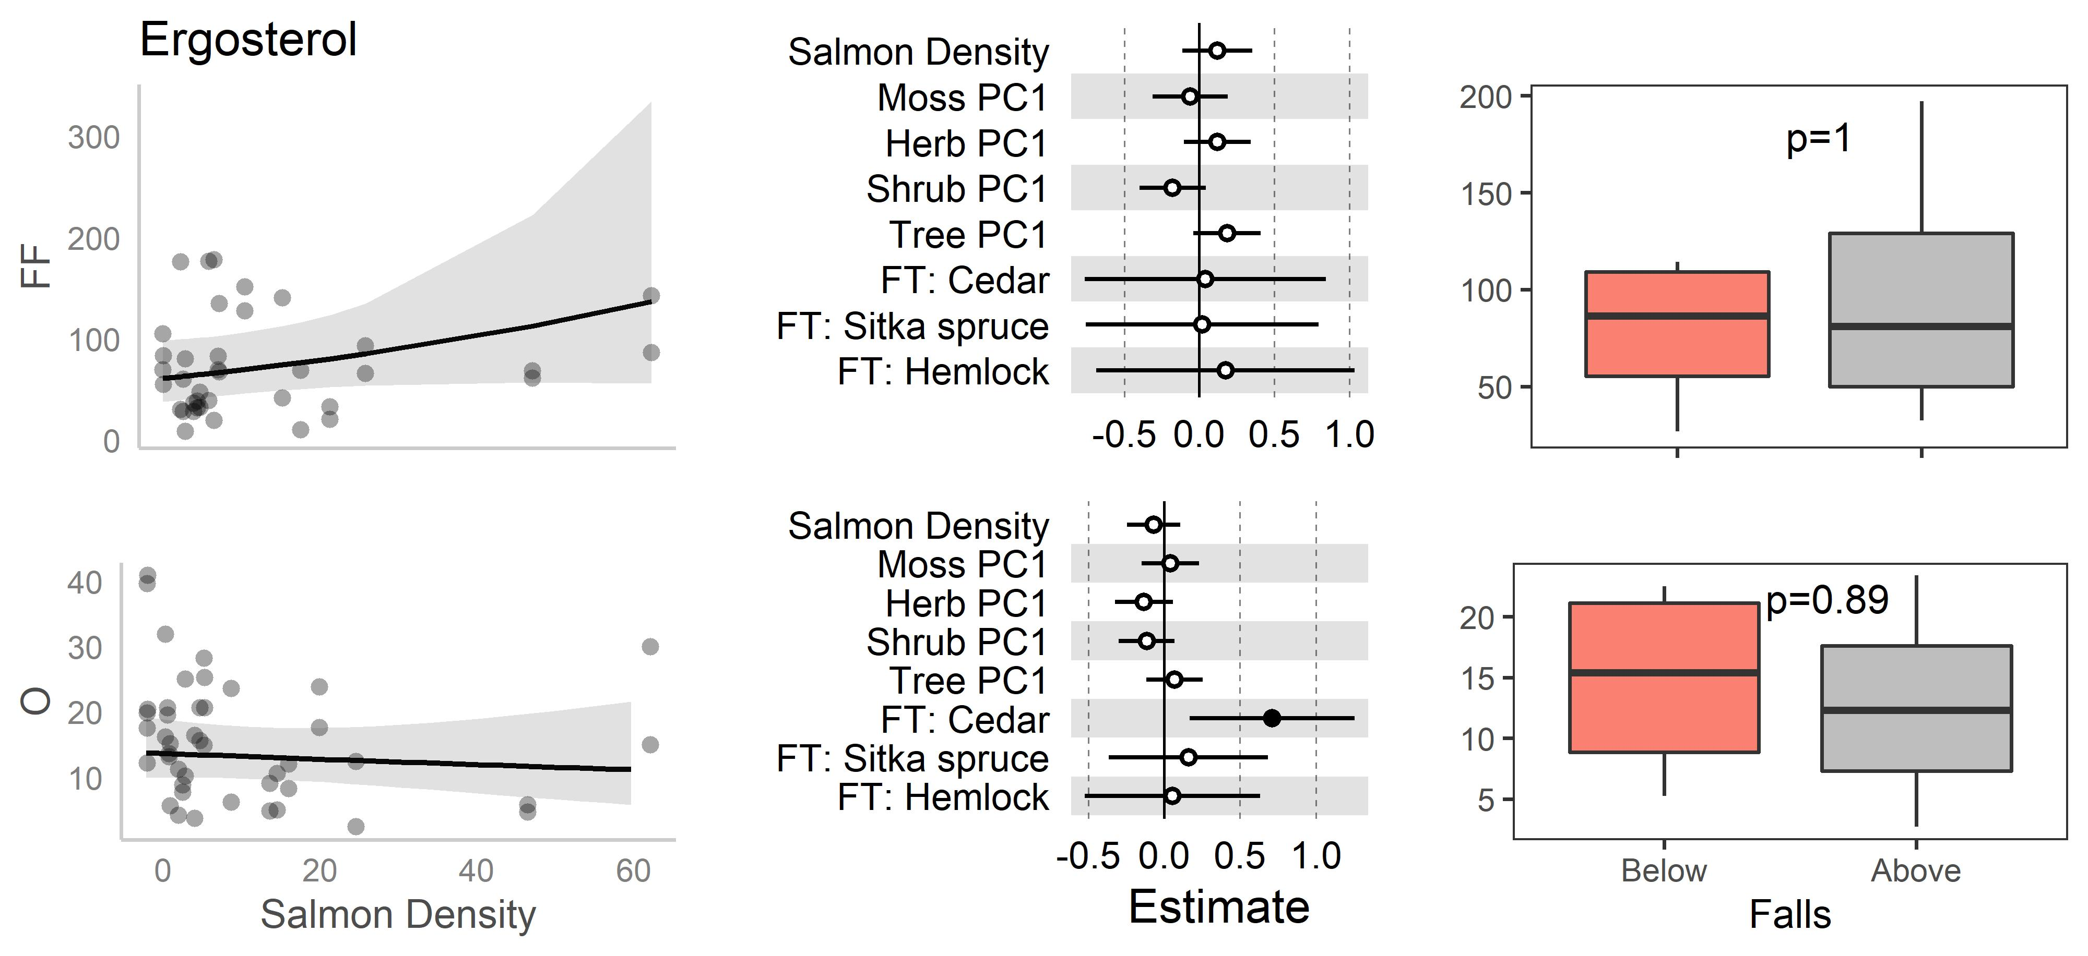
Figure 2-6: Ergosterol GLM results for regional gradient data and boxplots for above/below waterfall data.
The top row of each chemical are forest floors (0-5 cm) and second row are organic soil (10-15 cm). The first column are scatterplots for the global model of each chemical as a function of salmon density, with prediction lines and 95% confidence intervals indicating marginal responses to salmon density keeping all other explanatory variables at their mean values. The middle column indicates model-averaged standardized coefficient values for each explanatory variable, with significant (p<0.05) values indicated by filled dots. Contrasts for focal tree coefficients (FT: Cedar, FT: Sitka Spruce, and FT: Hemlock) indicate differences relative to Amabilis Fir. The rightmost columns are boxplots of above falls (AF; grey coloured box) and below falls (BF; salmon coloured box) data, with P-values indicated for paired Wilcoxon tests. Top and bottom of each box denote 75th and 25th quantiles respectively; whiskers show 1.5*IQR; dark central line indicates median values.

Table 2-4: ANOVA table summary for above/below waterfall paired Wilcoxson tests.
For each response variable, the mean below falls (BF), the mean above falls (AF), the difference between them (∆, AF- BF), the V-statistic, and P-values are displayed. Green and red boxes highlight either positive or negative mean differences (∆) or significant (P<0.05) results. Yellow boxes highlight marginally significant results (0.1 < P < 0.05). 2 above/below pairs per site; 4 sites; n = 8.

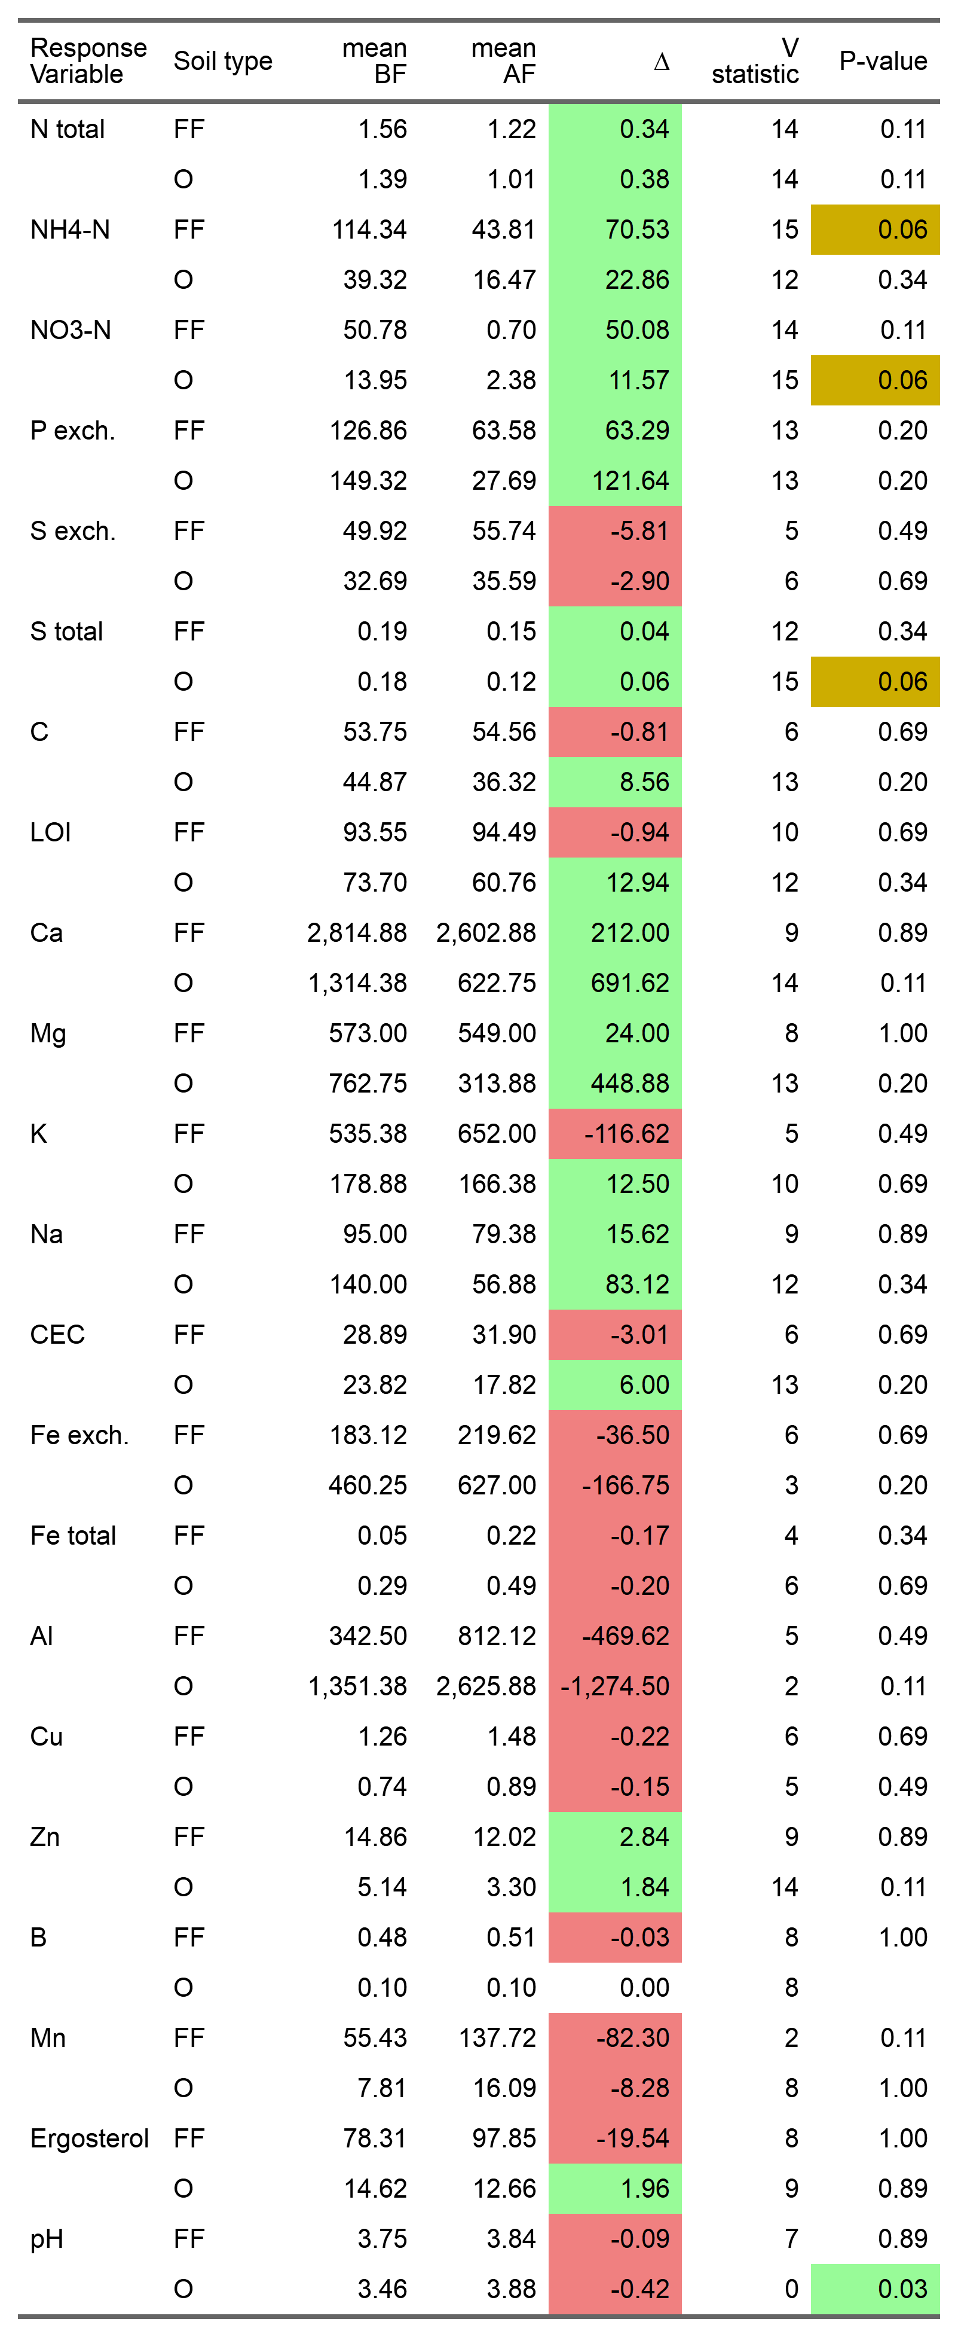
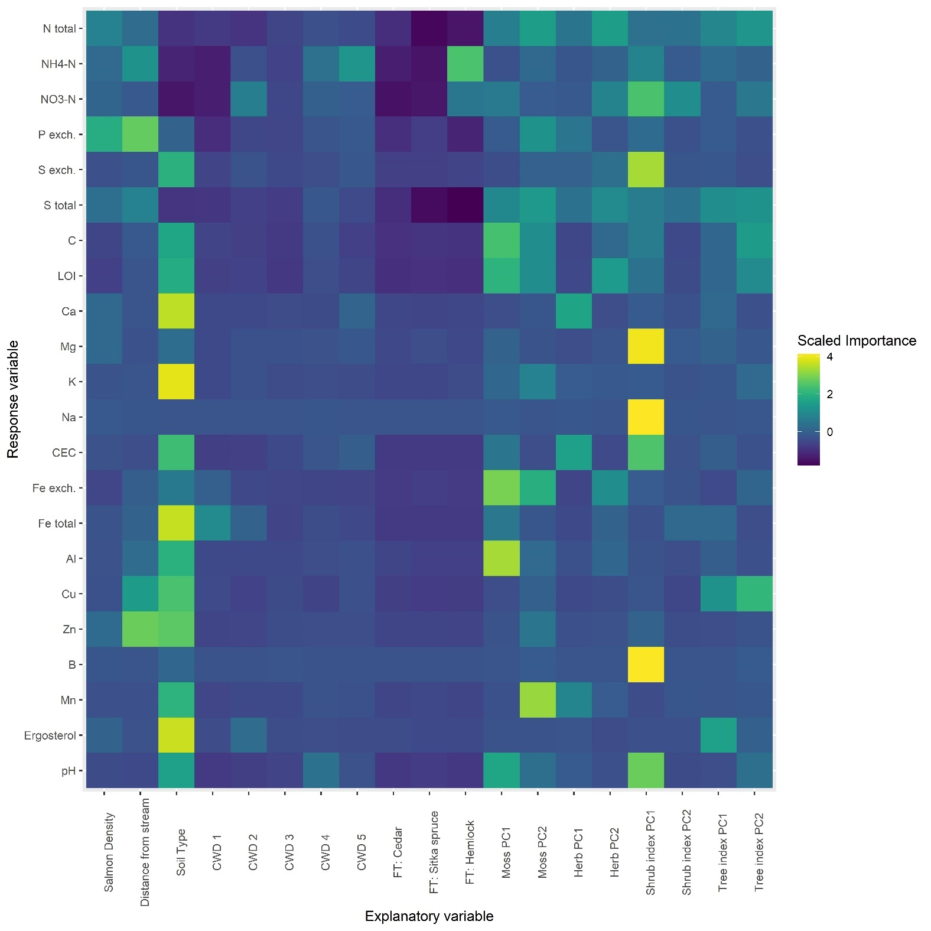
Figure 2-7: Random forest model response for all chemical response variables as a function of an extended set of explanatory variables.
Focal tree importance values are relative to Amabilis fir.

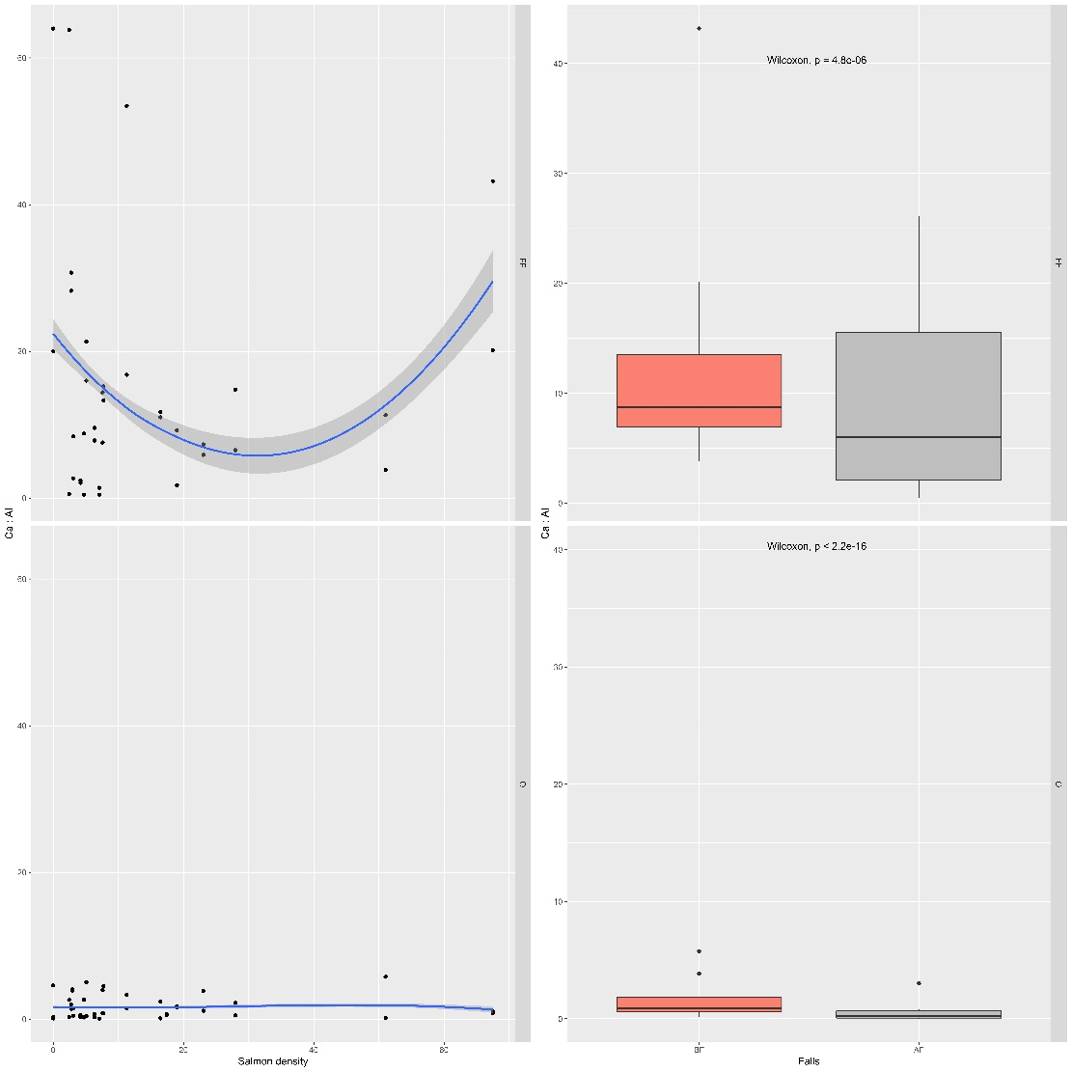
Figure 2-8: Calcium to aluminum ratio along the salmon regional gradient and above and below waterfalls.
Top row are forest floor soils, and the bottom row organic soil. Blue lines are loess curves with span of 1.2.
Table 2-5: Summary of salmon-soil chemistry results.
Single asterix indicates moderate statistical significance (0.05<P<0.1); double or more asterixes indicate significance (P<0.05).
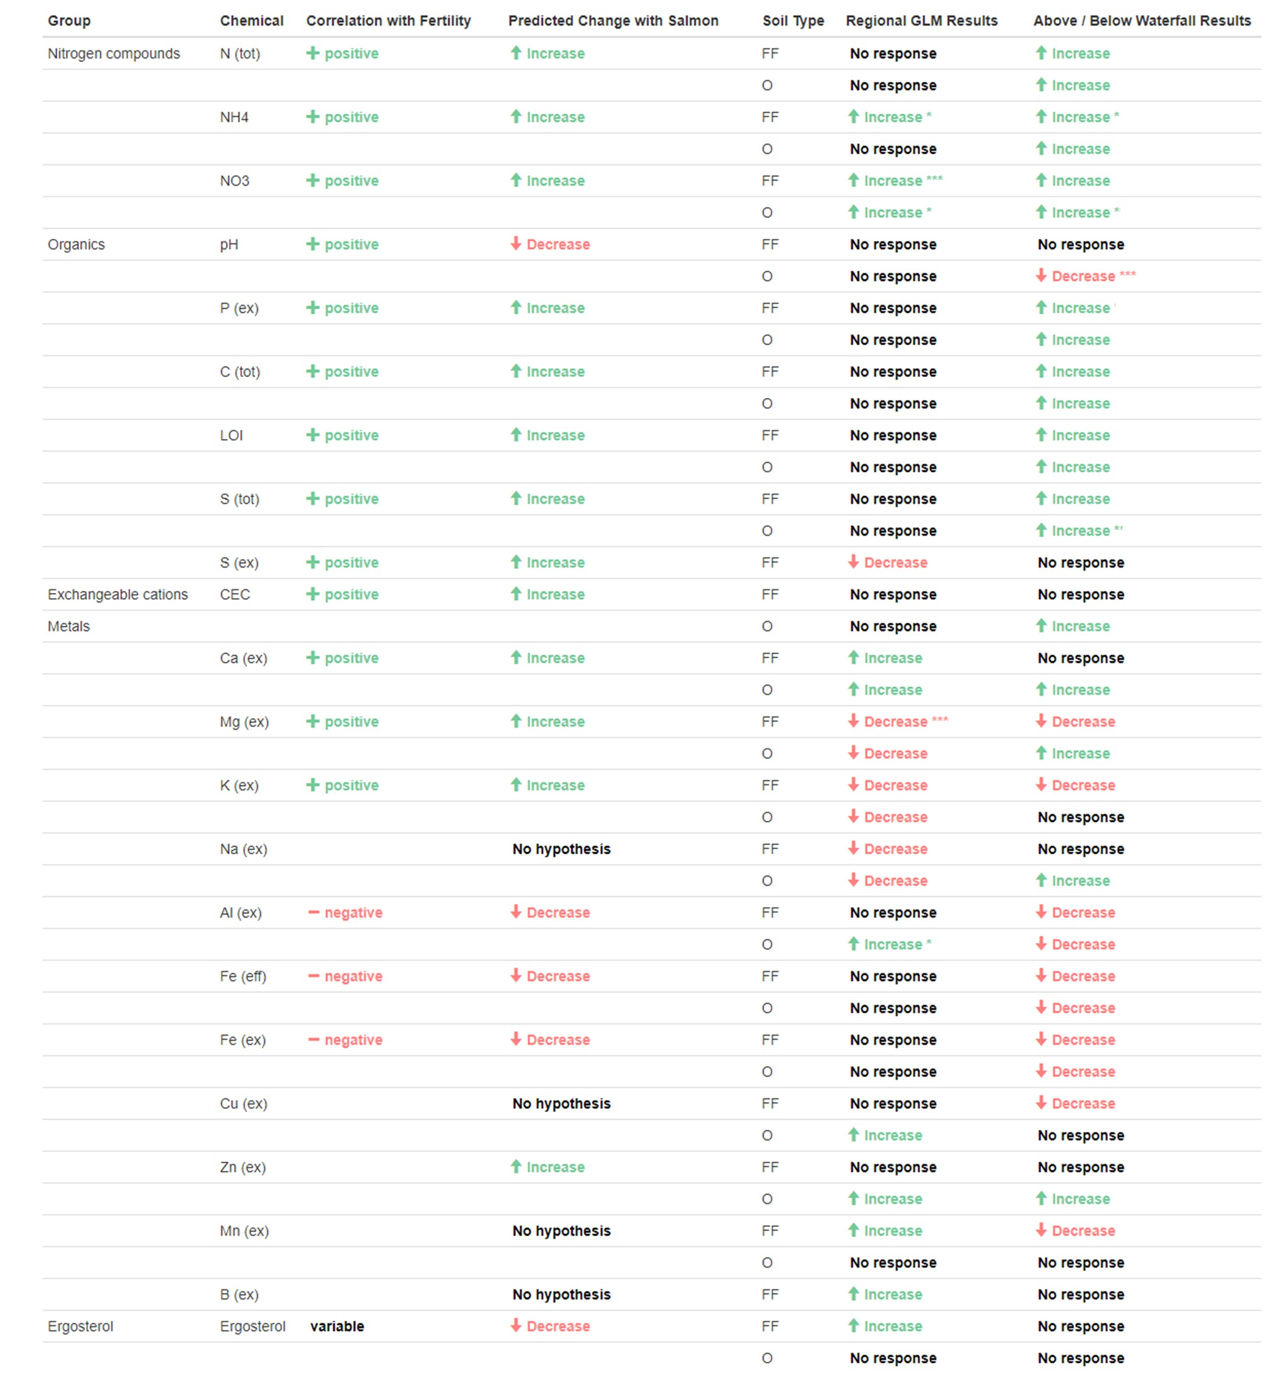
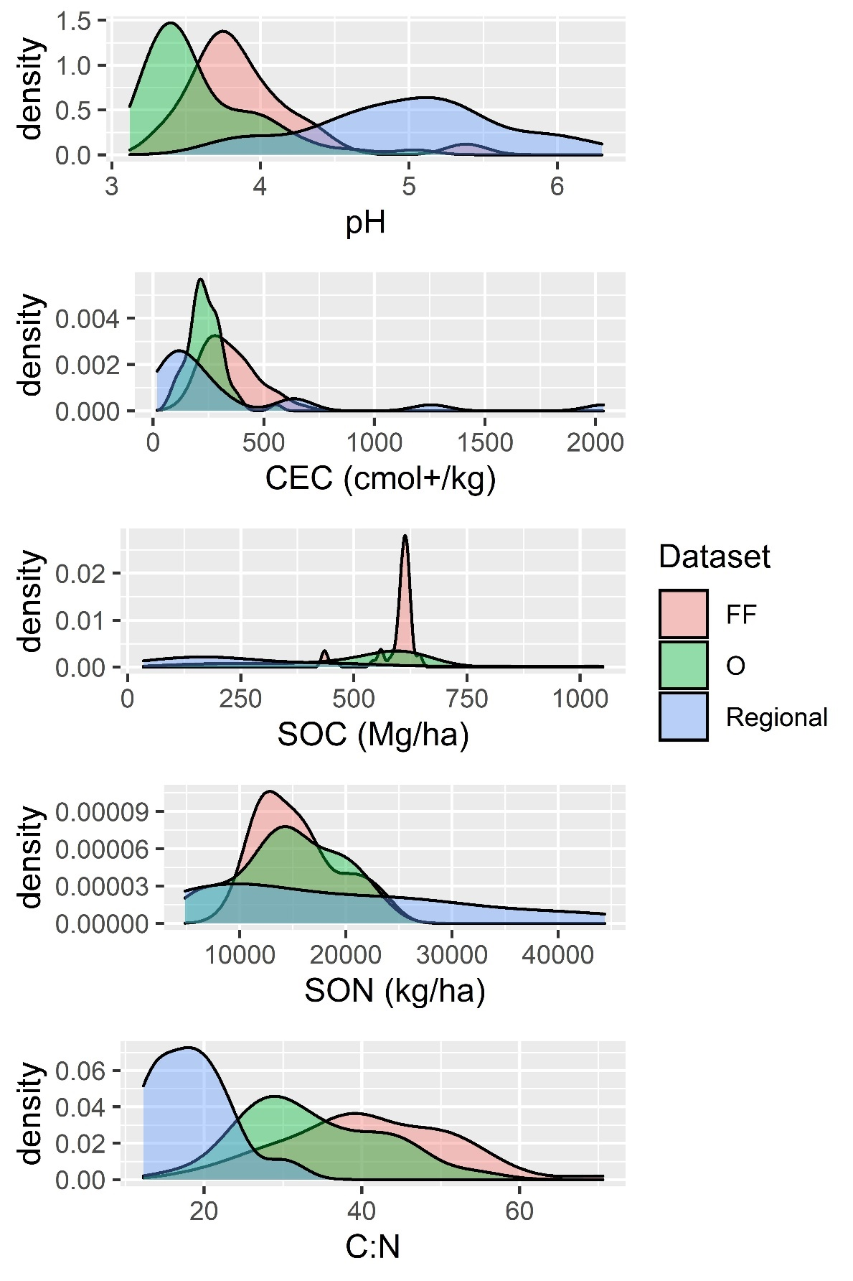
Figure 2-9: A comparison of forest floor and organic soil values from across a regional gradient of salmon density for pH, cation exchange capacity (CEC), total soil organic carbon (SOC), soil organic nitrogen (SON) and the C:N ratio for forest floor soil from this study (FF), organic soil from this study (O) and regional averages
for these values from a recent meta-analysis of regional coastal temperate rainforest soils (Carpenter et al., 2014). SOC and SON are assuming a bulk density of 0.15 g/cm³ and a depth of 1m.

Sporocarp ¹⁵N natural abundance along a gradient of salmon density

Introduction
Every year, salmon return to their natal streams to spawn and die. Their return is attended to by terrestrial and aquatic animals, which consume, transform, and distribute the nutrients contained in salmon flesh throughout the riparian zone. These ‘marine-derived nutrients’ (MDN) include additions of nitrogen, phosphorus, calcium, and other elements to the ecosystem (Chapter 2). These nutrients shape riparian plant (Hocking & Reynolds, 2011), animal (Reimchen, 2017; Wagner & Reynolds, 2019), and soil (Chapter 4) communities, and for these reasons salmon have been called keystone species in terrestrial Pacific coast ecosystems (Helfield & Naiman, 2006; J. Walsh et al., in prep).
Nitrogen has been the primary response variable investigated in studies examining salmon effects on terrestrial ecosystems due to its role as a limiting nutrient in temperate forests and agricultural settings (LeBauer & Treseder, 2008). Nitrogen has a well-characterized stable isotope chemistry commonly used in ecological applications (Fry, 2007), and measurement of ¹⁵N is inexpensive enough to permit regional, temporal, and experimental comparisons under conditions of high natural variability. Due to being predators of marine origin, salmon are enriched in ¹⁵N, a fact that presents a natural δ¹⁵N signal that has been exploited as a means to infer MDN contributions to the nitrogen budgets of riparian zones (Gende et al., 2004; Hocking & Reimchen, 2006; Reimchen et al., 2003).
Inferences about salmon and MDN effects on nitrogen budgets commonly compare a reference site without MDN inputs to sites with MDN inputs, allowing confounding variance between sites to be statistically eliminated (Bilby et al., 2003; Helfield & Naiman, 2002; Kline et al., 1990; Reimchen, 2017). Typical values of estimated MDN contribution to N budgets are around 20%, but range from 0% to 98% depending on ecological context and which ecosystem compartment is being measured (i.e. taxonomic identity of plant or animal, soil, water column, etc.). These ‘two-member mixing models’ make two assumptions: 1. reference sites are biogeochemically similar to sample sites; and 2. no fractionation occurs along the biochemical pathway between salmon and sample. These models have been shown to be particularly sensitive to the former, with error in reference sample choice and/or measurement having disproportionate effects on estimates (A. E. Morris et al., 2005b; Reimchen, 2017). With regards to the latter, N isotope fractionation is likely to be the rule rather than the exception in soil and plant processes (Craine et al., 2015) and should be accounted for to have confidence in estimates of MDN contributions to nitrogen budgets.
One process known to fractionate N is the transfer of N to plants by mycorrhizal fungi (E. A. Hobbie & Ouimette, 2009). Mycorrhizal fungi scavenge nitrogen and other nutrients from the soil and exchange these products for energy-rich carbon compounds provided by associated plants. This exchange can account for large proportions of plant budgets for both C and N (S. E. Smith & Read, 2008). Mycorrhizal fungi have traditionally been separated by ‘guild’, based on their physiology (e.g. ectomycorrhizal, arbuscular, ericoid), and the guild and taxonomic identity of the fungal partner explains large proportions of variation in δ¹⁵N of host plant foliar N (Craine et al., 2009). As N is absorbed by fungi, ¹⁵N-enriched N is preferentially incorporated into fungal protein and remains belowground (E. A. Hobbie & Colpaert, 2003; A. Taylor et al., 1997), resulting in N translocated to the plant being isotopically depleted. Over time, this results in ¹⁵N-depletion of plant hosts, and an isotopic divergence between plant ¹⁵N and fungal and soil ¹⁵N (E. A. Hobbie et al., 2005). Due to this process, isotope comparisons between foliar, fungal, and soil samples have been used to estimate levels of mycorrhiza-mediated N flux (J. E. Hobbie & Hobbie, 2006), with ¹⁵N divergence between foliar and fungal samples correlated with rates of mycorrhizal transfer.
Nitrogen addition studies show that rates of mycorrhizal transfer tend to decline with nitrogen inputs (Nylund & Wallander, 1992). As N concentration increases, plants are able to uptake labile-N directly, and hence obviate the need to invest photosynthate in their fungal partners (M. N. Högberg et al., 2010; Kranabetter & MacKenzie, 2009). This predicts a decline in mycorrhizal activity along MDN gradients, and hence a convergence in ¹⁵N difference between belowground compartments (sporocarps and soil) on the one hand, and aboveground compartments (plants and litter) on the other. This prediction assumes an even distribution of nutrients on the landscape. An alternative prediction arises, however, when nutrient patches are unevenly distributed: mycorrhizal-mediated N transfer is predicted to increase since the higher search efficiency and lower metabolic maintenance costs of fungal hyphae relative to plant roots encourages carbon partitioning to fungal partners (Bending & Read, 1995; Peay et al., 2011). Given the spatially and temporally over-dispersed nutrient patch distribution associated with both salmon carcasses and animal feces and urine (Hilderbrand et al., 1999), this alternative prediction supposes that if mycorrhizal partners are able to rapidly capture, immobilize, and transfer MDN, this would be beneficial for host plants, and thus mycorrhizal transfer rates would increase along MDN gradients. These circumstances are thought to favour fungal diversity and biomass (Moeller, 2014), and predict a divergence in ¹⁵N values between belowground and aboveground compartments. By measuring δ¹⁵N of these ecosystem compartments these predictions may be compared and tested.
Covariates to these considerations are fungal phylogenetic identity (Mayor et al., 2009; A. Taylor et al., 1997, 2003), the depth and source of nutrient acquisition (E. A. Hobbie et al., 2019), and how much plant carbon export is occurring (E. A. Hobbie & Högberg, 2012). Nutrient acquisition functional types that extend nutrient acquisition range, such as exploration type, hydrophobicity, and the presence of rhizomorphs, all tend to increase fungal ¹⁵N (E. A. Hobbie & Agerer, 2009) and may be expected in nutrient environments with patchy resources (Peay et al., 2011). Given the nature of salmon inputs, it is expected that elevated ¹⁵N be particularly associated with aminophyllic and protein feeding strategies associated with ‘corpse’ fungi such as those fungi in the genera Laccaria and Hebeloma (Sagara, 1975, 1995; Tibbett & Carter, 2003).
In turn, plant foliar ¹⁵N is affected by plant species, the mycorrhizal guilds they associate with (Craine et al., 2009), internal cycling (Evans, 2001; Kalcsits et al., 2014), and the chemical identity of assimilation targets (Takebayashi et al., 2010). In addition, latitude and climate (Amundson et al., 2003; Craine et al., 2009), water availability (Handley et al., 1999), and rooting depth have been shown to shape ¹⁵N concentrations. Litter follows similar patterns to trees, and soils become increasingly enriched with profile depth as isotopically lighter plant matter accumulates on the surface (E. A. Hobbie & Ouimette, 2009); at the same time, a parallel process accumulates ¹⁵N in organic soils as decomposition and humification preferentially concentrates ¹⁵N in recalcitrant N-fractions in the soil (E. A. Hobbie et al., 2019). Observed isotopic ratios will reflect the net effects of all these factors, and thus care must be taken in interpretation of ¹⁵N signals.
Finally, N addition is generally associated with increasing foliar %N and decreasing soil C:N ratios as both bulk soil nitrogen concentrations increase and soil carbon concentrations decrease due to increased soil respiration (Levy-Booth et al., 2016). We thus predict that along MDN gradients foliar N will increase and soil immobilized carbon will decrease, although it is expected that this may be complicated by shifting plant communities along MDN gradients (Hocking & Reynolds, 2011; Prescott, 2002).
The primary goal of this study is to investigate the role fungi play in the ecosystem metabolism of MDN in migratory salmon rivers of the west coast of Canada. To do this, I sampled soil, mushrooms, and litter at 16 streams across a gradient of salmon densities. δ¹⁵N, %N, δ¹³C, and %C were measured, and these samples were combined with foliar sample data from an earlier study at these same sites (Hocking & Reynolds, 2011). Fungal species were identified through a combination of molecular and morphological techniques, and fungal functional types were assigned to sporocarps at the genus level using the FunGuild database (Nguyen et al., 2016). The nearest large tree was recorded, as well as percent cover of mosses, herbs, shrubs and trees around each sampling point. We predicted the following: 1. All ecosystem compartments would increase in δ¹⁵N as MDN inputs increased (the ‘salmon effect’); 2. δ¹⁵N values would follow the pattern: sporocarp > soil > plant > litter; 3. Decreasing mycorrhizal-plant N flux due to increasing MDN enrichment would be evidenced through a convergence of soil – mushroom – plant δ¹⁵N over the MDN gradient (‘mycorrhizal transfer effect’); in contrast, a divergence of these values would indicate increasing mycorrhizal-plant N flux, and would be consistent with alternative predictions due to the exploitation of patchy resources (‘the resource-patch effect’); 4. %N would increase across all ecosystem compartments along the MDN gradient; and 5. soil %C and C:N ratio would decrease with MDN inputs; and finally, 6. Fungal δ¹⁵N would be influenced by species identity and be highest in taxa of known nitrophyllic or aminophilic feeding strategy.

Materials and Methods
Study sites:
Samples were collected from 16 watersheds in Heiltsuk First Nation traditional territory on the Central Coast of British Columbia, Canada, near the town of Bella Bella (Appendix A). This study was conducted in mid-October, and fungal fruiting coincided with the onset of fall rains and the salmon run. Soils were primarily acidic lignic and humic folisols, consisting of largely homogenous deep, well decomposed organic layers (Carpenter et al., 2014). At each watershed, an opportunistic sampling methodology was used and the first ten mushrooms found at each site were collected. Since mycorrhizal mushrooms were the desired targets, only sporocarps growing out of moss and soil were collected and known saprotrophs ignored. At sites with less than ten available mushrooms as many as possible were collected. At each sporocarp, a 5m-radius circular vegetation plot was measured, and percent cover of moss, herb, shrub, and tree species estimated. Fungi were described in the field, photographed, and sporocarps collected. Soil samples were taken at two locations: (1) from the F and H layers (“litter layer”), just below moss and bulk litter at 0-5 cm, and (2) deeper soil (“soil layer”) taken at 10-15 cm. This resulted in n=166 triplicate samples for each sampling point (“mushroom”, “litter”, “soil”). In the field laboratory, sporocarps were again photographed, spore prints collected, and a morphological character database constructed for morphological identification. Sporocarps were then dried overnight in a consumer dehydrator and frozen with the soil and litter samples in a -20°C freezer.
Sporocarp identification:
Morphological identification was carried out by Allen Larocque with the help of Dr. Emma Harrower (all taxa, particularly Cortinarius) and Dr. Anna Bazzicalupo (Russulaceae). We identified 144 samples to genus level (87%) but only 28 to species level (16%). To further clarify species identity, a molecular barcoding approach was used and both methodologies used to corroborate a final identification.
Molecular barcoding methods:
The ITS region was sequenced for all samples using ITS1/ITS4 primer pairs (White et al., 1990). DNA from sporocarps was extracted using Qiagen plantEZ kit; quantified using a Qubit fluorescent spectrometer; and sent for Sanger sequencing by Macrogen Inc., Korea. Sequence data was manually inspected, cleaned, aligned, and trimmed using Geneious version 2020.1 (http://www.geneious.com; (Kearse et al., 2012)). Double-stranded ITS contigs (n=115) had their ITS1 and 2 regions extracted with ITSx (Bengtsson‐Palme et al., 2013) and these were classified with a Naïve Bayes classifier trained on the UNITE dataset (Nilsson et al., 2019). Single stranded reads were used in cases where contigs could not be assembled but where reads were still of sufficient sequencing quality (n=31). Together this permitted identification of the genus of 137 samples (83%), and the species of 111 samples (67%). The morphological and molecular identifications were manually compared and a consensus identification made for the genus of 164 samples (99%) and the species of 136 samples (82%). These consensus identifications were used for further analysis. Finally, fungal trophic mode and guild was annotated using FunGuild (Nguyen et al., 2016); and exploration type, hydrophobicity, and presence of rhizomorphs assigned manually on a genus level based on the literature (Agerer, 2006; E. A. Hobbie & Agerer, 2009).
Isotope analysis:
Samples were lyophilized and ground by hand with mortar and pestle using liquid N₂. They were weighed into tin cups and analyzed in an Elementar Vario EL Cube Elemental Analyzer (EA) and Isoprime Isotope Ratio Mass Spectrometer (IRMS) at the UBC Forestry Stable Isotope Facility. In all samples, %N, %C, ¹⁵N and ¹³C were measured; however, in soil samples low C:N ratios interfered with accurate ¹³C measurement and this measure was excluded from analysis.
Vegetation isotope data:
Plant isotope data was contributed by Dr. Morgan Hocking (Hocking & Reynolds, 2011) and included two ericoid mycorrhizal species, false azalea (Rhododendron menziesii) and red huckleberry (Vaccinium parvifolium), and two arbuscular mycorrhizal species, false-lily-of-the-valley (Maianthemum dilatatum) and salmonberry (Rubus spectabilis). Where possible, they were matched by watershed to the data collected here (11/16 matching sites).
Annual fish data:
Fish counts were contributed by the Reynolds lab and Heiltsuk Nation (Appendix B). Salmon counts were made on a watershed level and salmon density data was calculated using the average salmon count of the three years prior to collection (2014 - 2016). This average count was multiplied by the average biomass of each salmon species and divided by the length of salmon-accessible stream reach to give an index of salmon density per meter of stream reach (following the methodology of Hocking & Reynolds, 2011 and Wagner & Reynolds, 2019). Salmon species were primarily chum (Oncorhynchus keta) and pink (O. gorbuscha), and densities ranged from 0 to 28 kg/salmon per meter of stream reach per year.
Vegetation PCAs:
PCAs were built from plant percent cover surveys around each mushroom-litter-soil sampling point (Appendix C). Four vegetation layers were examined: mosses, herbs, shrubs, and trees. Percent variation explained and loading interpretation for the first two PCA axes of each layer are: 1.) moss: PC1 42% variance explained, positive - Lanky moss (Rhytidiadelphus loreus); PC2 25% variance explained, negative - step moss (Hylocomium splendens); 2.) herbs: PC1 35.5% variance explained, positive - deer fern (Struthiopteris spicant), negative – spiny wood fern (Dryopteris expansa); PC2 29% variance explained, positive – spiny wood fern and deer fern, negative – bunchberry (Cornus canadensis); 3.) shrubs: PC1 34.7% variance explained, positive – Alaskan blueberry (Vaccinium alaskansae); PC2 27.6% of variation, positive - salal (Gaultheria shallon) and false azalea (Rhododendron menziesii), and negative - salmonberry (Rubus spectabilis). 4.) trees: PC1 56% variance explained, positive – Sitka spruce (Picea sitchensis), negative - western hemlock (Tsuga heterophylla); PC2 22.6% variance explained, positive – Amabilis fir (Abies amabilis); negative – western red-cedar (Thuja plicata).
Statistical Analysis:
Response variables were mushroom, litter, soil and vegetation δ¹⁵N, %N, δ¹³C, %C and C:N ratios. Explanatory variables measured for the sporocarp samples included salmon density; the first axis of moss, herb, shrub and tree PCAs; distance to stream; the species of the nearest large tree (red alder (Alnus rubra), western hemlock, Sitka spruce, Amabilis fir, or western red-cedar); and mushroom genus. Since the vegetation data lacked the suite of covariates measured in the sporocarp, litter, and soil data, simple linear models were constructed with the equation:
$\left(response variable\right)\sim \left(salmon density\right)*(sample type)$.
Intercepts and slopes were compared using the R package Emmeans (Lenth, 2020), plotted with ggplot2 (Wickham, 2016) (Figure 3-2) and regression anova-like tables for slopes, intercepts, and interaction terms constructed (Table 3-1) and pairwise comparisons made of slopes and intercepts (Table 3-2).
To investigate the relative importance of explanatory variables, a GLM model-averaging approach was used to explore driving factors behind soil, sporocarps, and litter samples (vegetation was excluded in this analysis as it lacked covariate data). These three sample types were analyzed separately since they were not independent as all samples were taken at a single sampling point. A linear model (the ‘full model’) was defined according to the equation:
$response variable \sim salmon density+fungal genus+{PCA1}_{moss}+{{PCA1}_{herb}+PCA1}_{tree}+{PCA1}_{shrub}+nearest large tree species+distance to stream$.
Explanatory variables were standardized prior to regression to account for differences in scale and units, and tested for collinearity via inspection of bivariate plots before modelling and via variance inflation factors (VIFs) after modelling. Assumptions for the full model were tested graphically using the DHARMa package in R (Hartig, 2020). Model assumptions were variable but tolerable and VIFs tolerably low (<3).
These full models were averaged with the MuMIn package in R (Barton, 2020) and all models were included in final coefficient estimates, weighted in proportion to their AICc values using conditional averaging (Galipaud et al., 2014).
To complement this analysis, a machine learning approach was used with a larger set of explanatory variables (adding the second PCA axis of each vegetation type). Random forest models were constructed for each response variable with the R caret and randomForest packages (Kuhn, 2008; Liaw & Wiener, 2002). Standardized importance coefficients of these explanatory variables were then visualized with a heatmap (
Figure 3-5).
δ¹⁵N vs. %N plots were constructed for each sample type and slopes and intercepts modelled via linear model $\left(δ15N \right) \sim \left(\%N\right)*(sample type)$ (Figure 3-6). In addition, δ¹³C and δ¹⁵N isoplots were constructed for vegetation, litter, and sporocarps. Soil was excluded from these isoplots as we did not have dependable δ¹³C values for these samples.
Finally, to visualize fungal phylogenetic and trophic differences, sporocarp δ¹⁵N was plotted for each fungal genus and coloured by trophic mode (Figure 3-8).

Results
δ¹⁵N signatures were highest in mushrooms, followed by soil, litter, and vegetation (Figure 3-2), and these increased for all measured sample types along the salmon density gradient. Multiple comparisons showed no difference between the y-intercepts of mushrooms and soil (A), and litter and vegetation (B), and slopes were identical across all sample types (Table 3-2). GLM analysis showed positive correlations with salmon density for all sample types (Figure 3-3). Distance to stream correlated negatively for soils but had no response for litter and mushrooms, while the moss PCA affected litter ¹⁵N, the herb PCA litter and soil ¹⁵N, and the tree PCA sporocarp ¹⁵N. Fungal genus showed a diversity of effects, with much larger uncertainties due to variable, and sometimes small, sample sizes. Of particular note were increased δ¹⁵N in Laccaria, Hebeloma, and Cortinarius. These trends were also evident in δ¹⁵N boxplots, where Laccaria, Cortinarius, Gliophorus, and Hebeloma had the highest δ¹⁵N values compared to other taxa (Figure 3-8). There was small sign of divergence of slopes across the MDN gradient (Figure 3-2). The random forest model (
Figure 3-5) accorded high importance to salmon density and the vegetation PCAs for all sample types, with salmon density being more important for litter and soil than sporocarps.
%N was highest in mushrooms, followed by vegetation, and then litter and soils together (Figure 3-2, Table 3-1). However, slopes of %N were not significantly different from zero for any of the sample types along the salmon gradient (Table 3-1). GLM analysis showed no effects of salmon density on %N, while distance from the stream was negatively correlated for litter. Nearest tree, the vegetation PCAs and fungal genus had a diversity of effects on %N (Figure 3-3). The random forest model accorded high importance to salmon and distance from the stream for litter and soil, but not mushroom sporocarps (
Figure 3-5), while the vegetation PCAs were of relatively high importance.
δ¹⁵N vs %N isoplots showed significant correlations between δ¹⁵N and %N for all sample types, and all slopes and intercepts were all significantly different from each other (Figure 3-6). Vegetation and litter showed positive slopes between δ¹⁵N and %N, soil roughly flat, and mushrooms a negative slope.
δ¹³C was highest in mushrooms, followed by litter and vegetation (Figure 3-2, Table 3-1) (no data for soil). Litter δ¹³C became depleted with increasing salmon density, while both vegetation and mushrooms became slightly enriched (small but significant slopes, Table 3-1). In the GLM analysis, litter showed a slight decrease in ¹³C with salmon density, but no response to fungal genus, the vegetation PCAs, or nearest tree. Mushroom δ¹³C however was positively (Gliophorus, Hypholoma, Mycena, Pholita) or negatively (Alnicola, Clavulina, Cortinarius, Craterellus, Hebeloma, Laccaria, Lactarius, and Russula) affected by genus (Figure 3-4). The random forest model accorded high importance to salmon density and the vegetation PCAs to both mushrooms and litter, and distance from the stream to litter (
Figure 3-5).
δ¹³C vs δ¹⁵N isoplot grouped vegetation, litter, and mushroom sporocarps separately (Figure 3-7), with mushroom sporocarp showing more variability along both axes than the other two sample types.
%C was highest in litter and mushrooms together, followed by vegetation, and then soil over most of its range (Figure 3-2, Table 3-1). Along the salmon density gradient, %C decreased for all sample types except plants, which did not change. The GLM analysis showed that mushroom and soil %C were negatively correlated with salmon density, and that distance from stream also decreased mushroom %C (Figure 3-4). Presence of alder decreased %C in all sample types, and fungal genus and vegetation had a diversity of effects. The random forest model accorded high importance to salmon density and distance from the stream for all sample types, as well as the various vegetation PCAs (
Figure 3-5).
C:N ratios were highest in litter, followed by soil, vegetation, and finally mushrooms (Figure 3-2, Table 3-1). C:N ratios stayed remarkably constant over the salmon density gradient; only soil had a slope significantly different than zero, and its C:N ratio decreased as salmon density increased. The GLM analysis similarly attributed a significant negative correlation to salmon density in soil (Figure 3-4), no association with distance to the stream, and a diversity of associations with fungal genus and vegetation. The random forest model also attributed high importance to salmon density and the vegetation PCAs, as well as distance from the stream (
Figure 3-5).
Finally, comparing δ¹⁵N values for different fungal genera showed particularly high values in Cortinarius, Laccaria, Gliophorus, and Hebeloma (Figure 3-8).

Discussion

Nitrogen Isotopes as indicators of N-cycling
The primary goal of this study was to examine the role of fungi in the ecosystem processing of MDN along migratory salmon rivers on the west coast of Canada. The first hypothesis was that salmon would increase δ¹⁵N of all ecosystem compartments. This was borne out in the analysis, with all compartments showing positive slopes along the MDN gradient (Figure 3-2). This was also supported by the GLM analysis, which showed positive correlations with MDN to soil, sporocarp and litter δ¹⁵N. This ‘salmon effect’ is consistent with previous work done at these sites, which showed similar trends in both plant (Hocking & Reynolds, 2011) and animal δ¹⁵N pools (Hocking et al., 2013).
The second hypothesis, that δ¹⁵N values would follow the order sporocarp > soil > litter > vegetation, was supported with y-intercepts in the predicted order (Figure 3-2). Multiple comparisons however showed that there was no significant difference between a) sporocarps and soils, on the one hand, and between b) vegetation and litter on the other (Table 3-2). This is consistent with an interpretation that emphasizes a separation between above-ground and below-ground components. Soil and litter values follow patterns in soil profiles previously reported in boreal systems (E. A. Hobbie & Högberg, 2012), and nearby on the west coast of Vancouver Island (Reimchen et al., 2003), where deeper soil profiles showed higher δ¹⁵N than shallower layers and plants (Vaccinium spp. and Rubus spectabilis) had the same or lower δ ¹⁵N than surrounding soil. This is consistent with net fractionation for ¹⁵N occurring with soil depth and fractionation against ¹⁵N at the root:soil interface (Craine et al., 2015).
This enrichment with depth tends to be higher under plant species with ectomycorrhizal associations (ECM) than arbuscular mycorrhizal (AM) ones (E. A. Hobbie & Ouimette, 2009). However, if there are high gaseous losses from soils, δ¹⁵N can instead show a ‘U’ shaped pattern with depth (P. Högberg et al., 2011). I expect minimal gaseous losses at these sites due to their very high organic matter, high C:N ratios, cold temperatures, very acid soils, and wet but well-drained conditions (Ji et al., 2015; Vermes & Myrold, 1992). Unfortunately, as only two soil depths were measured in this study we cannot distinguish between linear and U-shaped trends with soil depth and so cannot directly address these alternatives. Measuring δ¹⁵N at multiple depths at these sites, as well as gaseous emissions directly, could give further insight on volatilization processes.
Contrary to expectations, I found no support for the third prediction of a convergence of δ¹⁵N values between plants and soils along the salmon density gradient. Slopes did tend to diverge across our MDN gradient (Figure 3-2), but given a lack of interaction effects between the slope estimate and sample type (Table 3-1) I consider this weak evidence for changing mycorrhizal transfer ratios across the MDN gradient. This is contrary to previous work looking at N-addition via fertilization in boreal forests (E. A. Hobbie et al., 2019), which showed that higher N additions reduced δ¹⁵N differences between plants and sporocarps. Unlike previous studies, interpretation here is complicated by the isotopically enriched nature of the N addition, which may accumulate in the fungi and would contribute to δ¹⁵N divergence, potentially countervailing any convergence expected due to lowered transfer rates. While acknowledging these limitations, I believe the most parsimonious explanation of no convergence or divergence in δ¹⁵N values are that N transfer rates do not change across this N-addition gradient. One possible reason for this could be that the N-addition here is primarily in organic form (Chapter 2).
While this situation likely prevails over the majority of the area at these sites, chemistries may be different in locally high-N hotspots under salmon carcasses. Denitrification rates have rarely been measured in MDN systems, but soils in a salmon carcass displacement experiment in Alaska showed no difference in transformation rates (Feddern et al., 2019). In measures of soils directly under salmon amendments in Idaho, most of the MDN-nitrogen was shown to enter the soil via the ammonia- and urea-rich metabolic wastes of flies and other insects (T. A. Wheeler & Kavanagh, 2017). This is consistent with high numbers of insect consumers seen in Haida Gwaii and British Columbia’s Central Coast (Hocking & Reimchen, 2002; Reimchen, 2017), and thus carcass exudates may avoid a stage of highly concentrated nitrate-N inputs. Given that I saw no nonlinear increase in ¹⁵N at high N-inputs, as would be expected with volatilization, I argue that denitrification is low in general in these soils. This could be confirmed either through incubation methodologies, inferred through transcriptomics or q-PCR, and ¹⁵N of exudate inputs directly measured to give better marine-member input estimates.
While not measuring denitrification directly, a bear exclusion experiment in Alaska showed very high transient N₂O flux when both salmon and bears were present (Holtgrieve et al., 2009). In general, N₂O flux rate is upregulated by high temperature, high NO₃⁻ concentrations, and high soil carbon concentrations (Qin et al., 2019). Since fungi lack the N₂O reductase gene needed to complete transformation to N_{2,} the large N₂O flux accompanying salmon arrival (Holtgrieve et al., 2009) may imply that fungi, not bacteria as commonly assumed, are the primary drivers of N metabolism in these systems (Laughlin & Stevens, 2002). This possibility suggests that we should center fungi in investigations of N-metabolism in salmon forests.
N₂O (g) can be produced by denitrifying processes, but its production may be mitigated through dissimilatory nitrogen reduction to ammonia (DNRA) (Rütting et al., 2011). DNRA reduces nitrate to ammonium, and competes with denitrification for NO₃ substrate. Ammonium has lower soil mobility and is less likely to be leached from soils than nitrate or off-gassed as nitrogenous gases; hence DNRA represents a pathway that retains nitrogen in the ecosystem. DNRA has been shown to account for between 20-100% of N metabolism in soil, including 99% in a Chilean temperate rainforest which resembles the biome investigated here. DNRA is favoured over denitrification in reduced, acidic, Fe-rich, cold, carbon-rich soil with high amounts of organic matter; these conditions exemplify the BC central coast Folisols investigated here. If predominant, it may present an alternative means of N cycling and create a tighter and less leaky N cycle than previously assumed (Amundson et al., 2003; Handley et al., 1999).
Indeed, measured nitrate pools in these systems are very low (Drake, 2005; Gende et al., 2007; Holtgrieve et al., 2009; T. A. Wheeler & Kavanagh, 2017) (Chapter 2). Ammonium is the dominant chemical form of labile N, and when differentiated, the ammonium pool showed increased ¹⁵N but nitrate did not (Feddern et al., 2019). This supports a salmon – protein – amino acid – urea - NH₄ pathway of N metabolism with minimal oxidation to nitrate, as speculated by (Gende et al., 2007). This scenario again would entail minimal fractionation from denitrification, and hence ¹⁵N signatures are more likely to reflect MDN addition than denitrification rates.

Effects of MDN on Nitrogen Concentrations
MDN had limited or no effect on %N values, contrary to the fourth hypothesis. This contrasts with previous studies on salmon forest soils, which found higher N in soils directly under or near carcasses (Drake et al., 2005; Gende et al., 2007; T. A. Wheeler et al., 2014; T. A. Wheeler & Kavanagh, 2017), downstream of salmon migration barriers (Perry et al., 2017) or outside of bear exclusion treatments (Holtgrieve et al., 2009). It is consistent, however, with previous findings showing no increase in soil N below salmon barriers (Bartz & Naiman, 2005), between enriched and non-enriched banks (Feddern et al., 2019), and in total N along these same gradients (Chapter 2). A possible reason for these discrepancies is the diversity of soil types investigated in the literature (D’Amore et al., 2011, 2020); whether nitrate, ammonium, total N, or organic-N is under discussion (Feddern et al., 2019; Gende et al., 2007); or the added complexity of diverse and changing soil and plant communities observed across these studies (Chapter 4).
In this study, neither foliar nor litter %N varied along the MDN gradient. Positive responses in understory plant foliar-%N to MDN have been shown at these or similar sites (Hocking & Reynolds, 2011, 2012; Sayer, 2008), although these studies included treatments over a wider salmon density range than was investigated here. Positive foliar-N responses have also been seen in spruce needles along enriched and non-enriched banks (Quinn et al., 2018), in multiple species at sites in Haida Gwaii (Reimchen, 2017), in moss and liverwort species (C. E. Wilkinson et al., 2005), and downstream of salmon migration barriers (Mathewson et al., 2003). One reason why this was not found here is that vegetation and soil communities change over this gradient (Hocking & Reynolds, 2011) (Chapter 4) and this was not directly controlled for here. Higher N addition may also be proportioned to increased plant biomass rather than nutrient density; at these and other sites it has been shown that salmon enhance tree growth (Quinn et al., 2018; Reimchen & Arbellay, 2018) and understory plant fecundity (Siemens et al., 2020).
Finally, along the MDN gradient sporocarps showed no, or perhaps even a decline, in %N. This is in contrast to expectations of a positive correlation from other N-addition studies (E. A. Hobbie et al., 2019) but consistent with a study from nearby forests (Kranabetter & MacKenzie, 2009). Interpretation here is difficult due to the phylogenetic diversity of measured sporocarps, the possible increase of total fungal biomass, and the possible up-regulation of mycorrhizal-N transfer.

Effects of MDN on Carbon Cycling
Consistent with the fifth prediction, soil, fungal, and litter carbon decreased along the MDN gradient (Figure 3-2). Nitrogen fertilization is thought to increase ecosystem metabolism and reduce soil C in the short term (Q. Gao et al., 2014) as recalcitrant C is accessed by soil microbes increasing their enzyme activity and plants decrease belowground C allocations to mycorrhizal partners (D. Tian et al., 2018). This decreased belowground allocation would be compounded by microbial processing, as labile C is thought to contribute more to long-term soil organic matter stores than lignic-C (Haddix et al., 2016). In the longer term however the opposite may be expected, as higher N availability leads to higher plant growth and hence greater biomass accumulation in the soil; a recent meta-analyses found a general pattern of N addition leading to increased soil C (Huang et al., 2020; Zang et al., 2016), although this response is likely complex and context dependent (Allison et al., 2009). In salmon systems in Alaska and Idaho, increased CO₂ production was observed after salmon additions (Holtgrieve et al., 2009) and under experimental carcasses (T. A. Wheeler & Kavanagh, 2017). These findings are consistent with the findings of decreased soil, litter, and sporocarp carbon along the MDN gradient.
One way of distinguishing whether this decrease in belowground-C is due to increased soil metabolism or decreased belowground allocation of plant-C is through correlations of δ¹³C (Hobbie, in review). I found a increasing trend in δ¹³C in vegetation and fungi along the MDN gradient and a decreasing trend in litter (Figure 3-2Figure 3-4), which would partially support the increased soil metabolism hypothesis since CO₂ respired by soil microbes is depleted in ¹³C which, all else being equal, would leave the remaining litter ¹³C-enriched instead of depleted (Werth & Kuzyakov, 2010). In addition, δ ¹³C is positively correlated with improved nitrogen accessibility in conifers (Walia et al., 2010) and improved water-use efficiency reduced fractionation factors during photosynthesis. Thus, these findings are consistent with both increased soil respiration and increased soil fertility.

¹⁵N and sporocarp taxonomic identity:
The sixth and final hypothesis was that variation in fungal δ¹⁵N would be accounted for by fungal phylogenetic and functional characters. I found high variation in fungal ¹⁵N, ranging from -16 to 20‰ (Figure 3-8). This represents very low and very high δ¹⁵N values relative to other studies, which range from +4‰ to +21‰, with typical values around 7‰ (Mayor et al., 2009). I could not account for the very low mushroom δ¹⁵N values with any of the covariates that were investigated. Despite this variance, fungal genus was a significant predictor of sporocarp δ¹⁵N for several fungal genera, with pronounced differences between taxa (Figure 3-3). Despite large standard errors due to small sample size in some genera, the elevated δ¹⁵N of Hebeloma and Laccaria are expected given their activity as nitrophiles (Sagara, 1995).

Conclusion
This study made use of a natural gradient of salmon density to examine effects on isotope and nutrient concentrations of soil, fungi, and litter, and was complemented by earlier measurements of vegetation. It was conducted in mid-October, which coincided with the coming of the fall rains, the salmon run, and fungal fruiting. The correlation of the MDN gradient and increased δ¹⁵N in all compartments, as well as decreasing soil %C demonstrate evidence of MDN subsidy and is consistent with an upregulation of soil metabolism. The lack of an effect on %N however differs from previous results in similar systems, but the finding here is difficult to interpret despite attempts to control for shifting vegetation and fungal communities along the natural MDN gradient. We found no evidence of δ¹⁵N divergence between aboveground and belowground compartments along the MDN gradient, which is consistent with an interpretation of no changes in mycorrhizal transfer rates in response to salmon inputs. This was supported by δ¹³C values of sporocarps and vegetation, which co-varied across the MDN gradient and were consistent with increased soil fertility. I was unable to distinguish if this is because MDN subsidies are irrelevant to mycorrhizal transfer dynamics at these sites or if mycorrhizal transfer rates increase due to resource patchiness in such a way as to stabilize expected declines in response to nitrogen fertilization. The expectations of increased δ¹⁵N in known aminophilic and nitrophyllic fungi were confirmed however, showing that these fungi preferentially took up MDN. The questions raised here regarding C and N cycling could be clarified via experiment or via better, and better parameterized, nutrient budget models of these sites.
Interpretation of δ¹⁵N stocks in this system is challenging, as stocks are affected by at least three factors: 1. enrichment from MDN; 2. fractionation effects from uptake, including transfer from mycorrhizal fungi, and 3. enrichment from volatilization processes. I believe volatilization to be low in these sites, and have shown evidence that there is no change in fractionation due to mycorrhizal transfer rates. Therefore I believe that most parsimonious explanation for elevated δ¹⁵N stocks at these sites are from MDN inputs.
This study is the first to integrate mycorrhizal sporocarp, soil, litter and vegetation isotope data in salmon forests, and I explicitly considered fungal phylogenetic identity and functional traits. It underlines the importance of soil type (D’Amore et al., 2020) and belowground dynamics in forest nitrogen cycling. In many respects, the folisols at these sites may be uniquely suited to retaining N inputs, potentially explaining the high productivity at these sites (Oliver et al., 2017). Ammonification and denitrification are likely low, and DNRA potentially high, however it remains possible that conditions are different in carcass hotspots. In total this supports previous findings of long-term ¹⁵N enrichment in response to salmon inputs, and finds that these inputs are well distributed through the soil – fungi – plant system.

Tables and Figures
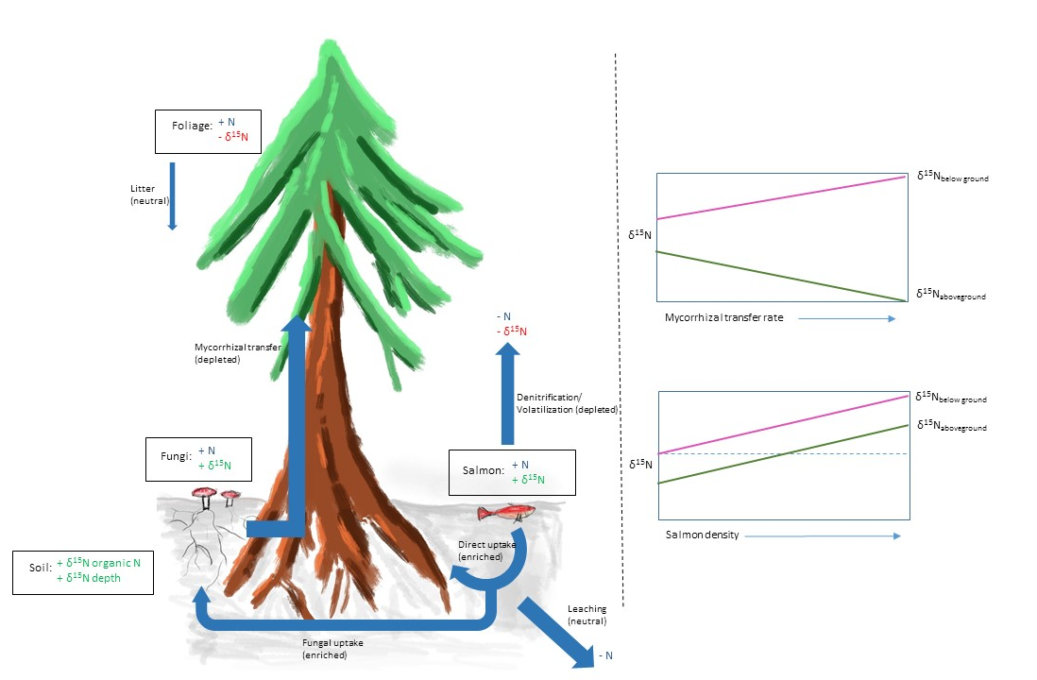
ii.
i.
B
A
Figure 3-1: A: Conceptual outline of N and ¹⁵N transfer, with expectations of isotopic enrichment in pools highlighted green and depletion in red. Expectations of fractionation factors associated with flows are in brackets. B: Expectations of ¹⁵N discrimination between belowground and aboveground compartments due to i. increases in mycorrhizal transfer rate; and ii. increasing salmon inputs.
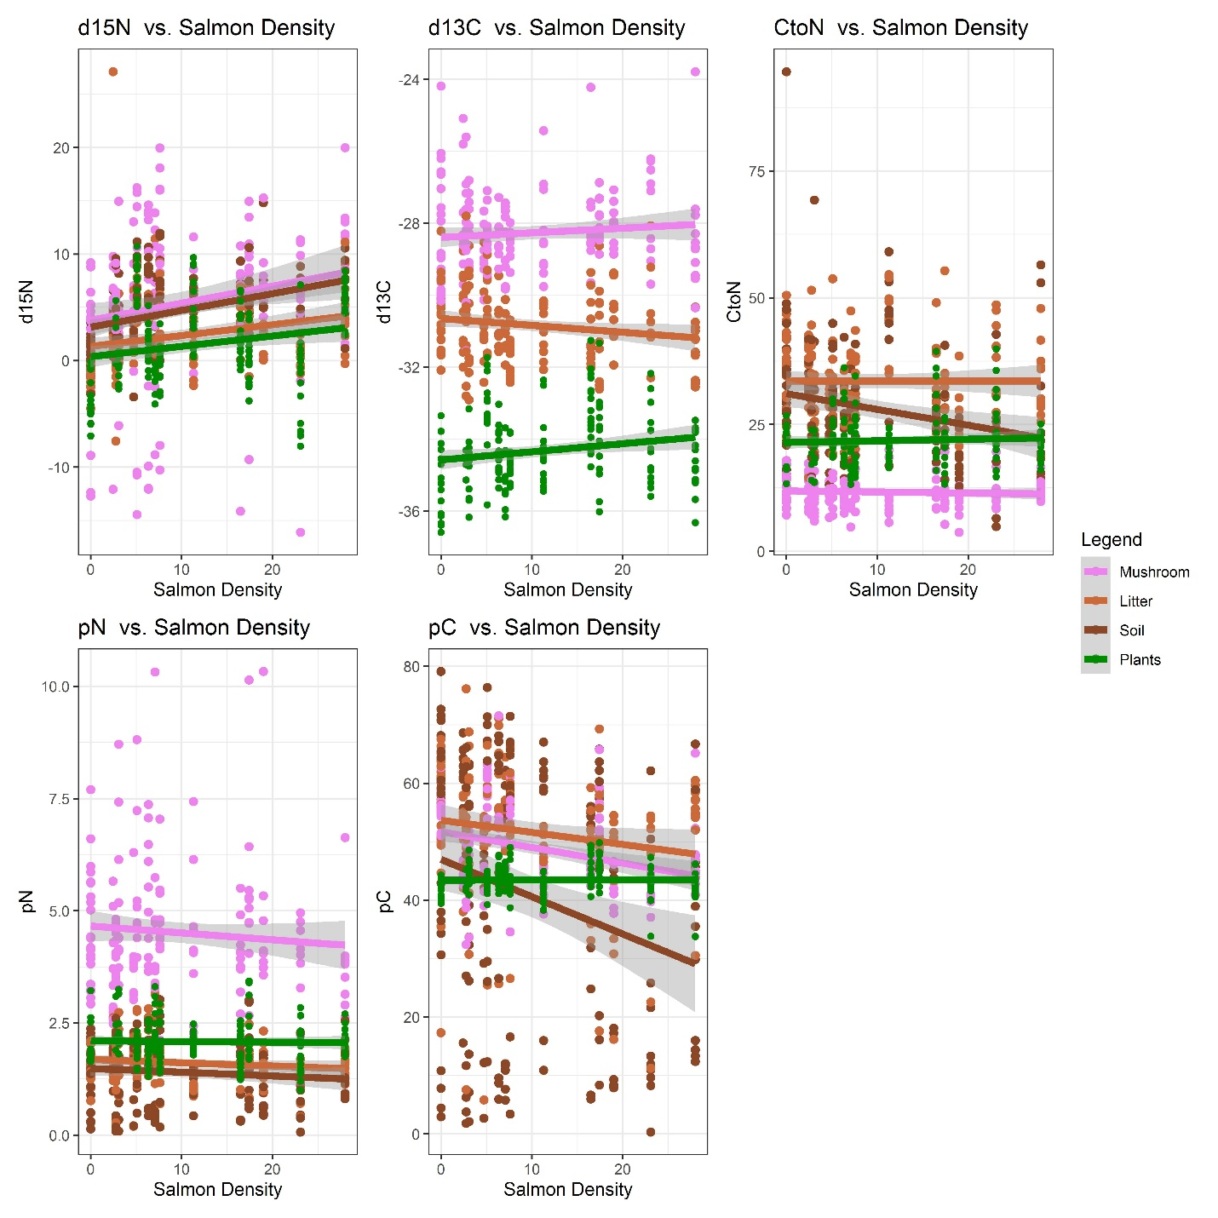
Figure 3-2: δ¹⁵N, %N, δ¹³C, %C, and C:N ratio as a function of salmon density (p in axes and titles denotes percent).
Colour denotes sample type. For significance of slopes, intercepts and interaction terms see Table 3-1; for pairwise comparisons see Table 3-2.
Table 3-1: ANOVA table for salmon density regressions.
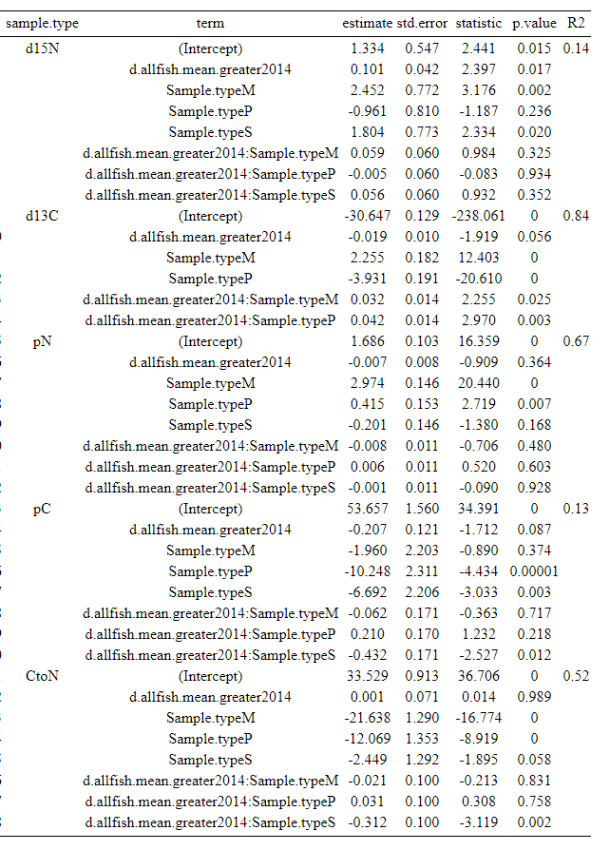

Table 3-2: Pairwise comparisons of intercepts and slopes for salmon density regressions.
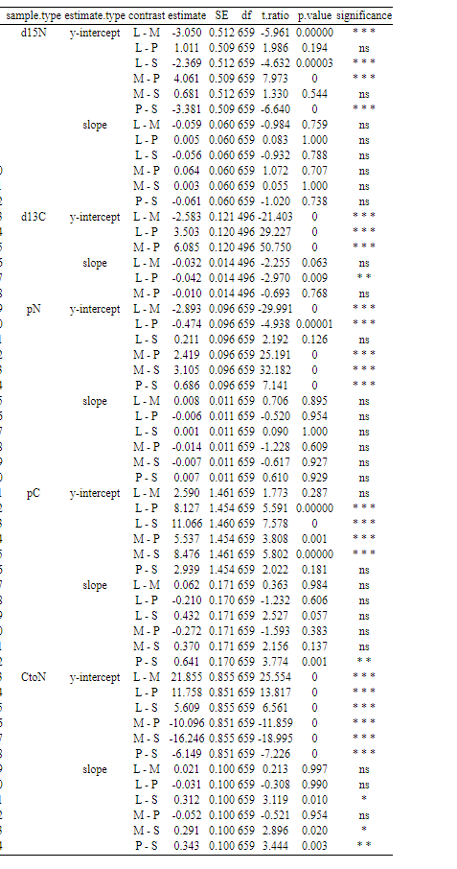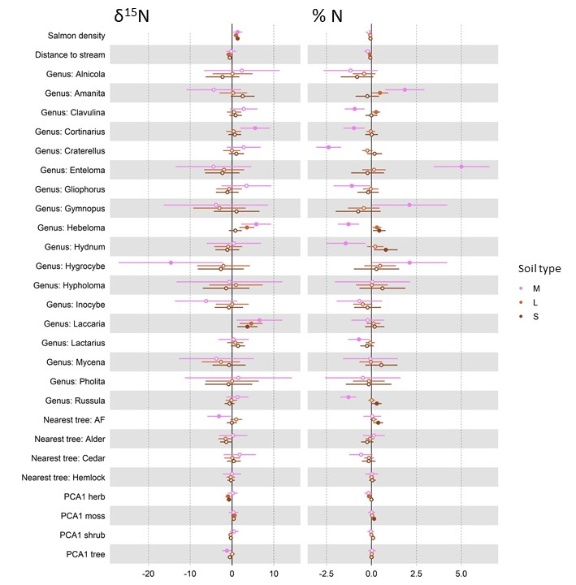
Figure 3-3: Averaged standardized GLM coefficients for all explanatory variables (EVs) in the linear models δ¹⁵N_{sample type} ~ EVs (first column) and %N_{sample type} ~ EVs (second column).
Models for each sample type were run separately and are denoted by colour, will full circles denoting significance at a p<0.05 level. Contrasts for the categorical variables are taken relative to ‘unidentified’ fungi for fungal “Genus”, and relative to Sitka spruce for “Nearest tree” species. X-axis denotes changes in the response variable.

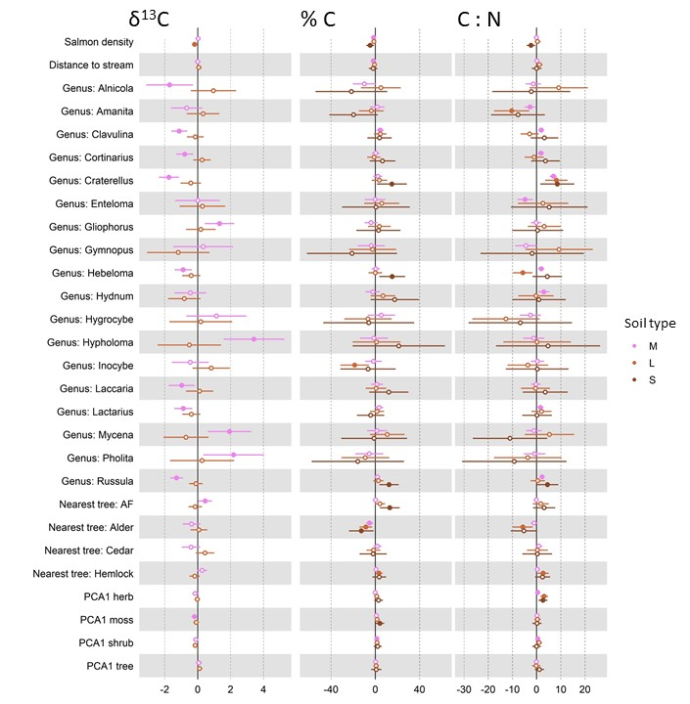
Figure 3-4: Averaged standardized GLM coefficients for all explanatory variables (EVs) in the linear models δ¹³C_{sample type} ~ EVs (first column) and %C_{sample type} ~ EVs (second column) and C_{sample type} : N_{sample type} ~ EVs (third column).
Models for each sample type were run separately and are denoted by colour, will full circles denoting significance at a p < 0.05 level. ¹³C is not shown for soil samples due to high measurement error. Contrasts for the categorical variables are taken relative to ‘unidentified’ fungi for fungal “Genus”, and relative to Sitka spruce for “Nearest tree” species. X-axis denotes changes in the response variable.

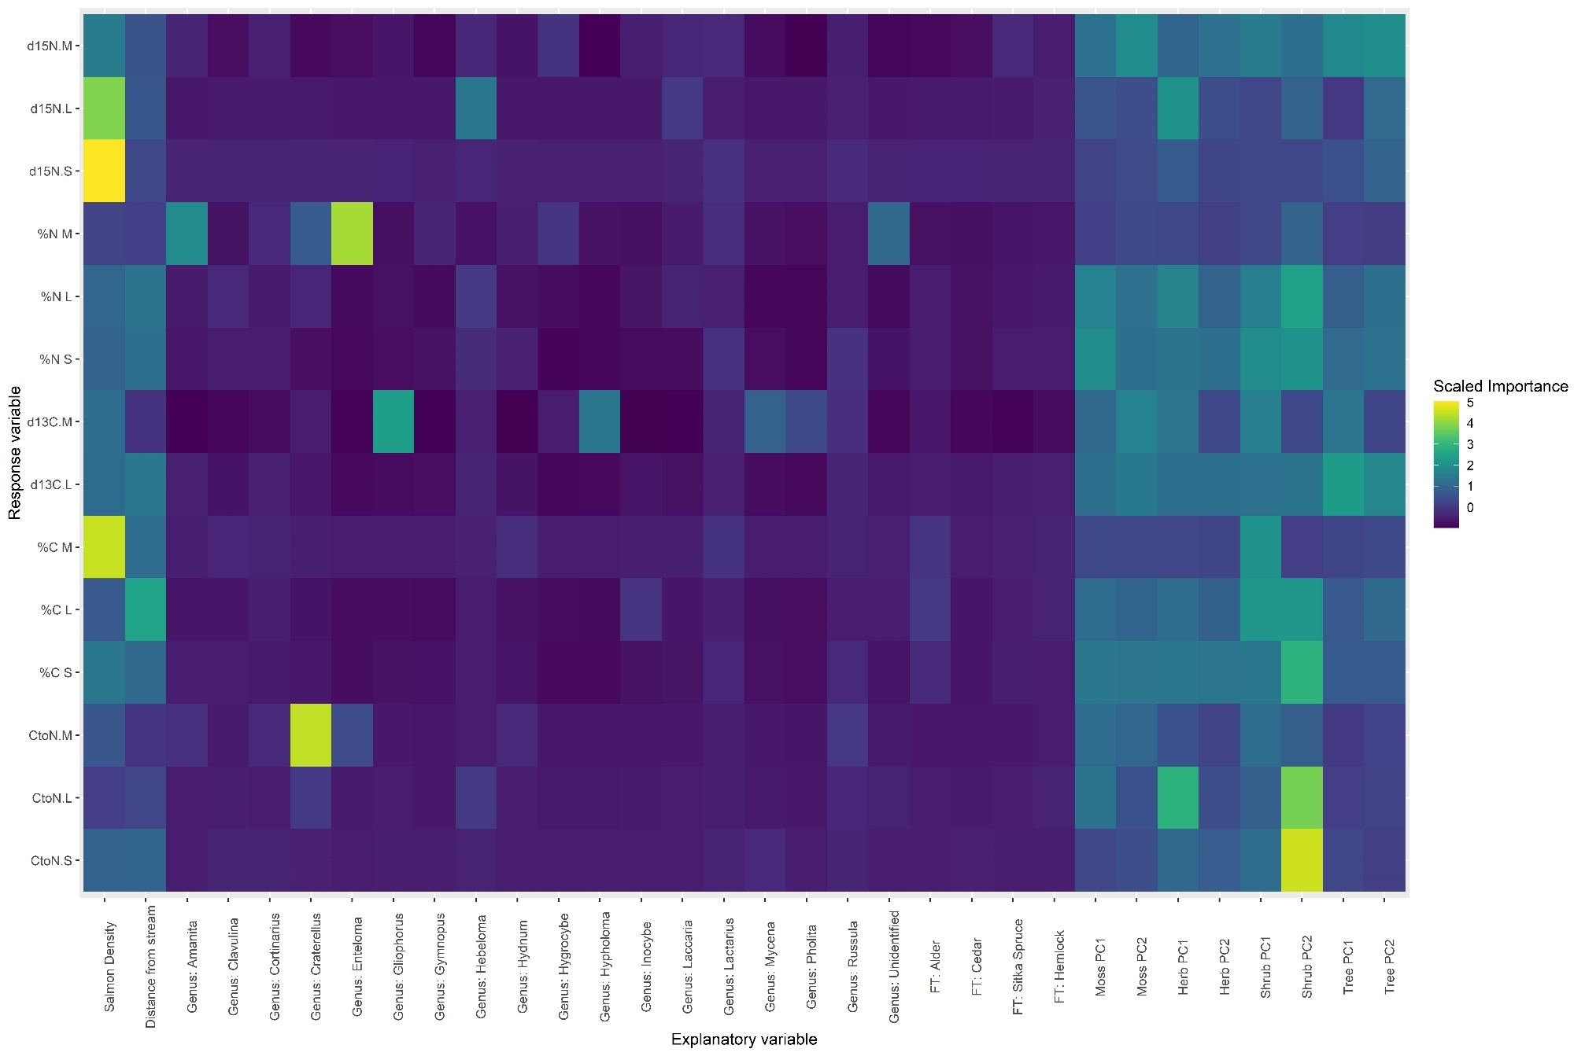
Figure 3-5: Heatmap of random forest model importance for mushroom, litter, and soil response variables.

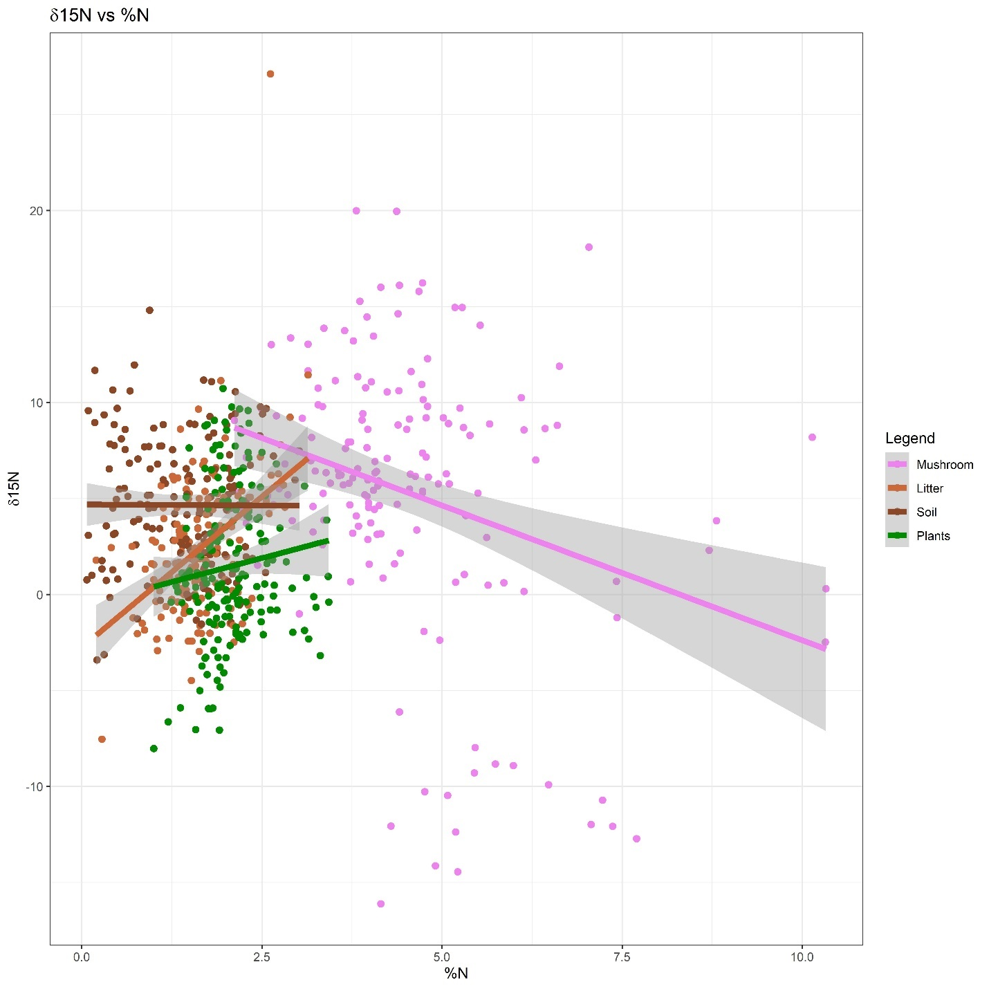
Figure 3-6: δ¹⁵N as a function %N, with sample type denoted by colour.
%N is a significant (p<0.05) predictor of δ¹⁵N, and all slopes and intercepts are significantly different from each other.

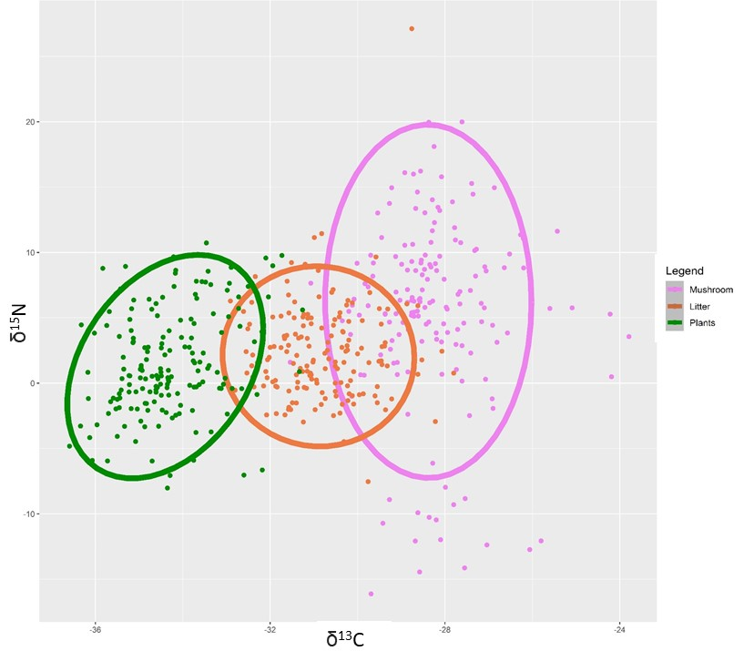
Figure 3-7: Isoplot of δ¹⁵N vs. δ¹³C for vegetation, litter, and mushroom samples.
Soil was excluded from this plot as its δ¹³C measurements had methodological issues due to low nitrogen content.
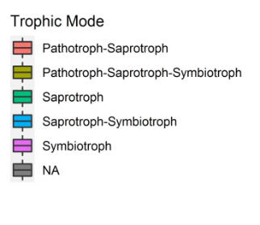
Figure 3-8: δ¹⁵N measures by genus.
Three of the four highest δ¹⁵ values are from known aminophiles – Cortinarius, Hebeloma, and Laccaria. Most of the sampled fungi were known symbiotrophs.

Salmon density influences soil fungal microbiome diversity and community composition

Introduction
Ecosystem subsidization is the transfer of energy, materials, and information from one ecosystem to another (Polis et al., 1997) and commonly affects the productivity, diversity, and species composition of recipient systems (S. F. Collins & Baxter, 2020). The mechanisms of these impacts are reflected in theoretical considerations of subsidy theory, which often invokes the alleviation of resource limitation as a mechanism to predict ecosystem responses. Increased nutrient availability increases system productivity due to higher resource levels but can also lower diversity due to constriction and simplification of multivariate niche space (Leroux & Loreau, 2008). In real-world systems, as nutrients are processed through biotic and abiotic pathways, the net effects of subsidization are emergent properties of the biology and natural history of the organisms involved; thus subsidies depend on both the ecological context of the recipient system and the quantity, quality, timing, and duration of inputs (Subalusky & Post, 2019).
An important system in framing ecosystem subsidy research has been the effects of Pacific salmon (Oncorhynchus sp.) migration on riparian systems (J. C. Walsh, Pendray, et al., 2020). Every year salmon return to their natal streams to spawn and die, and their return is attended to by terrestrial and aquatic animals, which consume, transform, and distribute the nutrients contained in salmon flesh throughout the riparian zone. These ‘marine-derived nutrients’ (MDN) include additions of nitrogen, phosphorus, calcium, and other elements to the ecosystem (Chapter 2), and have been shown to affect plant (Hocking & Reynolds, 2011) and animal (Wagner & Reynolds, 2019) communities. The results of these effects have been shown to be system- and taxa-dependent. For example, inside lakes and streams, benthic invertebrate community diversity decreased and composition changed with salmon (E. Y. Campbell et al., 2011; Stewart et al., 2019), while terrestrial insects showed mixed responses (Stewart et al., 2019). Plant diversity generally decreases along salmon density gradients, and assemblages shift to nitrophyllic and more phylogenetically dispersed communities (Hocking & Reynolds, 2011; Hurteau et al., 2016). Bird density and diversity on the other hand increased at these sites (Field & Reynolds, 2011; Wagner & Reynolds, 2019). In an explicit investigation of trophic cascades in Alaska, mice and vole diets were shown to change with salmon-attracting bears, who distributed seeds in their scat (Shakeri et al., 2018). Productivity investigations show higher plant growth (Quinn et al., 2018) and increased reproductive allocation (Siemens et al., 2020) with increasing salmon density. Despite these diverse results over 25 years of research in salmon-subsidy systems, the ecosystem-level effects of salmon addition have remained relatively under-investigated (10 out of 172 relationships (J. C. Walsh, Pendray, et al., 2020)).
While the short-term effects of salmon addition are generally mediated via direct consumption of carcasses (Reimchen, 2017), the long-term effects of salmon addition on plants are mediated by soil processes. Soil microbes play an active role in these processes (Baldrian, 2019; J. Harris, 2009), where bacteria, protists, and fungi gather, transform, and stabilize soil nutrients and react dynamically to changing environmental conditions and gradients (Z. B. Zhao et al., 2020). Fungi and bacteria operate in partnership with plants to aerate and energize soil processes, and mycorrhizal fungi in particular use their sophisticated enzymatic machinery to scavenge soil nutrients and trade these for carbon- and energy-rich plant photosynthates (S. E. Smith & Read, 2008).
In grasslands, the addition of multiple limiting resources reduced plant diversity, increased productivity, and increased species turnover in relative proportion to the number of limiting resources added to the system (Harpole et al., 2016). In forests, long-term nitrogen addition from atmospheric and chemical sources reduce microbial biomass (Treseder, 2008). As next-generation sequencing technologies have proliferated, characterization of soil microbiome communities has become more sophisticated; these studies have confirmed that diversity decreases with fertilization even as rates of nutrient cycling increase (Fierer, 2017).
As sequencing technologies have enabled quantification of in-situ soil communities, emerging databases have allowed taxonomic classifications to be paired with functional traits (Nguyen et al., 2016; Zanne et al., 2020). Separating fungal reads by feeding strategy (saprotrophic or symbiotrophic/ mycorrhizal) allows for the testing of trait-driven hypotheses. For example, as soil nutrient levels increase, it is typically predicted that mycorrhizal fungi decrease in relative abundance as plants are increasingly able to access nutrients directly without the need of their (now less competitive) fungal partners (Kutorga et al., 2013). Saprotrophs, on the other hand, are expected to increase in relative abundance as litter quality improves and C:N ratios decrease. Alternative hypotheses may be generated however; for example, given the spatial and temporal heterogeneity characteristic of salmon carcass addition, is it possible that fungal network maintenance may be favoured as fungal hyphae may respond more flexibly than plant roots to nutrient hotpots in pulsed subsidy systems such as salmon forest ecosystems (Moeller & Neubert, 2015). Directly measuring fungal communities offers a way to disentangle these hypotheses.
This study investigated the response of soil fungal microbiome diversity and composition to natural gradients of marine-derived nutrients in Heiltsuk Nation territory on the central coast of British Columbia, Canada (Appendix A). Two environmental comparisons were used: one consisting of 23 watersheds along a regional gradient of salmon density, which varies from an average of 0 to 67 kg of salmon per m of linear stream reach per year. The other comparison is between sites above and below salmon-blocking waterfalls at four of these streams. I investigated two soils depths: forest floor (0-5 cm depth) and organic soil (10-15 cm); and amplified two gene targets (ITS2 and SSU) to gauge fungal community composition. The ITS2 region was chosen due to previous use in identifying ectomycorrhizal fungi, while the SSU region was chosen due to previous use in identifying arbuscular fungi (Guichon, 2015). The purpose of this study was to i. quantify and classify, for the first time, fungal communities in salmon forest soils; ii. assess differential effects of MDN on fungal relative abundance; iii. assess the effects of MDN on fungal community species richness, Shannon diversity, and phylogenetic dispersion; iv. assess the effects of MDN on structuring between-site fungal β-diversity. Where possible, I was interested in identifying differences in these responses between symbiotrophic and saprotrophic feeding strategies. I predicted (i) that symbiotrophic fungi would dominate fungal sequences at these sites, and (ii) that saprotroph relative abundance would increase with MDN addition while mycorrhizal abundance could either decrease or increase depending on whether resource heterogeneity or increased nutrient accessibility were more relevant to fungal biomass. I also predicted that salmon would have differential effects on different fungal taxa. I further predicted that (iii) fungal community species richness and Shannon diversity would decrease with salmon density, and that phylogenetic dispersion would mirror plant communities and increase along MDN gradients (Hurteau et al., 2016). Furthermore, I predicted that that (iv) beta diversity would be affected by MDN across sites.

Materials and Methods

Study sites
This study was conducted in Heiltsuk First Nation traditional territory in the Central Coast Regional District of British Columbia, Canada, near the town of Bella Bella (Appendix A). The study sites are in the Central variant of the Very Wet Hypermaritime subzone of the Coastal Western Hemlock biogeoclimatic zone (CWHvh2) (MFLNRORD, 2018). Dominated by a cool maritime climate with high rainfall, the landscape is a mosaic of highland bogs where water is stagnant, and forested slopes where water sheds (Lamb & Megill, 2003). The forested riparian zones are a mix of western hemlock (Tsuga heterophylla), western red cedar (Thuja plicata), Amabilis fir (Abies amabilis), and Sitka spruce (Picea sitchensis), with red alder (Alnus rubra) appearing in disturbed sites. The understory includes huckleberry and blueberry species (Vaccinium parvifolium, V. alaskensae, and V. ovalifolium), false azalea (Menziesia furruginea), salal (Gaultheria shallon), salmonberry (Rubus spectabilis), and devil’s club (Oploplanax horridus).
Regional soils are dominated by prevalently alkaline and peralkaline geochemistry (Souther, 1986), and recent glacial dynamics imply that soil formation has occurred only in the last ~14,000 years (Eamer et al., 2017). Ferro-Humic Podzols dominate the region, extending from northern Vancouver Island to Prince Rupert. The Central Coast is characterized by a narrow coastal band of Folisols that encompass these study sites (Carpenter et al., 2014). The soils found at the study sites were primarily Humic and Lignic Folisols (Organic order, Folisol great group), with the occasional Ferro-Humic Podzol (Podzolic order, Ferro-Humic great group) (n=4). See Appendix A for further soil descriptions.
A total of 23 streams were included in the study, representing a gradient of salmon density (0 – 67 kg salmon per meter of stream reach per year). These streams have been well studied previously (Hocking & Reynolds, 2011) and have ongoing long term (12+ years) salmon density measurements. Four of the 23 streams had waterfalls, which were included as above/below comparisons. This study was conducted in July and August in order to be as distant annually from the salmon run as possible, and to emphasize long-term and legacy effects of salmon deposition.

Soil sampling
Two soil cores were collected from each stream, with an additional two cores above waterfalls in the five watersheds where they occurred. Samples were taken from microsites of flat, deep soil (>50 cm), within 100 m of the stream mouth, and within 60 m perpendicular to the stream. At each microsite, a small soil pit was dug to 50 cm depth and the distance from the stream mouth and to the closest bank recorded. The litter layer was removed and the top 5 cm of the F and H layers were collected as a single sample (“forest floor”). The underlying 10-15 cm of organic soil was collected as a second sample (“organic”).
Forest floors were generally dominated by decomposing moss and conifer needles. Deeper soils were found to match soil maps and were almost exclusively Lignic and Humic Folisols (Drw) (C. A. Fox & Tarnocai, 2011), with homogenous organic composition of down to gravel or bedrock.

Plant Community and Watershed Size
At each core, the largest tree (the “dominant tree”) was identified to species and its size and proximity to the core estimated. Trees and shrubs, and herbs and mosses, were recorded with a two-tiered nested approach.
First, a 5 m radius circular plot was centered on the soil core and every tree with dbh > 1 cm recorded. Tree species identity, circumference, distance and relative bearing from the core were measured. To estimate the effect of each tree on the soil core, a “tree influence index” was calculated as:
$i_{tree}=\frac{circumference}{distance to soil core}$.
Similarly, shrubs with height >1 m were identified to species and their aboveground size estimated by measuring their cubic volume ($h x l x w$). Their distance and bearing to the core was measured, and these figures combined to estimate the effect of each shrub on the soil core as a “shrub influence index”, calculated as:
$i_{shrub}=\frac{shrub volume}{distance to soil core}$.

For each tree and shrub species j, the influence indices of all individuals at each plot were summed, giving an estimate of the aggregate effect of species j on each soil core.
Next, a smaller 1 m² plot was centered on the soil core. Percent cover of each moss and herb species j was visually assessed. This again provides an estimate for each moss and herb species j localized around the soil core in every plot.
Finally, dimensionality of tree influence indices, shrub influence indices, moss percent cover, and herb percent cover were each reduced via principal component analysis (PCA) for use as explanatory variables in later analyses. This resulted in one PCA for each of the four vegetation layers. In each PCA, the variation explained and major loading for the first principal axis was: moss (36% of variation explained; positive direction - lanky moss); herbs (35%; positive – salal, deer fern; negative – false lily of the valley, spiny wood fern); shrubs (34%; positive – salal; negative – false azalea, Vaccinium spp.); trees (39% of variation; negative – cedar) (Appendix C).
To account for watershed size as an explanatory variable, PCA was conducted using catchment area, stream magnitude, spawning length, and bankfull width (after Wagner & Reynolds 2019). The first axis accounted for 52% of the variation and was used as an explanatory variable where appropriate in downstream analysis.

Salmon density data
Annual fish data was contributed by the Reynolds lab at Simon Fraser University, Department of Fisheries and Oceans, and the Heiltsuk First Nation (Appendix B). Salmon biomass for year t at site j was calculated by multiplying annual salmon escapement estimates of site j by the average biomass of the corresponding species i at spawning time $({estimated biomass}_{tj}=\sum_{i=1}^{4}{{escapement}_{tji}*{average individual biomass at spawning}_{ i}}$). Four salmon species are found in these study sites: Chum (Oncorhynchus keta), Pink (O. gorbusha), Coho (O. kisutch), and Sockeye (O. nerka); biomass estimates at spawning for Chum and Pink were taken from previous values at these sites (Hocking & Reynolds, 2011), and Coho and Sockeye were taken from the literature (Shaul et al., 2007). Chum and Pink accounted for the vast majority of salmon at the sites (>90% of total biomass). Annual biomass measures for each stream j were estimated with a 3-year moving average. From these biomass estimates, density indices were calculated by dividing estimated biomass by the length of spawning reach of each watershed $(density=\frac{estimated biomass}{length of spawning reach} )$ and is henceforth referred to as “salmon density”. Its units are thus $\frac{(kg of salmon)}{(m of stream reach)(year) }$(see Appendix B for further information).

Molecular analysis
DNA was extracted from 5 mg of wet soil using the Powersoil DNA isolation kit (MoBio Laboratories Inc., Carlsbad, CA, USA). DNA concentration and quality was quantified using a NanoDrop 2000 (Thermo Fisher Scientific Inc, Wilmington, DE, USA) and Quantus fluorometer (Promega, Madison, WI, USA) using the Qubit dsDNA HS assay kit (Thermo Fisher Scientific Inc, Wilmington, DE, USA). DNA was diluted to 10 ng/µl and PCR amplicons created and quality control conducted by BC Cancer Genome Science Center (Vancouver, BC). Amplified regions were then pooled by template, Direct Seq libraries constructed, and libraries pooled to be sequenced in a single Illumina MiSeq 250 base PET run with v3 chemistry. Two regions were amplified: the ITS2 region, using primers gITS7 (F) (Ihrmark et al., 2012) (GTGARTCATCGARTCTTTG ) and ITS4 (R) (White et al., 1990) (TCCTCCGCTTATTGATATGC); and a portion of the SSU region, using primers NS31 (F) (TTG GAG GGC AAG TCT GGT GCC) (Simon et al., 1992) and a AM1, AM2 and AM3 degenerate primer (R) (Santos-González et al., 2007) (GTT TCC CGT AAG GYG CCR AA).

Bioinformatics
Microbiome bioinformatics was performed with QIIME2 V.2019.7 (Bolyen et al., 2019). Raw FASTAq sequences were binned into two workflows, one for each amplicon, with Cutadapt (M. Martin, 2011). To control for read-through Illumina errors, the ‘sliding window’ function from Trimmomatic V0.39 was used to truncate reads when the average quality score on a 4-base moving average fell below 20 (Bolger et al., 2014). Each workflow was demultiplexed and quality filtered with the q2-demux plugin. ITS2 sequences were processed through ITSexpress (Rivers et al., 2018) to filter, trim, and export the variable ITS2 region and both amplicons were filtered, denoised, merged and had chimeras removed via DADA2 (Callahan, McMurdie, et al., 2016). Taxonomic assignments were made using a naïve Bayes classifier (Bokulich et al., 2018) trained on the UNITE database for ITS2 amplicons (Abarenkov et al., 2010; Nilsson et al., 2019); and a merged MAARJAM (Öpik et al., 2010) and SILVA (Quast et al., 2013) database for the SSU amplicons, which was created with the Qiime2 merge_taxa function. Before being used for classifier training, the UNITE database was processed with ITSx (Bengtsson‐Palme et al., 2013) parallelized with akutils v.1.2 (Andrews, 2016), with reduced stringency parameter of 1 to avoid dropping reads with short amplicons. Finally, Funguild (Nguyen et al., 2016) was used to assign guild membership and trophic information to identified fungal taxa.

Statistical Analysis
Two datasets were considered in this study: one along a regional gradient of salmon density (‘regional gradient data’) and the other a comparison between sites above and below salmon-blocking waterfalls (‘above/below’ data). Each sample consisted of two soil depths (forest floor, FF, and organic, O), and each of these samples amplified two amplicons: ITS2 and SSU. To address my hypotheses about differing effects of trophic mode, three taxonomic groups were investigated: ‘all taxa’, which include all sequences; and ‘symbiotrophs’ and ‘saprotrophs’, which include only the subset of sequences that were identified and annotated by FunGuild, and respectively included the term ‘symbiotroph’ or ‘saprotroph’ in their ‘trophic mode’ designations. To visualize total amplicon read and taxonomic distribution, heat trees were plotted using the R packages phyloseq (McMurdie & Holmes, 2013), taxa (Z. S. Foster et al., 2018) and metacodeR (Z. S. Foster et al., 2017).
Four community metrics were chosen as response variables to compare communities: relative abundance of symbiotrophs and saprotrophs, species richness, Shannon’s diversity index, and phylogenetic dispersion. Three approaches were used to examine these relationships: i. simple bivariate visualization; ii. hypothesis testing via a GLM approach, which allowed for the consideration of a subset of covariates at these sites; and iii. an exploratory approach using random forest models to examine a wider set of covariates.
First, to most directly examine the effects of salmon density in the regional data on fungal communities, response variables were plotted against salmon density for all taxonomic groups and loess curves drawn to visualize trends. Above/below data was visualized with Tukey boxplots and hypothesis testing performed by paired Wilcoxon tests.
Second, hypothesis testing was accomplished using a GLM model-averaging framework. GLMs were constructed with the equation ${Community metric}_{i} \sim salmon density+soil type+ nearest focal tree+moss percent cover PCA1+herb percent cover PCA1+shrub influence index PCA1+tree influence index PCA1$ for every taxonomic group i. Gaussian and Gamma families were considered, and identity, log, and inverse link functions chosen where appropriate on domain, theoretical grounds, and model fit. Collinearity and model assumptions were checked visually using the R packages DHARMa (Hartig, 2020) and performance (Lüdecke et al., 2020). Since we were concerned primarily with the sign and direction of effects, a model averaging approach was used using the MuMIn package in R (Barton, 2020). All models were included in final coefficient estimates, weighted in proportion to their AICc values using conditional averaging (Galipaud et al., 2014). All explanatory variables were standardized prior to regression to account for differences in scale and units, and standardized coefficients and their confidence intervals visualized via forestplots (Scheinin et al., 2021). Finally, interpretation of coefficients was aided through inspection of marginal effects with the aid of the visreg package (Breheny & Burchett, 2017).
Third, to assess the relative importance of environmental and soil factors on community response variables, a suite of physical variables (four variables, including salmon density), chemical variables (21 variables), and vegetation variables (16 variables) (Chapter 2) were included in random forest models constructed in R with the caret and randomForest packages (Kuhn, 2008; Liaw & Wiener, 2002). Standardized importance coefficients of these explanatory variables were then visualized via heatmaps.
Beta diversity was ordinated and visualized with NDMS plots (Legendre & Legendre, 2012; Lozupone et al., 2011). Since the ITS2 region diversifies on relatively short time scales, Unifraq distances are inappropriate and so standardized Bray-Curtis distance was used for the ITS sequences and weighted UniFraq distance calculated from the generated SSU tree for SSU amplicons. Separate ordinations were conducted for each amplicon. NMDS was fit using 20 iterations and collapsed to two dimensions. Significance was assessed using analysis of variance using distance matrices as implemented in the ‘adonis2’ method in the R package vegan (Oksanen et al., 2013). In the regional gradient data, effects of salmon density were modelled with the equation $Y\sim Salmon density+Watershed size PCA1+ Nearest Tree Species+Soil Type$, while in above/below data the formula $Y\sim Above or below waterfall+ Nearest Tree Species+Soil Type$ was used. To account for model uncertainty and collinearity between salmon density and watershed size, these analyses were repeated with salmon density and waterfall placed last in the models.
Differential composition analysis was conducted using the MaAsLin2 package (Mallick et al., 2021). ASV tables were filtered by removing all taxa in fewer than 5% of samples and abundance fewer than 10 reads across all samples (Callahan, Sankaran, et al., 2016). Gradient data was modelled as a linear function of salmon density, and above/below data as a function of being above or below the respective waterfall, using centered log-transform (CLT) on ASV reads for each case. Salmon density was Z-transformed prior to modelling. Forest floor and organic soils were treated separately, as were the two amplicons, resulting in eight final model sets. Since MaAsLin2 assigns coefficients on the ASV level, coefficients for non-tip taxa as well as taxa that were represented by multiple ASVs were constructed by taking the average of the coefficients of contributing ASVs weighted by the relative abundance among significant taxa. Finally, coefficients were visualized via heat trees in R using the metacodeR package (Z. S. Foster et al., 2017).

Results

Sequencing and community composition
ITS reads: A total of 1.86 million clean, double-stranded Illumina reads were obtained after demultiplexing; after dada2 filtering this resulted in 1.12 million reads representing 3,165 ASVs. A total of 2,100 (66.3%) were identified at the class level; 1,333 (42%) at the genus level and 605 (20%) at the species level. FunGuild annotations were successfully applied to 1,660 taxa (52% of the total); and 832 (55.3% of annotated samples) included the word ‘symbiotroph’ in the Funguild “Trophic Mode” designation; and 1,108 (73.6%) the word ‘saprotroph’ (taxa with both designations were included in both groups). The top fungal classes by average relative abundance represented in the complete data set were Agaricomycetes (50.0%), Leotiomycetes (8.3%), Eurotiomycetes (8.1%), and Mortierellomycetes (7.0%). The ten most abundant genera were Tylospora (19.8%), Mortierella (7.3%), Russula (7.2%), Archaeorhizomyces (6.3%), Cenococcum (6.2%), Elaphomyces (4.7%), Clavulina (2.9%), Piloderma (2.7%), Cortinarius (2.0%), and Meliniomyces (1.9%). The phylogenetic distribution of relative abundance is summarized in Figure 4-1.
SSU reads: 160 thousand double-stranded Illumina reads were obtained after demultiplexing; after dada2 filtering this resulted in 76,332 reads representing 461 ASVs. A total of 300 (65%) of taxa were identified at the class level; 143 (31%) at the genus level and 119 (25.8%) to the species level. FunGuild annotations were successfully applied to 302 taxa (65.5% of the total), and 134 (44.4% of the annotated samples) included the word ‘symbiotroph’ in the Funguild “Trophic Mode” designation; and 95 (31.5%) the word ‘saprotroph’. The top fungal classes by mean relative abundance were Agaricomycetes (66.8%), Eurotiomycetes (17.6%), Sordariomycetes (7.2%), Glomeromycetes (4.0%), and Leotiomycetes (2%). The ten most abundant genera were Russula (41.5%), Piloderma (27.3%), Camarophyllopsis (4.7%), Lactarius (4.5%), Trichoderma (3.9%), Gliophorus (2.5%), Glomus (1.4%), an unidentified Agaricales (2.4%), and an uncultured Glomus (1.5%). The phylogenetic distribution of relative abundance is summarized in Figure -2.

Community metrics

Relative Abundance
Communities were dominated by symbiotrophs (Figure 4-3). Symbiotrophs generally increased along salmon gradients, with the exception of SSU forest floor symbiotrophs which decreased, although often these relationships were U-shaped (Figure 4-3). Saprotrophs, meanwhile, stayed flat. Loess curves of the different fungal communities showed a maxima in abundance between 30 and 40 kg of salmon per meter per year.
GLM results showed no effect of salmon on ITS relative abundances between the trophic modes, but saprotrophs were higher in forest floors than organic soil and the species of the nearest focal tree and the local plant community were important for both symbiotrophs and saprotrophs (Figure 4-7). SSU reads showed a significant increase in response to salmon inputs in symbiotrophs but no response in saprotrophs (Figure 4-8). Moss PCA1 was negatively correlated with symbiotroph relative abundance, and no effect was found from the other factors.
Amongst ‘all taxa’ ITS reads, random forest models apportioned maximum importance to ammonium, red-cedar as the nearest tree, and the herb community for symbiotroph relative abundance (first column facet in Figure 1-9), and magnesium was important for saprotrophs. For ‘all taxa’ SSU sequences, iron, aluminum, magnesium, phosphorus, and the plant community was important for symbiotroph relative abundance; for symbiotroph relative abundance nitrogen, ammonium, sulfur, watershed size, and the moss community were important (Figure 4-10).

Species richness
ITS communities were more species-rich than SSU communities, and richness was approximately equal between symbiotrophs and saprotrophs (Figure 4-4). Richness generally stayed flat as a function of salmon density, with the exception of SSU forest floors, where it increased with salmon density to a local maximum at 30 kg salmon m⁻¹ yr⁻¹.
GLM results however showed an increase in species richness with increasing salmon density among ITS reads (Figure 4-7). In addition, richness was higher in forest floors relative to organic soil, and was also affected by the tree and herb community. SSU sequences showed no change in richness with salmon density, and higher richness in saprotrophs in forest floors than organic soils.
For ‘all taxa’ ITS amplicons, the most important explanatory variables were manganese, copper, zinc, and pH (Figure 1-9). Symbiotrophs also attributed high importance to phosphorus, ammonium, and herbs PCA2. Saprotrophs were associated with manganese, copper, and ergosterol concentrations. Similar results were found for the SSU sequences (Figure 4-10), where phosphorus, pH, magnesium, and the moss and shrub communities were important for ‘all taxa’. Symbiotrophs were affected by watershed size and distance to the stream, while saprobes were strongly affected by ammonium, total N, iron, and the moss community.

Shannon diversity
Bivariate plots for Shannon diversity showed complex relationships with salmon density, where they either decreased, did not change, or increased with salmon depending on amplicon or taxa subset (Figure 4-5). Symbiotrophs were significantly less diverse below falls than above falls.
GLM results for Shannon’s diversity index followed those for species richness, with ITS diversity increasing with salmon density and being higher in forest floors than organic soils (Figure 4-7). SSU diversity, however, did not significantly respond to salmon density. Amongst the tree community, the presence of cedar was again the most relevant.
Random forest models proportioned high importance to pH, ammonium, ergosterol and the herb and tree community for ‘all taxa’; phosphorus, and pH for symbiotrophs; and sulfur and phosphorus for saprobes (Figure 4-9). SSU reads were more responsive, with ‘all taxa’ being driven by ammonium, the shrub and tree community, and the presence of class-4 coarse woody debris; symbiotrophs were affected by tree PCA2; and saprobes by ammonium, total nitrogen, phosphorus, total iron, and the herb community (Figure 4-10).

Phylogenetic Dispersion
Communities were generally underdispersed relative to random assortment (negative PDIs; Figure 4-6). Bivariate plots for the phylogenetic dispersion index (PDI) showed mixed relationships between fungal communities with salmon density, with forest floor communities generally decreasing or not responding to salmon density, and organic soil communities decreasing, with similarly mixed results in the comparison between above and below falls (Figure 4-6).
These mixed results were borne out in the GLM analysis; however ITS ‘all taxa’ tended to increase with salmon density (Figure 4-7), although this was not seen in either symbiotrophs or saprobes indicating that this is driven either by unidentified taxa or taxa with different trophic modes. ITS PDI was also lower for symbiotrophs in forest floors and was affected by the nearest tree and the moss community. SSU PDI was similarly sensitive to soil type, nearest tree, and the moss and shrub communities.
Finally, for ITS sequences of ‘all taxa’, the variable of highest importance was nitrate concentrations, and magnesium, sodium, and CEC were important for saprotrophs (Figure 4-9). SSU sequences showed sensitivity to ammonium, particularly amongst saprotrophs; ergosterol and exchangeable sulfur were also of high importance (Figure 4-10).

Beta diversity
For ITS sequences in the gradient data, salmon density, watershed size, soil type, and nearest dominant tree were all significant (P<0.05) in ADONIS tests across all data subsets (“all”, “symbiotrophs” and “saprotrophs”) (Figure 4-11, top row). Significance of salmon density was robust to variable order in model specification; only in “saprotrophs” did salmon density cease to be significant when placed last (p=0.12). Similarly, in ITS above/below data, being above or below the waterfall was significant in all ADONIS tests across all subsets, and this was robust to explanatory variable order (Figure 4-11, bottom row). Stress for these plots was low (maximum = 0.25).
SSU gradient sequences were less structured along salmon density gradients – “all reads” were significantly clustered in ADONIS tests by nearest tree and soil type, but not salmon density or watershed size (Figure 4-12, top row). For symbiotrophs, only watershed size was significant, and for saprotrophs salmon density and soils also tended to matter (p=0.08 and 0.09 respectively). These were robust to changes in variable order. The above/below data showed significant differences in all tests, regardless of variable order (Figure 4-12, bottom row). In addition, nearest tree was significant for saprotrophs (p=0.029), and both nearest tree and soil were moderately significant for saprotrophs (p=0.065 and 0.07). Stress for these plots was low (maximum = 0.1).

Compositional changes along salmon gradient
MaAsLin2 models showed significant taxonomic responses to salmon inputs (Figure 4-13 & Figure 4-14). ITS sequences along the regional gradient, Tylospora, Sebacina, and an unidentified Strophariaceae and Thelephoraceae increased in forest floors while Mortierella and Chaetosphaeria decreased; and in organic soils Sebacina, two Hypocreales, and an unidentified Heliotales increased while Mortierella decreased. In above/below waterfall comparisons, Melniomyces and Russula were higher in forest floors below falls and Mortierella and Solicoccozyma were lower. In organic soil, Tylospora, Clavulina, Cenococcum, and unidentified Agaricales and Chaetosphaeriales were higher below falls while Solicoccozyma and Mortierella were lower. SSU sequences showed no change in forest floors either along the regional gradient or between waterfall sites, while in organic soils Russula, Piloderma, and Trichoderma increased along salmon gradients, and Trichoderma was also higher below than above falls.

Discussion

Fungal communities of the central coast
The first objective of this study was to characterize riparian soil fungal communities on the central coast of BC. I was able to identify to genus approximately 40% of ASVs, and this demonstrates that there is still significant uncharacterized fungal diversity in these soils. ITS and SSU sequencing was intended to characterize the ectomycorrhizal and arbuscular mycorrhizal fungal communities respectively; the ten-fold higher read count for ITS sequences supports the hypothesis that these sites are dominated by ectomycorrhizal fungi and their associated plant hosts (western hemlock, Sitka spruce, amabilis fir). This is despite the presence of relatively common arbuscular mycorrhizal plants, such as salmonberry, most herbs, and cedar. Ericoid fungi (the order Heliotales, among others) were also well represented, reflecting the acidic nature of the soils and the understory dominance by blueberry, huckleberry (Vaccinium spp.) and false azalea (Rhododendron menziesii).

Responses to MDN

Relative abundance
I found saprobic fungal community did not respond to the salmon density gradient, leading me to reject the second hypothesis that saprotrophs would respond negatively to MDN addition. Instead, the higher saprobe abundance in forest floors than organic soil and the importance of cedar reflects changes in nutrient cycling driven by tree species (Prescott & Grayston, 2013). I found some positive correlations between symbiotrophs and MDN among SSU sequences, agreeing with our hypothesis that symbiotrophs would respond to resource subsidies and their proximity. Symbiotrophs showed a maxima between 0 and 40 kg·salmon·m⁻¹·yr⁻¹, corresponding to nitrogen inputs in amounts approximately equal to that experimentally determined to be most beneficial to tree growth (~200 kg ha⁻¹yr⁻¹) (Reid et al., 2017). Describing these associations was hampered by small within-site sample size, nonlinear relationships, and high leverage generated by the gap in data between high-salmon sites Neekas and Clatse and the rest of the data. SSU symbiotrophs also responded positively to MDN addition; to the degree that SSU sequences are representative of arbuscular mycorrhizal fungi, this may reflect changes along MDN gradients in plant community from nitrogen-poor (and ericoid/ectomycorrizal) to nitrogen-rich (and arbuscular mycorrhizal) fungal assemblages (Hocking & Reynolds, 2011).

α-diversity
The first part of my third hypothesis was that MDN addition would be associated with a decrease in α-diversity (species richness and Shannon diversity). The GLM analysis supported the opposite: ITS sequence showed significantly positive effects of MDN on α-diversity for all taxonomic groups, while SSU sequences showed no effect (or even some support for a decline among saprobes). This is the opposite of established understanding that EMF species richness declines in response to N fertilization and atmospheric N deposition, while shifts to more nutrient-rich plant regimes are associated with higher AMF diversity (Jones et al., 2012; Lilleskov et al., 2001, 2002; Wallenda & Kottke, 1998). This increase in diversity may reflect increased spatial- and temporal- heterogeneity created by salmon inputs, as well as increased photosynthate flux to roots and symbionts allowing plants to access a diversity of nutrient sources.
The driving factors behind ITS symbiotroph richness were phosphorus and ammonium (Figure 4-9). P is known to interact with N to impact microbial diversity, as shifting stochiometries of these two macronutrients select for or against different fungi based on their nutritional requirements (Delgado‐Baquerizo et al., 2017). Of highest importance to ITS saprotroph richness was manganese; manganese plays a role as a cofactor in lignin-decay enzymes of fungal origin and manganese limitation has been shown both to reduce decomposition rates in N-rich soils (Berg et al., 2010; Whalen et al., 2018) and increase soil organic matter (Kranabetter, 2019; Stendahl et al., 2017).

Phylogenetic dispersion
The second half of my third hypothesis was that phylogenetic dispersion would increase along MDN gradients. In general, the sites were underdispersed relative to random assortment, indicating dispersal limitation and/or spatial structuring of these communities (Golan & Pringle, 2017; Horton, 2017). I found that salmon inputs increased PDI amongst ‘all taxa’, but not among either symbiotrophs or saprotrophs sequences alone. This indicates that it is driven by fungi of unidentified trophic modes. In another study at these sites, increased dispersion with MDN subsidy was found in a dataset of 60 plant species collected at these sites, where salmon density was associated with greater phylogenetic dispersion and reduced plant species richness (Hurteau et al., 2016). High nutrient availability tends to reduce phylogenetic clumping as habitat filtering and competition alter species composition, which is reflected in higher phylogenetic dispersion indices. While previous work has shown this to be driven by plant traits (López‐García et al., 2017), here the factor of prime importance was nitrate concentrations. Hence, I interpret this as mirroring previous studies on the plant community, and as likely being driven by a combination of changes in competition and habitat filtering due to increased nutrient inputs from salmon carcasses.

Β diversity
Turning to my fourth hypothesis, beta diversity ordinations on ITS sequences supported the hypothesis that salmon density both along regional gradients and above/below waterfalls had a role in structuring fungal communities. This effect was slightly less strong for saprotrophs than for symbiotrophs, perhaps reflecting their differing ecology, and consistent with the less responsive abundance observations noted above. The MDN gradient did not affect SSU fungal community structure for ‘all taxa’ or symbiotrophs, but did in saprotrophs, which may indicate feedbacks between MDN and plant communities at these sites (Hocking & Reynolds, 2011); however, this should be taken as tenuous given the low sequence numbers of saprotrophs in the SSU reads. Taken together, this supports the idea of an overall effect of salmon density on regional-scale community structuring, as well as reaffirms the importance of tree species in determining local soil microbiomes (Prescott & Grayston, 2013).

Genus-level differential responses
My fifth hypothesis was that MDN would have differential effects on specific taxa, and this was addressed via differential abundance analysis. Among ITS sequences, Tylospora increased along the salmon gradient in forest floors, and was also higher below falls in organic soils. Tylospora are corticoid mycorrhizal fungi (A. F. S. Taylor & Alexander, 1991) and have been implicated as being active N metabolizers and high N₂O producers (Prendergast-Miller et al., 2011). They are common in N-rich soils and are competitive when inorganic-N concentrations are high (Prendergast-Miller et al., 2011). Fungal denitrification frequently dominates bacterial denitrification in acidic soils (H. Chen et al., 2015), and hence the high abundance of Tylospora may have ecosystem-level implications for N metabolism and denitrification, which has previously been assumed to be bacterially driven with only minimal consideration of fungi (Holtgrieve et al., 2009). In these data, Tylospora was categorized as a symbiotroph, hence likely accounts for a large proportion of the importance of ammonium and total-N assigned to these taxa.
Sebacina was also frequently found to increase with salmon addition. Sebacinales are a mycorrhizal clade able to colonize a wide range of hosts, including mosses, ferns, and other plants; where they form ericoid, orchid, ecto- and endo-mycorrhiza, as well as act as root endophytes (Vohník et al., 2016). They are capable scavengers of ammonium and phosphorus, and recently have been shown to be adept at scavenging nitrogen from organic amino acids as well (Ray et al., 2019). This same study demonstrated sophisticated flexibility in phosphorus metabolism, and they may play a role in adaptively buffering the changing levels of phosphorus availability characteristic of salmon forest soils.
Mortierella were found to decrease in response to salmon inputs. Mortierella are a large genus of soil saprotrophs which grow in close association with plant roots (Werner et al., 2016). They include a number of species that promote plant growth in agricultural settings (Ozimek & Hanaka, 2021); one mechanism proposed for this being the solubilization of phosphorus (H. Zhang et al., 2011) which is important in liberating phosphorus from aluminum complexes in acidic soils, a role which may be of less importance at higher phosphorus inputs.
Among SSU sequences, Russula, Piloderma, and Trichoderma increased with salmon inputs. Russula has multiple ecological roles and have demonstrated strong habitat partitioning amongst species (Geml et al., 2010), and are also well represented in sporocarp counts at these sites (Chapter 3). Piloderma was highly represented amongst the SSU samples and, like Tylospora, plays an active role in denitrification (Prendergast-Miller et al., 2011) and also in accessing organic N and delivering it to mycorrhizal partners (Heinonsalo et al., 2015). Trichoderma, meanwhile, are also able to metabolize nitrogen from organic sources, and have found recent usage in agricultural settings due to their action as biocontrol agents and a plant growth promoter (Schweiger et al., 2021; Vinale et al., 2012).

Conclusion
This study demonstrated changes in fungus relative abundance, diversity, and community composition along gradients of MDN. In addition, I found differential responses to MDN along taxa subsets separated by trophic mode. The primary environmental correlates included elements directly deposited by salmon such as nitrogen, ammonium, nitrate, and phosphorus (Drake et al., 2005), as well as other trace elements recently shown to impact fungal diversity such as manganese (Kranabetter, 2019). Moss, herbs, shrubs, trees and coarse woody debris were also all important correlates, and given theoretical implications that nutrient subsidies increase interaction strength between species and can increase the magnitude of trophic cascades (Leroux & Loreau, 2008) this may reflect complex feedbacks between nutrient inputs, soil microbiomes, and the plant community. Differences exist between continuous and pulsed additions (Weber & Brown, 2013), with some evidence that pulses of nutrients are ‘better’ at promoting diversity and ecosystem functioning. These salmon forests thus represent a unique window into these processes. There remain relatively few investigations of soil fungal microbiome changes along complex gradients such as the one investigated here. Salmon additions represent the addition of a diverse number of organic nutrients and chemicals, and this study emphasizes that comparison with nitrogen gradients alone may not capture the full story driving community dynamics.

Tables and Figures
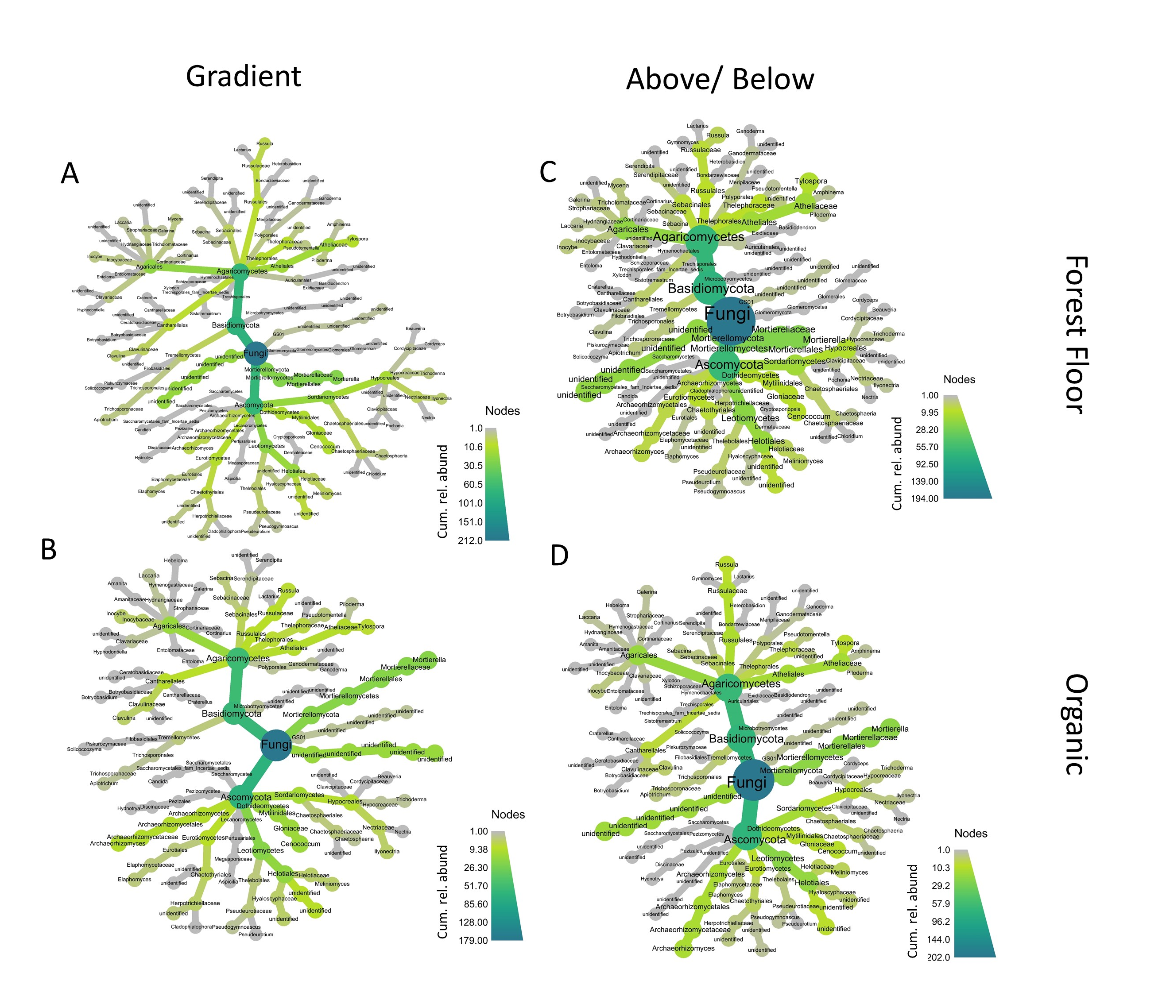
Figure 4-1: Heat trees of ITS relative abundance agglomerated to genus for the regional gradient data for forest floor (A) and organic (B) soils
; and using four sites with waterfalls both above and below falls for the forest floor (C) and organic (D) soils. Non-tip taxa are sums of downstream nodes; darker color indicates higher cumulative relative abundance in that taxon. Ascomycota and Agaricomycetes dominated these communities. Phylogenies reflect ITS relationships rather than consensus trees.

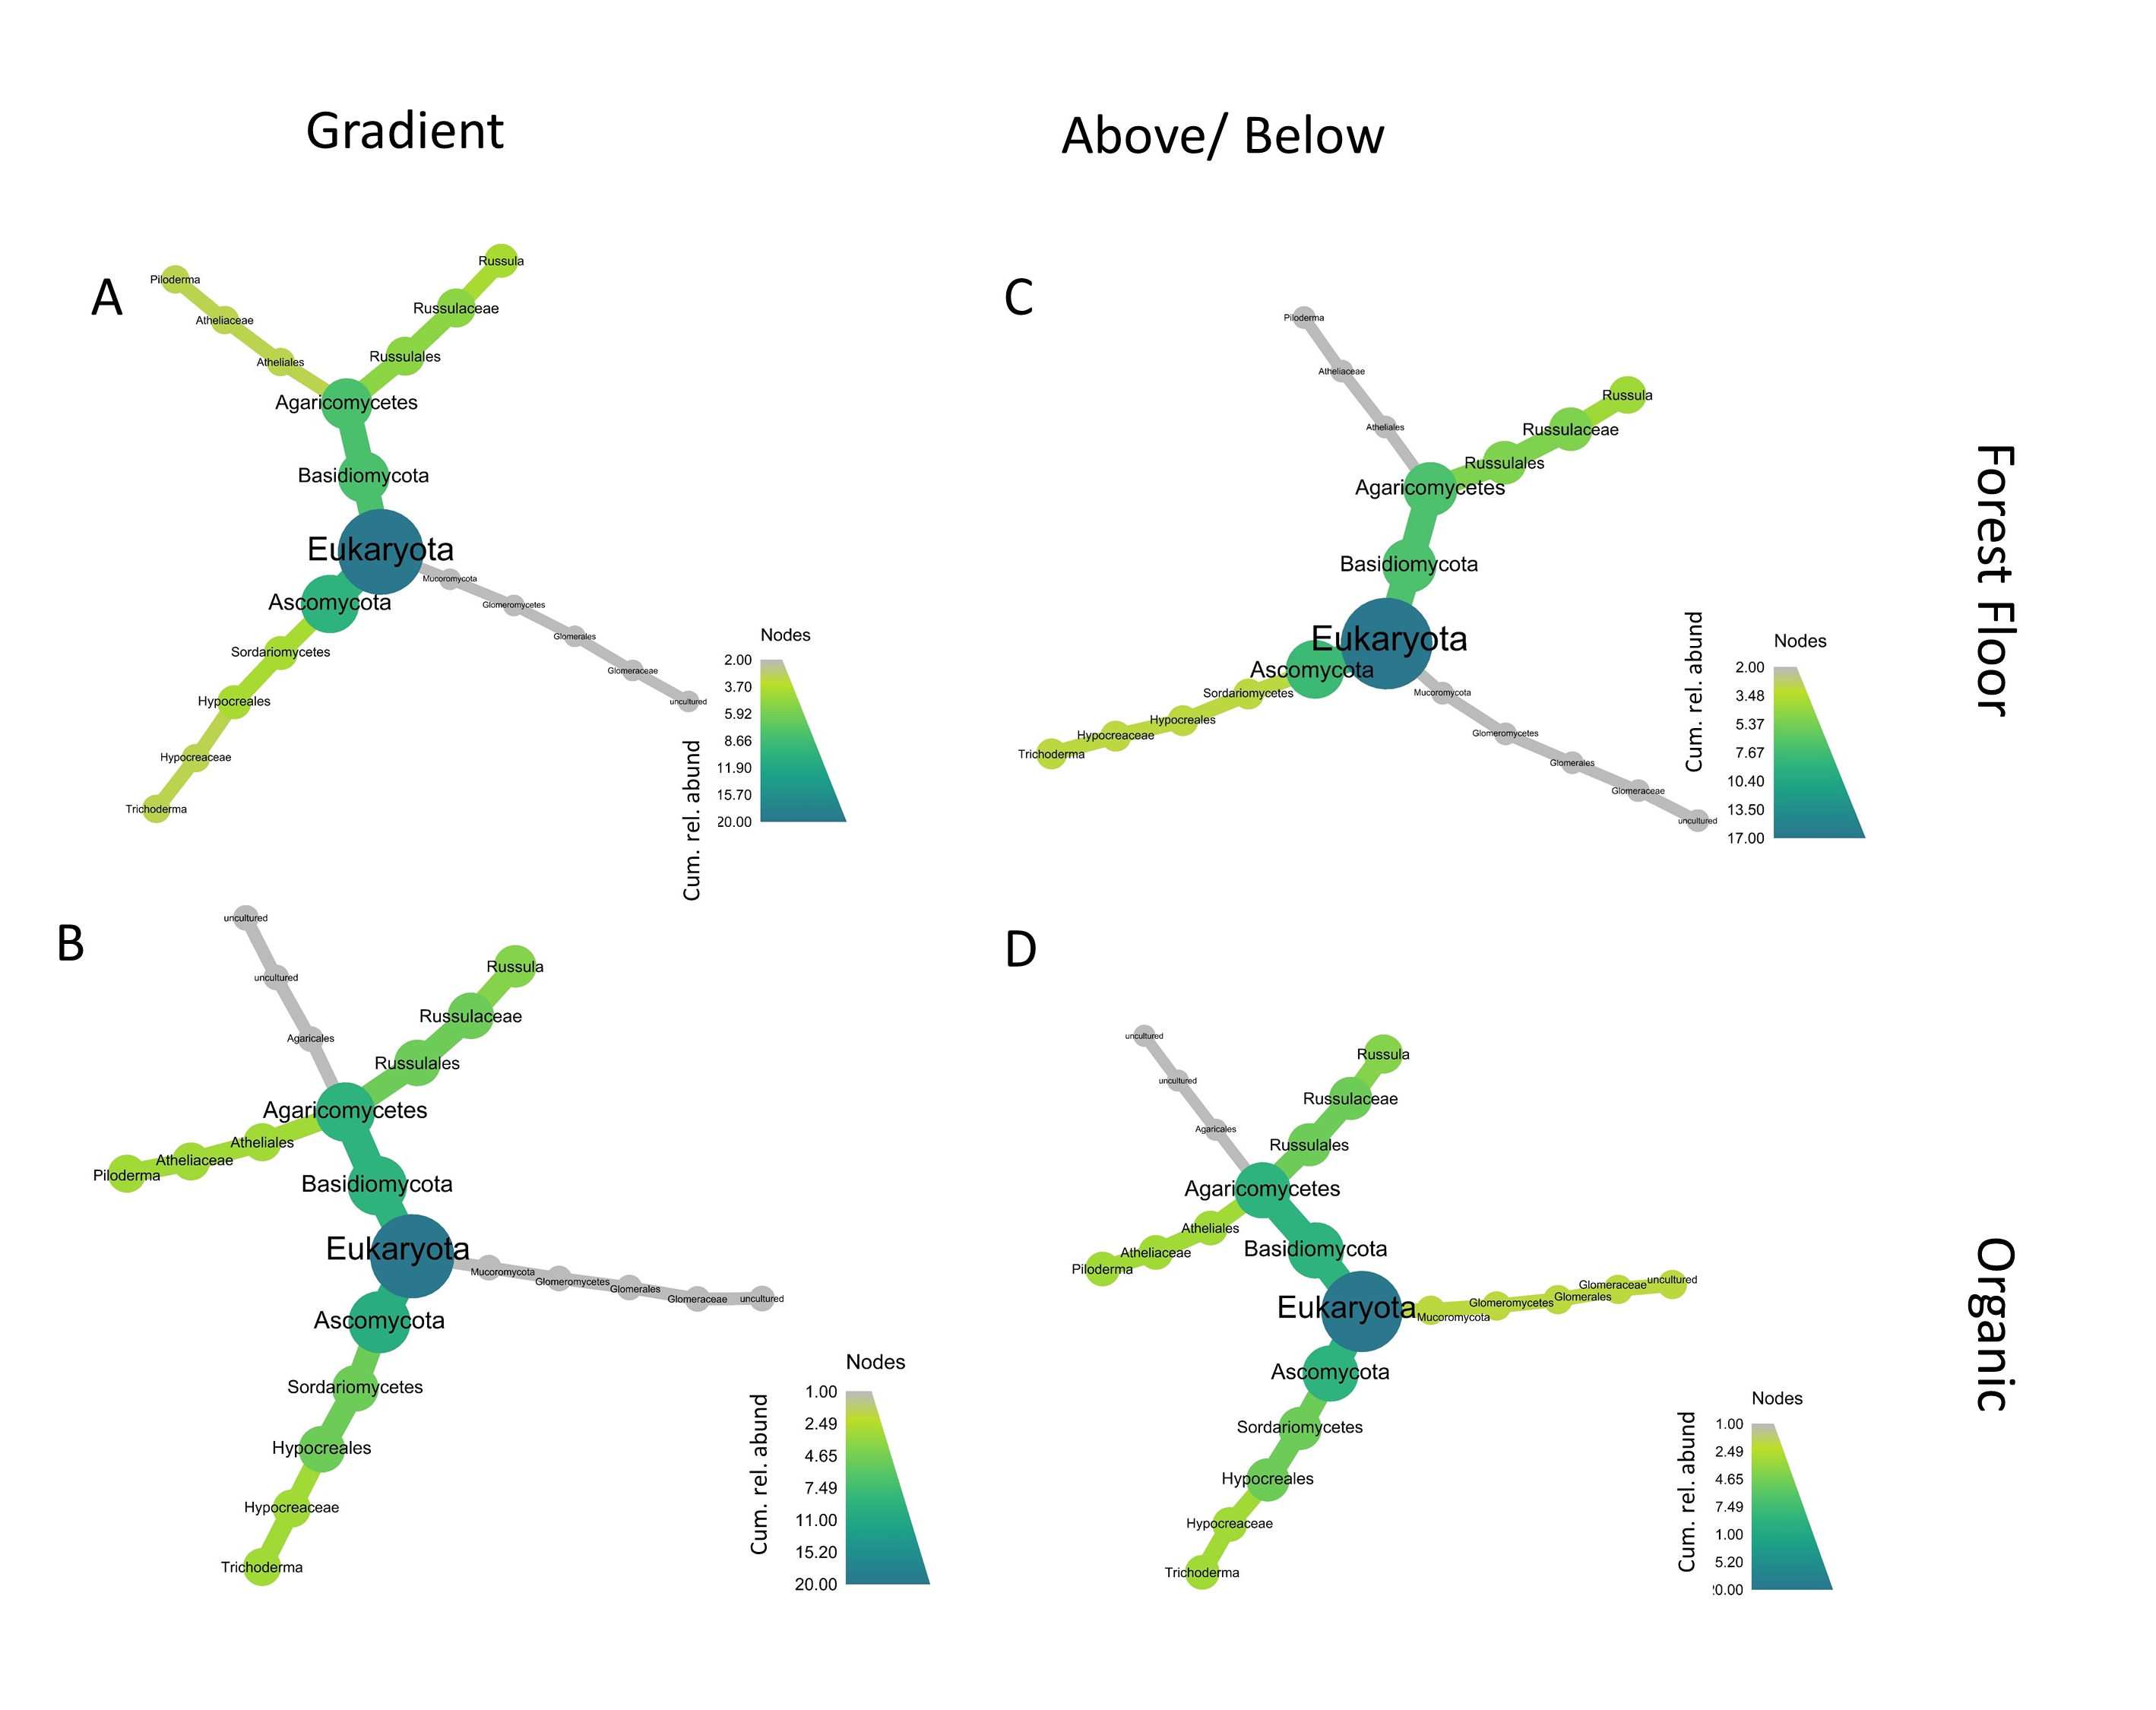
Figure -2: : Heat trees of SSU relative abundance agglomerated to genus for the regional gradient data for forest floor (A) and organic (B) soils
; and using four sites with waterfalls both above and below falls for the forest floor (C) and organic (D) soils. Non-tip taxa are sums of downstream nodes; darker color indicates higher relative abundance in that taxon. Ascomycota and Agaricomycetes dominated these communities. Phylogenies reflect SSU relationships rather than consensus trees.
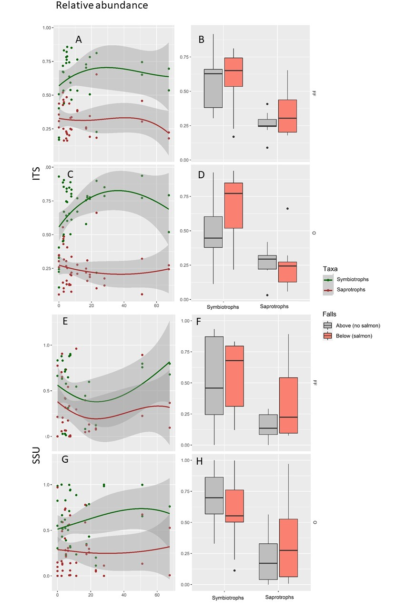
Figure 4-3: Relative read abundance for ITS (A-D) and SSU (E-H) amplicons for forest floor soil (first and third row) and organic soil (second and fourth row)
; scatter plots (A, C, E, G) are representations of the gradient data; Tukey boxplots (B, D, F, H) are representations of the above/below falls dataset. X-axis is salmon density (scatter plots) or above/below waterfalls (above/below data). Green curves are a subset of FunGuild-identified sequences that include the word ‘symbiotroph’ in their trophic mode designation; and brown similarly includes only those of ‘saprotroph’ trophic mode. Lines are loess curves smoothed with a tricubic weighting function over a neighbourhood of 1.2% of the data. Tukey boxplots are drawn from above (gray) and below (salmon color) waterfalls; dark bars are the median; boxes the 25th and 75th percentiles; upper and lower whiskers represent ± 1.5*(IQR), where IQR is the interquartile range; data outside the whiskers displayed as points.
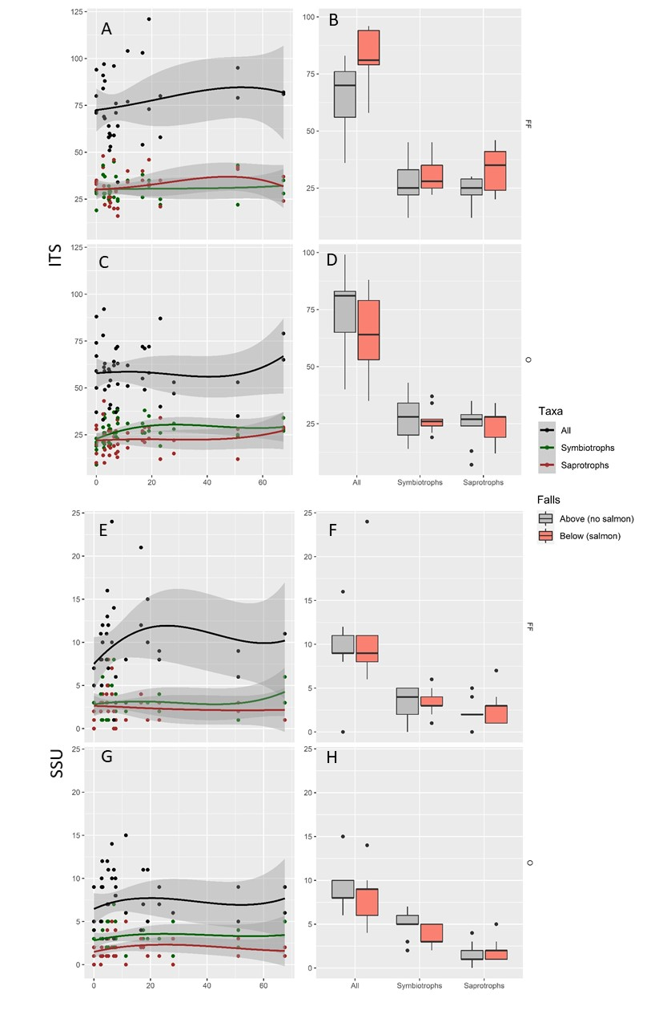
Figure 4-4: Species richness for ITS (A-D) and SSU (E-H) amplicons for forest floor soil (first and third row) and organic soil (second and fourth row)
; scatter plots (A, C, E, G) are representations of the gradient data; Tukey boxplots (B, D, F, H) are representations of the above/below dataset. X-axis is salmon density (scatter plots) or above/below waterfalls (above/below data). Black lines include all taxa, green are a subset of FunGuild-identified sequences that include the word ‘symbiotroph’ in their trophic mode designation; and brown similarly includes only those of ‘saprotroph’ trophic mode. Lines are loess curves smoothed with a tricubic weighting function over a neighbourhood of 1.2% of the data. Tukey boxplots are drawn from above (gray) and below (salmon color) waterfalls; dark bars are the median; boxes the 25th and 75th percentiles; upper and lower whiskers represent ± 1.5*(IQR), where IQR is the interquartile range; data outside the whiskers displayed as points.
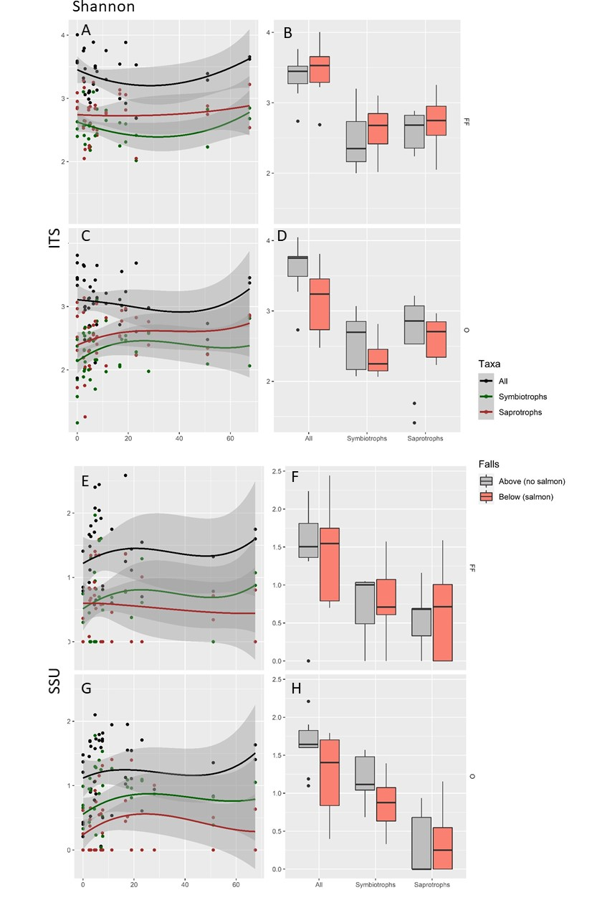
Figure 4-5: Shannon diversity for ITS (A-D) and SSU (E-H) amplicons for forest floor soil (first and third row) and organic soil (second and fourth row)
; scatter plots (A, C, E, G) are representations of the gradient data; Tukey boxplots (B, D, F, H) are representations of the above/below dataset. X-axis is salmon density (scatter plots) or above/below waterfalls (above/below data). Black lines include all taxa, green are a subset of FunGuild-identified sequences that include the word ‘symbiotroph’ in their trophic mode designation; and brown similarly includes only those of ‘saprotroph’ trophic mode. Lines are loess curves smoothed with a tricubic weighting function over a neighbourhood of 1.2% of the data. Tukey boxplots are drawn from above (gray) and below (salmon color) waterfalls; dark bars are the median; boxes the 25th and 75th percentiles; upper and lower whiskers represent ± 1.5*(IQR), where IQR is the interquartile range; data outside the whiskers displayed as points.
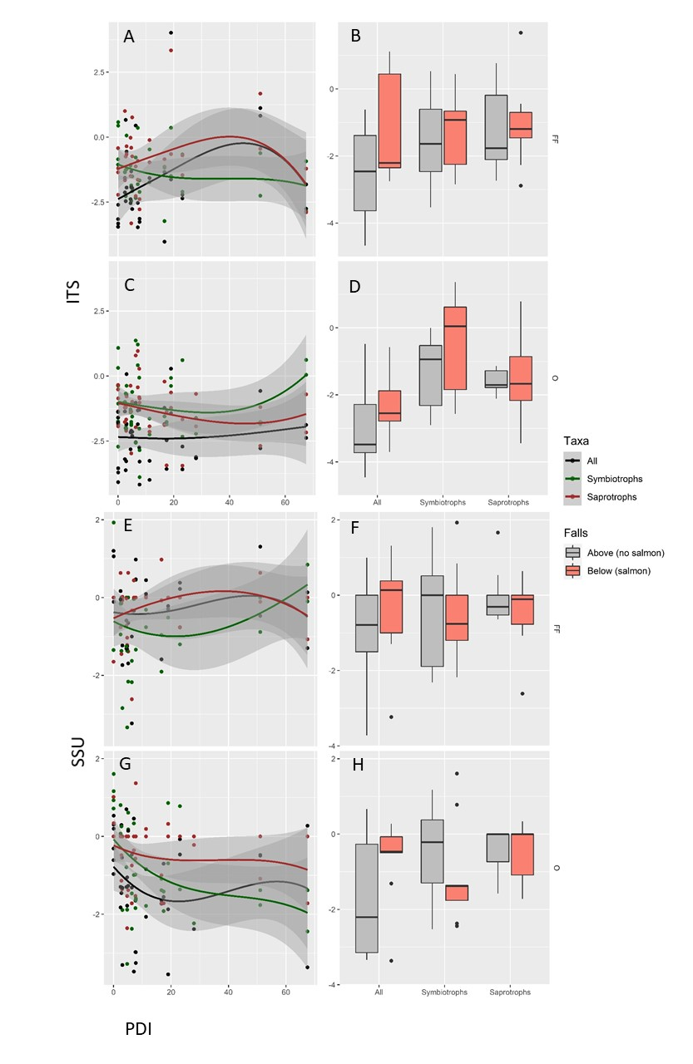
Figure 4-6: Phylogenetic dispersion index (PDI) for ITS (A-D) and SSU (E-H) amplicons for forest floor soil (first and third row) and organic soil (second and fourth row)
; scatter plots (A, C, E, G) are representations of the gradient data; Tukey boxplots (B, D, F, H) are representations of the above/below dataset. X-axis is salmon density (scatter plots) or above/below waterfalls (above/below data). Black lines include all taxa, green are the subset of FunGuild-identified sequences that include the word ‘symbiotroph’ in their trophic mode designation; and brown similarly includes only those of ‘saprotroph’ trophic mode. Lines are loess curves smoothed with a tricubic weighting function over a neighbourhood of 1.2% of the data. Tukey boxplots are drawn from above (gray) and below (salmon color) waterfalls; dark bars are the median; boxes the 25th and 75th percentiles; upper and lower whiskers represent ± 1.5*(IQR), where IQR is the interquartile range; data outside the whiskers displayed as points. Here PD is calculated from ITS and SSU trees respectively. Positive values indicate communities are overdispersed relative to random expectation; negative values indicate underdispersion. The communities seen here were generally underdispersed.

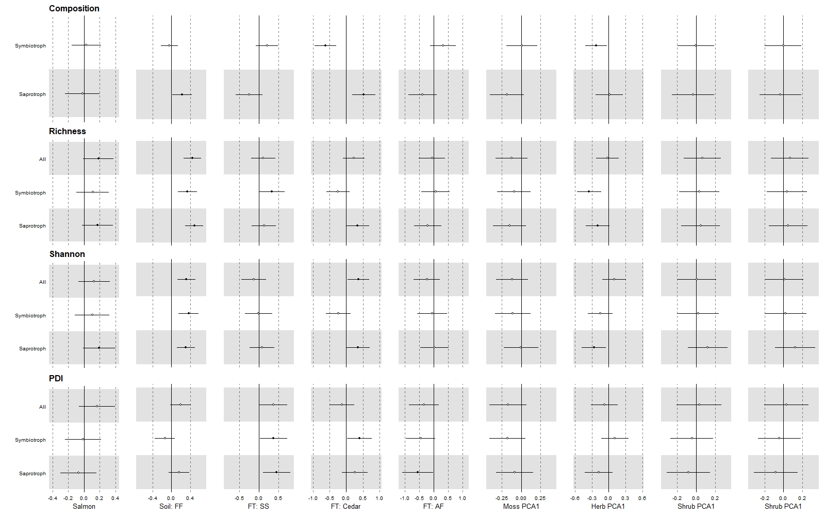
Figure 4-7: Standardized model-averaged coefficients for ITS GLMs for three taxonomic groups
(‘all taxa’, ‘symbiotrophs’ and ‘saprotrophs’) for relative abundance (“Composition”), species richness (“Richness”), Shannon diversity and phylogenetic dispersion (“PDI”) across seven explanatory variables (columns: Salmon density, Soil Type, nearest Focal Tree, moss community PCA1, herb community PCA1, shrub influence index PCA1, and tree influence index PCA1). Soil type consists of two levels, Forest Floor and Organic; here relative difference between O and FF are displayed. Focal Tree consists of 4 levels: Sitka spruce, cedar, western hemlock, and amabilis fir; here all coefficients are taken relative to amabilis fir. Horizontal whiskers are 95% confidence intervals, dark circles indicate a significant result.
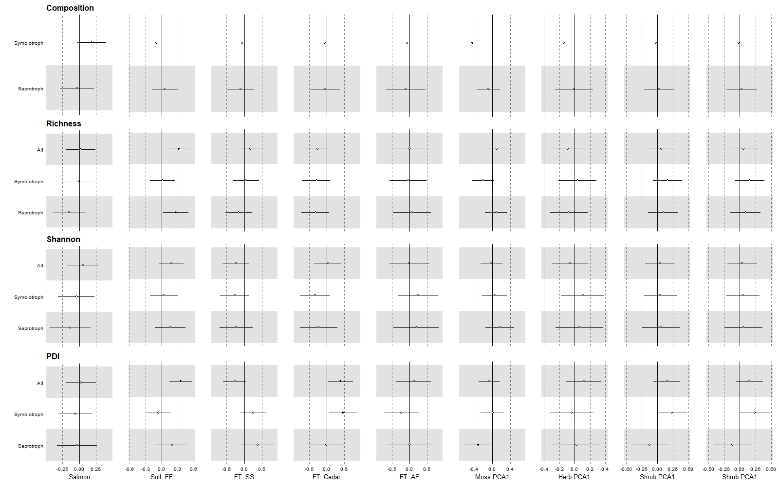
Figure 4-8: Standardized model-averaged coefficients for SSU GLMs for three taxonomic groups
(x-axis: ‘all taxa’, ‘symbiotrophs’ and ‘saprotrophs’) ) for relative abundance (“Composition”), species richness (“Richness”), Shannon diversity and phylogenetic dispersion (“PDI”) across seven explanatory variables (Salmon density, Soil Type, nearest Focal Tree, moss community PCA1, herb community PCA1, shrub influence index PCA1, and tree influence index PCA1). Soil type consists of two levels, Forest Floor and Organic; here relative difference between O and FF are displayed. Focal Tree consists of 4 levels: Sitka spruce, cedar, western hemlock, and amabilis fir; here all coefficients are taken relative to amabilis fir. Horizontal whiskers are 95% confidence intervals, dark circles indicate a significant result.

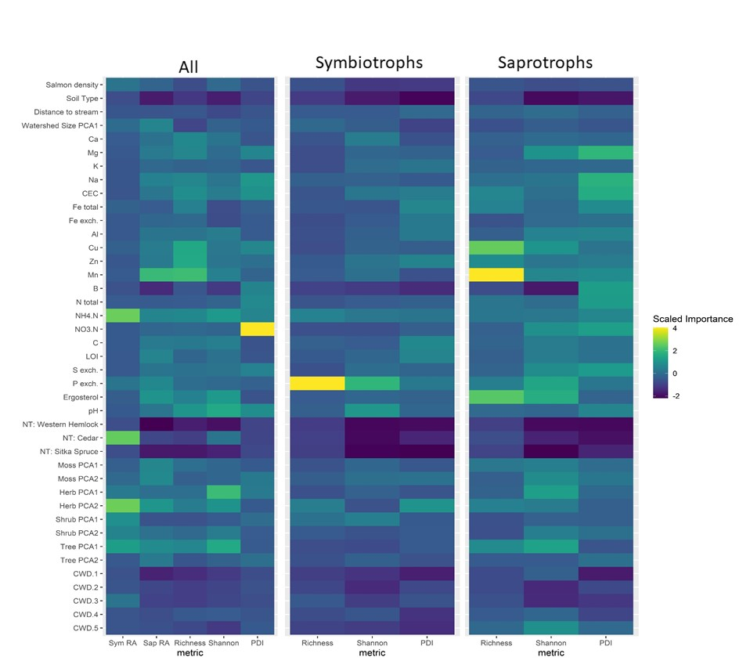-
Figure 4-9: Heatmap of ITS random forest model importance coefficients for community metrics across the regional salmon density gradient.
Included are three community subsets (column facets): ‘all reads’ (complete sequence dataset), ‘symbiotrophs’ (includes only FunGuild-annotated taxa that include the word ‘symbiotroph’ in their trophic mode descriptor), and ‘saprotrophs’ (include only FunGuild-annotated taxa that include the word ‘saprotroph’ in their trophic mode descriptor). X-axis columns are the relative abundance of symbiotrophs and saprotrophs (“Sym RA” and “Sap RA”), species richness (“Richness”), Shannon diversity, and phylogenetic dispersion index (PDI). Explanatory variables (y-axis) include 41 variables encompassing (from top to bottom): physical differences (salmon density to watershed size), chemical variables (Ca to pH), nearest dominant tree (NT: Western Hemlock to NT: Sitka Spruce); the first two axes of vegetation percent cover (moss and herbs) and vegetation influence indices (trees and shrubs); and percent cover of five coarse woody debris classes (CWD 1 – 5). Categorical variables are taken relative to reference levels; forest floors have only two levels (forest floors and organic); nearest tree have 4 levels and are taken relative to amabilis fir.

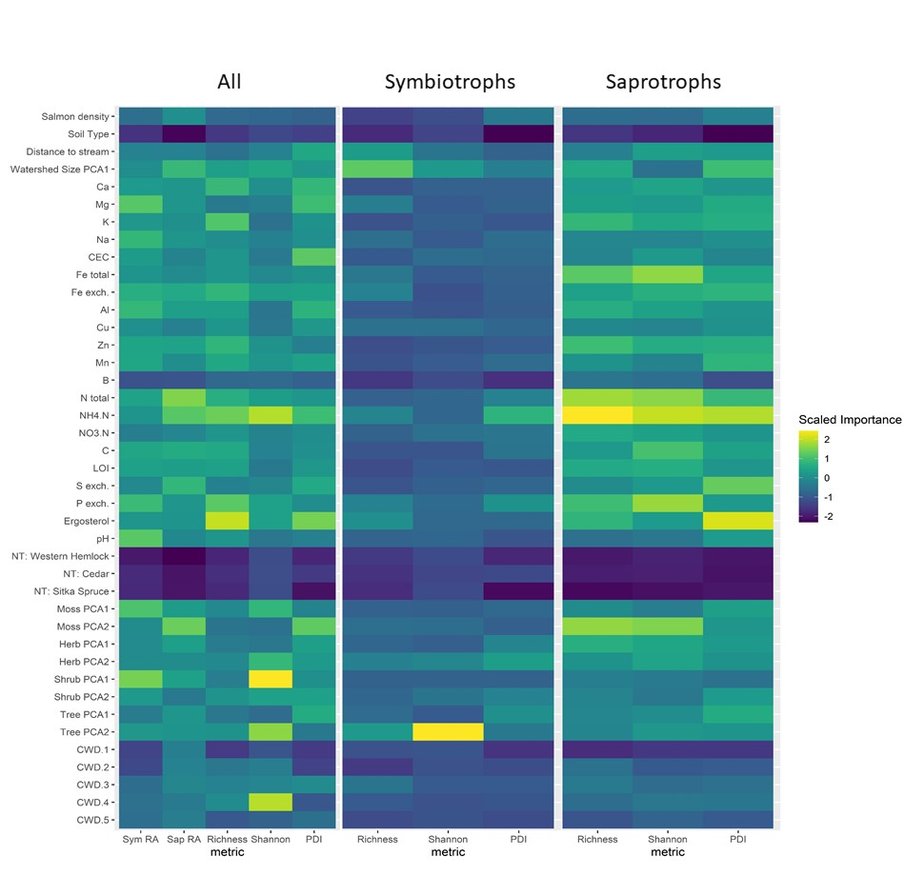
Figure 4-10: SSU random forest model importance coefficients for community metrics over the regional salmon density gradient.
Included are three community subsets (column facets): ‘all reads’ (complete sequence dataset), ‘symbiotrophs’ (includes only FunGuild-annotated taxa that include the word ‘symbiotroph’ in their trophic mode descriptor), and ‘saprotrophs’ (include only FunGuild-annotated taxa that include the word ‘saprotroph’ in their trophic mode descriptor). X-axis columns are the relative abundance of symbiotrophs and saprotrophs (“Sym RA” and “Sap RA”), species richness (“Richness”), Shannon diversity, and phylogenetic dispersion (PDI). Explanatory variables (y-axis) include 41 variables encompassing (from top to bottom): physical differences (salmon density to watershed size), chemical variables (Ca to pH), nearest dominant tree (NT: Western Hemlock to NT: Sitka Spruce); the first two axes of vegetation percent cover (moss and herbs) and vegetation influence indices (trees and shrubs); and percent cover of five coarse woody debris classes (CWD 1 – 5). Categorical variables are taken relative to reference levels; forest floors have only two levels (forest floors and organic); nearest tree have 4 levels and are taken relative to amabilis fir.

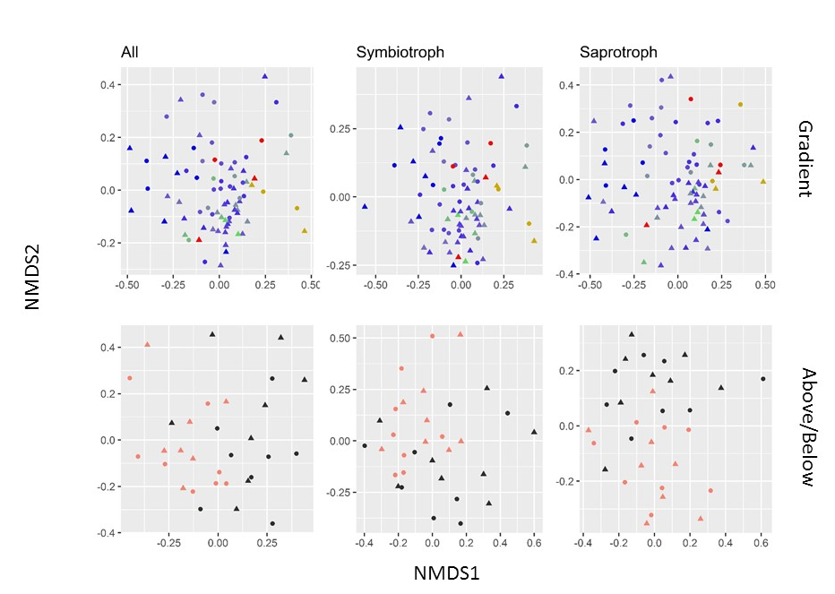
Figure 4-11: ITS beta diversity NMDS plots (2-axis) standardized Bray-Curtis distance over three community subsets (columns): ‘all reads’, ‘symbiotrophs’, and ‘saprotrophs’.
In gradient data (top row) warmer colours are sites with higher salmon density; and above/below data (bottom row) salmon coloured are below falls (with salmon) and black is above falls (no salmon). Circles are forest floor soils, and triangles organic soils. Salmon density was significant factor in all ADONIS tests on the gradient, and waterfall was significant in all above/below tests.
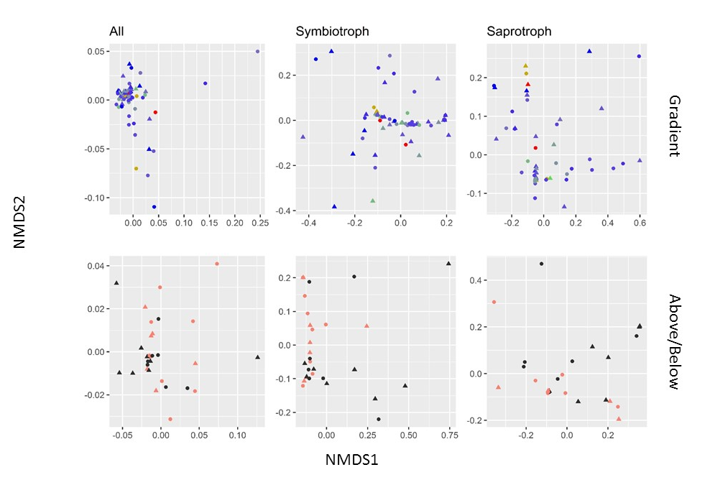
Figure 4-12: SSU beta diversity NMDS plots (2-axis) using weighted unifrac distance over three community subsets (columns): ‘all reads’, ‘symbiotrophs’, and ‘saprotrophs’.
In gradient data (top row) warmer colours are sites with higher salmon density; and above/below data (bottom row) salmon coloured are below falls (with salmon) and black is above falls (no salmon). Circles are forest floor soils, and triangles organic soils. In the gradient ordinations, salmon density was only moderately significant in the saprotroph data (p=0.08). In the above/below data, ‘falls’ was significant in across all subsets.

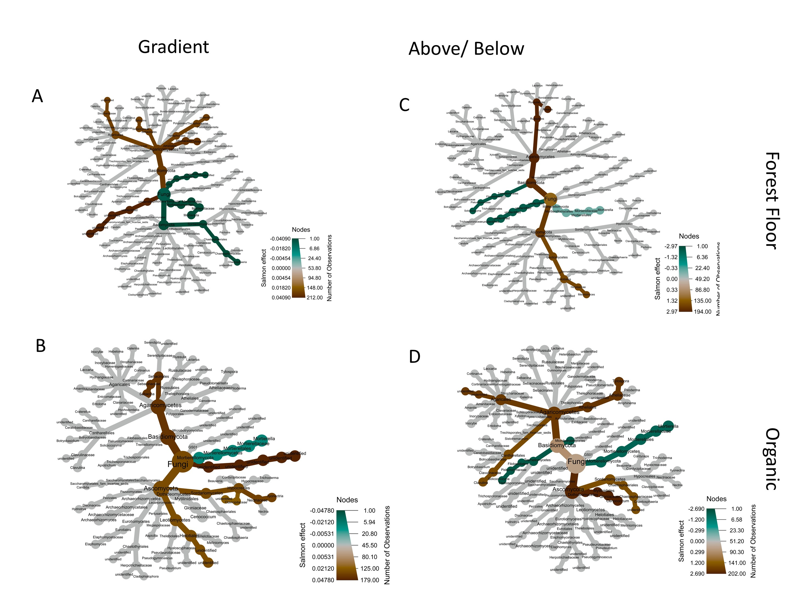
Figure 4-13: ITS differential analysis coefficients.
Coefficients are from differential analysis using the MaAsLin2 package (see methods); green indicates down-regulation and brown up-regulation in response to salmon density (gradient data; left column) or being below falls (above/below data; right column). Forest floors (top row) and organic soil (bottom row) were analyzed separately. Only significant coefficients are shown; the cumulative effects on non-tip taxonomic groups are inferred by taking the average of downstream significant coefficients weighted by relative abundance.

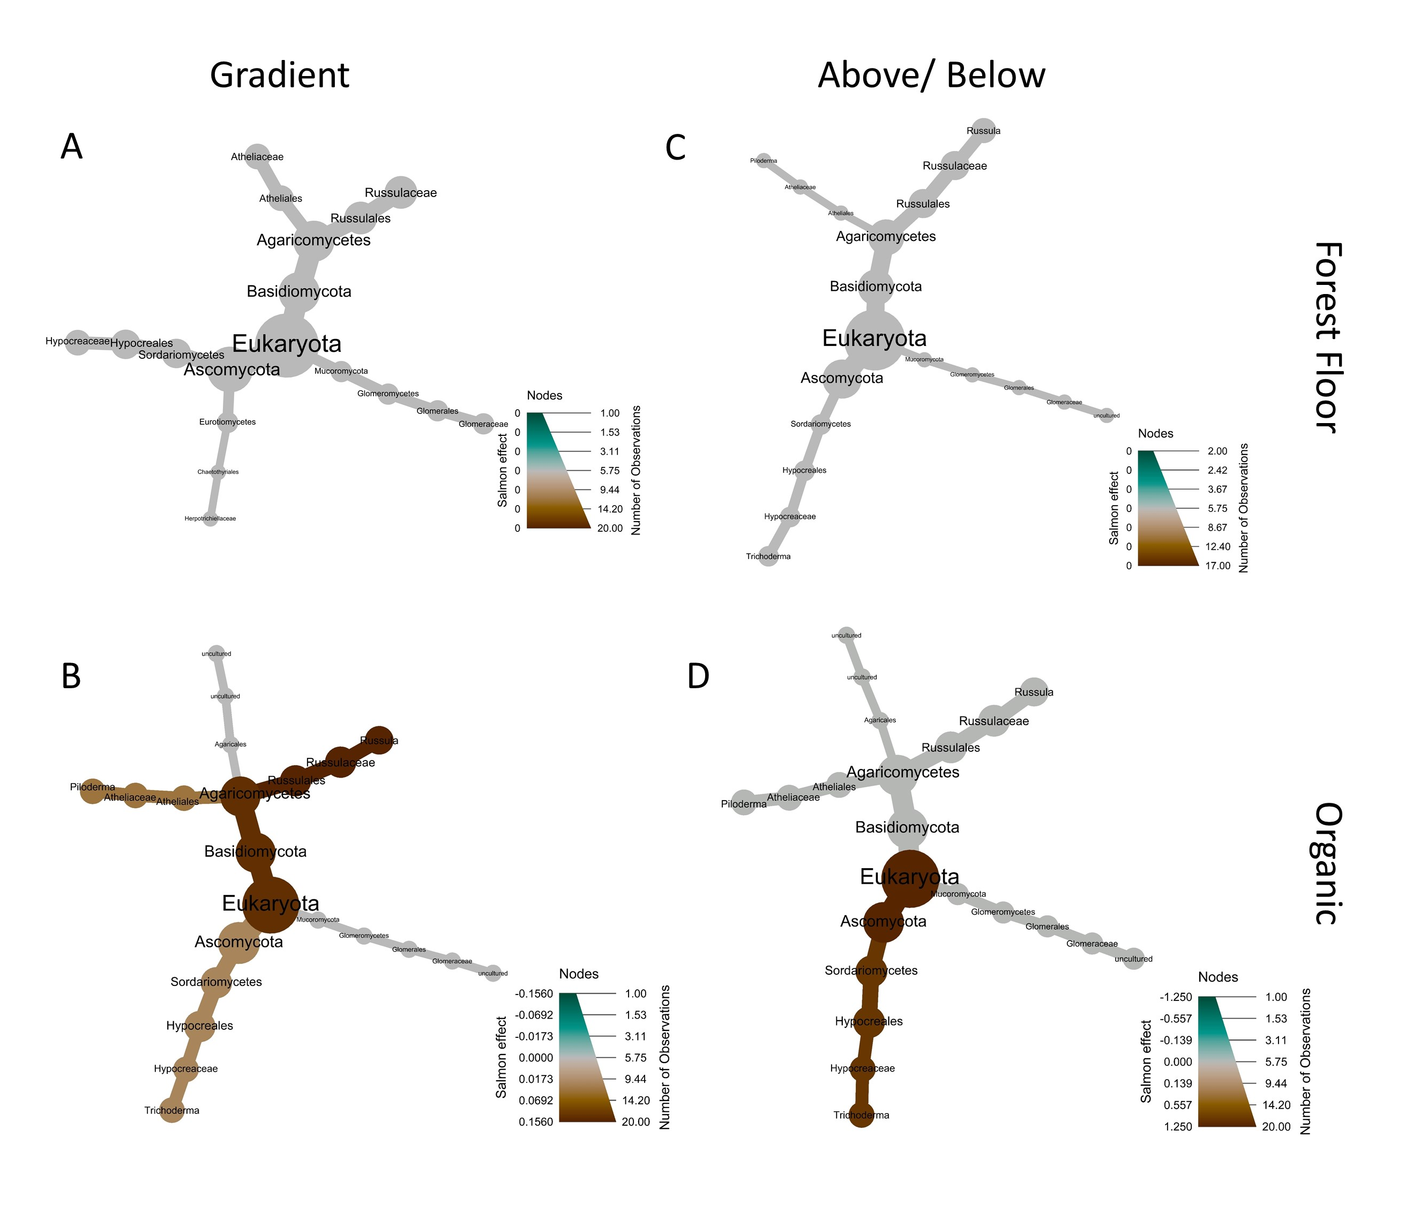
Figure 4-14: SSU differential abundance effect coefficients.
Coefficients are from differential analysis using the MaAsLin2 package (see methods); green indicates down-regulation and brown up-regulation in response to salmon density (gradient data; left column) or being below falls (above/below data; right column). Forest floors (top row) and organic soil (bottom row) were analyzed separately. Only significant coefficients are shown; the cumulative effects on non-tip taxonomic groups are inferred by taking the average of downstream significant coefficients weighted by relative abundance.

Soil bacteria diversity and community composition changes along salmon density gradients

Introduction
Soil microbiomes play a critical role in soil metabolism, health, and chemistry (Santoyo et al., 2017), and can impact plant growth, health, and resistance to biotic and abiotic stressors (Compant et al., 2019). Bacterial communities decompose dead plant and fungal matter, play key roles in macro- and micro-nutrient cycles, and partake in complex rhizosphere interactions (Lladó et al., 2017). Soil microbiome diversity and community composition is associated with ecosystem productivity and resilience (Saleem et al., 2019; Van Der Heijden et al., 2008), and as such characterizing soil microbiome responses to environmental and anthropological gradients is important in managing soil health (Fierer, 2017). Forest soils have received relatively less attention than agricultural soils, and their diversity remains a major challenge in both microbiome characterization and measurement of their responses to environmental gradients (Lladó et al., 2018).
One of the most important environmental gradients for plant health in forests is nitrogen availability (LeBauer & Treseder, 2008), and given widespread forest fertilization campaigns (Reid et al., 2017), anthropological deposition from air pollution (Kanakidou et al., 2016), and repeated clearcutting cycles (Hume et al., 2018), understanding how soils respond to both N accretion and depletion is necessary for responsible management. Soil bacteria are critical in mediating steps in the nitrogen cycle (Lladó et al., 2017) such as nitrification, denitrification, N₂ fixation, and consolidation of N into recalcitrant soil pools. Hence bacterial community diversity and composition is directly relevant to ecosystem-level processes. Evidence is accumulating that characterizes community-level responses to N addition: in acidic tropical soils in China, nitrogen addition decreased microbiome diversity, increased the relative abundance of copiotrophic phyla such as Proteobacteria and Actinobacteria, and decreased the relative abundance of oligotrophic phyla such as Burkholderia and Rhizomicrobium (Nie et al., 2018). In Pacific Northwest soils, fertilization changes bacterial abundance, community composition, and metabolic rates (Levy-Booth et al., 2016). Research indicates differences in microbiome response to N deposition depending on the chemical form of added nitrogen; inorganic nitrogen deposition inhibits soil C processes and reduces decomposition, nutrient cycling, and respiration, while organic nitrogen has the opposite effect (Du et al., 2014). While slower soil metabolism may result in higher C accumulation in the soil, it may also result in macro- and micro-nutrient deficiencies that reduce soil fertility in the long term (Dhaliwal et al., 2019). This is relevant in applied settings: in a pilot study on Vancouver island, fish-based organic amendments (fish silage) achieved higher fertilization responses than inorganic fertilizer amendments (Prescott, 1997). Despite this, relative to inorganic-N inputs, organic-N inputs to soil have received less attention, particularly along natural rather than artificial gradients.
One well-studied natural gradient of organic-N addition are riparian zones around spawning Pacific salmon (Oncorrhynchus spp.). Every autumn, salmon return to the streams of their birth to spawn and die. Their return is attended to by terrestrial and aquatic animals, which consume, transform, and distribute the nutrients contained in salmon flesh throughout the riparian zone. These ‘marine-derived nutrients’ (MDN) include additions of nitrogen, phosphorus, calcium, and other elements to the ecosystem (Chapter 2), and can account for large percentages of the total N budgets of these systems (A. E. Morris et al., 2005b; Reimchen, 2017). These nutrients have been shown to shape riparian plant (Hocking & Reynolds, 2011) and animal (Reimchen, 2017; Wagner & Reynolds, 2019) communities, and while a few studies have investigated effects on soil chemistry and nutrient cycling (Drake, 2005; Feddern et al., 2019; Holtgrieve et al., 2009) none have directly measured effects on the soil microbiome community. Here I leverage the proliferation of next-generation environmental sequencing to characterize these communities for the first time.
This study examined changes in soil bacterial community abundance, diversity, and composition along salmon spawning streams in Heiltsuk traditional territory on the Central Coast of British Columbia, Canada (Appendix A). Two natural gradients of salmon density were used: a regional salmon density gradient along 23 streams varying between 0 and 67 kg of salmon per m of linear reach per year, and above and below salmon-blocking waterfalls at four of these sites. These sites have been previously used for plant (Hocking & Reynolds, 2011; Siemens et al., 2020), vertebrate (Wagner & Reynolds, 2019), and insect (Hocking et al., 2013) studies and represent an ongoing effort to characterize terrestrial effects of salmon migration. From each site, we collected soil cores and used Illumina environmental sequencing on amplified 16S sequences to identify bacterial relative abundance and identity. My purpose was to i. characterize bacterial soil communities in these soils; ii. assess effects of salmon density on bacterial species richness, Shannon’s diversity index, and phylogenetic dispersion; iii. assess effects of salmon density on bacterial community composition; iv. determine chemical and environmental correlates for these responses. I predicted that i. bacterial communities would be similar to other temperate rainforest sites dominated by acidic soils; ii. species richness and Shannon’s diversity index would decrease, and phylogenetic dispersion increase with increasing salmon density; iii. bacterial phyla would be differentially affected by salmon deposition, with positive responses in copiotrophic taxa and negative responses in oligotrophic taxa; and iv. environmental and chemical factors would be reflected in changes in bacterial sequence abundance.

Materials and Methods

Study sites
This study was conducted in Heiltsuk Nation traditional territory in the Central Coast Regional District of British Columbia, Canada, near the town of Bella Bella (Appendix A). The study sites are in the Central variant of the Very Wet Hypermaritime subzone of the Coastal Western Hemlock biogeoclimatic zone (CWHvh2) (MFLNRORD, 2018). Dominated by a cool maritime climate with high rainfall, the landscape is a mosaic of highland bogs where water is stagnant, and forested slopes where water sheds (Lamb & Megill, 2003). The forested riparian zones are a mix of western hemlock (Tsuga heterophylla), western red cedar (Thuja plicata), Amabilis fir (Abies amabilis), and Sitka spruce (Picea sitchensis), with red alder (Alnus rubra) on disturbed sites. The understory includes huckleberry and blueberry species (Vaccinium parvifolium, V. alaskensae, and V. ovalifolium), false azalea (Menziesia furruginea), salal (Gaultheria shallon), salmonberry (Rubus spectabilis), and devil’s club (Oploplanax horridus).
Regional soils are dominated by prevalently alkaline and peralkaline geochemistry (Souther, 1986), and recent glacial dynamics imply that soil formation has occurred only in the last ~14,000 years (Eamer et al., 2017). Ferro-Humic Podzols dominate the region, extending from northern Vancouver Island to Prince Rupert. The Central Coast is characterized by a narrow coastal band of Folisols that encompass the study sites (Carpenter et al., 2014). The soils found at the study sites were primarily Humic and Lignic Folisols (Organic order, Folisol great group), with the occasional Ferro-Humic Podzols (Podzolic order, Ferro-Humic great group) (n=4). See Appendix A for further soil descriptions.
A total of 23 streams were included in the study, representing a gradient of salmon density (0 – 67 kg salmon per meter of stream reach per year). These streams have been well studied previously (Hocking & Reynolds, 2011) and have ongoing long term (12+ years) salmon density measurements. Four of the 23 streams had waterfalls which were included as above/below comparisons. This study was intentionally conducted in July and August to be as distant annually from the salmon run as possible, and in order to emphasize long-term and legacy effects of salmon deposition. See Appendix A for further site descriptions.

Soil sampling
Two soil cores were collected from each stream, with an additional two cores above waterfalls in the five watersheds where they occurred. Samples were taken from microsites of flat, deep soil (>50 cm), within 100 m of the stream mouth, and within 60 m perpendicular to the stream. At each microsite, a small soil pit was dug to 50 cm depth and the distance from the stream mouth and to the closest bank recorded. The litter layer was removed and the top 5 cm of the F and H layers were collected as a single sample (“forest floor”). The underlying 10-15 cm of organic soil was collected as a second sample (“organic”). Forest floors were generally dominated by decomposing moss and conifer needles. Deeper soils were found to match soil maps and were almost exclusively Lignic and Humic Folisols (Drw) (C. A. Fox & Tarnocai, 2011), with homogenous organic composition of down to gravel or bedrock.

Plant Community and Watershed Size
At each core, the largest tree (the “dominant tree”) was identified to species and its size and proximity to the core estimated. Trees and shrubs, and herbs and mosses, were recorded with a two-tiered nested approach.
First, a 5 m radius circular plot was centered on the soil core and every tree with dbh > 1 cm recorded. Tree species identity, circumference, distance and relative bearing from the core were measured. To estimate the effect of each tree on the soil core, a “tree influence index” was calculated as:
$i_{tree}=\frac{circumference}{distance to soil core}$.
Similarly, shrubs with height >1 m were identified to species and their aboveground size estimated by measuring their cubic volume ($h x l x w$). Their distance and bearing to the core was measured, and these figures combined to estimate the effect of each shrub on the soil core as a “shrub influence index”, calculated as:
$i_{shrub}=\frac{shrub volume}{distance to soil core}$.

For each tree and shrub species j, the influence indices of all individuals at each plot were summed, giving an estimate of the aggregate effect of species j on each soil core.
Next, a smaller 1 m² plot was centered on the soil core. Percent cover of each moss and herb species j was visually assessed. This again provides an estimate for each moss and herb species j localized around the soil core in every plot.
Finally, dimensionality of tree influence indices, shrub influence indices, moss percent cover, and herb percent cover were each reduced via principal component analysis (PCA) for use as explanatory variables in later analyses. This resulted in one PCA for each of the four vegetation layers. In each PCA, the variation explained and major loading for the first principle axis was: moss (36% of variation explained; positive direction - lanky moss); herbs (35%; positive – salal, deer fern; negative – false lily of the valley, spiny wood fern); shrubs (34%; positive – salal; negative – false azalea, Vaccinium spp.); trees (39% of variation; negative – cedar) (Appendix C). To account for watershed size as an explanatory variable, PCA was conducted using catchment area, stream magnitude, spawning length, and bankfull width (after Wagner & Reynolds 2019). The first axis accounted for 52% of the variation and was used as an explanatory variable where appropriate in downstream analysis.

Salmon density data
Annual fish data was contributed by the Reynolds lab at Simon Fraser University, Department of Fisheries and Oceans, and the Heiltsuk First Nation (Appendix B). Salmon biomass for year t at site j was calculated by multiplying annual salmon escapement estimates of site j by the average biomass of the corresponding species i at spawning time $({estimated biomass}_{tj}=\sum_{i=1}^{4}{{escapement}_{tji}*{average individual biomass at spawning}_{ i}}$). Four salmon species are found in these study sites: Chum (Oncorhynchus keta), Pink (O. gorbusha), Coho (O. kisutch), and Sockeye (O. nerka); biomass estimates at spawning for Chum and Pink were taken from previous values at these sites (Hocking & Reynolds, 2011), and Coho and Sockeye were taken from the literature (Shaul et al., 2007). Chum and Pink accounted for the vast majority of salmon at the sites (>90% of total biomass). Annual biomass measures for each stream j were estimated with a 3-year moving average. From these biomass estimates, density indices were calculated by dividing estimated biomass by the length of spawning reach of each watershed $(density=\frac{estimated biomass}{length of spawning reach} )$ and is henceforth referred to as “salmon density”. Its units are thus $\frac{(kg of salmon)}{(m of stream reach)(year)}$(see Appendix B for further information).

Molecular analysis
DNA was extracted from 0.5 mg of wet soil gathered from four locations in the bulk soil sample using the Powersoil DNA isolation kit (MoBio Laboratories Inc., Carlsbad, CA, USA). DNA concentration and quality was quantified using a NanoDrop 2000 (Thermo Fisher Scientific Inc, Wilmington, DE, USA) and a Quantus fluorometer (Promega, Madison, WI, USA) using the Qubit dsDNA HS assay kit (Thermo Fisher Scientific Inc, Wilmington, DE, USA). DNA was diluted to 10 ng/µl and PCR amplicons created and quality control conducted by BC Cancer Genome Science Center (Vancouver, BC). The V3V4 portion of the 16S rRNA region was targeted using primers 341F (CCTACGGGNGGCWGCAG) and 805R (GACTACHVGGGTATCTAATCC) (Herlemann et al., 2011; Qiu et al., 2020). Amplified regions were then pooled by template, Direct Seq libraries constructed, and libraries pooled to be sequenced in a single Illumina MiSeq 250 base PET run with v3 chemistry.

Bioinformatics
Microbiome bioinformatics was performed with QIIME2 V.2019.7 (Bolyen et al., 2019). To control for read-through Illumina errors, the ‘sliding window’ function from Trimmomatic V0.39 was used to truncate reads when the average quality score on a 4-base moving average fell below 20 (Bolger et al., 2014). Sequences were demultiplexed and quality filtered with the q2-demux plugin, and then filtered, denoised, and had chimeras removed via DADA2 (Callahan, McMurdie, et al., 2016). Taxonomic assignments were made using a naïve Bayes classifier (Bokulich et al., 2018) trained on the SILVA v.132_99 (Quast et al., 2013) database.

Statistical Analysis
Two datasets were considered in this study: one along a regional gradient of salmon density (‘regional gradient data’) and the other a comparison between sites above and below salmon-blocking waterfalls (‘above/below’ data). Each sample consisted of two soil depths (forest floor, FF, and organic, O). To visualize total amplicon read and taxonomic distribution, heat trees were plotted using the R packages phyloseq (McMurdie & Holmes, 2013), taxa (Z. S. Foster et al., 2018) and metacodeR (Z. S. Foster et al., 2017).
Three community metrics were chosen as response variables to compare bacterial communities: species richness, Shannon’s diversity index, and phylogenetic dispersion. Three approaches were used to examine these relationships: i. simple bivariate comparisons; ii. hypothesis testing via a GLM approach, which allowed for the consideration of a subset of covariates chosen from consideration of past work at these sites; and iii. an exploratory approach using random forest models with a wider set of covariates.
First, to most directly examine the effects of salmon density in the regional data on bacterial communities, response variables were plotted against salmon density and loess curves drawn to visualize trends. Above/below data was visualized with Tukey boxplots and hypothesis testing performed by paired Wilcoxon tests.
Second, hypothesis testing was accomplished using a GLM model-averaging framework. GLMs were constructed with the equation ${Community metric}_{i} \sim salmon density+soil type+ nearest focal tree+moss percent cover PCA1+herb percent cover PCA1+shrub influence index PCA1+tree influence index PCA1$ for every taxonomic group i. Gaussian and Gamma families were considered, and identity, log, and inverse link functions chosen where appropriate on domain and model fit. Collinearity and model assumptions were checked visually using the R packages DHARMa (Hartig, 2020) and performance (Lüdecke et al., 2020). Since I was concerned primarily with the sign and direction of effects, a model averaging approach was used using the MuMIn package in R (Barton, 2020). All models were included in final coefficient estimates, weighted in proportion to their AICc values using conditional averaging (Galipaud et al., 2014). All explanatory variables were standardized prior to regression to account for differences in scale and units, and standardized coefficients and their confidence intervals visualized via forestplots (Scheinin et al., 2021). Finally, interpretation of coefficients was aided through inspection of marginal effects with the aid of the visreg package (Breheny & Burchett, 2017).
Third, to assess the relative importance of environmental and soil factors on community response variables, a suite of physical variables (four variables, including salmon density), chemical variables (21 variables), and vegetation variables (16 variables) (Chapter 2) were included in random forest models constructed in R with the caret and randomForest packages (Kuhn, 2008; Liaw & Wiener, 2002). Standardized importance coefficients of these explanatory variables were then visualized via heatmaps.
Beta diversity was visualized with NDMS plots using standardized Bray-Curtis distance and separate ordinations for each soil depth (Legendre & Legendre, 2012; Lozupone et al., 2011) (Figure 5-7). NMDS was calculated using 20 iterations and collapsed to two dimensions. Significance testing was performed using analysis of variance of distance matrices as implemented in the “adonis2” method in the R package vegan (Oksanen et al., 2013). Effects in the regional gradient data were modelled with the equation $Y\sim Salmon density+Watershed size PCA1+ Nearest Tree Species$, while for above/below data the formula $Y\sim Above or below waterfall+ Nearest Tree Species+Soil Type$ was used. To account for model uncertainty and collinearity between salmon density and watershed size, these analyses were repeated with salmon density or waterfall placed last in the model.
Differential composition analysis was conducted using the MaAsLin2 package (Mallick et al., 2021). ASV tables were filtered by removing all taxa in fewer than 5% of samples and abundance fewer than 10 reads across all samples (Callahan, Sankaran, et al., 2016). Gradient data was modelled as a linear function of salmon density, and above/below data as a function of being above or below the respective waterfall, using centered log-transform (CLT) on ASV reads for each case. Forest floor and organic soils were treated separately, resulting in four final models. Since MaAsLin2 assigns coefficients on the ASV level, coefficients for non-tip taxa as well as taxa that were represented by multiple ASVs were constructed by taking the average of the coefficients of contributing ASVs weighted by the relative abundance among significant taxa. Finally, coefficients were again visualized in their phylogenetic context via heat trees using the metacodeR package (Z. S. Foster et al., 2017).

Results

Sequencing and community composition
A total of 1,298,822 double-stranded Illumina reads were obtained after demultiplexing; after dada2 filtering this resulted in 149,697 reads representing 1750 ASVs. Of these 275 were singletons. A total of 1544 (88%) of these ASVs were identified at the kingdom level; 1455 (83%) at the phylum level; 1477 (83%) at the class level; 1396 (80%) at the order level; 1281 (73%) at the family level, 1058 (60%) at the genus level, and 599 (34%) to the species level. At the kingdom level, Bacteria represented 89% of taxa, Archaea 10%, and Eukaryotes 1%. The top phyla represented by relative abundance were Acidobacteria (42.9%), Proteobacteria (19.0%), Bacteroidetes (8.4%), Verrucomicrobia (7.0%), Planctomycetes (5.4%), Euryarchaeota (4.9%), Thaumarchaeota (4.0%), and Actinobacteria (4.0%) (Figure 4-1). On the ASV level, most identified taxa were rare: for example, filtering ASVs by removing all reads with less than 5% prevalence and less than 10 total reads removed 94% of sequences. Phylogenetic distribution of identified amplicon abundance is visualized in Figure 4-1.

Community metrics

Species Richness
Bivariate plots showed no response in species richness to salmon density, either in the regional gradient data or above/below falls (Figure 5-2). The GLM results showed a positive trend with salmon on species richness, and significant effects from nearest tree species (Figure 5-5). Soil type and moss, herb, and tree community also had large but non-significant effects.
The exploratory analysis attributed high importance to copper, potassium, and moss PCA1. Tree PCA2, which contains a high weighting of snags and stumps, and Class-4 coarse woody debris, were also important (Figure 5-6).

Shannon diversity
Similar to richness, Shannon diversity showed no response in bivariate plots of either the gradient or above/below data (Figure 4-5). No response to salmon was also borne out in the GLM analysis, although also similar to species richness soil type, nearest tree species, and moss and tree PCAs were important.
Random forest models attributed high importance to total N, phosphorus, and moss PCA1 in determining Shannon diversity, with potassium and CEC also being important (Figure 5-6).

Phylogenetic Dispersion
Bacterial communities were underdispersed relative to random assortment (negative values of PDI, Figure 4-6). Salmon again had no effect, with bivariate plots showing no relationship with PDI in either the gradient or above/below data (Figure 4-6). GLM modelling results showed no effect from salmon, with the only significant effect being from the moss community with nearest tree species and herb PCA1 also being important (Figure 5-5).
Similar to species richness, phylogenetic dispersion was strongly related to tree PCA2 and moss PCA1 (Figure 5-6). Also of high importance was the distance to the stream, potassium, and ergosterol concentrations.

Beta diversity
I found that salmon addition had some role in structuring forest floor communities between sites, but not organic soil communities. Salmon was significant in forest floor ADONIS tests, but only when placed after both watershed size and closest dominant tree in the model, indicating that there was some interaction between tree species and salmon addition. The same pattern was found in above/below forest floors, where waterfalls were significant but only when placed after closest dominant tree species. Organic soils showed no significance of salmon addition, but tree species did drive bacterial communities. Stress for all NDMS plots was low (maximum = 0.25).

Compositional changes along salmon gradient
MaAsLin2 models showed minimal significant taxonomic responses to salmon inputs (visualized in Figure 5-8). No responses were seen in forest floors, but in organic soil an uncultured Proteobacterium in the RCP2-54 clade increased along the salmon gradient. Below falls sites had higher levels of Acidothermus, a decrease in Acidibacter, and an increase in one Acidobacteriia Subgroup 2 clade and a decrease in another.

Discussion

Bacteria communities of the Central Coast
The first goal of this study was to characterize and quantify the bacterial microbiomes at these sites. At the phylum level, communities were dominated by Acidobacteria and Proteobacteria, two phyla that are categorized as common in ‘low-pH’ clusters internationally in the International Soil Microbiome Atlas (Delgado-Baquerizo et al., 2018). This is reflective of the low pH and high organic matter content of the soils at these sites (Chapter 2) and generally in the Pacific Northwest (Buotte et al., 2020; Oliver et al., 2017). Relative to these typical ‘low-pH’ clusters however I found some key differences: we found relatively low abundances of Actinobacteria and Chloroflexi, and higher abundances of Bacteroidetes and Verrucomicrobia.
The ratio of common to rare ASVs found here (~2%) is identical to estimates on a global scale (Delgado-Baquerizo et al., 2018). The prevalence of ASVs with highly localized distribution (one or two sites) highlights the high diversity and high localization of microbial diversity in temperate rainforests (Lladó et al., 2018). The soils here have the highest carbon and organic matter contents on the planet (Chapter 2; Oliver et al., 2017), which is a major driver of microbial diversity in global datasets (Lladó et al., 2018). Indeed, the coastal Pacific Northwest remains a global hotspot of unknown and uncharacterized bacterial communities (Delgado-Baquerizo, 2019).

Responses of bacterial communities to MDN inputs
The first part of my second hypothesis was that species richness and Shannon diversity would decrease with salmon addition. Contrary to expectations, I found no effect of salmon on either richness or Shannon diversity. However, I found high importance attributed to moss PCA1 and tree PCA2, indicating that both abundance and diversity are driven by the availability of late-stage decaying wood and local edaphic conditions. Diversity was also associated with total-N, phosphorus, and potassium. Nitrogen is also a major driver of soil bacterial communities (Fierer, 2017), and higher nitrogen availability increases bacteria : fungi biomass ratios (X. Wang et al., 2019). Phosphorus availability has been found to increase soil microbial biomass (Shi et al., 2013), although it likely interacts with mycorrhizal activity (L. Zhang et al., 2018). Potassium is one of the most important plant nutrients and root-associated bacteria play important roles solubilizing potassium and rendering it accessible to plant hosts (Teotia et al., 2017).
The second part of my third hypothesis was that bacterial communities would become more phylogenetically dispersed with salmon addition. Here I also fail to reject the null hypothesis of no change, as salmon had no effect in either regional or above/below data. This is in contrast to both plant communities (Hurteau et al., 2016) at these sites and belowground fungal communities in the same samples (Chapter 4). The variables of highest importance were distance to the stream, tree PCA2 and moss PCA1, indicating that this metric was largely driven by water availability and the plant community. Ergosterol was also relatively important, indicating that fungal abundance interacts with the phylogenetic dispersion of bacterial communities, perhaps due to increased competition and/or facilitation from fungi.
My fourth hypothesis was that beta diversity would be driven by salmon density. I found that salmon were significant in structuring forest floor bacterial communities but not organic soils; and forest floors were significant only after considering tree species. This is consistent with the primary driver of bacterial communities being a combination of litter fall and root exudates (Prescott & Grayston, 2013), and only after these are taken into account does salmon emerge as an important variable. The tree species effect remained important for organic soils, but I found no effect from salmon. Given that labile resources from salmon decay that are amenable to bacterial uptake are likely taken up quickly, it is sensible that communities in forest floors are affected more than deeper soils.
My fifth hypothesis was that bacterial phyla would be differentially affected by salmon. This was not supported in forest floors, but some taxa were differentially affected by salmon inputs in organic soils. Taxa increasing in response to salmon were an uncultured RCP2-54, Acidthermus, and an uncultured Subgroup 2 Acidbacteriia. RCP2-54 and Acidbacteriia Subgroup 2 have previously been associated with phosphorus additions, particularly in acidic soils (Mason et al., 2021). Acidthermus, meanwhile, has been associated with the breakdown of nitrogen-rich substances in a recent lignocellulose-based composting study (Zhu et al., 2021). Taken together, it is sensible that these taxa respond to nitrogen- and phosphorus-rich salmon inputs. On the other hand, Acidibacter and an uncultured Acidobacteriia was found to decrease with salmon inputs. Acidibacter have been found to decrease with increasing pH in arctic soil (Kim et al., 2014), and has also been found to be associated with zinc and soil organic matter (Guo et al., 2017).

Conclusion
This study characterized bacterial communities in these soils for the first time. I found no or only minor effects of MDN on bacterial species richness, Shannon diversity, and phylogenetic dispersion. Between sites, tree species of the closest dominant tree was consistently the most important factor in structuring communities, and MDN affected taxa in organic soil but not forest floors. The taxa associated with MDN inputs were often associated with nitrogen or phosphorus metabolism.
Given the timing of this study in late summer (August), as distant in the annual round as possible from the salmon run of the previous year, this study may be taken as evidence for long-term legacy effects of MDN subsidy on bacterial communities. This may account for the paucity of responses among bacterial communities, and I would expect sampling immediately after the salmon run would show strong responses by the bacterial community. Next steps would be to repeat this sampling during or immediately after the salmon run, when rapidly-responding bacterial populations (Kuzyakov & Blagodatskaya, 2015) would be more immediately affected by MDN presence and the successional stages of community response to salmon decay better characterized.

Tables and Figures
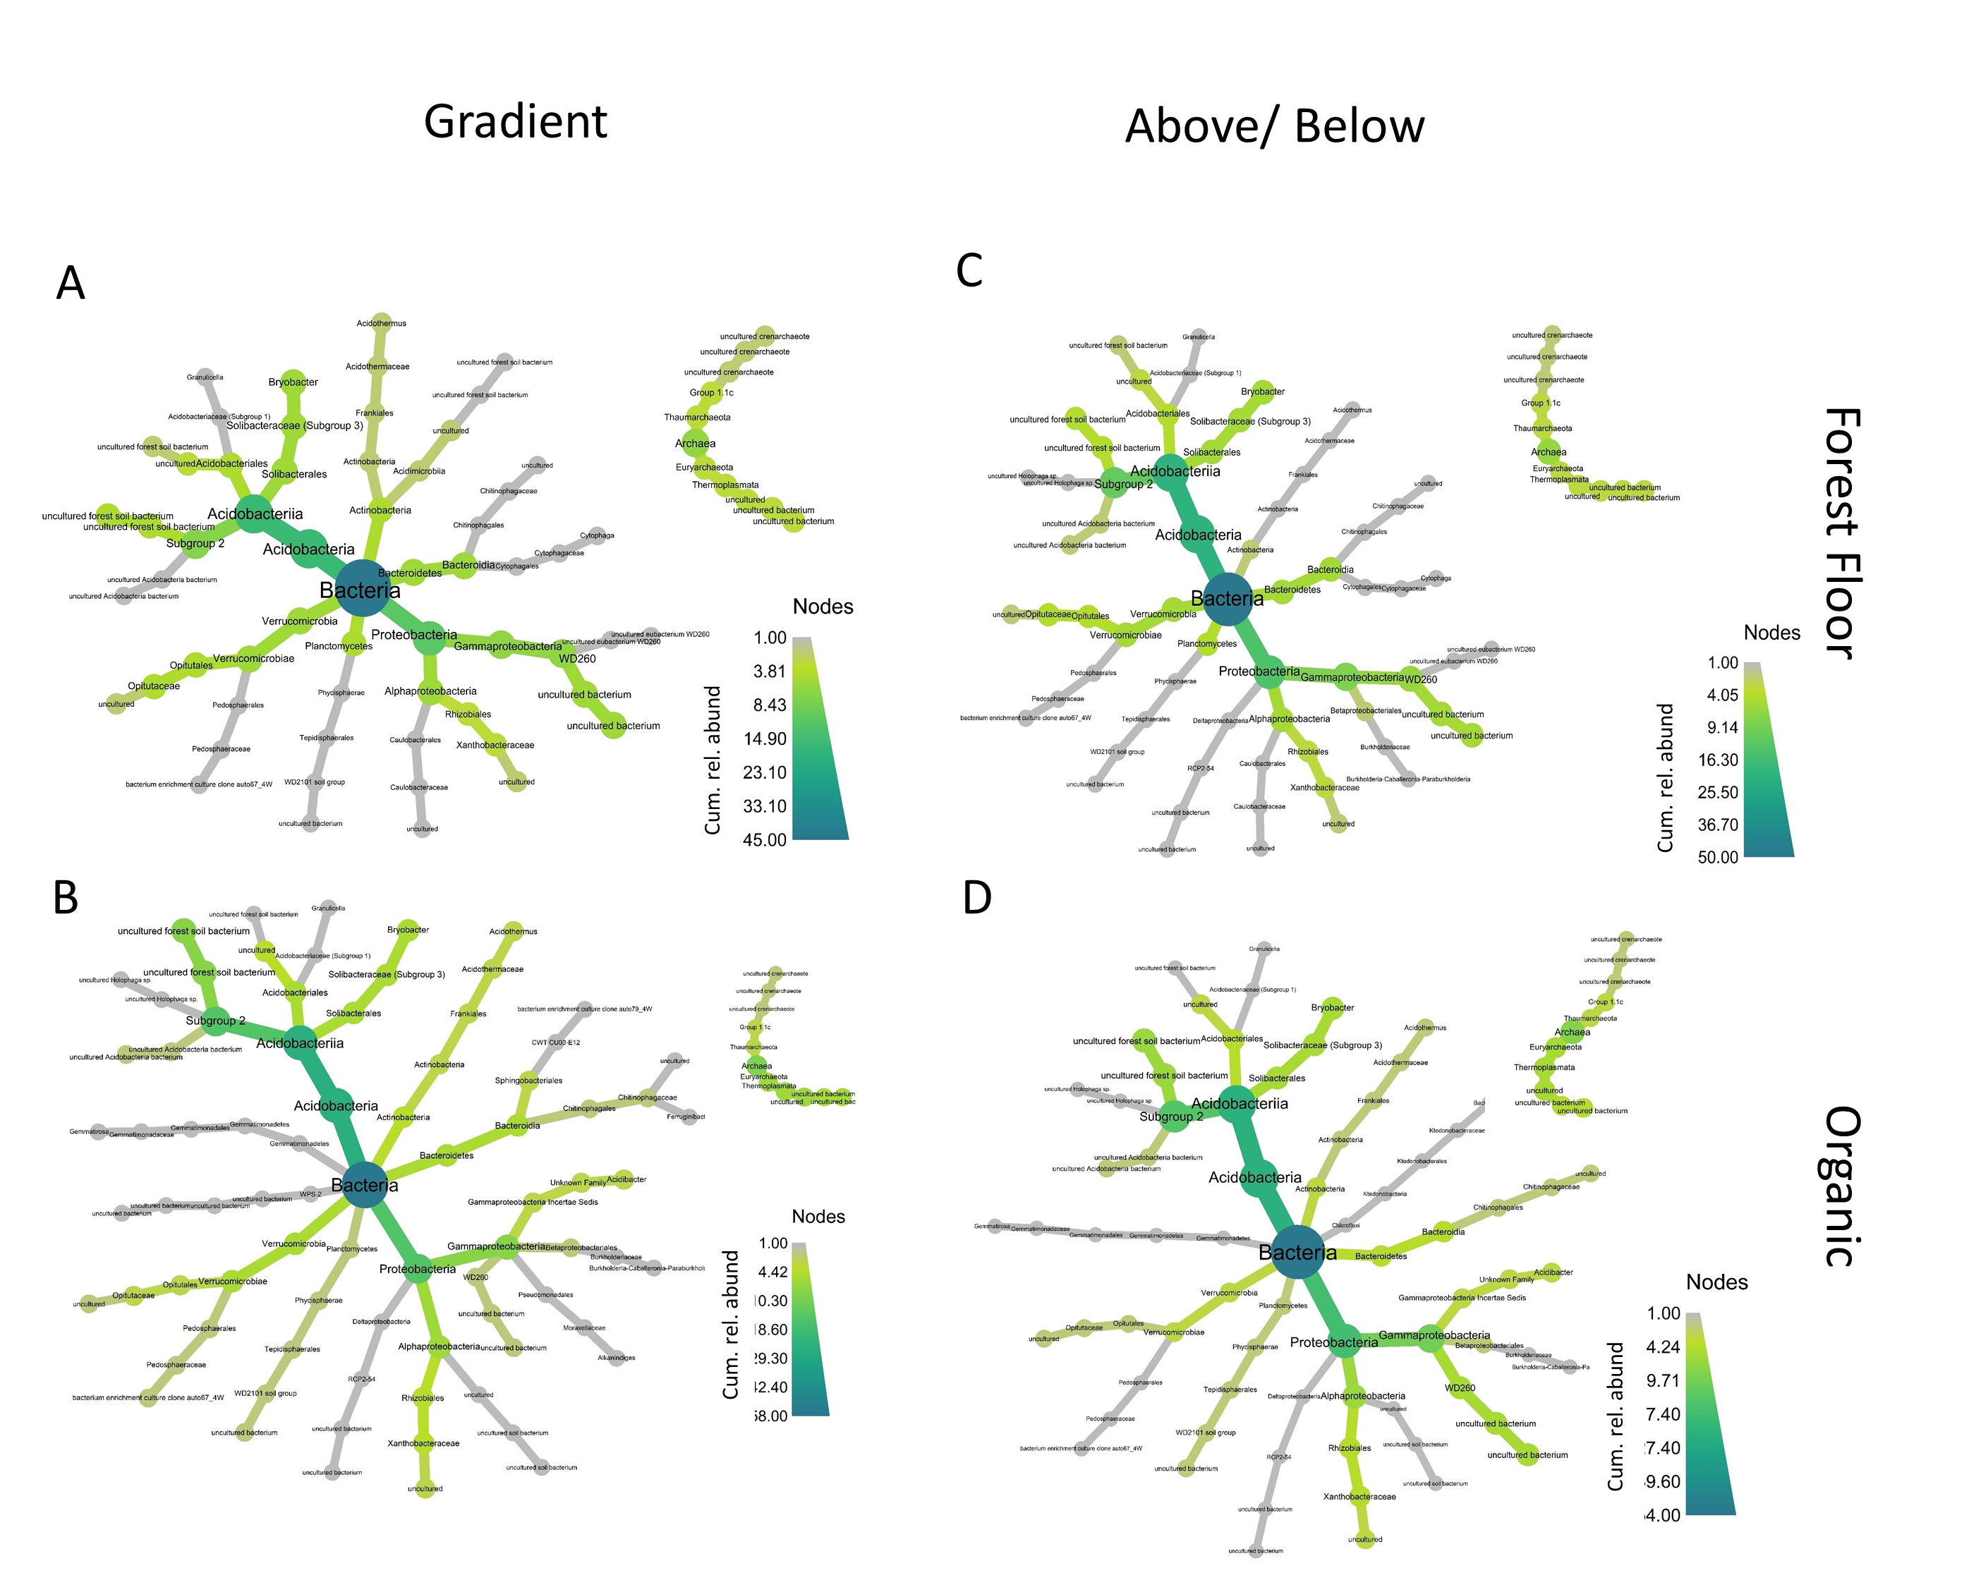
Figure 5-1: Heat trees of 16S relative abundance agglomerated to genus along gradient forest floor (A) and organic (B) soils; and above/below forest floor (C) and organic (D) datasets.
Non-tip taxa are sums of downstream nodes; darker color indicates higher relative abundance of that taxon. Acidobacteria and Proteobacteria dominated these communities.

Figure 5-2: Community species richness for forest floor soil (top row) and organic soil (bottom row)
; scatter plots (left column) are representations of the gradient data and Tukey boxplots (right column) visualizations of the above/below data. X-axis is salmon density (scatter plots) or above/below waterfalls (above/below data). Lines are loess curves smoothed with a tricubic weighting function over a neighbourhood of 1.2% of the data. Boxplots are drawn from above (gray) and below (salmon color) data; dark bars are the median; boxes the 25th and 75th percentiles; upper and lower whiskers represent ± 1.5*(IQR), where IQR is the interquartile range; data outside the whiskers displayed as points.

Figure 5-3: Community Shannon diversity for forest floor soil (top row) and organic soil (bottom row)
; scatter plots (left column) are representations of the gradient data and Tukey boxplots (right column) visualizations of the above/below data. X-axis is salmon density (scatter plots) or above/below waterfalls (above/below data). Lines are loess curves smoothed with a tricubic weighting function over a neighbourhood of 1.2% of the data. Boxplots are drawn from above (gray) and below (salmon color) data; dark bars are the median; boxes the 25th and 75th percentiles; upper and lower whiskers represent ± 1.5*(IQR), where IQR is the interquartile range; data outside the whiskers displayed as points.
Figure 5-4: Community phylogenetic dispersion index (PDI) for forest floor soil (top row) and organic soil (bottom row)
; scatter plots (left column) are representations of the gradient data and Tukey boxplots (right column) visualizations of the above/below data. X-axis is salmon density (scatter plots) or above/below waterfalls (above/below data). Lines are loess curves smoothed with a tricubic weighting function over a neighbourhood of 1.2% of the data. Boxplots are drawn from above (gray) and below (salmon color) data; dark bars are the median; boxes the 25th and 75th percentiles; upper and lower whiskers represent ± 1.5*(IQR), where IQR is the interquartile range; data outside the whiskers displayed as points. Phylogenetic dispersion was measured using generated 16S trees. Positive values indicate communities are overdispersed relative to random expectation; negative values indicate underdispersion.

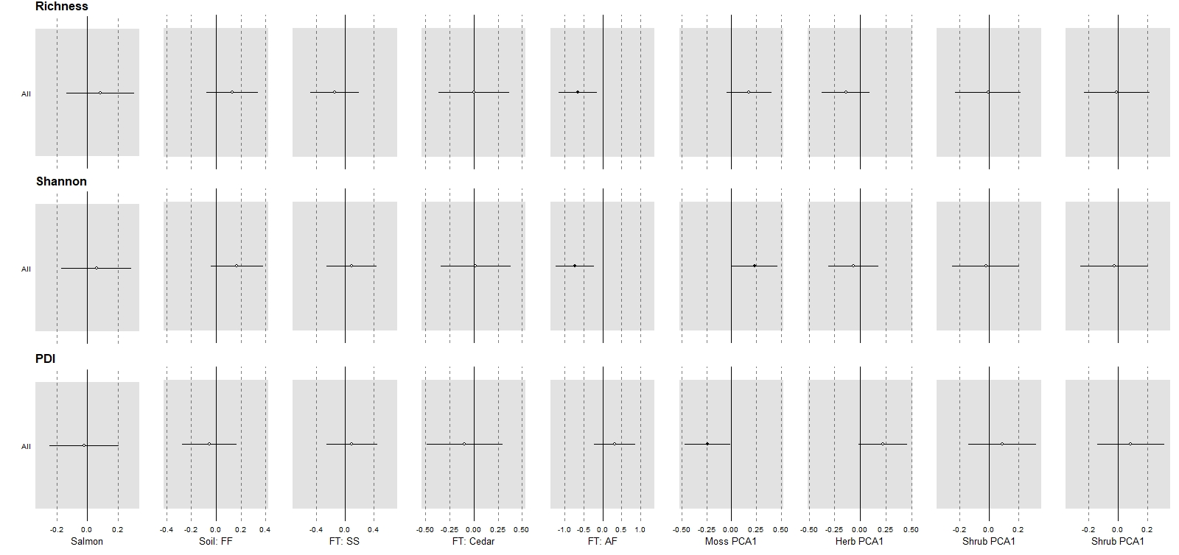
Figure 5-5: Standardized GLM model-averaged coefficients for four community measures
(rows: species richness, Shannon diversity, and phylogenetic dispersion index) across seven explanatory variables (columns: Salmon density, Soil Type, nearest Focal Tree, moss community PCA1, herb community PCA1, shrub influence index PCA1, and tree influence index PCA1). Soil type consists of two levels, Forest Floor and Organic; here relative difference between O and FF are displayed. Focal Tree consists of four levels: Sitka spruce, cedar, western hemlock, and Amabilis fir; here all coefficients are taken relative to Amabilis fir. Horizontal whiskers are 95% confidence intervals, dark circles indicate a significant result.

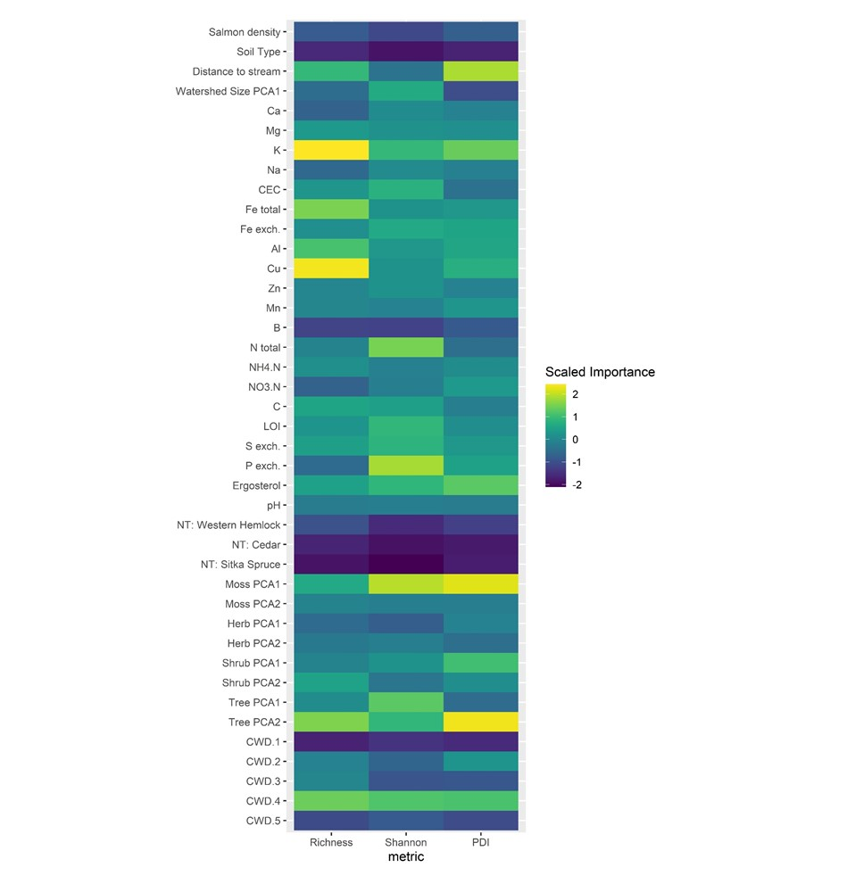
Figure 5-6: Heatmap of 16S random forest model importance coefficients for community metrics
on all reads of the ‘gradient data’. X-axis columns are species richness, Shannon diversity, and phylogenetic dispersion (PD). Explanatory variables (y-axis) include 41 variables encompassing (from top to bottom): physical differences (salmon density to watershed size), chemical variables (Ca to pH), nearest dominant tree (NT: Western Hemlock to NT: Sitka Spruce); the first two axes of vegetation percent cover (moss and herbs) and vegetation influence indices (trees and shrubs); and percent cover of five coarse woody debris classes (CWD 1 – 5). Categorical variables are taken relative to reference levels; forest floors have only two levels (forest floors and organic); nearest tree have 4 levels and are taken relative to Amabilis fir.

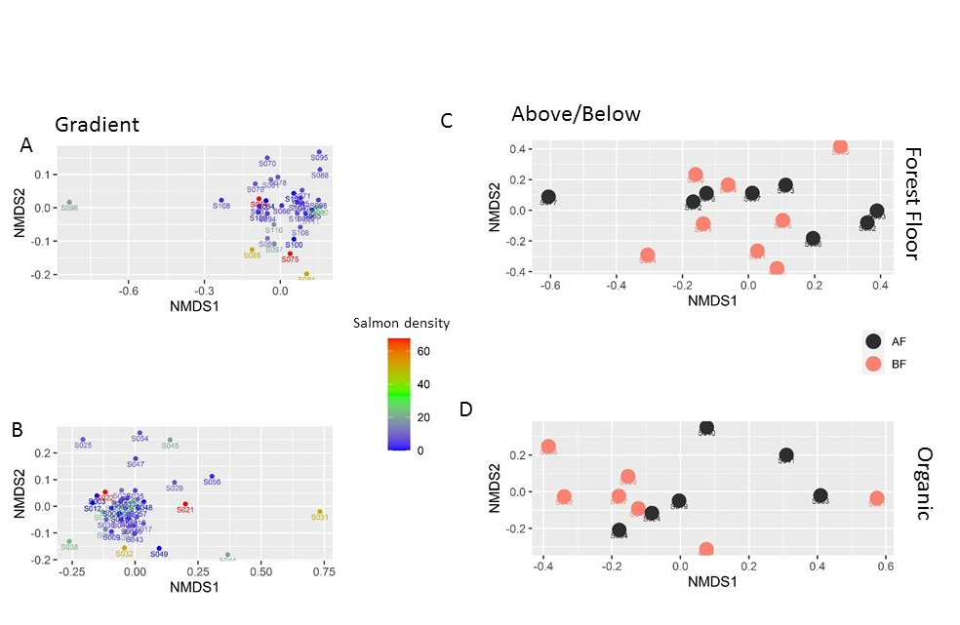
Figure 5-7: 16S beta diversity NMDS plots
(2-axis) using Bray-Curtis distance on forest floor (top row) and organic soil (bottom row). In gradient data plots (left column), warmer colours indicate sites with higher salmon density; and above/below data (right column) salmon coloured are below falls (with salmon) and black is above falls (no salmon). Circles are forest floor soils, and triangles organic soils. Salmon density and waterfall status were significant in ADONIS hypothesis testing only in forest floors and only when placed last in the model.
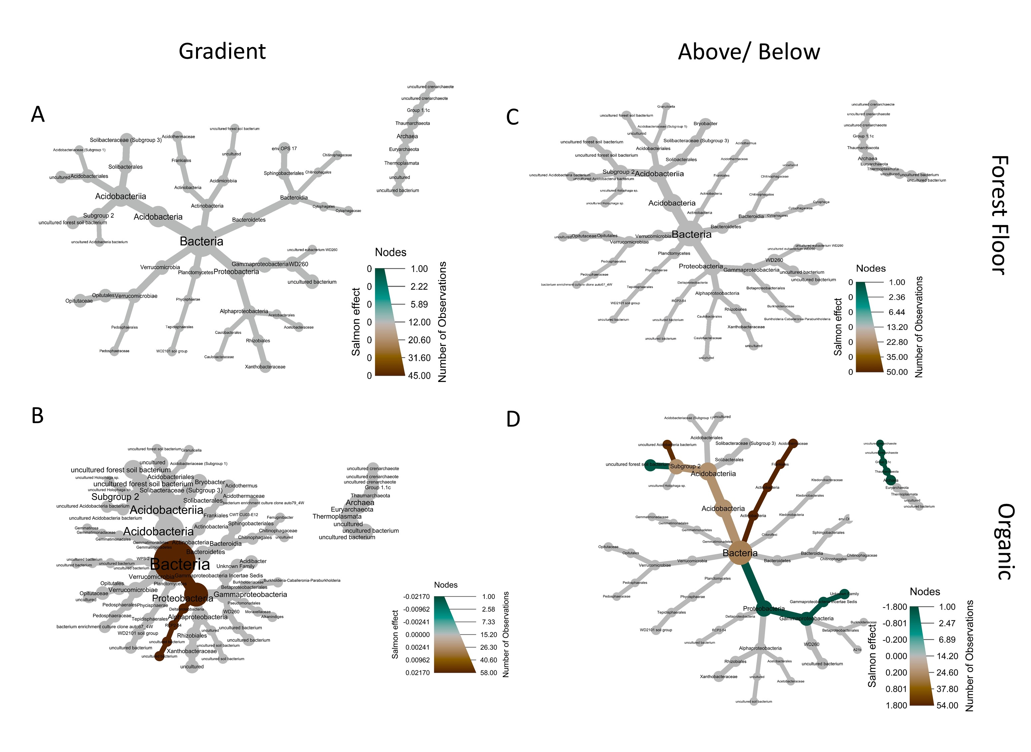
Figure 5-8: 16S differential abundance analysis coefficients.
Coefficients are from differential analysis using the MaAsLin2 package (see methods); green indicates down-regulation and brown up-regulation in response to salmon density (gradient data; left column) or being below falls (above/below data; right column). Forest floors (top row) and organic soil (bottom row) were analyzed separately. Only significant coefficients are shown; the cumulative effects on non-tip taxonomic groups are inferred by taking the average of downstream significant coefficients weighted by relative abundance.

Fate of artificial MDN addition

Introduction
Every spring and fall, the return of ocean-going salmon to their natal streams to spawn and die represents an ecosystem nutrient subsidy to coastal forests in the Pacific Northwest. The ecosystem-level effects of marine derived nutrient (MDN) inputs have long been studied in riparian forests, and salmon fertilization has been shown to have individual and community-level effects on vegetation, soil, and animals (Chapter 1). Salmon carcasses are distributed by bears, wolves and other animals throughout the forest (Reimchen, 2017). The distributed carcasses, as well as urine and feces of scavenging animals, decompose and the concomitant nutrients enter soil systems and can be incorporated into plant tissues (Hocking & Reynolds, 2011). Plant uptake is mediated by bacteria, fungi, insects, and other soil organisms (Chapters 2-5). Ultimately these nutrients end up in animal, vegetation, and soil compartments; the equilibrial long-term concentrations of these nutrients has commonly been demonstrated through elemental and isotope analysis (Sayer, 2008).
Equilibrial concentrations may however be an inaccurate indicator of nutrient flux as equilibrial isotope concentrations are a function of both bulk nutrient flux and the net strength of molecular bonds in any given compartment. Due to their higher molecular weight, heavier isotopes tend to be retained in the ecosystem component with the strongest bonds (Fry, 2007). In forest soil systems, some of the strongest N-bond containing compounds are fungal chitin (Bowman & Free, 2006; Tharanathan & Kittur, 2003), and ¹⁵N has been shown to accumulate in these compounds (E. A. Hobbie et al., 2012; E. A. Hobbie & Högberg, 2012). Along salmon streams, it has been shown that mycorrhizal fungi have isotopically enriched signatures relative both to the surrounding soil and neighbouring vegetation (Chapter 3). It has been shown that one process contributing to this differential is mycorrhizal fungi transferring isotopically-depleted nitrogen to their host plants (E. A. Hobbie & Högberg, 2012).
In soils, this nutrient subsidy has shown to be highly localized in space: soil nitrate, ammonium, and ¹⁵N have been found to be highest in soils within 10 cm of salmon carcasses in Alaska, with this effect decreasing to background concentrations at around 30 cm (Gende et al., 2007). Another salmon carcass addition experiment on 11 streams conducted on the Central Coast of British Columbia found that salmon addition increased plant %N and δ¹⁵N eight months after application relative to control sites 2 m away (Hocking & Reynolds, 2012). These two studies demonstrate that, in the short term at least, salmon nutrients tend to remain near their sites of deposition.
Temporally, redistribution of nitrogen from salmon carcasses seems to occur on a scale of days, with studies in Alaska, Washington state, and Idaho showing NH₄⁺and NO₃⁻ levels rose 1-3 days after carcass addition. Other nutrients found in salmon carcasses, such as phosphorus and calcium, rise over a time scale of months to years (Bartz & Naiman, 2005; Drake et al., 2006; Drake, 2005; T. A. Wheeler & Kavanagh, 2017).
Unlike equilibrial effects, short-term kinetic flow of nutrients is more difficult to study due to their transient nature, uncertainty in chemical and physical isotopic fractionation factors, and the complexity of forest and soil processes. To address this, a pulse-chase experiment was employed in Washington state by depositing labelled NH₄⁺ alongside other nutrients simulating salmon carcass decay; this ¹⁵N was traced through soil and Western red cedar (Thuja plicata) tissue pools for one year (Drake et al., 2006). This study showed maximum ¹⁵N presence in soil pools 30 days after application, with uptake by cedar trees occurring over the following six months, spiking in spring growth the following year. The authors estimated that as much as 80% of ¹⁵N was retained in plots after one year, indicating that most added nitrogen was stabilized by the soil microbial and plant communities despite high rainfall and presumed high levels of soil leaching. Given that one of the primary means of stabilizing soil nitrogen are mycorrhizal fungi (Frey, 2019), I postulate that high estimates of retained-N in salmon forests are due to fungal N-stabilization and associated plant uptake.
The objective of the present study was to measure short-term uptake and distribution of salmon-like nutrients in salmon forest soils in Heiltsuk traditional territory, British Columbia, Canada. I was particularly interested in the potential role of mycorrhizal fungi in increasing plant uptake and the distribution of nitrogen to surrounding plants. To answer these questions, I employed a modified re-creation of Drake et al.’s 2006 pulse-chase experiment. I wanted to measure how long riparian shrubs took to uptake labelled nitrogen, and predicted that this uptake would decline with distance. I also wanted to test if isotope distribution was directional or diffused more evenly across the plot. Finally, I wanted to test if a fungicide treatment would stop or slow isotope translocation to plant tissues. This study design thus uses a fungicide treatment in an explicit time-and-space design to test the rate of tracer uptake, the distance of spread, and whether or not this was affected by a fungicide treatment.

Materials and Methods

Study site
This study was conducted in the Goatbushu watershed in Heiltsuk First Nation traditional territory in the Central Coast Regional District of British Columbia, Canada near the community of Bella Bella (Appendix A). This region is located in the Central variant of the Very Wet Hypermaritime subzone of the Coastal Western Hemlock biogeoclimatic zone (CWHvh2) (MFLNRORD, 2018), and is dominated by cool maritime climate, high rainfall, and mature temperate rainforests. Goatbushu watershed was chosen to balance of accessibility, availability of a decade of ongoing salmon count data, and maximize synergy with other studies (Chapters 2-5, Wagner & Reynolds, 2019). The stream lies at the mouth of a tidal lagoon and estuary (Error! Reference source not found. - Error! Reference source not found.). Mature forests in this area consist of a mix of Western hemlock (Tsuga heterophylla), Western redcedar (Thuja plicata), Amabilis fir (Abies amabilis), and Sitka spruce (Picea sitchensis), with red alder (Alnus rubra) appearing in disturbed areas. The understory includes huckleberry and blueberry species (Vaccinium parvifolium, V. alaskensae, and V. ovalifolium), false azalea (Menziesia furruginea), salal (Gaultheria shallon), salmonberry (Rubus spectabilis), and devil’s club (Oploplanax horridus). The forest was hand-logged in the early 1960s, and accessible areas near the stream mouth today consist of second-growth forest surrounded by old-growth on upland slopes.

Experimental design
In early July, six plots were selected near the mouth of Goatbushu creek, three on each side of the stream. In each plot, vegetation data was taken in a five-meter radius circle: all shrubs >10cm tall had height, width and length measured to approximate shrub volume as a rectangular prism. All trees with circumference >5cm had their circumference measured and height estimated. Shrub and tree distance from origin and bearing in polar coordinates were measured and used in combination with volumetric data to generate 2-D shrub-and-tree maps of the plots. Percent cover estimates of coarse woody debris, herbaceous layer, and moss layer were taken for both a 1m² subplot (detailed) in the centre of the plot and the entire 5m radius circle (approximate).
In all plots a modified Hoagland solution was used to mimic exudates emerging from salmon decay. Following (Drake et al., 2006), the solution was designed to contain the same nitrogen, potassium, calcium, sulfur, magnesium, and phosphorus as a 1.5 kg salmon, corresponding to the average pink salmon in this watershed (Hocking & Reynolds, 2011). This was smaller than a similar addition performed by Drake et al., whom were mimicking larger chum salmon found at their Washington State site. Nitrogen and sulfur were added via ammonium sulfate ((NH₄)₂SO₄); phosphorus and calcium as calcium phosphate (Ca(HPO₄)²⁻H₂O); potassium and sulfur as potassium sulfate (K₂SO₄); and magnesium and sulfur as magnesium sulfate (MgSO₄). All salts were dissolved in 7.5 L distilled water and applied via hand sprayer directly to a 1m² area of soil over a period of 10 minutes to allow for percolation and avoid pooling. Given molar ratio constraints from using these salts, it was not possible to exactly match element masses in the solution with ratios found in salmon carcasses; hence element addition was prioritized in the order: nitrogen, phosphorus, potassium, magnesium. This resulted in a solution with approximately 30X as much sulfur as desired and 11X as much calcium. See Appendix D for detailed stochiometric calculations.
Two plots were treated exactly as above and served as controls (i.e., control plots also received fertilization). Two plots additionally received 10 atom% ¹⁵N labeled ammonium sulfate as nitrogen source and served as the ¹⁵N treatment. In two final plots the fertilizer mix with labelled ammonium sulfate was applied as well as a fungicide and served as the ¹⁵N + fungicide treatment. This resulted in two replicates of each treatment, one on each side of the stream, for a total of six plots.
Many fungicides are toxic to fish, and the importance of this creek as an active salmon spawning site precluded the use of strong or long-lasting fungicides in this experiment. An off-the shelf brand (Daconil) chlorothalonil was chosen due to its widespread use in agriculture, gardens and golf courses and its low toxicity in natural settings (Van Scoy & Tjeerdema, 2014). Chlorothalonil has limited mobility in soil and adsorbs aggressively to organic particles in both soil and water (Dell et al., 1994); hence diffusion is minimal (centimeters to tens of centimeters). When in water, it has low solubility (Vogue et al., 1994), and preferentially adsorbs to floating organic particles. It has a short half-life in soil of 12.3 days, and degrades to negligible values within 76 days (Putnam et al., 2003). It has been used successfully in ecological experiments by limiting the metabolic activity of fungi (Habte et al., 1992; Laatikainen & Heinonen-Tanski, 2002), but it has been shown to not reduce mycorrhizal colonization rates (Aleksandrowicz-Trzcinska, 2008). This indicates that chlorothalonil likely has minimal medium-term impacts on the mycorrhizal community. Here we applied approximately 12.5g of chlorothalonil to each m² plot.
This study employed a spatially-explicit repeated-measures sampling protocol. Ten or more ‘focal shrubs’ were chosen per plot; these were selected to be varying distances from the centre of the plot and included five Vaccinium spp. (a combination of V. ovalifolium and V. parvifolium) and five false azalea (Rhododendron menziesii, previously Menziesia ferruginea (Craven, 2011)) of differing distances from the origin. A subset of plots also included some salmonberry (Rubus spectabilis) and western hemlock seedlings (Tsuga heterophyla). 1-4 leaf samples were taken from each shrub at 10 time steps: day 0 (before application), 1, 2, 4 ,7, 12, 20, 27, 33 and 40. Sites were sampled between July 4th and August 13th 2018. At every sampling period leaves were picked by hand from each individual (approximately four leaves for Vaccinium and two for R. menziesii), and frozen for later analyses. In the lab, these were dehydrated in a vacuum drier, pulverized with a Retsch MM 300 homogenizer bead mill, weighed into tin cups and analyzed in an Elementar Vario EL Cube Elemental Analyzer (EA) and Isoprime Isotope Ratio Mass Spectrometer (IRMS) at the UBC Forestry Stable Isotope Facility. In all samples, %C, %N, δ¹³C and δ¹⁵N were measured.

Analysis:
All data management, plotting, and statistical analyses were performed in R (R Core Team, 2019). To visualize treatment effects, raw δ¹⁵N values were plotted as time series and fit with loess function curves with span=1.2 fit using ggplot2 (Wickham, 2016) (Figure 6-1). For analysis, δ¹⁵N values were translated such that they were all positive (+5‰) and log-transformed to compress the range, and similarly plotted (Figure 6-2). Plants were collapsed within treatments, and distances binned into three groups and again fit with loess curves (Figure 6-3). Three dimensional plots were constructed of the translated log-transformed values as a function of day since application and distance from the center of the core using the R package car (J. Fox & Weisberg, 2019); loess smoother curves were fit according to the ‘smooth’ function using package defaults (Figure 6-4). As a first approximation three linear models were fit to the data: a linear model using the equation $\log{δ15N}\sim day*distance*treatment$, a linear mixed effect model using plant as a random effect, and a generalized linear model using the Gamma family function. Although AIC comparisons indicated best fit with the generalized linear model, we present the linear model fit below due to ease of interpretation and because our main interest was the direction, rather than the size, of effects (Table 6-1). To capture nonlinearity in the data, a Michaelis-Menten function was fit to the time series data of only the closest plant to the plot center in each plot, using the R function nls with additional self-starting functions from nlraa (Miguez, 2021). This function estimates two parameters: Vmax, which estimates the δ15N value at the asymptote of the function, and KM, which estimates the day at which uptake reached half of Vmax.

Results

Rate and distance of uptake
Appreciable amounts of ¹⁵N labelled nitrogen was taken up by day 4 by the closest plant in both the ¹⁵N and the ¹⁵N + fungicide treatments (Figure 6-1). Among these plants, uptake levelled off at approximately day 12 for the δ¹⁵N treatment, and at approximately day 27 for the ¹⁵N + fungicide treatment.
Relative to plants further away, the closest plant took up roughly an order of magnitude more labelled nitrogen than more distant plants by the end of the experiment (thousands ‰ δ¹⁵N relative to hundreds), with uptake curves decreasing roughly exponentially with distance (Figure 6-4). Similar uptake was seen irrespective of plant species.
The main effects of the linear modelling showed significant positive correlation with time and a negative correlation with distance (Table 6-1). Slopes for both the control and the fungicide treatments were significantly lower than the ¹⁵N treatment. I found multiple significant secondary and tertiary interaction effects. As we expected given the nonlinear nature of the data, model fit was generally poor.
The fungicide treatment both reduced and delayed uptake. Nonlinear Michaelis-Menten parameterizations including only the plants closest to the centers of the plot found higher V_{max} in the ¹⁵N treatment than the ¹⁵N + fungicide treatment (Figure 6-5). Similarly, the ¹⁵N treatment reached its K_{M} sooner than the fungicide treatment (~day 2 vs day 4).

Discussion
Significant uptake of labelled ¹⁵N occurred in the plants, particularly those closest to the additions. Fungicide treatment interfered with this uptake, as fungicide treatments demonstrated both slower and lower uptake than treatments without fungicide. It should be noted that these results occurred despite having a large rainstorm blow in the day after application, which may have leached and/or displaced both ¹⁵N signal and other added nutrients from the addition area. I conclude that, in principle, this experiment is a good proof-of-concept that may be employed in future studies.
In a previous experiment, a similar isotope addition approach was used to trace nutrient additions in a large mature cedar (Drake et al., 2006). In large cedars, expression of the label in foliar tissues was found to take months, with most of the uptake inferred to take place over the winter. Here in riparian ericaceous shrubs, uptake occurs much faster, with signal showing in terminal leaves one to three days after application, even in late-summer when nutrient allocation to mature leaves is expected to be low.
While high levels of uptake were observed in the closest plant, uptake also occurred in plants further away in two of the four isotope addition plots (for example, plots 2 and 3, Figure 6-2). There was some evidence that this uptake was directional, with plants that acquired ¹⁵N tending to be in the same cardinal direction in each plot.
To my knowledge this is the first time that inhibition of nutrient uptake in plants has been shown to be associated with chlorothalonil application. The mechanism of action of chlorothalonil is to inhibit fungal cell thiols, also known as mercaptans. They are the functional group in the amino acid cysteine and important in a number of enzymatic cofactors. In general, fungicides are applied as foliar sprays rather than a ‘soil drench’ application as used here. Ecological studies using chlorothalonil generally look at inhibitory effects on fungi in greenhouse or laboratory settings (Teste et al., 2006) and few have been conducted under field conditions. In one field study, molecular techniques were used to measure the community effects of chlorothalonil application on three soil treatments: turfgrass, forest soil, and agricultural soil (Sigler & Turco, 2002). These authors suggested that chlorothalonil inhibits new fungal growth, but leaves existing structures in place. This is in line with other work showing minimal impact on mycorrhizal structures (Aleksandrowicz-Trzcinska, 2008; Teste et al., 2006). By day 40 the fungicide treatment had almost converged with the asymptote seen in the ¹⁵N treatment, corresponding roughly to a 90% reduction in the active chemical.
In conclusion, this study showed uptake of labelled nitrogen over a period of days in riparian shrubs. Uptake declined with distance, was potentially directional, and this uptake was disrupted in the short-term through a soil-drench fungicide treatment. This study thus serves as an important preliminary study that can be used to control for fungal nitrogen uptake in other experimental settings.

Tables and Figures
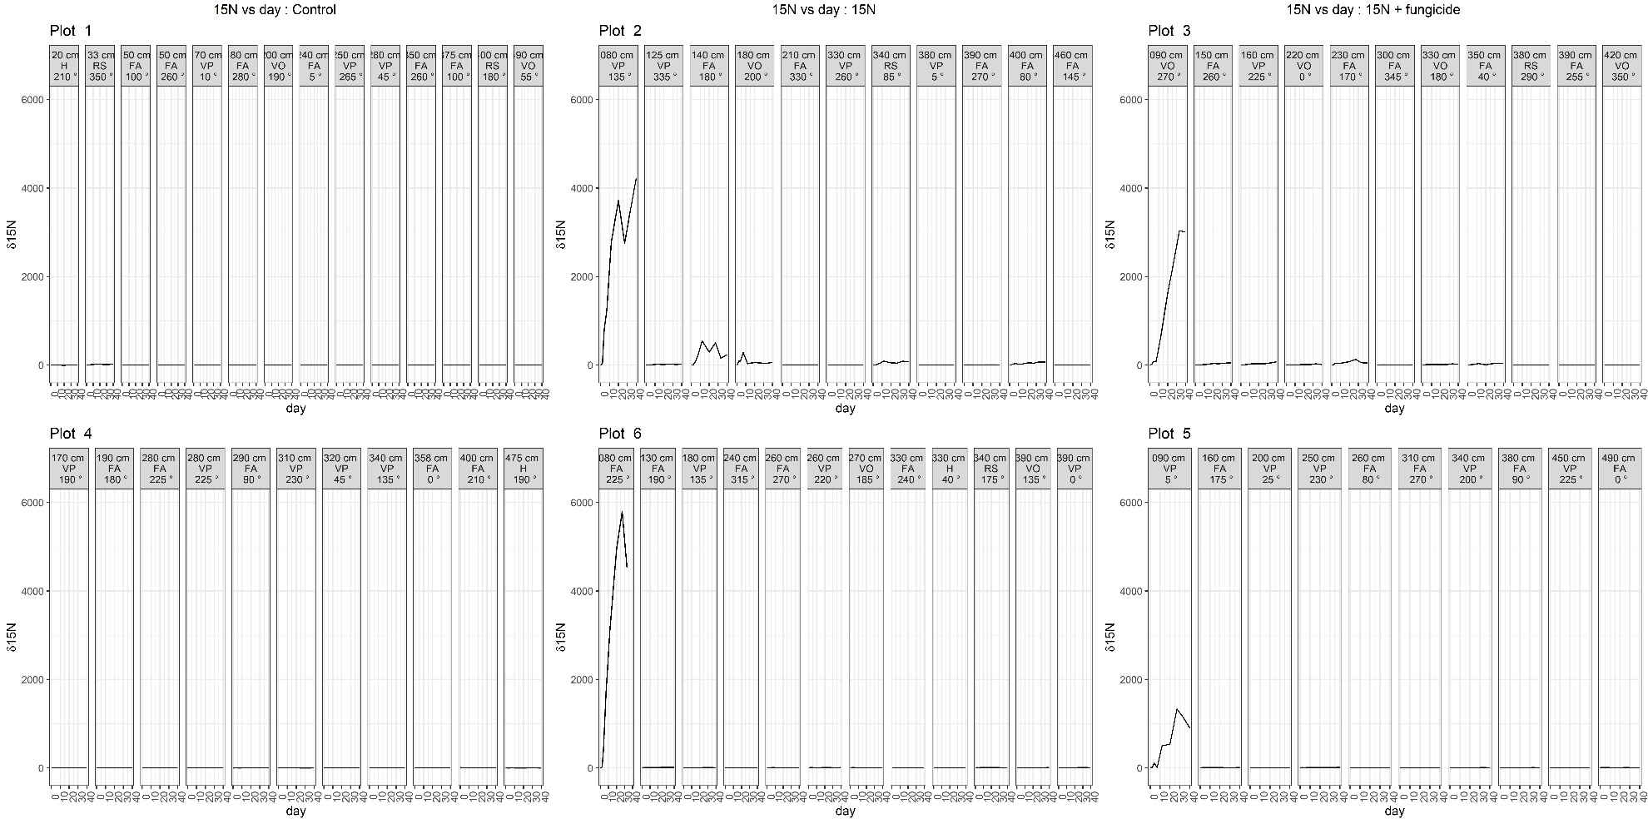
Figure 6-1: Time series of δ¹⁵N values per plant
(each facet) in each of the three treatments (control, ¹⁵N, and ¹⁵N + fungicide; columns). For each plant, the distance from the center the plot, the plant species, and bearing are indicated in the title bar of each facet (H = hemlock seedling, RS = Rubus spectabilis, FA = False Azalea, VP = Vaccinium parviflorum, VO = Vaccinium ovalifolium).

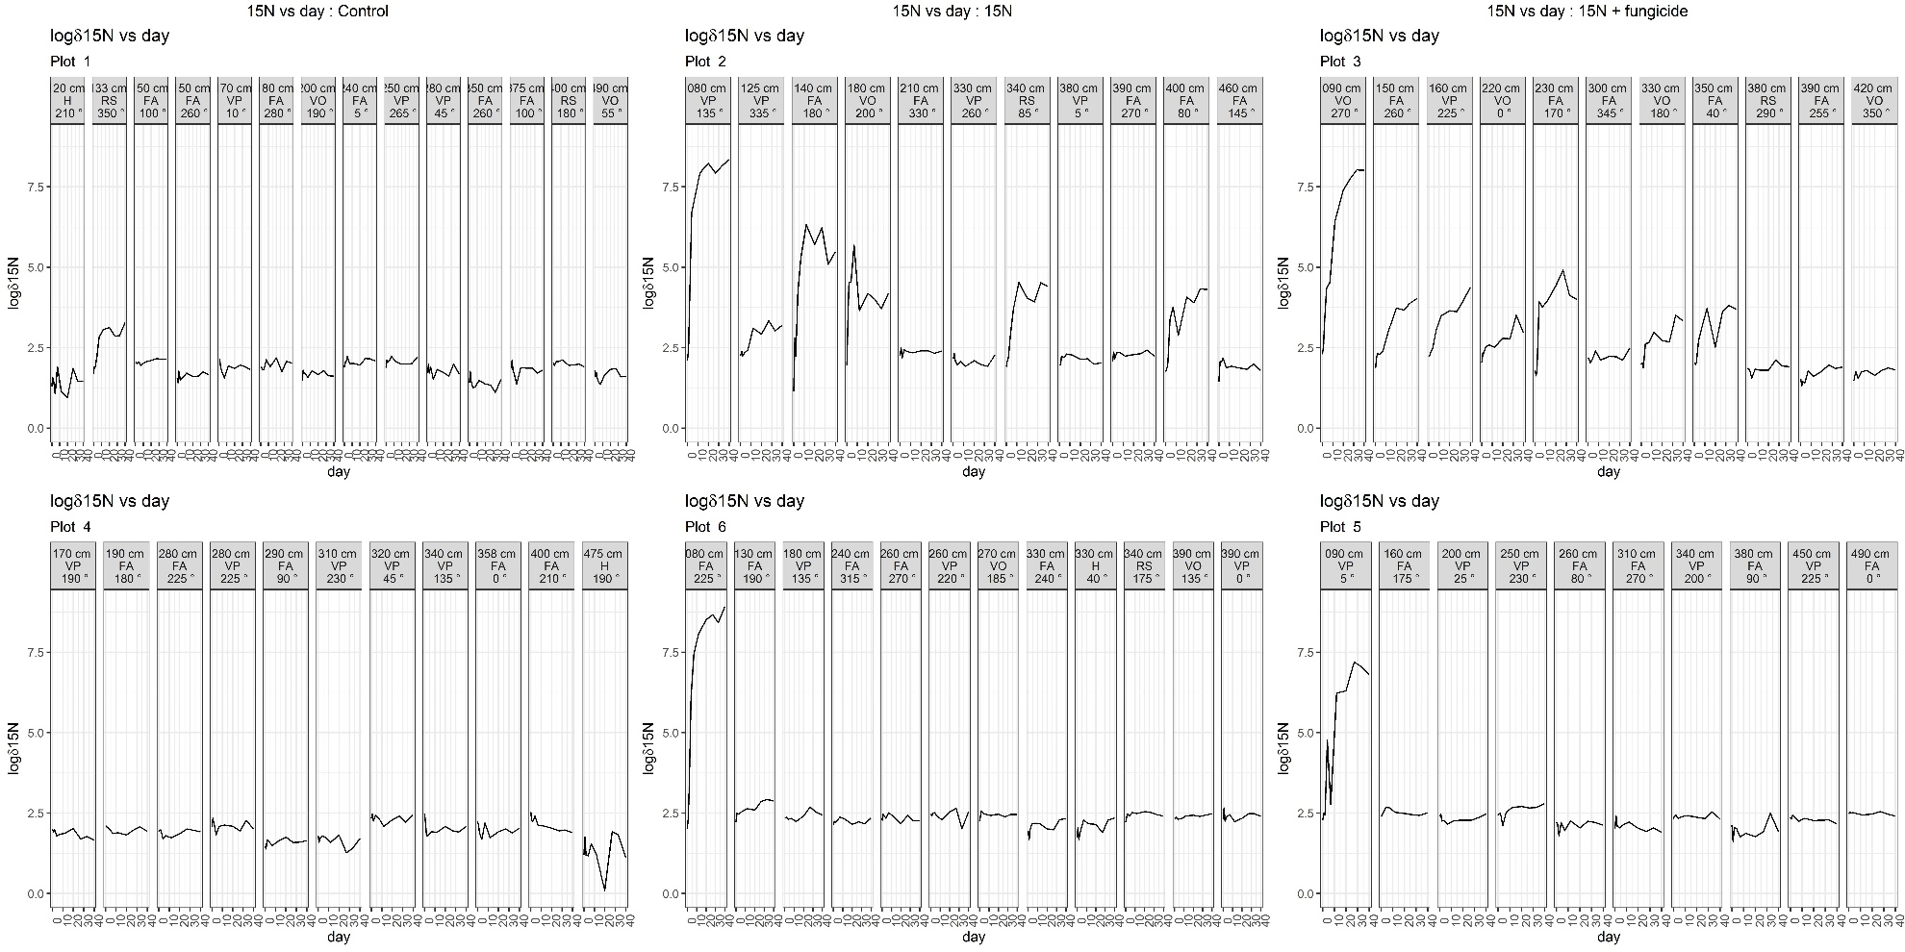
Figure 6-2: Time series of log δ¹⁵N values per plant
(each facet) in each of the three treatments (control, ¹⁵N, and ¹⁵N + fungicide; columns). For each plant, the distance from the center the plot, the plant species, and bearing are indicated in the title bar of each facet (H = hemlock seedling, RS = Rubus spectabilis, FA = False Azalea, VP = Vaccinium parviflorum, VO = Vaccinium ovalifolium).

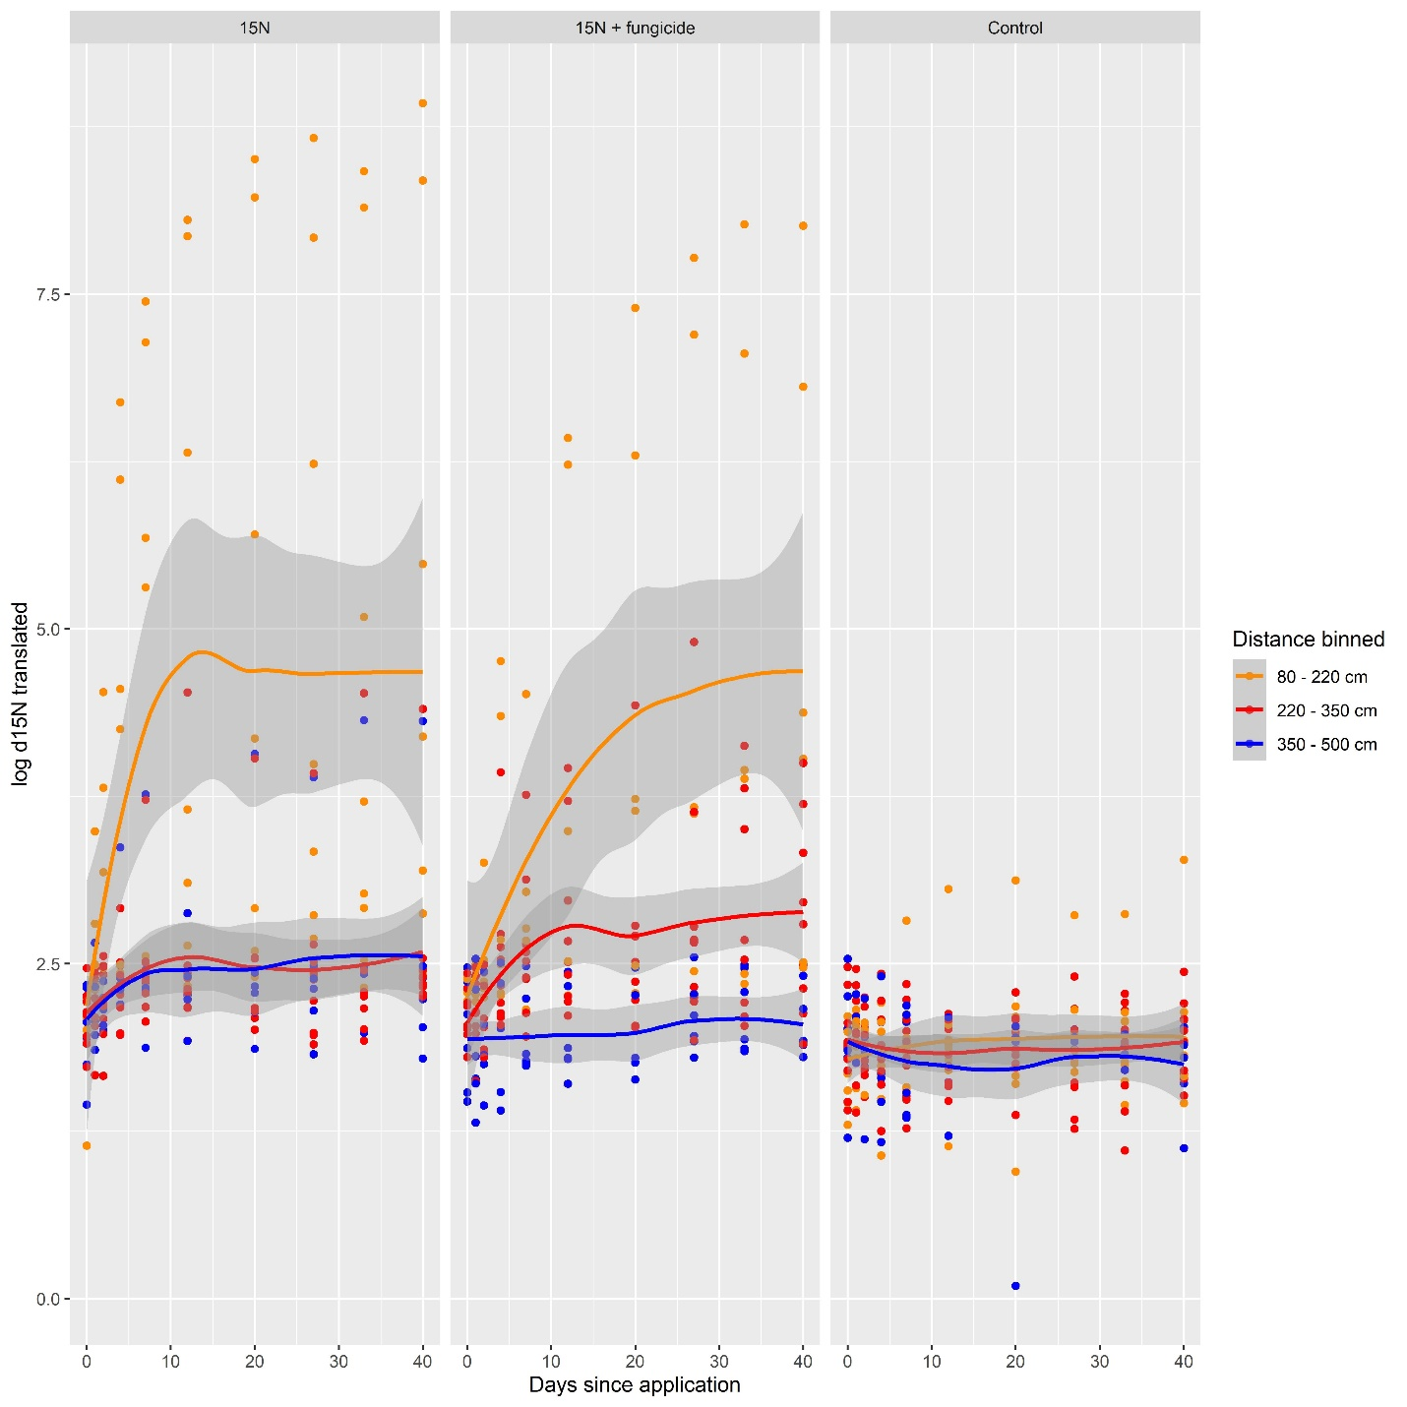
Figure 6-3: log transformed δ¹⁵N values as a function of days since application.
Colour denotes distance from the center of the plot, and have been binned into three groups for easier interpretation. Faceted by treatment. δ¹⁵N values have been translated such that all values were positive prior to the log-transform. The fungicide treatment led to slower uptake.

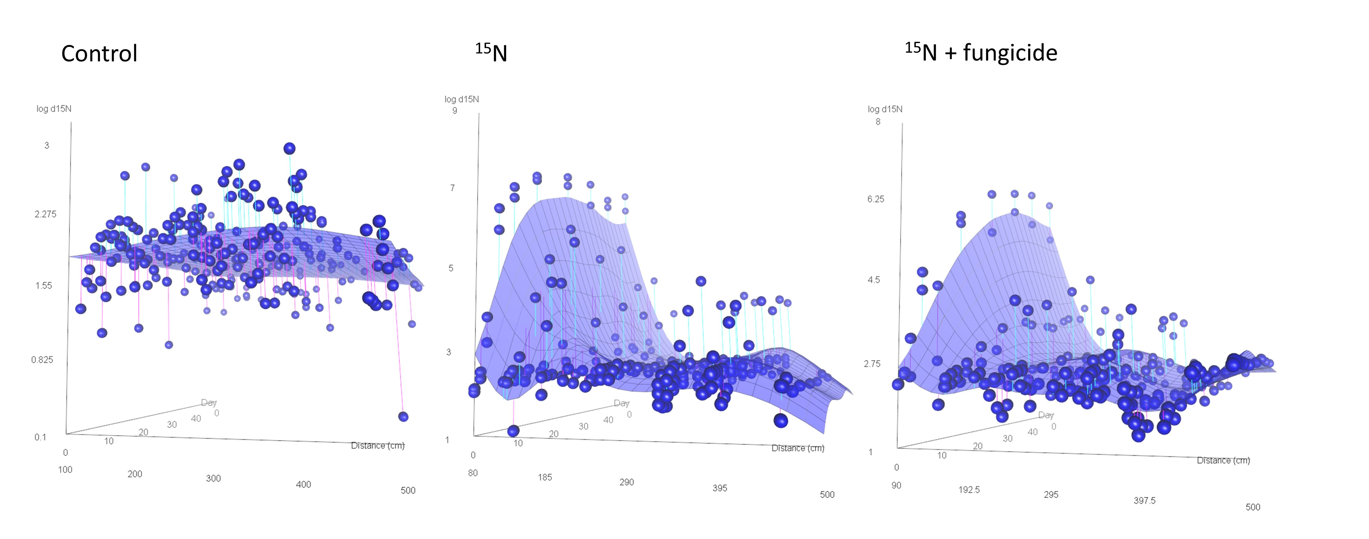
Figure 6-4: 3-D plots of translated log δ¹⁵N values for the three treatment groups as a function of distance from the center of the plot and days since application.
Note the different y-axis scales.

Table 6-1: Regression table for the LM translated log ¹⁵N ~ day * distance * treatment.
Treatment contrasts are taken relative to the δ¹⁵N treatment.
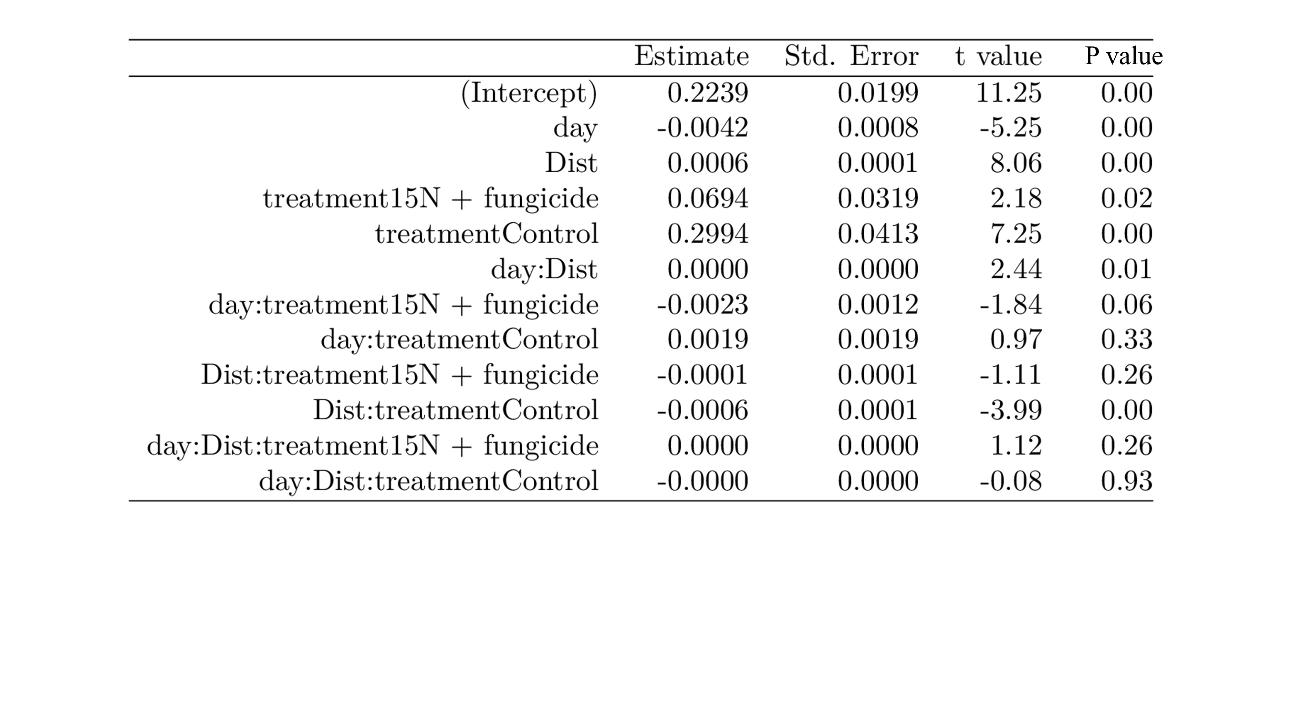
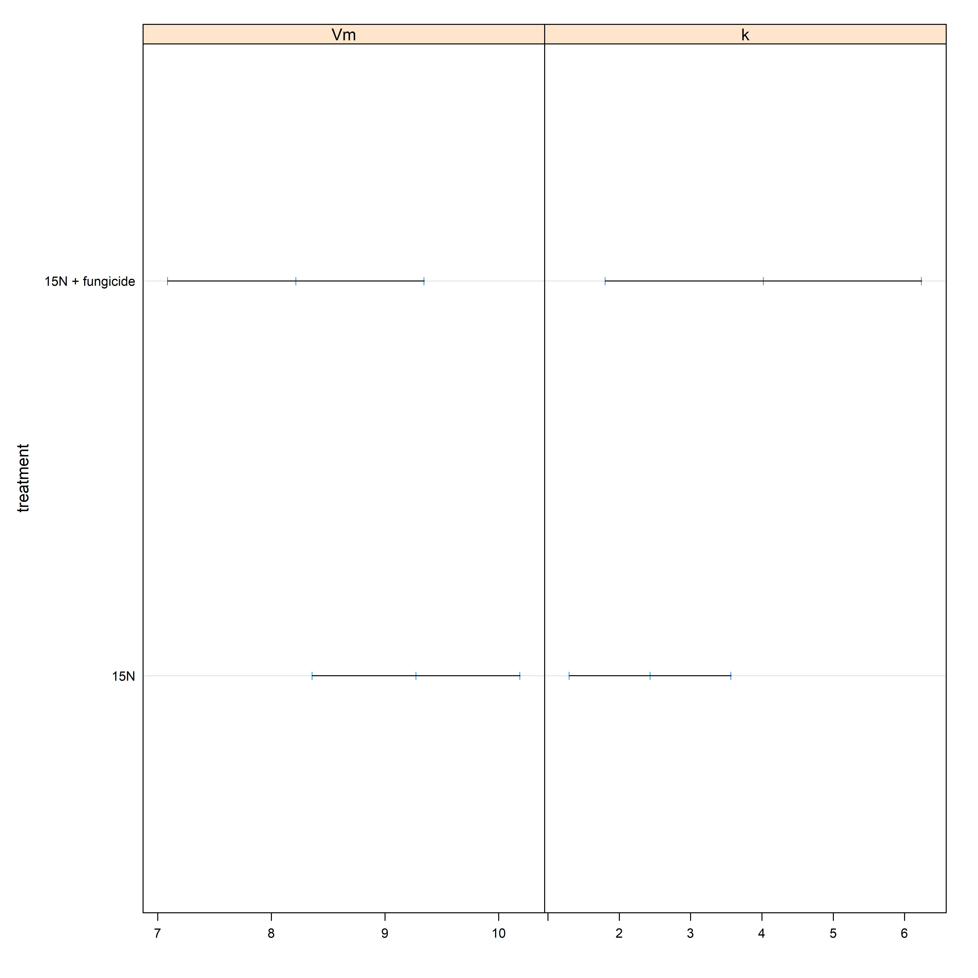
Figure 6-5: Estimated V_{max} and K_{M} values from Michaelis-Menten function fits of the closest plant for each treatment group.
Here V_{max} indicates the log of the δ¹⁵N value reached by the asymptote, and K_{M} indicates the day at which uptake reached half of V_{max}. Here we see the fungicide treatments reached a lower asymptote (V_{max}) and took longer to do so (higher k).

Conclusion and summary

Summary
The extent, quantity, and effects of salmon nutrient subsidies on recipient terrestrial systems has received much attention over the last 30 years. Through the work presented in this thesis, I add to this accumulated body of research by asking the overarching question “how do salmon-derived nutrients change soils in salmon forests?”. In Chapter 1 I provided a literature review of previous work, and set up the questions and logical structure of the rest of the thesis. In chapter 2, I asked “how do salmon affect forest soil chemistry”, and provided insight to the chemical impacts on soils, which to date has largely focused on nitrogen fertilization to the exclusion of other macro- and micro- nutrients. In chapter 3, I attempted to answer the questions “how do salmon inputs affect mushrooms” and “how do salmon inputs affect soil-fungi-vegetation nitrogen dynamics”. I performed the first mushroom survey in this region, and added mushroom sporocarp nutrient and natural abundance isotope measurements to existing catalogues of vegetation, animal, and soil isotopic signatures. I then leveraged differences between these ecosystem compartments to answer questions about net fractionation between stocks of soils, mushrooms, and plants and discussed the implications to isotope fractionation and bulk nitrogen and carbon flow. In chapter 4, I asked “how do salmon inputs affect soil fungal communities”, and used next-generation environmental sequencing to measure the effects of salmon inputs on fungal relative abundance, diversity, and community composition. In chapter 5 I ask the same question of bacterial communities. Finally, in chapter 6 I used a nitrogen addition experiment to measure nitrogen uptake by riparian shrubs and experimentally test the effect of fungal inhibition on uptake rates. In aggregate, the work in this thesis underscores the active role of soils and soil microbiomes in mediating salmon nutrient inputs in salmon forests.

Synopsis of Chapter 2
Chapter 2 examined the effects of MDN on soil and forest floor chemistry, and attempted to answer the question of how salmon inputs affect soil chemistry. In particular, I was interested in if and how salmon inputs impact the fertility of recipient sites. This chapter made comparisons from 23 sites representing a gradient of salmon inputs, as well as above and below salmon-blocking waterfalls at four of these sites. I examined the responses of 22 chemical measurements to salmon inputs and vegetation composition. Aggregate soil chemistry profiles (i.e. weighting each chemical equally) showed significant effects from salmon density, the closest dominant tree, as well as moss and shrub communities, demonstrating the important role salmon inputs have in driving soil chemistry. Examining each response variable in turn along the regional salmon density gradient, I found significant increases in ammonium (NH₄⁺), nitrate (NO₃⁻), and copper (Cu) with salmon, and increasing trends in exchangeable phosphorus (P), exchangeable sulfur (S), calcium (Ca²⁺), and aluminum (Al). Salmon density was also associated with significant decreases in magnesium (Mg⁺) and sodium (Na²⁺), and decreasing trends in potassium (K⁺). Comparisons between above and below sites showed moderately significantly higher ammonium (NH₄⁺), nitrate (NO₃⁻), and sulfur (S); and positive trends in exchangeable phosphorus (P), magnesium (Mg²⁺), and sodium (Na⁺) below waterfalls. This was accompanied by significantly lower pH and a negative trend in manganese (Mn) below falls. I also found vegetation, soil depth, and distance from the stream to be important factors in structuring soil chemistry.
These data led to my acceptance of the hypothesis that salmon inputs are, in aggregate, important in structuring soil chemistry and improving fertility at these sites. I had high confidence in the evidence that nitrate and ammonium increased with salmon inputs, and moderate confidence that salmon increased calcium and phosphorus concentrations. I also found that other exchangeable cations (primarily potassium and magnesium) decreased with salmon density. This was consistent with my alternative hypothesis where, similar to agricultural systems, high levels of N-inputs would result in nitrogen-driven acidification and nitrate-cation co-leaching. There was some evidence of acidification, and interpreted this as evidence that nitrate-assisted co-leaching of cations could be occurring, but calcium may be replaced via direct deposition from salmon carcasses more quickly than it was being lost. I also questioned whether inorganic models of N-addition are appropriate for the organic and stoichiometrically diverse additions embodied by salmon carcasses, and argue for the centering of soil classification in discussing net impacts of salmon inputs on soil chemistry. In total, I found a complex suite of soil chemical changes associated with salmon inputs, and that these changes are consistent with the hypothesis of a general increase in fertility at these sites.

Synopsis of Chapter 3
Chapter 3 asked ‘how do salmon inputs affect mushrooms’, and attempted to make inferences on nutrient cycling in salmon forests. I used δ¹⁵N and δ¹³C natural abundance as primary signals to understand nutrient stocks and flows. δ¹⁵N is one of the primary measures used in the literature to quantify salmon inputs to riparian systems, and thus I was able to add mushroom sporocarps to the growing literature on salmon-associated δ¹⁵N. I found that δ¹⁵N increased monotonically in sporocarps, soil, vegetation, and litter along the salmon gradient. This is consistent with past studies on the Central Coast of British Columbia and other regions and is consistent with salmon-N being pervasive and well distributed throughout these systems.
Previous work has also used these measures as proxies to investigate the level of mycorrhizal transfer between plants and their symbiotic fungi (J. E. Hobbie & Hobbie, 2006), allowing me to ask whether nutrient inputs from salmon affected these transfer rates. Inorganic nitrogen inputs have been shown to reduce mycorrhizal transfer rates in boreal systems (E. A. Hobbie et al., 2019), while spatially clustered nutrients are theorized to increase mycorrhizal transfer rates (Moeller & Neubert, 2015). Reductions in mycorrhizal transfer rates predict a convergence between belowground and aboveground δ¹⁵N values, and increases in transfer rates predict a divergence between these compartments. I found no evidence of either along the salmon density gradient I investigated, and δ¹⁵N differences between ecosystem compartments were consistent across the salmon gradient. The most parsimonious interpretation of this was that salmon inputs do not change mycorrhizal transfer rates in these systems, but it is possible that both a decrease in transfer rate due to fertilization and an increase due to spatial effects were occurring in such a way as to compensate for each other. How fertilization affects mycorrhizal transfer rates has general applications in agriculture and other fields, and further experimental and theoretical work will need to be done to distinguish these hypotheses.
Finally, I note that interpretation of these ecosystem-level patterns is challenging, and my interpretation was confronted by a lack of scientific knowledge in general on chemical functioning in acidic organic forest soils. Specifically, future quantification of volatilization rates through both denitrification and ammonification will aid in answering these questions, as well as measurements of the dissimilatory-nitrate-reduction-to-ammonia (DNRA) in Central Coast Folisols. I also note that these dynamics may be different in nutrient hotspots directly under salmon, and underscore that the interpretation of δ¹⁵N values in salmon forests require a holistic approach cognizant of both bulk flow and associated isotopic fractionation processes.

Synopsis of Chapter 4
In Chapter 4 I asked ‘how do salmon inputs affect soil fungal communities’, and I investigated the effects of MDN on both organic soil and the forest floor. To do so, I employed next-generation environmental sequencing on the same regional salmon density gradient and above and below waterfall soil samples as chapters 2 and 5, using two sequence barcoding targets – one for the internal transcribed spacer region (ITS), targeting ectomycorrhizal fungi, and another for the RNA small subunit (SSU), targeting arbuscular mycorrhizal fungi; however, I found both amplicons amplified both types of fungi. I looked at how fungal relative abundance changed with salmon inputs, as well as α-diversity as measured by both species’ richness and Shannon’s index. β- diversity was investigated on the entire dataset, as well as community structuring via phylogenetic dispersion. All of these response variables were also correlated with vegetation measures as covariates, as well as the soil chemistry values obtained in Chapter 2. Finally, I also used differential expression analysis to highlight particular fungal taxa that either changed in abundance with salmon input. Since I was particularly interested in changes in mycorrhizal fungi (symbiotrophs), where possible these analyses were repeated separating reads by trophic mode (i.e. either saprotrophic or symbiotrophic).
I found that salmon inputs impacted symbiotrophs more than saprotrophs. Salmon inputs were significant factors in all β-diversity ordinations, demonstrating that diversity on a regional scale is affected by MDN inputs. Salmon inputs had no effect on ITS read abundance, but increased symbiotrophic SSU abundance. Species richness and Shannon diversity increased with salmon inputs in ITS reads, but not SSU reads. Phylogenetic dispersion was negative in all communities (i.e. they were underdispersed), but this had no correlation with salmon inputs. Among ITS reads, I found that phosphorus, manganese, and surrounding vegetation were important correlates with these metrics. Among SSU reads, I found that distance to the stream, ammonium concentrations, and phosphorus were particularly important. These findings point to salmon inputs being important in directly structuring fungal diversity and community composition through carcass-mediated nitrogen and phosphorus inputs, as well as indirectly via changes in vegetation structure and soil chemistry.
I found fungal communities in these soils to be dominated by Tylospora, Mortierella, and Russula, with fungi in the Order Heliotales and the Genus Piloderma also well represented. I was able to identify approximately 40% of the reads to genus level; constrained to these communities, differential expression analysis found that salmon inputs generally decreased fungal abundance. However, below-falls in particular saw an increase, relative to above-falls sites, in species such as Sebacina which are known to have aminophyllic feeding strategies. These findings show that salmon inputs have widespread effects on fungal communities, filtered by species identity and trophic mode.
In general, community-level studies on the effects of salmon inputs remain relatively rare. This chapter addresses this gap by using the fungal microbiome to show that salmon mediated nutrient inputs have community-level effects on recipient terrestrial sites.

Synopsis of Chapter 5
In Chapter 5 I used the same methods and samples as Chapter 2 and 4 to ask “how do salmon inputs affect soil bacterial communities”, and look at the effects of MDN on soil and forest floors. Using the V3V4 region of the 16S rRNA gene as a barcoding target, I quantified and classified bacterial environmental sequences both along a regional gradient of salmon density and above and below waterfalls. I then used species richness and Shannon’s diversity, and phylogenetic dispersion as response variables to test the effects of salmon inputs on these community metrics. I also compared β-diversity across communities using constrained ordinations. Finally, differential abundance analysis highlighted taxa that significantly increased or decreased across either the regional gradient or between above- and below-waterfall sites.
The most abundant identified phylum was Acidobacteria, representing 41% of reads. Proteobacteria was also very common, representing an additional 20% of sequence reads. I found a large number of phyla occurring at only one or two sites; this matches global trends of both high localization and high diversity in soil bacteria. I interpreted these data as primarily reflecting the acidic and carbon-rich nature of the Folisols encountered at these sites.
Overall, salmon inputs were found to have little impact on community metrics. Closest large tree species and the PCA axes of surrounding vegetation were found to be the primary correlates with our community metrics; this finding is in line with established literature which shows that vegetation, through both litter and root exudates, is important in structuring bacterial communities. Distance to the stream, potassium concentrations, and ergosterol concentrations were also all important correlates with our community metrics, indicating that water availability, potassium, and interactions with soil fungi are also important drivers of community structure.
On a regional scale, I found that after considering ordinations by the closest dominant tree species, salmon inputs were significant in forest floors but not organic soils. This shows that salmon inputs are important in these soils over nine months after the previous salmon run, but that their effects may be constrained to forest floors and shallow soil layers. The differential abundance analysis showed no significant changes in forest floors, but in organic soils some taxa associated with nitrogen and phosphorus metabolism increased in response to salmon inputs.
In general, these findings show that vegetation is the most important driver of soil bacterial abundance and community structure, but that salmon density has additional net effects on community composition. I argue that given the high turnover in bacterial communities, and that I took my samples ten months after the previous salmon run, these findings likely under-estimate bacterial community response to salmon inputs.

Synopsis of Chapter 6
Chapter 6 was an attempt to answer the question “do mycorrhizal fungi uptake MDN, and if so, do they play a role in distributing these resources to neighbouring vegetation”. I used a study design varying over both space and time along with a fungicide treatment intended to knock out fungal activity to test the importance of fungi-assisted nutrient uptake. I found that labelled nitrogen was rapidly taken up by shrubs nearest the application, and plants further away received appreciable signal as well. Expression of labelled-N in foliar tissues reached an asymptote on the scale of days, and both this asymptote as well as the rate of uptake was reduced by the fungicide treatment. This study thus serves as both a proof-of-concept of a spatial approach to studying short-term nitrogen uptake in riparian shrubs, as well as a successful use of an environmentally benign fungicide to moderate uptake rates.

Research strengths and limitations

Design strengths and limitations
The two study designs employed in this thesis are between-stream regional observations along salmon streams that receive a gradient of salmon inputs (‘regional gradient’ design), and above/below comparisons within a subset of these watersheds that have waterfalls that block salmon migration (‘above/below’ design). Each of these designs present some experimental challenges and caveats.

Regional salmon density gradient design
The regional gradient design confounds watershed-level variability co-occurring with variability arising from salmon inputs. In this thesis I’ve chosen to ignore east-west regional gradients in rainfall patterns, individual salmon size, and vegetation communities noted in Hocking et al. 2011. The canonical way to account for this would be to include watershed as a random covariate in a mixed model; however, the small number of sampling points per watershed precluded confident variance estimates on the watershed level and thus I avoided this modelling structure. This risks pseudoreplication, as cores within site are treated as independent despite occurring within the same watershed; given however that the soil cores were taken on opposite sides of the stream and that the response variables are expected to be highly localized around the soil cores I judged this to be acceptable. This was supported by initial plots of within vs. between watershed variation, as well as similar results obtained with simplified mixed models which explicitly take this design structure into account.
Salmon density also tends to be highly correlated with watershed size; in initial model selection (and some final models) I included various watershed size estimates as additional independent variables, including a ‘watershed size’ PCA included in Chapter 2 (following Wagner et al. 2019). In these models generally salmon density explained more variation than watershed size, and the collinearity introduced by including watershed size would have precluded using model averaging as an approach (Cade, 2015). Hence in most models I chose to exclude watershed size as a covariate, and as such watershed size should be kept in mind when interpreting these results.
Another issue with these data is the large gap in salmon density between 35 and 60 kg • m⁻¹ yr⁻¹. In regressions, this leads to high leverage given to the large and high salmon density watersheds Neekas and Clatse which, combined with what are in some response variables extreme values for these sites, tends to dominate some of the regression curves associated with these relationships. This is exacerbated by the fact that Neekas and Clatse are flatter and wider floodplains qualitatively different than the generally steep-sided streams present on other sites. In addition, there is some evidence of inverse-U shaped relationships for some response variables (i.e. unimodal with a local maximum) which may be expected to occur at high nitrogen inputs. I examined this in preliminary investigations by alternatively excluding and including these sites in my analysis; in the final writing I’ve tried to be transparent and include raw data where possible.

Above and below waterfall design
The above/below waterfall design controls for regional and watershed-level variability by sampling within a few tens of meters above and below waterfalls in the same watershed. It suffers, however, from confounding salmon input variability with environmental variability arising from changes in topography, vegetation, and edaphic profiles above and below waterfalls. While I made efforts to control for this (i.e., by including vegetation metrics), it was evident that at some sites soils and plant communities were qualitatively different above and below falls. I believe that this is one reason why, in general, I found stronger differences above and below waterfalls than in the regional datasets.

Common limitations to both designs
Finally, for both sampling designs the sample size at each site was small relative to the likely underlying variation at these sites, and the spatial scale of the samples (either soil cores or mushroom sporocarps) is small relative to the area for which we are drawing inferences. I made some early efforts to quantify variation at a single site in a trial field season (i.e. transects of sampling points perpendicular to two streams), but these proved not very insightful. In addition, in the case of next-generation sequencing, there were methodological constraints due to all samples being run in a single run, precluding an analysis of trial samples to estimate site-level variance before the bulk of samples were sequenced.
The sampling considerations are compounded by the spatial and temporal heterogeneity created by salmon carcasses, animal feces, and urine. While sampling was intentionally conducted in such a way as to minimize cases of glaring sampling bias (i.e., by avoiding areas directly under salmon carcasses), these biases should be kept in mind when interpreting these data. It is difficult to study clustered phenomena in general with common ecological designs, and consideration of the non-random nature of salmon inputs should be given explicit consideration in future studies.
Given that the regional salmon density gradient and the above and below waterfall approaches each have strengths and weaknesses, I view them throughout the thesis as complementary rather than in conflict. Having these ‘dual windows’ on the effects of salmon input allows for increased confidence in cases where results agree between the two designs. It also led to difficulty of interpretation when these conflicted. While this situation is not ideal, it is common to all observational studies employed on these systems, it is my hope that more data, rather than less, clarified more issues than it obscured in the resultant inferences.

Molecular characterization of fungal and bacterial communities: from sequences to function
Studies using environmental sequencing are all filtered through a number of biasing steps: experimental sampling bias, laboratory sampling bias, gene copy number bias, PCR bias, sequencing bias, and finally database bias (Orgiazzi et al., 2015). Common to many fungal and bacterial microbiome studies, I found many unidentified sequences at these sites. In addition, once identified, there are large gaps in our databases when attempting to connect species identity with function (Jansson & Hofmockel, 2018). Over time these gaps will close, and the datasets gathered here will be available for re-analysis on Genbank at a future date.

Next steps

Next steps for salmon forest soil chemistry and ecosystem functioning
There remains considerable uncertainty in how acidic forest soils function – our understanding of the interplay between pH, soil organic matter, and the exchange capacities of diverse elements and compounds is currently undergoing rapid revision (Jiang et al., 2018; Ross et al., 2008), and I expect it will continue to be in flux for some time. When one overlays upon this complexity the dynamic community and ecosystem ecology of the soil microbiome, the plant community, and all the interactions between the two, interpretation of natural gradients becomes daunting. This is doubly true given high temporal and spatial heterogeneity on multiple scales in salmon forests, which makes many results difficult to generalize. In many ways, these sciences are still in their early stages.
Scientific study of the effects of natural gradients and natural inputs, such as salmon nutrients, require sensible null hypotheses for comparison. In past studies, as in this thesis, this has been provided by through the use of reference systems (i.e. above waterfalls, or at nearby reference sites with fewer salmon inputs, etc.). Given the complexity of these systems, a more mechanistic and predictively powerful methodology may prove to be the use of well-parameterized and well-designed stochiometric models of forest energy and material flows. These are particularly important in cases where results require the consideration of both fractionation rates and bulk flow; in these cases often observed isotope stocks can be ‘explained’ through multiple hypotheses that are difficult or impossible to differentiate (i.e. they are ‘overdetermined’ in an epistemological sense). Constructing such a framework is an ambitious project; quantification of the effects of salmon inputs as done here may be a good start that could be built upon (e.g. (Reimchen, 2017)).
With regards to nitrogen, this thesis as well as much of the extant literature constrains itself to consideration of nitrate, ammonium, and total N. It is known however that peptides and amino acids are both directly taken up by plants (Homyak et al., 2021) and fungi (Näsholm et al., 2009), and that organic nitrogen may be the dominant form of nitrogen in soil; this is energetically favourable to the organisms involved when substrates can be directly assimilated instead of being metabolically broken down and then re-synthesized. Organic-N metabolism in soils is on the cutting edge of soil chemistry (‘here be dragons’), and clarifying the stocks and flows of organic-N in these soils is an important step in elucidating nitrogen dynamics in these forests.
Similarly, organic-P is thought to dominate phosphorus dynamics in acidic soils (B. L. Turner & Blackwell, 2013) and so a comprehensive assessment of P dynamics must include organic-P. Given conflicting discussion on what the ‘limiting nutrient’ is in these forests (and, indeed, even whether this is the correct paradigm in forest ecosystems), a more holistic approach to soil fertility that considers phosphorus and other elements may be more appropriate.
Finally, an important part of soil organic matter are lipids, which originate primarily from plant and animal sources and in British Columbia represent between 1-6% of soil dry weight (Dinel et al., 1990). Direct measurement of soil lipids offers an unexplored and independent (relative to nitrogen) avenue to measure recent and historical salmon inputs to riparian systems. Lipids can be long-lived in soil, and have long been used in archeological investigations (Evershed, 1993; Evershed et al., 2002). Their decay is being increasingly well characterized due to use in forensic investigations (Stokes et al., 2009). Given the preponderance of the use of nitrogen and nitrogen-isotopes in quantifying salmon inputs, a diversification of these measures is warranted to corroborate quantifications of MDN inputs.

Next steps for soil community ecology
The advent of next-generation environmental sequencing has led to a proliferation of studies characterizing soil microbial communities. In this thesis I performed initial surveys characterizing the fungal and bacterial communities of salmon forest soils. These could be extended through targeted barcoding efforts to identify and quantify particular taxonomic and functional groups: for example, ammonia oxidizing bacteria, which generally dominate sites with pH<5.5 (Prosser and Nicol 2012), and bacteria associated with dissimilatory nitrate reduction to ammonium (DNRA), which have important functional implications for nitrogen cycling in riparian forest soils. Archaea also often account for high proportions of rRNA in acidic forest soils (Kemnitz et al., 2007), are important in nitrogen cycling (Nicol et al. 2008), and should be quantified to complete our picture of the microbial ecology in these soils.
In addition, the role of soil fauna remains uninvestigated. Micromorphological investigations show that Folisols are strongly affected by faunal activity, particular the activity of oribatid mites (C. A. Fox et al., 1994; C. A. Fox & Tarnocai, 2011). I observed exotic invasive earthworms in at least one site (Hooknose), which change soil chemical and physical properties and have profound impacts on plant communities (Addison, 2008; Arcese & Rodewald, 2019). Mesofauna are known to contribute to litter breakdown and nitrogen cycling (Cárcamo et al., 2001), and amoebae have direct and indirect effects on soil chemistry and the community structure of both fungi and bacteria (D. M. Wilkinson & Mitchell, 2010). Nematodes are one of the largest soil taxa by mass, and include both predacious and omnivorous species that are cornerstones of the soil community (Yeates, 2007). All these taxa play important roles in the nutrient cycling and likely interact both directly and indirectly with salmon inputs.
Finally, functional studies leveraging of these technologies such as environmental transcriptomics give us a means to gauge ecosystem processes in real time. Monitoring the expression of various genes involved in nitrogen cycling (e.g. amoA, nosZ, etc.) could profitably be used to measure short-term responses of the soil community to N-addition (Levy-Booth et al., 2014). This would also give insight into some important ecosystem processes, such as denitrification rates, that are major obstacles in using natural abundance isotope patterns to make inferences in these systems.

Implications for local people and the Heiltsuk Nation
This thesis demonstrates that salmon-derived nutrients have wide-ranging ecological effects on soil chemistry, ecosystem metabolism, and soil fungal communities. Coastal communities already know how vitally important salmon are for both their own communities and the plant and animal relatives with whom the land is shared.
First, the effects of salmon inputs on riparian soils shown here are consistent with fertilization and increased soil fertility due to nitrogen, phosphorus, and calcium inputs. This work thus adds to and reinforces previous studies highlighting the importance of salmon in maintaining riparian forest sites. Of particular importance may be the limited support shown for the idea of salmon acting as a calcium cation pump, where over long timescales other cations (sodium, magnesium, potassium) are displaced from the soil profile and replaced with calcium inputs. This may imply the development of deficiencies in these elements, of which potassium may be the most impactful due to its biological importance (ref). Accompanying this, I found some support for nitrogen-associated acidification at these sites; this may account for the extremely acidic nature of these soils.
Second, the role of salmon in modifying stand metabolism is also consistent with the model of salmon inputs acting as fertilizing agents in these systems. Accompanied with previously recognized shifts in plant community composition to arbuscular communities (characterized especially by culturally important plants such as salmonberry and devil’s club) these shifts may be particularly desired by coastal communities.
Third, it comes as no surprise that salmon change soil fungal communities. It would be interesting to connect the data found in the foray here to more experienced foragers and those who spend more time on the land. Connecting fungal sporocarps to ecological context can help inform observations about underlying soil conditions which may have management implications.
Finally, one of the take-aways of this thesis is that many of the questions I was trying to answer really require long-term, sustained observations from interested parties. Setting up this sort of integrative monitoring program is challenging given academic and funding constraints. Heiltsuk Nation is really the only polity capable of doing this work, and I firmly believe they are the appropriate ones to direct and implement work carried out in their land.

Conclusion
The main question of this thesis was ‘how do salmon inputs change soils in salmon forests”, and in this thesis I examined the effects of salmon inputs on riparian soil chemistry and microbial communities. The initial step in understanding how a system functions is first describing what is there – the chemical analyses in chapter 2 and the community sequencing in chapters 4 and 5 are an attempt at this, and will provide baselines for soil chemistry and fungal and bacterial community composition for future work. The second step in understanding how a system functions is describing what the things that are present do – as databases connecting microbial identity to microbial function accumulate, we will be able to infer functional responses across natural gradients like the ones investigated in this thesis. Chapter 3 was such an effort to infer ecosystem functional responses to salmon inputs, and the use of stable isotope natural abundances in mushroom sporocarps and other ecosystem compartments is the first study to use stable isotopes to investigate community-level nutrient cycling in salmon forests. Chapters 4 and 5 applied environmental sequencing to examine fungal and bacterial community responses to marine-derived nutrients. Finally, Chapter 6 presented the pilot of an experimental procedure that may be put to use in future studies attempting to isolate the effects of fungal metabolism as an experimental treatment. In general, this thesis answered most of the questions as originally laid out, and opened up many more.
This thesis was conducted on the Central Coast of British Columbia, in a region where soils are dominated by Folisols. Some of the effects of salmon inputs on the soils shown here are different than some of those observed at sites in Western Alaska (Feddern et al., 2019) and inland sites in Idaho (T. A. Wheeler & Kavanagh, 2017). Soils are active, rather than passive, players in forest biogeochemical cycling and differences in the effects of salmon inputs have been shown to be dependent on edaphic conditions even on a single site (D’Amore et al., 2011). Here I echo calls to center forest soils in the conversation (D’Amore et al., 2020), and regional soil differences may explain some of the variation observed in this literature.
The acidic and high-organic matter nature of Folisols may make them particularly well suited to retaining and recycling deposited nutrients relative to soils at other sites. If this is the case, salmon declines on the BC central coast (Connors, Jones, Kellock, et al., 2018) and the Pacific Northwest/Columbia basin (Kohler et al., 2013) may be concentrated precisely in the places where edaphic factors make their inputs most important for terrestrial environments. Understanding the interactions between MDN inputs, soils, and vegetation is particularly relevant when climate change is leading to projected (L. G. Crozier et al., 2008) and observed (L. Crozier, 2015; Nielsen et al., 2013) northern range shifts in salmon populations. A comprehensive effort to document the diversity of responses amongst soil types to salmon inputs across current and projected salmon distributions will answer some of these questions.
In a similar vein, to the degree that salmon forest soils are driven by long-term rather than short-term accumulation of marine-derived nutrients (both from natural and anthropological sources), sea-level rise due to global heating may inundate many of the more productive larger and flatter riparian sites (Thorne et al., 2018). Climate change is expected to have wide-ranging effects on coastal riparian forests relevant to salmon populations, including changes in the timing and magnitude of stream discharge, increased frequency of flooding, warmer freshwater thermal regimes, and a reduction in snowpack (Shanley et al., 2015). If salmon forests require decades to centuries to accumulate sufficient nutrients to reach an equilibrial ‘salmon-forest’ steady state, new northern habitats will not compensate for the loss of long-established southern habitats, leading to a net loss of salmon-forest systems.
Caution should be applied in interpreting environmental correlations such as those demonstrated in much of this thesis, and some of the questions I set out to answer proved to be difficult to address. At the same time, experimental approaches are often site- and time-specific, difficult or impossible to do on adult trees, and their necessary artificiality also makes generalization difficult. Are salmon forests more fertile than other sites and, if so, why? How should we measure fertility in these systems, and relative to which species? How is the diversity of chemicals and elements deposited by salmon carcasses cycled through the ecosystem, and how is this mediated by vegetal and microbial communities? How do we interpret ‘big data’ from sequencing studies, and which taxa are particularly relevant to ecosystem function? Are the results I found here on Folisolic soils generalizable to other soil orders? And finally: do mycorrhizal fungi play an active role in distributing salmon nutrients that is biologically relevant? Despite the efforts presented in this thesis, these remain largely open questions. It is my hope that the work presented here will provide the starting point for refining and addressing these questions in future studies.

Bibliography
Abarenkov, K., Henrik Nilsson, R., Larsson, K.-H., Alexander, I. J., Eberhardt, U., Erland, S., Høiland, K., Kjøller, R., Larsson, E., Pennanen, T., Sen, R., Taylor, A. F. S., Tedersoo, L., Ursing, B. M., Vrålstad, T., Liimatainen, K., Peintner, U., & Kõljalg, U. (2010). The UNITE database for molecular identification of fungi - recent updates and future perspectives: Letters. New Phytologist, 186(2), 281–285. https://doi.org/10.1111/j.1469-8137.2009.03160.x
Adams, M. S., Service, C. N., Bateman, A., Bourbonnais, M., Artelle, K. A., Nelson, T., Paquet, P. C., Levi, T., & Darimont, C. T. (2017). Intrapopulation diversity in isotopic niche over landscapes: Spatial patterns inform conservation of bear–salmon systems. Ecosphere, 8(6), e01843. https://doi.org/10.1002/ecs2.1843
Addison, J. A. (2008). Distribution and impacts of invasive earthworms in Canadian forest ecosystems. Biological Invasions, 11(1), 59–79. https://doi.org/10.1007/s10530-008-9320-4
Agerer, R. (2006). Fungal relationships and structural identity of their ectomycorrhizae. Mycological Progress, 5(2), 67–107. https://doi.org/10.1007/s11557-006-0505-x
Aleksandrowicz-Trzcinska, M. (2008). Wzrost naturalnych odnowien sosny zwyczajnej i stan ich mikoryz po chemicznej ochronie przed osutka. Leśne Prace Badawcze, 69(1), 7–14.
Allison, S. D., LeBauer, D. S., Ofrecio, M. R., Reyes, R., Ta, A.-M., & Tran, T. M. (2009). Low levels of nitrogen addition stimulate decomposition by boreal forest fungi. Soil Biology and Biochemistry, 41(2), 293–302. https://doi.org/10.1016/j.soilbio.2008.10.032
Amundson, R., Austin, A. T., Schuur, E. a. G., Yoo, K., Matzek, V., Kendall, C., Uebersax, A., Brenner, D., & Baisden, W. T. (2003). Global patterns of the isotopic composition of soil and plant nitrogen. Global Biogeochemical Cycles, 17(1), 1031. https://doi.org/10.1029/2002GB001903
Anderson, D. W., & Scott Smith, C. A. (2011). A history of soil classification and soil survey in Canada: Personal perspectives. Canadian Journal of Soil Science, 91(5), 675–694.
Andrews, L. (2016). akutils-v1.2: Facilitating analyses of microbial communities through QIIME. Zenodo. https://doi.org/10.5281/zenodo.61581
Arcese, P., & Rodewald, A. (2019). Predictors and consequences of earthworm invasion in a coastal archipelago. Biological Invasions, 21. https://doi.org/10.1007/s10530-019-01942-w
Asada, T., Warner, B. G., & Pojar, J. (2003). Environmental factors responsible for shaping an open peatland  forest complex on the hypermaritime north coast of British Columbia. Canadian Journal of Forest Research, 33(12), 2380–2394. https://doi.org/10.1139/x03-174
Atlas, W. I., Ban, N. C., Moore, J. W., Tuohy, A. M., Greening, S., Reid, A. J., Morven, N., White, E., Housty, W. G., Housty, J. A., Service, C. N., Greba, L., Harrison, S., Sharpe, C., Butts, K. I. R., Shepert, W. M., Sweeney-Bergen, E., Macintyre, D., Sloat, M. R., & Connors, K. (2021). Indigenous Systems of Management for Culturally and Ecologically Resilient Pacific Salmon (Oncorhynchus spp.) Fisheries. BioScience, 71(2), 186–204. https://doi.org/10.1093/biosci/biaa144
Augerot, X., Foley, D. N., Steinback, C., Fuller, A., Fobes, N., & Spencer, K. (2005). Atlas of Pacific salmon: The first map-based status assessment of salmon in the North Pacific. University of California Press Berkeley.
Bach, E. M., Williams, R. J., Hargreaves, S. K., Yang, F., & Hofmockel, K. S. (2018). Greatest soil microbial diversity found in micro-habitats. Soil Biology and Biochemistry, 118, 217–226. https://doi.org/10.1016/j.soilbio.2017.12.018
Bailey, C. J., Andersson, L. C., Arbeider, M., Bradford, K., & Moore, J. W. (2019). Salmon egg subsidies and interference competition among stream fishes. Environmental Biology of Fishes, 102(6), 915–926. https://doi.org/10.1007/s10641-019-00880-9
Bailey, C. J., & Moore, J. W. (2020). Resource pulses increase the diversity of successful competitors in a multi-species stream fish assemblage. Ecosphere, 11(9), e03211.
Baldrian, P. (2017). Forest microbiome: Diversity, complexity and dynamics. FEMS Microbiology Reviews, 41(2), 109–130. https://doi.org/10.1093/femsre/fuw040
Baldrian, P. (2019). The known and the unknown in soil microbial ecology. FEMS Microbiology Ecology, 95(2). https://doi.org/10.1093/femsec/fiz005
Barto, E. K., Weidenhamer, J. D., Cipollini, D., & Rillig, M. C. (2012). Fungal superhighways: Do common mycorrhizal networks enhance below ground communication? Trends in Plant Science, 17(11), 633–637. https://doi.org/10.1016/j.tplants.2012.06.007
Barton, K. (2020). MuMIn: Multi-Model Inference. https://CRAN.R-project.org/package=MuMIn
Bartz, K. K., & Naiman, R. J. (2005). Effects of salmon-borne nutrients on riparian soils and vegetation in southwest Alaska. Ecosystems, 8(5), 529–545.
Battles, J. J., Fahey, T. J., Driscoll, C. T., Blum, J. D., & Johnson, C. E. (2014). Restoring Soil Calcium Reverses Forest Decline. Environmental Science & Technology Letters, 1(1), 15–19. https://doi.org/10.1021/ez400033d
Baveye, P. C., Otten, W., Kravchenko, A., Balseiro-Romero, M., Beckers, É., Chalhoub, M., Darnault, C., Eickhorst, T., Garnier, P., Hapca, S., Kiranyaz, S., Monga, O., Mueller, C. W., Nunan, N., Pot, V., Schlüter, S., Schmidt, H., & Vogel, H.-J. (2018). Emergent Properties of Microbial Activity in Heterogeneous Soil Microenvironments: Different Research Approaches Are Slowly Converging, Yet Major Challenges Remain. Frontiers in Microbiology, 9. https://doi.org/10.3389/fmicb.2018.01929
Ben-David, M., Bowyer, R. T., Duffy, L. K., Roby, D. D., & Schell, D. M. (1998). Social behavior and ecosystem processes: River otter latrines and nutrient dynamics of terrestrial vegetation. Ecology, 79(7), 2567–2571.
Ben-David, M., Hanley, T. A., Klein, D. R., & Schell, D. M. (1997). Seasonal changes in diets of coastal and riverine mink: The role of spawning Pacific salmon. Canadian Journal of Zoology, 75(5), 803–811. https://doi.org/10.1139/z97-102
Bending, G. D., & Read, D. J. (1995). The structure and function of the vegetative mycelium of ectomycorrhizal plants. New Phytologist, 130(3), 401–409. https://doi.org/10.1111/j.1469-8137.1995.tb01834.x
Bengtsson‐Palme, J., Ryberg, M., Hartmann, M., Branco, S., Wang, Z., Godhe, A., Wit, P. D., Sánchez‐García, M., Ebersberger, I., Sousa, F. de, Amend, A., Jumpponen, A., Unterseher, M., Kristiansson, E., Abarenkov, K., Bertrand, Y. J. K., Sanli, K., Eriksson, K. M., Vik, U., … Nilsson, R. H. (2013). Improved software detection and extraction of ITS1 and ITS2 from ribosomal ITS sequences of fungi and other eukaryotes for analysis of environmental sequencing data. Methods in Ecology and Evolution, 4(10), 914–919. https://doi.org/10.1111/2041-210X.12073
Berg, B., Davey, M. P., De Marco, A., Emmett, B., Faituri, M., Hobbie, S. E., Johansson, M.-B., Liu, C., McClaugherty, C., Norell, L., Rutigliano, F. A., Vesterdal, L., & Virzo De Santo, A. (2010). Factors influencing limit values for pine needle litter decomposition: A synthesis for boreal and temperate pine forest systems. Biogeochemistry, 100(1), 57–73. https://doi.org/10.1007/s10533-009-9404-y
Bethlenfalvay, G. J., Reyes-Solis, M. G., Camel, S. B., & Ferrera-Cerrato, R. (1991). Nutrient transfer between the root zones of soybean and maize plants connected by a common mycorrhizal mycelium. Physiologia Plantarum, 82(3), 423–432. https://doi.org/10.1111/j.1399-3054.1991.tb02928.x
Bigler, B. S., Welch, D. W., & Helle, J. H. (1996). A review of size trends among North Pacific salmon (Oncorhynchus spp.). Canadian Journal of Fisheries and Aquatic Sciences, 53(2), 455–465.
Bilby, R. E., Beach, E. W., Fransen, B. R., Walter, J. K., & Bisson, P. A. (2003). Transfer of Nutrients from Spawning Salmon to Riparian Vegetation in Western Washington. Transactions of the American Fisheries Society, 132(4), 733–745. https://doi.org/10.1577/T02-089
Bilby, R. E., Fransen, B. R., & Bisson, P. A. (1996). Incorporation of nitrogen and carbon from spawning coho salmon into the trophic system of small streams: Evidence from stable isotopes. Canadian Journal of Fisheries and Aquatic Sciences, 53(1), 164–173.
Binkley, D., & Fisher, R. F. (2019). Ecology and management of forest soils (Fifth edition). Wiley-Blackwell.
Blevins, L. L., Prescott, C. E., & Van Niejenhuis, A. (2006a). The roles of nitrogen and phosphorus in increasing productivity of western hemlock and western redcedar plantations on northern Vancouver Island. Forest Ecology and Management, 234(1), 116–122. https://doi.org/10.1016/j.foreco.2006.06.029
Blevins, L. L., Prescott, C., & Van Niejenhuis, A. (2006b). The roles of nitrogen and phosphorus in increasing productivity of western hemlock and western redcedar plantations on northern Vancouver Island. Forest Ecology and Management, 234(1), 116–122. https://doi.org/10.1016/j.foreco.2006.06.029
Blighe, K., & Lun, A. (2020). PCAtools: PCAtools: Everything Principal Components Analysis. https://github.com/kevinblighe/PCAtools
Boano, F., Harvey, J. W., Marion, A., Packman, A. I., Revelli, R., Ridolfi, L., & Wörman, A. (2014). Hyporheic flow and transport processes: Mechanisms, models, and biogeochemical implications. Reviews of Geophysics, 52(4), 603–679. https://doi.org/10.1002/2012RG000417
Bohn, H. L., Myer, R. A., & O’Connor, G. A. (2001). Soil Chemistry, 3rd Edition (2 edition). Wiley.
Bojórquez-Quintal, E., Escalante-Magaña, C., Echevarría-Machado, I., & Martínez-Estévez, M. (2017). Aluminum, a Friend or Foe of Higher Plants in Acid Soils. Frontiers in Plant Science, 8. https://doi.org/10.3389/fpls.2017.01767
Bokulich, N. A., Kaehler, B. D., Rideout, J. R., Dillon, M., Bolyen, E., Knight, R., Huttley, G. A., & Gregory Caporaso, J. (2018). Optimizing taxonomic classification of marker-gene amplicon sequences with QIIME 2’s q2-feature-classifier plugin. Microbiome, 6(1), 90. https://doi.org/10.1186/s40168-018-0470-z
Bolger, A. M., Lohse, M., & Usadel, B. (2014). Trimmomatic: A flexible trimmer for Illumina sequence data. Bioinformatics, 30(15), 2114–2120. https://doi.org/10.1093/bioinformatics/btu170
Bolyen, E., Rideout, J. R., Dillon, M. R., Bokulich, N. A., Abnet, C. C., Al-Ghalith, G. A., Alexander, H., Alm, E. J., Arumugam, M., Asnicar, F., Bai, Y., Bisanz, J. E., Bittinger, K., Brejnrod, A., Brislawn, C. J., Brown, C. T., Callahan, B. J., Caraballo-Rodríguez, A. M., Chase, J., … Caporaso, J. G. (2019). Reproducible, interactive, scalable and extensible microbiome data science using QIIME 2. Nature Biotechnology, 37(8), 852–857. https://doi.org/10.1038/s41587-019-0209-9
Bowen, L., von Biela, V. R., McCormick, S. D., Regish, A. M., Waters, S. C., Durbin-Johnson, B., Britton, M., Settles, M. L., Donnelly, D. S., Laske, S. M., Carey, M. P., Brown, R. J., & Zimmerman, C. E. (2020). Transcriptomic response to elevated water temperatures in adult migrating Yukon River Chinook salmon (Oncorhynchus tshawytscha). Conservation Physiology, 8(1). https://doi.org/10.1093/conphys/coaa084
Bowman, S. M., & Free, S. J. (2006). The structure and synthesis of the fungal cell wall. BioEssays, 28(8), 799–808. https://doi.org/10.1002/bies.20441
Brady, N. C., & Weil, R. R. (2016). The nature and properties of soils. Pearson.
Breheny, P., & Burchett, W. (2017). Visualization of Regression Models Using visreg. The R Journal, 9(2), 56. https://doi.org/10.32614/RJ-2017-046
Brownlee, C., Duddridge, J. A., Malibari, A., & Read, D. J. (1983). The structure and function of mycelial systems of ectomycorrhizal roots with special reference to their role in forming inter-plant connections and providing pathways for assimilate and water transport. Plant and Soil, 71(1–3), 433–443.
Bruns, T. D., Bidartondo, M. I., & Taylor, D. L. (2002). Host Specificity in Ectomycorrhizal Communities: What Do the Exceptions Tell Us? Integrative and Comparative Biology, 42(2), 352–359. https://doi.org/10.1093/icb/42.2.352
Buée, M., Courty, P. E., Mignot, D., & Garbaye, J. (2007). Soil niche effect on species diversity and catabolic activities in an ectomycorrhizal fungal community. Soil Biology and Biochemistry, 39(8), 1947–1955. https://doi.org/10.1016/j.soilbio.2007.02.016
Bunn, R. A., Simpson, D. T., Bullington, L. S., Lekberg, Y., & Janos, D. P. (2019). Revisiting the ‘direct mineral cycling’ hypothesis: Arbuscular mycorrhizal fungi colonize leaf litter, but why? The ISME Journal, 13(8), 1891–1898. https://doi.org/10.1038/s41396-019-0403-2
Buotte, P. C., Law, B. E., Ripple, W. J., & Berner, L. T. (2020). Carbon sequestration and biodiversity co-benefits of preserving forests in the western United States. Ecological Applications, 30(2), e02039. https://doi.org/10.1002/eap.2039
Burnham, K. P., & Anderson, D. R. (2003). Model Selection and Multimodel Inference: A Practical Information-Theoretic Approach (2nd ed. 2002. Corr. 3rd printing 2003 edition). Springer.
Cade, B. S. (2015). Model averaging and muddled multimodel inferences. Ecology, 96(9), 2370–2382. https://doi.org/10.1890/14-1639.1
Cairney, J. W. G. (2000). Evolution of mycorrhiza systems. Naturwissenschaften, 87(11), 467–475.
Callahan, B. J., McMurdie, P. J., Rosen, M. J., Han, A. W., Johnson, A. J. A., & Holmes, S. P. (2016). DADA2: High-resolution sample inference from Illumina amplicon data. Nature Methods, 13(7), 581–583. https://doi.org/10.1038/nmeth.3869
Callahan, B. J., Sankaran, K., Fukuyama, J. A., McMurdie, P. J., & Holmes, S. P. (2016). Bioconductor Workflow for Microbiome Data Analysis: From raw reads to community analyses. F1000Research, 5, 1492. https://doi.org/10.12688/f1000research.8986.2
Campbell, E. Y., Benbow, M. E., Tiegs, S. D., Hudson, J. P., Lamberti, G. A., & Merritt, R. W. (2011). Timber harvest intensifies spawning-salmon disturbance of macroinvertebrates in southeastern Alaskan streams. Journal of the North American Benthological Society, 30(1), 49–59.
Campbell, S., & Butler, V. (2010). Archaeological Evidence for Resilience of Pacific Northwest Salmon Populations and the Socioecological System Over the Last ~7,500 Years. Anthropology Faculty Publications and Presentations. http://pdxscholar.library.pdx.edu/anth_fac/19
Cárcamo, H. A., Prescott, C. E., Chanway, C. P., & Abe, T. A. (2001). Do soil fauna increase rates of litter breakdown and nitrogen release in forests of British Columbia, Canada? Canadian Journal of Forest Research, 31(7), 1195–1204.
Carothers, C., Sformo, T. L., Cotton, S., George, J. C., & Westley, P. A. H. (2019). Pacific Salmon in the Rapidly Changing Arctic: Exploring Local Knowledge and Emerging Fisheries in Utqiaġvik and Nuiqsut, Alaska. ARCTIC, 72(3), 273–288. https://doi.org/10.14430/arctic68876
Carpenter, D. N., Bockheim, J. G., & Reich, P. F. (2014). Soils of temperate rainforests of the North American Pacific Coast. Geoderma, 230–231, 250–264. https://doi.org/10.1016/j.geoderma.2014.04.023
Carter, M. R., & Gregorich, E. G. (Eds.). (2007). Soil Sampling and Methods of Analysis (2 edition). CRC Press.
Cederholm, C. J., Bilby, R. E., Bisson, P. A., Bumstead, T. W., Fransen, B. R., Scarlett, W. J., & Ward, J. W. (1997). Response of juvenile coho salmon and steelhead to placement of large woody debris in a coastal Washington stream. North American Journal of Fisheries Management, 17(4), 947–963.
Cederholm, C. J., Houston, D. B., Cole, D. L., & Scarlett, W. J. (1989). Fate of Coho Salmon (Oncorhynchus kisutch) Carcasses in Spawning Streams. Canadian Journal of Fisheries and Aquatic Sciences, 46(8), 1347–1355. https://doi.org/10.1139/f89-173
Cederholm, C. J., Kunze, M. D., Murota, T., & Sibatani, A. (1999a). Pacific Salmon Carcasses: Essential Contributions of Nutrients and Energy for Aquatic and Terrestrial Ecosystems. Fisheries, 24(10), 6–15. https://doi.org/10.1577/1548-8446(1999)024<0006:PSC>2.0.CO;2
Cederholm, C. J., Kunze, M. D., Murota, T., & Sibatani, A. (1999b). Pacific Salmon Carcasses: Essential Contributions of Nutrients and Energy for Aquatic and Terrestrial Ecosystems. Fisheries, 24(10), 6–15. https://doi.org/10.1577/1548-8446(1999)024<0006:PSC>2.0.CO;2
Cederholm, C. J., & Peterson, N. P. (1985). The retention of coho salmon (Oncorhynchus kisutch) carcasses by organic debris in small streams. Canadian Journal of Fisheries and Aquatic Sciences, 42(6), 1222–1225.
Ceska, A., & Scagel, A. M. (2011). Indicator Plants of Coastal British Columbia. UBC Press.
Chen, H., Mothapo, N. V., & Shi, W. (2015). Soil moisture and pH control relative contributions of fungi and bacteria to N2O production. Microbial Ecology, 69(1), 180–191. https://doi.org/10.1007/s00248-014-0488-0
Chen, Y., Camps-Arbestain, M., Shen, Q., Singh, B., & Cayuela, M. L. (2018). The long-term role of organic amendments in building soil nutrient fertility: A meta-analysis and review. Nutrient Cycling in Agroecosystems, 111(2), 103–125. https://doi.org/10.1007/s10705-017-9903-5
Christensen, J. R. (2008). Factors affecting persistent organic pollutant (POP) accumulation in British Columbia grizzly bears (Ursus arctos horribilis) [Thesis]. https://dspace.library.uvic.ca//handle/1828/890
Christie, K. S., & Reimchen, T. E. (2005). Post-Reproductive Pacific Salmon, Oncorhynchus spp., as a Major Nutrient Source for Large Aggregations of Gulls, Larus spp. The Canadian Field-Naturalist, 119(2), 202–207.
Christie, K. S., & Reimchen, T. E. (2008). Presence of salmon increases passerine density on Pacific Northwest streams. The Auk, 125(1), 51–59.
Ciarkowska, K., & Miechówka, A. (2019). The effect of understory on cation binding reactions and aluminium behaviour in acidic soils under spruce forest stands (Southern Poland). Biogeochemistry, 143(1), 55–66. https://doi.org/10.1007/s10533-019-00550-z
Claeson, S. M., Li, J. L., Compton, J. E., & Bisson, P. A. (2006). Response of nutrients, biofilm, and benthic insects to salmon carcass addition. Canadian Journal of Fisheries and Aquatic Sciences, 63(6), 1230–1241. https://doi.org/10.1139/f06-029
Clague, J., & Ward, B. (2011). Pleistocene Glaciation of British Columbia. Developments in Quaternary Science, 15, 563–573. https://doi.org/10.1016/B978-0-444-53447-7.00044-1
Colella, J., Lan, T., Talbot, S. L., Lindqvist, C., & Cook, J. A. (2021). Whole-genome resequencing reveals persistence of forest-associated mammals in Late Pleistocene refugia along North America’s North Pacific Coast. Journal of Biogeography, 48(5), 1153–1169. https://doi.org/10.1111/jbi.14068
Colella, J., Lan, T., Talbot, S., Lindqvist, C., & Cook, J. (2020). Whole-genome sequencing reveals a deeper history of dynamic biotic complexity along North America’s North Pacific Coast. Authorea Preprints.
Coleman, D. C. (2008). From peds to paradoxes: Linkages between soil biota and their influences on ecological processes. Soil Biology and Biochemistry, 40(2), 271–289. https://doi.org/10.1016/j.soilbio.2007.08.005
Collins, B. D., & Montgomery, D. R. (2002). Forest Development, Wood Jams, and Restoration of Floodplain Rivers in the Puget Lowland, Washington. Restoration Ecology, 10(2), 237–247. https://doi.org/10.1046/j.1526-100X.2002.01023.x
Collins, S. F., & Baxter, C. V. (2020). Beyond “Donors and Recipients”: Impacts of Species Gains and Losses Reverberate Among Ecosystems Due to Changes in Resource Subsidies. In J. M. Kraus, D. M. Walters, & M. A. Mills (Eds.), Contaminants and Ecological Subsidies: The Land-Water Interface (pp. 157–176). Springer International Publishing. https://doi.org/10.1007/978-3-030-49480-3_8
Collins, S. F., Baxter, C. V., Marcarelli, A. M., & Wipfli, M. S. (2016). Effects of experimentally added salmon subsidies on resident fishes via direct and indirect pathways. Ecosphere, 7(3), n/a-n/a. https://doi.org/10.1002/ecs2.1248
Collins, S. F., Marcarelli, A. M., Baxter, C. V., & Wipfli, M. S. (2015). A critical assessment of the ecological assumptions underpinning compensatory mitigation of salmon-derived nutrients. Environmental Management, 56(3), 571–586.
Colombi, B. J., & Brooks, J. (2012). Keystone Nations: Indigenous Peoples and Salmon Across the North Pacific. School for Advanced Research Press.
Compant, S., Samad, A., Faist, H., & Sessitsch, A. (2019). A review on the plant microbiome: Ecology, functions, and emerging trends in microbial application. Journal of Advanced Research, 19, 29–37.
Connors, K., Jones, E., Honka, L., Kellock, K., Hertz, E., & Riddell, B. (2018). The Pacific salmon explorer: A data driven look at salmon populations and their habitats. Salish Sea Ecosystem Conference. https://cedar.wwu.edu/ssec/2018ssec/allsessions/516
Connors, K., Jones, E., Kellock, K., Hertz, E., Honka, L., & Belzile, J. (2018). BC Central Coast: A Snapshot of Salmon Populations and Their Habitats (Technical Report).
Courty, P.-E., Buée, M., Diedhiou, A. G., Frey-Klett, P., Le Tacon, F., Rineau, F., Turpault, M.-P., Uroz, S., & Garbaye, J. (2010). The role of ectomycorrhizal communities in forest ecosystem processes: New perspectives and emerging concepts. Soil Biology and Biochemistry, 42(5), 679–698. https://doi.org/10.1016/j.soilbio.2009.12.006
Cox, K. D., Davies, H. L., Davidson, K. H., Gerwing, T. G., Dudas, S. E., & Juanes, F. (2020). Shellfish subsidies along the Pacific coast of North America. Ecography, 43(5), 668–681. https://doi.org/10.1111/ecog.04476
Craine, J. M., Brookshire, E. N. J., Cramer, M. D., Hasselquist, N. J., Koba, K., Marin-Spiotta, E., & Wang, L. (2015). Ecological interpretations of nitrogen isotope ratios of terrestrial plants and soils. Plant and Soil, 396(1–2), 1–26.
Craine, J. M., Elmore, A. J., Aidar, M. P. M., Bustamante, M., Dawson, T. E., Hobbie, E. A., Kahmen, A., Mack, M. C., McLauchlan, K. K., Michelsen, A., Nardoto, G. B., Pardo, L. H., Peñuelas, J., Reich, P. B., Schuur, E. A. G., Stock, W. D., Templer, P. H., Virginia, R. A., Welker, J. M., & Wright, I. J. (2009). Global patterns of foliar nitrogen isotopes and their relationships with climate, mycorrhizal fungi, foliar nutrient concentrations, and nitrogen availability. New Phytologist, 183(4), 980–992. https://doi.org/10.1111/j.1469-8137.2009.02917.x
Craven, L. A. (2011). Diplarche and Menziesia transferred to Rhododendron (Ericaceae) [Text]. https://doi.org/info:doi/10.3767/000651911X568594
Crisp, T. (2000). Trout & Salmon: Ecology, Conservation and Rehabilitation (1 edition). Wiley-Blackwell.
Cronan, C. S., & Grigal, D. F. (1995). Use of Calcium/Aluminum Ratios as Indicators of Stress in Forest Ecosystems. Journal of Environmental Quality, 24(2), 209–226. https://doi.org/10.2134/jeq1995.00472425002400020002x
Crozier, L. (2015). Impacts of Climate Change on Salmon of the Pacific Northwest. https://www.nwfsc.noaa.gov/trt/lcm/Literature_Review_%20Impacts_of_Climate_Change_on_Salmon_2014.pdf
Crozier, L. G., Hendry, A. P., Lawson, P. W., Quinn, T. P., Mantua, N. J., Battin, J., Shaw, R. G., & Huey, R. B. (2008). Potential responses to climate change in organisms with complex life histories: Evolution and plasticity in Pacific salmon. Evolutionary Applications, 1(2), 252–270. https://doi.org/10.1111/j.1752-4571.2008.00033.x
Cubitt, F., Butterworth, K., & McKinley, R. S. (2008). A Synopsis of Environmental Issues Associated with Salmon Aquaculture in Canada. In K. Culver & D. Castle (Eds.), Aquaculture, Innovation and Social Transformation (pp. 123–162). Springer Netherlands. https://doi.org/10.1007/978-1-4020-8835-3_10
Cullon, D. L., Yunker, M. B., Alleyne, C., Dangerfield, N. J., O’Neill, S., Whiticar, M. J., & Ross, P. S. (2009). Persistent organic pollutants in chinook salmon (Oncorhynchus tshawytscha): Implications for resident killer whales of british columbia and adjacent waters. Environmental Toxicology and Chemistry, 28(1), 148–161. https://doi.org/10.1897/08-125.1
Cunningham, C. J., Anderson, C. M., Wang, J. Y.-L., Link, M., & Hilborn, R. (2019). A management strategy evaluation of the commercial sockeye salmon fishery in Bristol Bay, Alaska. Canadian Journal of Fisheries and Aquatic Sciences, 76(9), 1669–1683.
D’Amore, D. V., Bonzey, N. S., Berkowitz, J., Rüegg, J., & Bridgham, S. (2011). Holocene soil-geomorphic surfaces influence the role of salmon-derived nutrients in the coastal temperate rainforest of Southeast Alaska. Geomorphology, 126(3–4), 377–386. https://doi.org/10.1016/j.geomorph.2010.04.014
D’Amore, D. V., Chaloner, D. T., Gerig, B. S., Berkowitz, J. F., & Bridgham, S. D. (2020). The nutrient legacy left by salmon tissue on riparian soils in Southeast Alaska. Soil Science Society of America Journal, 84(3), 877–887.
D’Amore, D. V., Hennon, P. E., Schaberg, P. G., & Hawley, G. J. (2009). Adaptation to exploit nitrate in surface soils predisposes yellow-cedar to climate-induced decline while enhancing the survival of western redcedar: A new hypothesis. Forest Ecology and Management, 258(10), 2261–2268. https://doi.org/10.1016/j.foreco.2009.03.006
Darimont, C. T., Paquet, P. C., & Reimchen, T. E. (2008). Spawning salmon disrupt trophic coupling between wolves and ungulate prey in coastal British Columbia. BMC Ecology, 8(1), 14. https://doi.org/10.1186/1472-6785-8-14
Darimont, C. T., Reimchen, T. E., & Paquet, P. C. (2003). Foraging behaviour by gray wolves on salmon streams in coastal British Columbia. Canadian Journal of Zoology, 81(2), 349–353. https://doi.org/10.1139/z02-246
Davis, L. G., & Madsen, D. B. (2020). The coastal migration theory: Formulation and testable hypotheses. Quaternary Science Reviews, 249, 106605. https://doi.org/10.1016/j.quascirev.2020.106605
Delgado-Baquerizo, M. (2019). Obscure soil microbes and where to find them. The ISME Journal, 13(8), 2120–2124. https://doi.org/10.1038/s41396-019-0405-0
Delgado-Baquerizo, M., Oliverio, A. M., Brewer, T. E., Benavent-González, A., Eldridge, D. J., Bardgett, R. D., Maestre, F. T., Singh, B. K., & Fierer, N. (2018). A global atlas of the dominant bacteria found in soil. Science, 359(6373), 320–325. https://doi.org/10.1126/science.aap9516
Delgado‐Baquerizo, M., Reich, P. B., Khachane, A. N., Campbell, C. D., Thomas, N., Freitag, T. E., Al‐Soud, W. A., Sørensen, S., Bardgett, R. D., & Singh, B. K. (2017). It is elemental: Soil nutrient stoichiometry drives bacterial diversity. Environmental Microbiology, 19(3), 1176–1188. https://doi.org/10.1111/1462-2920.13642
Dell, C. J., Throssell, C. S., Bischoff, M., & Turco, R. F. (1994). Estimation of Sorption Coefficients for Fungicides in Soil and Turfgrass Thatch. Journal of Environmental Quality, 23(1), 92–96. https://doi.org/10.2134/jeq1994.00472425002300010013x
Dhaliwal, S. S., Naresh, R. K., Mandal, A., Singh, R., & Dhaliwal, M. K. (2019). Dynamics and transformations of micronutrients in agricultural soils as influenced by organic matter build-up: A review. Environmental and Sustainability Indicators, 1–2, 100007. https://doi.org/10.1016/j.indic.2019.100007
Diacono, M., & Montemurro, F. (2011). Long-Term Effects of Organic Amendments on Soil Fertility. In E. Lichtfouse, M. Hamelin, M. Navarrete, & P. Debaeke (Eds.), Sustainable Agriculture Volume 2 (pp. 761–786). Springer Netherlands. https://doi.org/10.1007/978-94-007-0394-0_34
Diakow, L. J., Mahoney, J. B., Haggart, J. W., Woodsworth, G. J., Gordee, S. M., Snyder, L. D., Poulton, T. P., Friedman, R. M., Villeneuve, M., & Fieldwork, G. (2003). Geology of the eastern Bella Coola map area (93 D), west-central British Columbia. BC Ministry of Energy, Mines and Petroleum Resources, 2003–1.
Dick, W. A., & Culman, S. W. (2017). Biological and Biochemical Tests for Assessing Soil Fertility. In Soil Fertility Management in Agroecosystems (pp. 134–147). John Wiley & Sons, Ltd. https://doi.org/10.2134/soilfertility.2014.0007
Diggon, S., Bones, J., Short, C. J., Smith, J. L., Dickinson, M., Wozniak, K., Topelko, K., & Pawluk, K. A. (2020). The Marine Plan Partnership for the North Pacific Coast – MaPP: A collaborative and co-led marine planning process in British Columbia. Marine Policy, 104065. https://doi.org/10.1016/j.marpol.2020.104065
Dinel, H., Schnitzer, M., & Mehuys, G. R. (1990). Soil Lipids: Origin, Nature, Content, Decomposition, and Effect on Soil Physical Properties. In J.-M. Bollag, Soil Biochemistry (0 ed., pp. 397–430). Routledge. https://doi.org/10.1201/9780203739389-8
Djedidi, S., Terasaki, A., Aung, H. P., Kojima, K., Yamaya, H., Ohkama-Ohtsu, N., Bellingrath-Kimura, S. D., Meunchang, P., & Yokoyama, T. (2014). Evaluation of the possibility to use the plant–microbe interaction to stimulate radioactive 137Cs accumulation by plants in a contaminated farm field in Fukushima, Japan. Journal of Plant Research, 128(1), 147–159. https://doi.org/10.1007/s10265-014-0678-3
Dolloff, C. A. (1993). Predation by river otters (Lutra canadensis) on juvenile coho salmon (Oncorhynchus kisutch) and Dolly Varden (Salvelinus malma) in southeast Alaska. Canadian Journal of Fisheries and Aquatic Sciences, 50(2), 312–315.
Donkersloot, R., Black, J., Carothers, C., Ringer, D., Justin, W., Clay, P., Poe, M., Gavenus, E., Voinot-Baron, W., & Stevens, C. (2020). Assessing the sustainability and equity of Alaska salmon fisheries through a well-being framework. Ecology and Society, 25(2).
Drake, D. C., Naiman, R. J., & Bechtold, J. S. (2006). Fate of nitrogen in riparian forest soils and trees: An 15n tracer study simulating salmon decay. Ecology, 87(5), 1256–1266. https://doi.org/10.1890/0012-9658(2006)87[1256:FONIRF]2.0.CO;2
Drake, D. C., Naiman, R. J., & Helfield, J. M. (2002). Reconstructing salmon abundance in rivers: An initial dendrochronological evaluation. Ecology, 83(11), 2971–2977. https://doi.org/10.1890/0012-9658(2002)083[2971:RSAIRA]2.0.CO;2
Drake, D. C., Sheppard, P. J., & Naiman, R. J. (2011). Relationships between salmon abundance and tree-ring δ15N: Three objective tests. Canadian Journal of Forest Research, 41(12), 2423–2432. https://doi.org/10.1139/x11-172
Drake, D. C., Smith, J. V., & Naiman, R. J. (2005). Salmon decay and nutrient contributions to riparian forest soils. Northwest Science, 79(1), 61–71.
Drake, Deanne. C. (2005). The fate and influence of salmon nutrients in riparian soils and trees: Seasonal to multi-century patterns [University of Washington]. http://weber.s.uw.edu/research/publications/ms_phd/Drake_D_PhD_W05.pdf
Du, Y., Guo, P., Liu, J., Wang, C., Yang, N., & Jiao, Z. (2014). Different types of nitrogen deposition show variable effects on the soil carbon cycle process of temperate forests. Global Change Biology, 20(10), 3222–3228. https://doi.org/10.1111/gcb.12555
Duffield, S. E. S. (2017). Long-term use of fish and shellfish resources revealed through vibracore sampling at EjTa-13, Hecate Island, Central Coast, BC [Thesis]. https://dspace.library.uvic.ca//handle/1828/8936
Eamer, J. B. (2017). Reconstruction of the Late Pleistocene and Holocene geomorphology of northwest Calvert Island, British Columbia [Thesis]. https://doi.org/Eamer JBR, Shugar DH, Walker IJ, Lian OB, Neudorf C. 2017. Distinguishing depositional setting for sandy deposits in coastal landscapes using grain shape. Journal of Sedimentary Research, 87(1): 1-11. http://dx.doi.org/10.2110/jsr.2016.92
Eamer, J. B., Shugar, D. H., Walker, I. J., Lian, O. B., Neudorf, C. M., & Telka, A. M. (2017). A glacial readvance during retreat of the Cordilleran Ice Sheet, British Columbia central coast. Quaternary Research, 87(3), 468–481.
Edmonds, R. L., Binkley, D., Feller, M. C., Sollins, P., Abee, A., & Myrold, D. D. (1989). Nutrient cycling: Effects on productivity of northwest forests. Maintaining the Long-Term Productivity of Pacific Northwest Forest Ecosystems. Edited by D. Perry, R. Meurisse, B. Thomas, R. Miller, J. Boyle, C. Perry, and R. Powers. Timber Press, Portland, Ore, 17–35.
Evans, R. D. (2001). Physiological mechanisms influencing plant nitrogen isotope composition. Trends in Plant Science, 6(3), 121–126. https://doi.org/10.1016/S1360-1385(01)01889-1
Evershed, R. P. (1993). Biomolecular archaeology and lipids. World Archaeology, 25(1), 74–93.
Evershed, R. P., Dudd, S. N., Copley, M. S., Berstan, R., Stott, A. W., Mottram, H., Buckley, S. A., & Crossman, Z. (2002). Chemistry of Archaeological Animal Fats. Accounts of Chemical Research, 35(8), 660–668. https://doi.org/10.1021/ar000200f
Ewald, G., Larsson, P., Linge, H., Okla, L., & Szarzi, N. (1998). Biotransport of Organic Pollutants to an Inland Alaska Lake by Migrating Sockeye Salmon ( Oncorhynchus nerka ). ARCTIC, 51(1), 40–47. https://doi.org/10.14430/arctic1043
Feddern, M. L., Holtgrieve, G. W., Perakis, S. S., Hart, J., Ro, H., & Quinn, T. P. (2019). Riparian soil nitrogen cycling and isotopic enrichment in response to a long-term salmon carcass manipulation experiment. Ecosphere, 10(11), e02958. https://doi.org/10.1002/ecs2.2958
Fenn, M. E., Huntington, T. G., McLaughlin, S. B., Eagar, C., Gomez, A., & Cook, R. B. ; (2006). Status of soil acidification in North America. Journal of Forest Science, 52, 3–13.
Field, R. D., & Reynolds, J. D. (2011). Sea to sky: Impacts of residual salmon-derived nutrients on estuarine breeding bird communities. Proceedings of the Royal Society of London B: Biological Sciences, 278(1721), 3081–3088. https://doi.org/10.1098/rspb.2010.2731
Fierer, N. (2017). Embracing the unknown: Disentangling the complexities of the soil microbiome. Nature Reviews Microbiology, 15(10), 579–590. https://doi.org/10.1038/nrmicro.2017.87
Finlay, R. D. (2008). Ecological aspects of mycorrhizal symbiosis: With special emphasis on the functional diversity of interactions involving the extraradical mycelium. Journal of Experimental Botany, 59(5), 1115–1126. https://doi.org/10.1093/jxb/ern059
Finlay, R. D., & Read, D. J. (1986). The Structure and Function of the Vegetative Mycelium of Ectomycorrhizal Plants. New Phytologist, 103(1), 143–156. https://doi.org/10.1111/j.1469-8137.1986.tb00603.x
Fisher, J. B., Badgley, G., & Blyth, E. (2012). Global nutrient limitation in terrestrial vegetation. Global Biogeochemical Cycles, 26(3). https://doi.org/10.1029/2011GB004252
Fisheries and Oceans Canada. (2005). Canada’s Policy for the Conservation of Wild Pacific Salmon. Fisheries and Oceans Canada.
Ford, J. S., & Myers, R. A. (2008). A Global Assessment of Salmon Aquaculture Impacts on Wild Salmonids. PLOS Biology, 6(2), e33. https://doi.org/10.1371/journal.pbio.0060033
Foster, M. S., Bills, G. F., & Mueller, G. M. (Eds.). (2004). Biodiversity of Fungi: Inventory and Monitoring Methods (1st edition). Academic Press.
Foster, Z. S., Chamberlain, S., & Grünwald, N. J. (2018). Taxa: An R package implementing data standards and methods for taxonomic data. F1000Research, 7.
Foster, Z. S., Sharpton, T. J., & Grünwald, N. J. (2017). Metacoder: An R package for visualization and manipulation of community taxonomic diversity data. PLoS Computational Biology, 13(2), e1005404.
Foundation, S. C. of B., Street, 301-2994 Douglas, & Victoria. (n.d.). First Nations Communities. Sierra Club BC. Retrieved June 25, 2015, from http://www.sierraclub.bc.ca/our-work/gbr/first-nations-communities
Fox, C. A., Preston, C. M., & Fyfe, C. A. (1994). Micromorphological and 13C NMR characterization of a humic, lignic, and histic folisol from British Columbia. Canadian Journal of Soil Science, 74(1), 1–15.
Fox, C. A., & Tarnocai, C. (2011). Organic soils of Canada: Part 2. Upland Organic soils. Canadian Journal of Soil Science, 91(5), 823–842. https://doi.org/10.4141/cjss10032
Fox, C. A., TARNOCAI, C., & TROWBRIDGE, R. (1987). Classification, macromorphology and chemical characteristics of Folisols from British Columbia. Canadian Journal of Soil Science, 67(4), 765–778.
Fox, J., & Weisberg, S. (2019). An R Companion to Applied Regression (Third). Sage. https://socialsciences.mcmaster.ca/jfox/Books/Companion/
Francis, R., & Read, D. J. (1984). Direct transfer of carbon between plants connected by vesicular–arbuscular mycorrhizal mycelium. Nature, 307(5946), 53–56. https://doi.org/10.1038/307053a0
Francis, T. B., Schindler, D. E., & Moore, J. W. (2006). Aquatic insects play a minor role in dispersing salmon-derived nutrients into riparian forests in southwestern Alaska. Canadian Journal of Fisheries and Aquatic Sciences, 63(11), 2543–2552. https://doi.org/10.1139/f06-144
Frey, S. D. (2019). Mycorrhizal Fungi as Mediators of Soil Organic Matter Dynamics. Annual Review of Ecology, Evolution, and Systematics, 50(1), 237–259. https://doi.org/10.1146/annurev-ecolsys-110617-062331
Fry, B. (2007). Stable Isotope Ecology (1st ed. 2006. 3rd. Corr. printing 2007 edition). Springer.
Galipaud, M., Gillingham, M. A. F., David, M., & Dechaume‐Moncharmont, F.-X. (2014). Ecologists overestimate the importance of predictor variables in model averaging: A plea for cautious interpretations. Methods in Ecology and Evolution, 5(10), 983–991. https://doi.org/10.1111/2041-210X.12251
Gao, F., Cui, X., Sang, Y., & Song, J. (2020). Changes in soil organic carbon and total nitrogen as affected by primary forest conversion. Forest Ecology and Management, 463, 118013. https://doi.org/10.1016/j.foreco.2020.118013
Gao, Q., Hasselquist, N. J., Palmroth, S., Zheng, Z., & You, W. (2014). Short-term response of soil respiration to nitrogen fertilization in a subtropical evergreen forest. Soil Biology and Biochemistry, 76, 297–300. https://doi.org/10.1016/j.soilbio.2014.04.020
Gao, W., Yang, H., Kou, L., & Li, S. (2015). Effects of nitrogen deposition and fertilization on N transformations in forest soils: A review. Journal of Soils and Sediments, 15(4), 863–879.
Geml, J., Laursen, G. A., Herriott, I. C., McFarland, J. M., Booth, M. G., Lennon, N., Nusbaum, H. C., & Taylor, D. L. (2010). Phylogenetic and ecological analyses of soil and sporocarp DNA sequences reveal high diversity and strong habitat partitioning in the boreal ectomycorrhizal genus Russula (Russulales; Basidiomycota). New Phytologist, 187(2), 494–507. https://doi.org/10.1111/j.1469-8137.2010.03283.x
Gende, S. M., Edwards, R. T., Willson, M. F., & Wipfli, M. S. (2002). Pacific Salmon in Aquatic and Terrestrial Ecosystems. BioScience, 52(10), 917–928. https://doi.org/10.1641/0006-3568(2002)052[0917:PSIAAT]2.0.CO;2
Gende, S. M., Miller, A. E., & Hood, E. (2007). The effects of salmon carcasses on soil nitrogen pools in a riparian forest of southeastern Alaska. Canadian Journal of Forest Research, 37(7), 1194–1202. https://doi.org/10.1139/X06-318
Gende, S. M., Quinn, T. P., Willson, M. F., Heintz, R., & Scott, T. M. (2004). Magnitude and Fate of Salmon-Derived Nutrients and Energy in a Coastal Stream Ecosystem. Journal of Freshwater Ecology, 19(1), 149–160. https://doi.org/10.1080/02705060.2004.9664522
Gende, S. M., Quinn, T. P., & Wilson, M. F. (2001). Consumption choice by bears feeding on salmon. Oecologia, 127(3), 372–382. https://doi.org/10.1007/s004420000590
Gerwing, T. G., & Plate, E. (2019). Effectiveness of nutrient enhancement as a remediation or compensation strategy of salmonid fisheries in culturally oligotrophic lakes and streams in temperate climates. Restoration Ecology, 27(2), 279–288. https://doi.org/10.1111/rec.12909
Golan, J. J., & Pringle, A. (2017). Long-Distance Dispersal of Fungi. In The Fungal Kingdom (pp. 309–333). John Wiley & Sons, Ltd. https://doi.org/10.1128/9781555819583.ch14
Gorzelak, M. A., Asay, A. K., Pickles, B. J., & Simard, S. W. (2015). Inter-plant communication through mycorrhizal networks mediates complex adaptive behaviour in plant communities. AoB Plants, plv050. https://doi.org/10.1093/aobpla/plv050
Greene, N. A., McGee, D. C., & Heitzmann, R. J. (2015). The Comox Harbour Fish Trap Complex: A Large-Scale, Technologically Sophisticated Intertidal Fishery from British Columbia. 52.
Gresh, T., Lichatowich, J., & Schoonmaker, P. (2000). An Estimation of Historic and Current Levels of Salmon Production in the Northeast Pacific Ecosystem: Evidence of a Nutrient Deficit in the Freshwater Systems of the Pacific Northwest. Fisheries, 25(1), 15–21. https://doi.org/10.1577/1548-8446(2000)025<0015:AEOHAC>2.0.CO;2
Groot, C., & Margolis, L. (Eds.). (1991). Pacific Salmon Life Histories (First Edition edition). UBC Press.
Guichon, S. H. A. (2015). Mycorrhizal fungi: Unlocking their ecology and role in the establishment and growth performance of different conifer species in nutrient-poor coastal forests [University of British Columbia]. https://open.library.ubc.ca/cIRcle/collections/ubctheses/24/items/1.0221252
Guo, H., Nasir, M., Lv, J., Dai, Y., & Gao, J. (2017). Understanding the variation of microbial community in heavy metals contaminated soil using high throughput sequencing. Ecotoxicology and Environmental Safety, 144, 300–306. https://doi.org/10.1016/j.ecoenv.2017.06.048
Gustafson, R. G., Waples, R. S., Myers, J. M., Weitkamp, L. A., Bryant, G. J., Johnson, O. W., & Hard, J. J. (2007). Pacific Salmon Extinctions: Quantifying Lost and Remaining Diversity. Conservation Biology, 21(4), 1009–1020. https://doi.org/10.1111/j.1523-1739.2007.00693.x
Haas, A. R., Edwards, D. N., & Sumaila, U. R. (2016). Corporate concentration and processor control: Insights from the salmon and herring fisheries in British Columbia. Marine Policy, 68, 83–90. https://doi.org/10.1016/j.marpol.2016.02.019
Habte, M., Aziz, T., & Yuen, J. E. (1992). Residual toxicity of soil-applied chlorothalonil on mycorrhizal symbiosis in Leucaena leucocephala. Plant and Soil, 140(2), 263–268. https://doi.org/10.1007/BF00010603
Haddix, M. L., Paul, E. A., & Cotrufo, M. F. (2016). Dual, differential isotope labeling shows the preferential movement of labile plant constituents into mineral-bonded soil organic matter. Global Change Biology, 22(6), 2301–2312. https://doi.org/10.1111/gcb.13237
Handley, L. L., Austin, A. T., Stewart, G. R., Robinson, D., Scrimgeour, C. M., Raven, J. A., Heaton, T. H. E., & Schmidt, S. (1999). The 15N natural abundance (δ15N) of ecosystem samples reflects measures of water availability. Functional Plant Biology, 26(2), 185–199.
Harding, J. M. S., Harding, J. N., Field, R. D., Pendray, J. E., Swain, N. R., Wagner, M. A., & Reynolds, J. D. (2019). Landscape Structure and Species Interactions Drive the Distribution of Salmon Carcasses in Coastal Watersheds. Frontiers in Ecology and Evolution, 7. https://doi.org/10.3389/fevo.2019.00192
Harding, J. N., Harding, J. M. S., & Reynolds, J. D. (2014). Movers and shakers: Nutrient subsidies and benthic disturbance predict biofilm biomass and stable isotope signatures in coastal streams. Freshwater Biology, 59(7), 1361–1377. https://doi.org/10.1111/fwb.12351
Harding, J. N., & Reynolds, J. D. (2014). Opposing forces: Evaluating multiple ecological roles of Pacific salmon in coastal stream ecosystems. Ecosphere, 5(12), art157. https://doi.org/10.1890/ES14-00207.1
Harpole, W. S., Sullivan, L. L., Lind, E. M., Firn, J., Adler, P. B., Borer, E. T., Chase, J., Fay, P. A., Hautier, Y., Hillebrand, H., MacDougall, A. S., Seabloom, E. W., Williams, R., Bakker, J. D., Cadotte, M. W., Chaneton, E. J., Chu, C., Cleland, E. E., D’Antonio, C., … Wragg, P. D. (2016). Addition of multiple limiting resources reduces grassland diversity. Nature, 537(7618), 93–96. https://doi.org/10.1038/nature19324
Harris, C. (2001). Fish, Law, and Colonialism: The Legal Capture of Salmon in British Columbia. University of Toronto Press.
Harris, C. (2004). How Did Colonialism Dispossess? Comments from an Edge of Empire. Annals of the Association of American Geographers, 94(1), 165–182. https://doi.org/10.1111/j.1467-8306.2004.09401009.x
Harris, J. (2009). Soil Microbial Communities and Restoration Ecology: Facilitators or Followers? Science, 325(5940), 573–574. https://doi.org/10.1126/science.1172975
Harrison, L. R., Bray, E., Overstreet, B., Legleiter, C. J., Brown, R. A., Merz, J. E., Bond, R. M., Nicol, C. L., & Dunne, T. (2019). Physical Controls on Salmon Redd Site Selection in Restored Reaches of a Regulated, Gravel-Bed River. Water Resources Research, 55(11), 8942–8966. https://doi.org/10.1029/2018WR024428
Hartig, F. (2020). DHARMa: Residual Diagnostics for Hierarchical (Multi-Level / Mixed) Regression Models. https://CRAN.R-project.org/package=DHARMa
Hayward, B. (1981). The Development of Relations of Production in the British Columbia Salmon Fishery [University of British Columbia]. https://doi.org/10.14288/1.0094868
Heinonsalo, J., Sun, H., Santalahti, M., Bäcklund, K., Hari, P., & Pumpanen, J. (2015). Evidences on the ability of mycorrhizal genus Piloderma to use organic nitrogen and deliver it to Scots pine. PloS One, 10(7), e0131561.
Helfield, J. M. (2001). Interactions of salmon, bear and riparian vegetation in Alaska [PhD Thesis]. University of Washington.
Helfield, J. M., & Naiman, R. J. (2001). Effects of salmon-derived nitrogen on riparian forest growth and implications for stream productivity. Ecology, 82(9), 2403–2409. https://doi.org/10.1890/0012-9658(2001)082[2403:EOSDNO]2.0.CO;2
Helfield, J. M., & Naiman, R. J. (2002). Salmon and alder as nitrogen sources to riparian forests in a boreal Alaskan watershed. Oecologia, 133(4), 573–582. https://doi.org/10.1007/s00442-002-1070-x
Helfield, J. M., & Naiman, R. J. (2006). Keystone Interactions: Salmon and Bear in Riparian Forests of Alaska. Ecosystems, 9(2), 167–180. https://doi.org/10.1007/s10021-004-0063-5
Hendershot, W. H., & Duquette, M. (1986). A Simple Barium Chloride Method for Determining Cation Exchange Capacity and Exchangeable Cations 1. Soil Science Society of America Journal, 50(3), 605–608. https://doi.org/10.2136/sssaj1986.03615995005000030013x
Herlemann, D. P., Labrenz, M., Jürgens, K., Bertilsson, S., Waniek, J. J., & Andersson, A. F. (2011). Transitions in bacterial communities along the 2000 km salinity gradient of the Baltic Sea. The ISME Journal, 5(10), 1571–1579. https://doi.org/10.1038/ismej.2011.41
Hicks, B. J., Wipfli, M. S., Lang, D. W., & Lang, M. E. (2005). Marine-derived nitrogen and carbon in freshwater-riparian food webs of the Copper River Delta, southcentral Alaska. Oecologia, 144(4), 558–569.
Hilborn, R., & Winton, J. (1993). Learning to enhance salmon production: Lessons from the salmonid enhancement program. Canadian Journal of Fisheries and Aquatic Sciences, 50(9), 2043–2056.
Hilderbrand, G. V., Farley, S. D., Robbins, C. T., Hanley, T. A., Titus, K., & Servheen, C. (1996). Use of stable isotopes to determine diets of living and extinct bears. Canadian Journal of Zoology, 74(11), 2080–2088. https://doi.org/10.1139/z96-236
Hilderbrand, G. V., Hanley, T. A., Robbins, C. T., & Schwartz, C. C. (1999). Role of brown bears (Ursus arctos) in the flow of marine nitrogen into a terrestrial ecosystem. Oecologia, 121(4), 546–550. https://doi.org/10.1007/s004420050961
Hobbie, E. A., & Agerer, R. (2009). Nitrogen isotopes in ectomycorrhizal sporocarps correspond to belowground exploration types. Plant and Soil, 327(1–2), 71–83. https://doi.org/10.1007/s11104-009-0032-z
Hobbie, E. A., Chen, J., & Hasselquist, N. J. (2019). Fertilization alters nitrogen isotopes and concentrations in ectomycorrhizal fungi and soil in pine forests. Fungal Ecology, 39, 267–275. https://doi.org/10.1016/j.funeco.2018.12.013
Hobbie, E. A., & Colpaert, J. V. (2003). Nitrogen availability and colonization by mycorrhizal fungi correlate with nitrogen isotope patterns in plants. New Phytologist, 157(1), 115–126.
Hobbie, E. A., & Högberg, P. (2012). Nitrogen isotopes link mycorrhizal fungi and plants to nitrogen dynamics. New Phytologist, 196(2), 367–382. https://doi.org/10.1111/j.1469-8137.2012.04300.x
Hobbie, E. A., Jumpponen, A., & Trappe, J. (2005). Foliar and fungal 15 N: 14 N ratios reflect development of mycorrhizae and nitrogen supply during primary succession: testing analytical models. Oecologia, 146(2), 258–268.
Hobbie, E. A., & Ouimette, A. P. (2009). Controls of nitrogen isotope patterns in soil profiles. Biogeochemistry, 95(2–3), 355–371. https://doi.org/10.1007/s10533-009-9328-6
Hobbie, E. A., Sánchez, F. S., & Rygiewicz, P. T. (2012). Controls of isotopic patterns in saprotrophic and ectomycorrhizal fungi. Soil Biology and Biochemistry, 48, 60–68. https://doi.org/10.1016/j.soilbio.2012.01.014
Hobbie, J. E., & Hobbie, E. A. (2006). 15n in Symbiotic Fungi and Plants Estimates Nitrogen and Carbon Flux Rates in Arctic Tundra. Ecology, 87(4), 816–822. https://doi.org/10.1890/0012-9658(2006)87[816:NISFAP]2.0.CO;2
Hocking, M. D., Dulvy, N. K., Reynolds, J. D., Ring, R. A., & Reimchen, T. E. (2013). Salmon subsidize an escape from a size spectrum. Proceedings of the Royal Society of London B: Biological Sciences, 280(1753), 20122433. https://doi.org/10.1098/rspb.2012.2433
Hocking, M. D., & Reimchen, T. E. (2002). Salmon-derived nitrogen in terrestrial invertebrates from coniferous forests of the Pacific Northwest. https://dspace.library.uvic.ca//handle/1828/5039
Hocking, M. D., & Reimchen, T. E. (2006). Consumption and distribution of salmon (Oncorhynchus spp.) nutrients and energy by terrestrial flies. Canadian Journal of Fisheries and Aquatic Sciences, 63(9), 2076–2086. https://doi.org/10.1139/f06-110
Hocking, M. D., & Reimchen, T. E. (2009). Salmon species, density and watershed size predict magnitude of marine enrichment in riparian food webs. Oikos, 118(9), 1307–1318. https://doi.org/10.1111/j.1600-0706.2009.17302.x
Hocking, M. D., & Reynolds, J. D. (2011). Impacts of Salmon on Riparian Plant Diversity. Science, 331(6024), 1609–1612. https://doi.org/10.1126/science.1201079
Hocking, M. D., & Reynolds, J. D. (2012). Nitrogen uptake by plants subsidized by Pacific salmon carcasses: A hierarchical experiment. Canadian Journal of Forest Research, 42(5), 908–917. https://doi.org/10.1139/x2012-045
Hocking, M. D., Ring, R. A., & Reimchen, T. E. (2009). The ecology of terrestrial invertebrates on Pacific salmon carcasses. Ecological Research, 24(5), 1091–1100. https://doi.org/10.1007/s11284-009-0586-5
Högberg, M. N., Briones, M. J. I., Keel, S. G., Metcalfe, D. B., Campbell, C., Midwood, A. J., Thornton, B., Hurry, V., Linder, S., Näsholm, T., & Högberg, P. (2010). Quantification of effects of season and nitrogen supply on tree below-ground carbon transfer to ectomycorrhizal fungi and other soil organisms in a boreal pine forest. New Phytologist, 187(2), 485–493. https://doi.org/10.1111/j.1469-8137.2010.03274.x
Högberg, P., Johannisson, C., Yarwood, S., Callesen, I., Näsholm, T., Myrold, D. D., & Högberg, M. N. (2011). Recovery of ectomycorrhiza after ‘nitrogen saturation’of a conifer forest. New Phytologist, 189(2), 515–525.
Holtgrieve, G. W., & Schindler, D. E. (2011). Marine-derived nutrients, bioturbation, and ecosystem metabolism: Reconsidering the role of salmon in streams. Ecology, 92(2), 373–385. https://doi.org/10.1890/09-1694.1
Holtgrieve, G. W., Schindler, D. E., & Jewett, P. K. (2009). Large predators and biogeochemical hotspots: Brown bear (Ursus arctos) predation on salmon alters nitrogen cycling in riparian soils. Ecological Research, 24(5), 1125–1135. https://doi.org/10.1007/s11284-009-0591-8
Homyak, P. M., Slessarev, E. W., Hagerty, S., Greene, A. C., Marchus, K., Dowdy, K., Iverson, S., & Schimel, J. P. (2021). Amino acids dominate diffusive nitrogen fluxes across soil depths in acidic tussock tundra. New Phytologist, n/a(n/a). https://doi.org/10.1111/nph.17315
Hood, E., Fellman, J. B., Edwards, R. T., D’Amore, D. V., & Scott, D. (2019). Salmon-derived nutrient and organic matter fluxes from a coastal catchment in southeast Alaska. Freshwater Biology, 64(6), 1157–1168. https://doi.org/10.1111/fwb.13292
Hood, E., Fellman, J., & Edwards, R. T. (2007). Salmon influences on dissolved organic matter in a coastal temperate brownwater stream: An application of fluorescence spectroscopy. Limnology and Oceanography, 52(4), 1580–1587.
Horton, T. R. (2017). Spore Dispersal in Ectomycorrhizal Fungi at Fine and Regional Scales. In L. Tedersoo (Ed.), Biogeography of Mycorrhizal Symbiosis (pp. 61–78). Springer International Publishing. https://doi.org/10.1007/978-3-319-56363-3_3
Huang, X., Terrer, C., Dijkstra, F. A., Hungate, B. A., Zhang, W., & van Groenigen, K. J. (2020). New soil carbon sequestration with nitrogen enrichment: A meta-analysis. Plant and Soil, 454(1), 299–310. https://doi.org/10.1007/s11104-020-04617-x
Hume, A. M., Chen, H. Y. H., & Taylor, A. R. (2018). Intensive forest harvesting increases susceptibility of northern forest soils to carbon, nitrogen and phosphorus loss. Journal of Applied Ecology, 55(1), 246–255. https://doi.org/10.1111/1365-2664.12942
Huntsman, A. G. (1948). Fertility and fertilization of streams. Journal of the Fisheries Board of Canada, 7(5), 248–253.
Hurteau, L. A., Mooers, A. Ø., Reynolds, J. D., & Hocking, M. D. (2016). Salmon nutrients are associated with the phylogenetic dispersion of riparian flowering-plant assemblages. Ecology, 97(2), 450–460. https://doi.org/10.1890/15-0379.1
Hyatt, K. D., McQueen, D. J., Shortreed, K. S., & Rankin, D. P. (2004). Sockeye salmon (Oncorhynchus nerka) nursery lake fertilization: Review and summary of results. Environmental Reviews, 12(3), 133–162.
Hynicka, J. D., Pett-Ridge, J. C., & Perakis, S. S. (2016). Nitrogen enrichment regulates calcium sources in forests. Global Change Biology, 22(12), 4067–4079.
Ignace, R. E. (2009). Our oral histories are our iron posts: Secwépemc stories and historical consciousness. Library and Archives Canada = Bibliothèque et Archives Canada.
Ihrmark, K., Bödeker, I. T. M., Cruz-Martinez, K., Friberg, H., Kubartova, A., Schenck, J., Strid, Y., Stenlid, J., Brandström-Durling, M., Clemmensen, K. E., & Lindahl, B. D. (2012). New primers to amplify the fungal ITS2 region – evaluation by 454-sequencing of artificial and natural communities. FEMS Microbiology Ecology, 82(3), 666–677. https://doi.org/10.1111/j.1574-6941.2012.01437.x
IMapBC. (2018). Ministry of Citizens Services BC. https://www2.gov.bc.ca/gov/content/data/geographic-data-services/web-based-mapping/imapbc
Isaak, D. J., Young, M. K., Nagel, D. E., Horan, D. L., & Groce, M. C. (2015). The cold-water climate shield: Delineating refugia for preserving salmonid fishes through the 21st century. Global Change Biology, 21(7), 2540–2553. https://doi.org/10.1111/gcb.12879
Jackson, S. L., & Heath, I. B. (1993). Roles of calcium ions in hyphal tip growth. Microbiological Reviews, 57(2), 367–382.
Jansson, J. K., & Hofmockel, K. S. (2018). The soil microbiome—From metagenomics to metaphenomics. Current Opinion in Microbiology, 43, 162–168. https://doi.org/10.1016/j.mib.2018.01.013
Ji, B., Yang, K., Zhu, L., Jiang, Y., Wang, H., Zhou, J., & Zhang, H. (2015). Aerobic denitrification: A review of important advances of the last 30 years. Biotechnology and Bioprocess Engineering, 20(4), 643–651. https://doi.org/10.1007/s12257-015-0009-0
Jiang, J., Wang, Y.-P., Yu, M., Cao, N., & Yan, J. (2018). Soil organic matter is important for acid buffering and reducing aluminum leaching from acidic forest soils. Chemical Geology, 501, 86–94. https://doi.org/10.1016/j.chemgeo.2018.10.009
Jin, H., Liu, J., Liu, J., & Huang, X. (2012). Forms of nitrogen uptake, translocation, and transfer via arbuscular mycorrhizal fungi: A review. Science China Life Sciences, 55(6), 474–482. https://doi.org/10.1007/s11427-012-4330-y
Johnston, N. T., Perrin, C. J., Slaney, P. A., & Ward, B. R. (1990). Increased juvenile salmonid growth by whole-river fertilization. Canadian Journal of Fisheries and Aquatic Sciences, 47(5), 862–872.
Jones, M. D., Phillips, L. A., Treu, R., Ward, V., & Berch, S. M. (2012). Functional responses of ectomycorrhizal fungal communities to long-term fertilization of lodgepole pine (Pinus contorta Dougl. Ex Loud. Var. Latifolia Engelm.) stands in central British Columbia. Applied Soil Ecology, 60, 29–40. https://doi.org/10.1016/j.apsoil.2012.01.010
Juday, C., Rich, W. H., Kemmerer, G. I., & Mann, A. (1932). Limnological studies of Karluk Lake, Alaska. Fishery Bulletin, 12, 407–436.
Kalcsits, L. A., Buschhaus, H. A., & Guy, R. D. (2014). Nitrogen isotope discrimination as an integrated measure of nitrogen fluxes, assimilation and allocation in plants. Physiologia Plantarum, 151(3), 293–304. https://doi.org/10.1111/ppl.12167
Kanakidou, M., Myriokefalitakis, S., Daskalakis, N., Fanourgakis, G., Nenes, A., Baker, A. R., Tsigaridis, K., & Mihalopoulos, N. (2016). Past, Present, and Future Atmospheric Nitrogen Deposition. Journal of the Atmospheric Sciences, 73(5), 2039–2047. https://doi.org/10.1175/JAS-D-15-0278.1
Kearse, M., Moir, R., Wilson, A., Stones-Havas, S., Cheung, M., Sturrock, S., Buxton, S., Cooper, A., Markowitz, S., Duran, C., Thierer, T., Ashton, B., Meintjes, P., & Drummond, A. (2012). Geneious Basic: An integrated and extendable desktop software platform for the organization and analysis of sequence data. Bioinformatics, 28(12), 1647–1649. https://doi.org/10.1093/bioinformatics/bts199
Kelly, B. C., Fernandez, M. P., Ikonomou, M. G., & Knapp, W. (2008). Persistent organic pollutants in aquafeed and Pacific salmon smolts from fish hatcheries in British Columbia, Canada. Aquaculture, 285(1–4), 224–233. https://doi.org/10.1016/j.aquaculture.2008.08.035
Kelly, B. C., Gray, S. L., Ikonomou, M. G., Macdonald, J. S., Bandiera, S. M., & Hrycay, E. G. (2007). Lipid Reserve Dynamics and Magnification of Persistent Organic Pollutants in Spawning Sockeye Salmon (Oncorhynchus nerka) from the Fraser River, British Columbia. Environmental Science & Technology, 41(9), 3083–3089. https://doi.org/10.1021/es061559n
Kemnitz, D., Kolb, S., & Conrad, R. (2007). High abundance of Crenarchaeota in a temperate acidic forest soil. FEMS Microbiology Ecology, 60(3), 442–448. https://doi.org/10.1111/j.1574-6941.2007.00310.x
Kim, H. M., Jung, J. Y., Yergeau, E., Hwang, C. Y., Hinzman, L., Nam, S., Hong, S. G., Kim, O.-S., Chun, J., & Lee, Y. K. (2014). Bacterial community structure and soil properties of a subarctic tundra soil in Council, Alaska. Fems Microbiology Ecology, 89(2), 465–475. https://doi.org/10.1111/1574-6941.12362
Kline, T. C. Jr., Goering, J. J., Mathisen, O. A., Poe, P. H., & Parker, P. L. (1990). Recycling of Elements Transported Upstream by Runs of Pacific Salmon: I, δ15N and δ13C Evidence in Sashin Creek, Southeastern Alaska. Canadian Journal of Fisheries and Aquatic Sciences, 47(1), 136–144. https://doi.org/10.1139/f90-014
Klinka, K., Krajina, V. J., Ceska, A., & Scagel, A. M. (1989). Indicator Plants of Coastal British Columbia. UBC Press.
Knorr, M., Frey, S. D., & Curtis, P. S. (2005). Nitrogen Additions and Litter Decomposition: A Meta-Analysis. Ecology, 86(12), 3252–3257. https://doi.org/10.1890/05-0150
Kohler, A. E., Kusnierz, P. C., Copeland, T., Venditti, D. A., Denny, L., Gable, J., Lewis, B. A., Kinzer, R., Barnett, B., & Wipfli, M. S. (2013). Salmon-mediated nutrient flux in selected streams of the Columbia River basin, USA. Canadian Journal of Fisheries and Aquatic Sciences, 70(3), 502–512. https://doi.org/10.1139/cjfas-2012-0347
Kranabetter, J. M. (2019). Increasing soil carbon content with declining soil manganese in temperate rainforests: Is there a link to fungal Mn? Soil Biology and Biochemistry, 128, 179–181. https://doi.org/10.1016/j.soilbio.2018.11.001
Kranabetter, J. M., Banner, A., & Groot, A. de. (2005). An assessment of phosphorus limitations to soil nitrogen availability across forest ecosystems of north coastal British Columbia. Canadian Journal of Forest Research, 35(3), 530–540. https://doi.org/10.1139/x04-192
Kranabetter, J. M., & MacKenzie, W. H. (2009). Contrasts Among Mycorrhizal Plant Guilds in Foliar Nitrogen Concentration and δ15N Along Productivity Gradients of a Boreal Forest. Ecosystems, 13(1), 108–117. https://doi.org/10.1007/s10021-009-9304-y
Kranabetter, J. M., Sholinder, A., & deMontigny, L. (2020). Contrasting conifer species productivity in relation to soil carbon, nitrogen and phosphorus stoichiometry of British Columbia perhumid rainforests.
Krkošek, M., Connors, B. M., Morton, A., Lewis, M. A., Dill, L. M., & Hilborn, R. (2011). Effects of parasites from salmon farms on productivity of wild salmon. Proceedings of the National Academy of Sciences, 108(35), 14700–14704. https://doi.org/10.1073/pnas.1101845108
Krümmel, E. M., Macdonald, R. W., Kimpe, L. E., Gregory-Eaves, I., Demers, M. J., Smol, J. P., Finney, B., & Blais, J. M. (2003). Aquatic ecology: Delivery of pollutants by spawning salmon. Nature, 425(6955), 255–256. https://doi.org/10.1038/425255a
Kuehn, C. (2014). A Second North American Hot-spot: Pleistocene Volcanism in the Anahim Volcanic Belt, west-central British Columbia. http://dx.doi.org/10.11575/PRISM/25002
Kuhn, M. (2008). Building Predictive Models in R Using the caret Package. Journal of Statistical Software, 28(1), 1–26. https://doi.org/10.18637/jss.v028.i05
Kutorga, E., Irsenaite, R., Iznova, T., Kasparavicius, J., Markovskaja, S., & Motiejunaite, J. (2013). Species diversity and composition of fungal communities in a Scots pine forest affected by the great cormorant colony. Acta Mycologica, 48(2). https://doi.org/10.5586/am.2013.019
Kuzyakov, Y., & Blagodatskaya, E. (2015). Microbial hotspots and hot moments in soil: Concept & review. Soil Biology and Biochemistry, 83, 184–199. https://doi.org/10.1016/j.soilbio.2015.01.025
Laatikainen, T., & Heinonen-Tanski, H. (2002). Mycorrhizal growth in pure cultures in the presence of pesticides. Microbiological Research, 157(2), 127–137. https://doi.org/10.1078/0944-5013-00139
Lackey, R. T. (2003). Pacific Northwest Salmon: Forecasting Their Status in 2100. Reviews in Fisheries Science, 11(1), 35–88. https://doi.org/10.1080/16226510390856529
Lamb, E. G., & Megill, W. (2003). The Shoreline Fringe Forest and Adjacent Peatlands of the Southern Central British Columbia Coast. The Canadian Field-Naturalist, 117(2), 209–217. https://doi.org/10.22621/cfn.v117i2.684
Larkin, G. A., & Slaney, P. A. (1997). Implications of trends in marine-derived nutrient influx to south coastal British Columbia salmonid production. Fisheries, 22(11), 16–24.
Laughlin, R. J., & Stevens, R. J. (2002). Evidence for fungal dominance of denitrification and codenitrification in a grassland soil. Soil Science Society of America Journal, 66(5), 1540–1548.
Lawson, A. E., Oehrtman, M., & Jensen, J. (2008). Connecting science and mathematics: The nature of scientific and statistical hypothesis testing. International Journal of Science and Mathematics Education, 6(2), 405–416.
LeBauer, D. S., & Treseder, K. K. (2008). Nitrogen Limitation of Net Primary Productivity in Terrestrial Ecosystems Is Globally Distributed. Ecology, 89(2), 371–379. https://doi.org/10.1890/06-2057.1
Legendre, P., & Legendre, L. F. J. (2012). Numerical Ecology (3 edition). Elsevier.
Legendre, P., Oksanen, J., & Braak, C. J. F. ter. (2011). Testing the significance of canonical axes in redundancy analysis. Methods in Ecology and Evolution, 2(3), 269–277. https://doi.org/10.1111/j.2041-210X.2010.00078.x
Lenth, R. (2020). emmeans: Estimated Marginal Means, aka Least-Squares Means. https://CRAN.R-project.org/package=emmeans
Leroux, S. J., & Loreau, M. (2008). Subsidy hypothesis and strength of trophic cascades across ecosystems. Ecology Letters, 11(11), 1147–1156. https://doi.org/10.1111/j.1461-0248.2008.01235.x
Lesnek, A. J., Briner, J. P., Lindqvist, C., Baichtal, J. F., & Heaton, T. H. (2018). Deglaciation of the Pacific coastal corridor directly preceded the human colonization of the Americas. Science Advances, 4(5), eaar5040. https://doi.org/10.1126/sciadv.aar5040
Letham, B., Lepofsky, D., & Greening, S. (2021). A post-glacial relative sea level curve for the central Douglas Channel area, British Columbia, Canada. Quaternary Science Reviews, 263, 106991. https://doi.org/10.1016/j.quascirev.2021.106991
Levi, P. S., Tank, J. L., Rüegg, J., Janetski, D. J., Tiegs, S. D., Chaloner, D. T., & Lamberti, G. A. (2013). Whole-stream metabolism responds to spawning Pacific salmon in their native and introduced ranges. Ecosystems, 16(2), 269–283.
Levi, P. S., Tank, J. L., Tiegs, S. D., Rüegg, J., Chaloner, D. T., & Lamberti, G. A. (2011). Does timber harvest influence the dynamics of marine-derived nutrients in Southeast Alaska streams? Canadian Journal of Fisheries and Aquatic Sciences, 68(8), 1316–1329. https://doi.org/10.1139/f2011-067
Levi, T., Hilderbrand, G. V., Hocking, M. D., Quinn, T. P., White, K. S., Adams, M. S., Armstrong, J. B., Crupi, A. P., Darimont, C. T., Deacy, W., Gilbert, S. L., Ripple, W. J., Shakeri, Y. N., Wheat, R. E., & Wilmers, C. C. (2020). Community Ecology and Conservation of Bear-Salmon Ecosystems. Frontiers in Ecology and Evolution, 8. https://doi.org/10.3389/fevo.2020.513304
Levy-Booth, D. J., Prescott, C., Christiansen, J. R., & Grayston, S. J. (2016). Site preparation and fertilization of wet forests alter soil bacterial and fungal abundance, community profiles and CO2 fluxes. Forest Ecology and Management, 375, 159–171. https://doi.org/10.1016/j.foreco.2016.05.033
Levy-Booth, D. J., Prescott, C., & Grayston, S. J. (2014). Microbial functional genes involved in nitrogen fixation, nitrification and denitrification in forest ecosystems. Soil Biology and Biochemistry, 75, 11–25. https://doi.org/10.1016/j.soilbio.2014.03.021
Liaw, A., & Wiener, M. (2002). Classification and regression by randomForest. R News, 2(3), 18–22.
Lichatowich, J., & Lichatowich, J. A. (2001). Salmon without rivers: A history of the Pacific salmon crisis. Island Press. https://books.google.ca/books?hl=en&lr=&id=TXGB-5KhZrIC&oi=fnd&pg=PA1&dq=Salmon+without+rivers:+A+history+of+the+Pacific+salmon+crisi&ots=jmf9BaNc0q&sig=NnEfjiprrxm0snqG9DiD728knWk
Lilleskov, E. A., Fahey, T. J., & Lovett, G. M. (2001). Ectomycorrhizal fungal aboveground community change over an atmospheric nitrogen deposition gradient. Ecological Applications, 11(2), 397–410.
Lilleskov, E. A., Hobbie, E. A., & Fahey, T. J. (2002). Ectomycorrhizal fungal taxa differing in response to nitrogen deposition also differ in pure culture organic nitrogen use and natural abundance of nitrogen isotopes. New Phytologist, 154(1), 219–231. https://doi.org/10.1046/j.1469-8137.2002.00367.x
Lincoln, A. E., & Quinn, T. P. (2019). Optimal foraging or surplus killing: Selective consumption and discarding of salmon by brown bears. Behavioral Ecology, 30(1), 202–212. https://doi.org/10.1093/beheco/ary139
Lindahl, B. D., & Tunlid, A. (2015). Ectomycorrhizal fungi – potential organic matter decomposers, yet not saprotrophs. New Phytologist, 205(4), 1443–1447. https://doi.org/10.1111/nph.13201
Lisi, P. J., & Schindler, D. E. (2011). Spatial variation in timing of marine subsidies influences riparian phenology through a plant-pollinator mutualism. Ecosphere, 2(9), art101. https://doi.org/10.1890/ES11-00173.1
Lladó, S., López-Mondéjar, R., & Baldrian, P. (2017). Forest Soil Bacteria: Diversity, Involvement in Ecosystem Processes, and Response to Global Change. Microbiology and Molecular Biology Reviews, 81(2). https://doi.org/10.1128/MMBR.00063-16
Lladó, S., López-Mondéjar, R., & Baldrian, P. (2018). Drivers of microbial community structure in forest soils. Applied Microbiology and Biotechnology, 102(10), 4331–4338. https://doi.org/10.1007/s00253-018-8950-4
López‐García, Á., Varela‐Cervero, S., Vasar, M., Öpik, M., Barea, J. M., & Azcón‐Aguilar, C. (2017). Plant traits determine the phylogenetic structure of arbuscular mycorrhizal fungal communities. Molecular Ecology, 26(24), 6948–6959. https://doi.org/10.1111/mec.14403
Loring, P. A., & Gerlach, C. (2010). Food Security and Conservation of Yukon River Salmon: Are We Asking Too Much of the Yukon River? Sustainability, 2(9), 2965–2987. https://doi.org/10.3390/su2092965
Lozupone, C., Lladser, M. E., Knights, D., Stombaugh, J., & Knight, R. (2011). UniFrac: An effective distance metric for microbial community comparison. The ISME Journal, 5(2), 169–172. https://doi.org/10.1038/ismej.2010.133
Lüdecke, D., Makowski, D., Waggoner, P., & Patil, I. (2020). performance: Assessment of Regression Models Performance. CRAN. https://doi.org/10.5281/zenodo.3952174
Maathuis, F. J. (2009). Physiological functions of mineral macronutrients. Current Opinion in Plant Biology, 12(3), 250–258. https://doi.org/10.1016/j.pbi.2009.04.003
Mallick, H., Rahnavard, A., McIver, L. J., Ma, S., Zhang, Y., Nguyen, L. H., Tickle, T. L., Weingart, G., Ren, B., Schwager, E. H., Chatterjee, S., Thompson, K. N., Wilkinson, J. E., Subramanian, A., Lu, Y., Waldron, L., Paulson, J. N., Franzosa, E. A., Bravo, H. C., & Huttenhower, C. (2021). Multivariable Association Discovery in Population-scale Meta-omics Studies (p. 2021.01.20.427420). https://doi.org/10.1101/2021.01.20.427420
Manley, D., Hansen, L., & Wright, H. (2005). SALMON RIVER NUTRIENT ENRICHMENT FOR FISH HABITAT RESTORATION 2005. 50.
Marcarelli, A. M., Baxter, C. V., & Wipfli, M. S. (2014). Nutrient additions to mitigate for loss of Pacific salmon: Consequences for stream biofilm and nutrient dynamics. Ecosphere, 5(6), 1–22.
Marmonier, P., Archambaud, G., Belaidi, N., Bougon, N., Breil, P., Chauvet, E., Claret, C., Cornut, J., Datry, T., Dole-Olivier, M.-J., Dumont, B., Flipo, N., Foulquier, A., Gérino, M., Guilpart, A., Julien, F., Maazouzi, C., Martin, D., Mermillod-Blondin, F., … Vervier, P. (2012). The role of organisms in hyporheic processes: Gaps in current knowledge, needs for future research and applications. Annales de Limnologie - International Journal of Limnology, 48(3), 253–266. https://doi.org/10.1051/limn/2012009
Martin, F., Delaruelle, C., & Hilbert, J.-L. (1990). An improved ergosterol assay to estimate fungal biomass in ectomycorrhizas. Mycological Research, 94(8), 1059–1064. https://doi.org/10.1016/S0953-7562(09)81333-6
Martin, M. (2011). Cutadapt removes adapter sequences from high-throughput sequencing reads. EMBnet.Journal, 17(1), 10–12. https://doi.org/10.14806/ej.17.1.200
Marty, C., Houle, D., Gagnon, C., & Courchesne, F. (2017). The relationships of soil total nitrogen concentrations, pools and C:N ratios with climate, vegetation types and nitrate deposition in temperate and boreal forests of eastern Canada. CATENA, 152, 163–172. https://doi.org/10.1016/j.catena.2017.01.014
Mason, L. m., Eagar, A., Patel, P., Blackwood, C. b., & DeForest, J. l. (2021). Potential microbial bioindicators of phosphorus mining in a temperate deciduous forest. Journal of Applied Microbiology, 130(1), 109–122. https://doi.org/10.1111/jam.14761
Mathewson, D. D., Hocking, M. D., & Reimchen, T. E. (2003). Nitrogen uptake in riparian plant communities across a sharp ecological boundary of salmon density. BMC Ecology, 3(1), 1–11. https://doi.org/10.1186/1472-6785-3-4
Mathisen, O. A., Parker, P. L., Goering, J. J., Kline, T. C., Poe, P. H., & Scalan, R. S. (1988). Recycling of marine elements transported into freshwater systems by anadromous salmon. SIL Proceedings, 1922-2010, 23(4), 2249–2258. https://doi.org/10.1080/03680770.1987.11899884
Mayor, J. R., Schuur, E. A., & Henkel, T. W. (2009). Elucidating the nutritional dynamics of fungi using stable isotopes. Ecology Letters, 12(2), 171–183.
McAllister, I., McAllister, K., Kennedy, R. F., & Young, C. (1997). The Great Bear Rainforest: Canada’s Forgotten Coast. Harbour.
McKervill, H. (1992). Salmon People. Whitecap Books Ltd.
McLaren, D., Fedje, D., Dyck, A., Mackie, Q., Gauvreau, A., & Cohen, J. (2018). Terminal Pleistocene epoch human footprints from the Pacific coast of Canada. PLoS ONE, 13(3). https://doi.org/10.1371/journal.pone.0193522
McMurdie, P. J., & Holmes, S. (2013). phyloseq: An R Package for Reproducible Interactive Analysis and Graphics of Microbiome Census Data. PLOS ONE, 8(4), e61217. https://doi.org/10.1371/journal.pone.0061217
Meehan, E. P., Seminet-Reneau, E. E., & Quinn, T. P. (2005). Bear predation on Pacific salmon facilitates colonization of carcasses by fly maggots. The American Midland Naturalist, 153(1), 142–151.
Mehlich, A. (1984). Mehlich 3 soil test extractant: A modification of Mehlich 2 extractant. Communications in Soil Science and Plant Analysis, 15(12), 1409–1416. https://doi.org/10.1080/00103628409367568
Metcalfe, R. J., Nault, J., & Hawkins, B. J. (2011). Adaptations to nitrogen form: Comparing inorganic nitrogen and amino acid availability and uptake by four temperate forest plants. Canadian Journal of Forest Research, 41(8), 1626–1637. https://doi.org/10.1139/x11-090
MFLNRORD. (2018). Biogeoclimatic Ecosystem Classification Subzone/Variant Map for the Mid-Coast Subunit [Map].
Miguez, F. (2021). nlraa: Nonlinear Regression for Agricultural Applications. https://CRAN.R-project.org/package=nlraa
Millard, P., & Grelet, G. (2010). Nitrogen storage and remobilization by trees: Ecophysiological relevance in a changing world. Tree Physiology, 30(9), 1083–1095. https://doi.org/10.1093/treephys/tpq042
Millerd, F. (2004). Expansion and Consolidation in The British Columbia Salmon Processing Industry.
Minakawa, N., & Gara, R. I. (1999). Ecological effects of a chum salmon (Oncorhynchus keta) spawning run in a small stream of the Pacific Northwest. Journal of Freshwater Ecology, 14(3), 327–335.
Mitchell, N. L., & Lamberti, G. A. (2005). Responses in dissolved nutrients and epilithon abundance to spawning salmon in southeast Alaska streams. Limnology and Oceanography, 50(1), 217–227.
Miyauchi, S., Kiss, E., Kuo, A., Drula, E., Kohler, A., Sánchez-García, M., Morin, E., Andreopoulos, B., Barry, K. W., Bonito, G., Buée, M., Carver, A., Chen, C., Cichocki, N., Clum, A., Culley, D., Crous, P. W., Fauchery, L., Girlanda, M., … Martin, F. M. (2020). Large-scale genome sequencing of mycorrhizal fungi provides insights into the early evolution of symbiotic traits. Nature Communications, 11(1), 5125. https://doi.org/10.1038/s41467-020-18795-w
Moeller, H. V. (2014). The role and maintenance of diversity in a multi-partner mutualism trees and ectomycorrhizal fungi.
Moeller, H. V., & Neubert, M. G. (2015). Multiple Friends with Benefits: An Optimal Mutualist Management Strategy? The American Naturalist, 187(1), E1–E12. https://doi.org/10.1086/684103
Molina, R., Massicotte, H., & Trappe, J. M. (1992). Specificity phenomena in mycorrhizal symbioses: Community-ecological consequences and practical implications. Mycorrhizal Functioning: An Integrative Plant-Fungal Process, 357, e423.
Monaghan, K. A., & Milner, A. M. (2008). Salmon carcasses as a marine-derived resource for benthic macroinvertebrates in a developing postglacial stream, Alaska. Canadian Journal of Fisheries and Aquatic Sciences, 65(7), 1342–1351. https://doi.org/10.1139/F08-058
Moore, J. W., & Schindler, D. E. (2004). Nutrient export from freshwater ecosystems by anadromous sockeye salmon (Oncorhynchus nerka). Canadian Journal of Fisheries and Aquatic Sciences, 61(9), 1582–1589.
Moore, J. W., Schindler, D. E., Carter, J. L., Fox, J., Griffiths, J., & Holtgrieve, G. W. (2007). BIOTIC CONTROL OF STREAM FLUXES: SPAWNING SALMON DRIVE NUTRIENT AND MATTER EXPORT. Ecology, 88(5), 1278–1291. https://doi.org/10.1890/06-0782
Morin, J. (2021, March 26). New Insights Into Pre-Contact Coast Salish Salmon Fisheries and Implications for Modern Stewardship. https://www.youtube.com/watch?v=QseIGs3ozyw&t=2298s
Morris, A. E., Stark, J. M., & Gilbert, B. K. (2005a). Evaluation of isotopic fractionation error on calculations of marine-derived nitrogen in terrestrial ecosystems. Canadian Journal of Forest Research, 35(7), 1604–1616.
Morris, A. E., Stark, J. M., & Gilbert, B. K. (2005b). Evaluation of isotopic fractionation error on calculations of marine-derived nitrogen in terrestrial ecosystems. Canadian Journal of Forest Research, 35(7), 1604–1616. https://doi.org/10.1139/x05-094
Morris, M. R., & Stanford, J. A. (2011). Floodplain succession and soil nitrogen accumulation on a salmon river in southwestern Kamchatka. Ecological Monographs, 81(1), 43–61.
Morrissey, C. A., Pollet, I. L., Ormerod, S. J., & Elliott, J. E. (2012). American Dippers Indicate Contaminant Biotransport by Pacific Salmon. Environmental Science & Technology, 46(2), 1153–1162. https://doi.org/10.1021/es2028058
Morton, T. (2010). The Ecological Thought. Harvard University Press.
Moss, M. L., & Cannon, A. (2011). The Archaeology of North Pacific Fisheries. University of Alaska Press.
Muckle, R. J. (2014). The First Nations of British Columbia, Third Edition: An Anthropological Overview. UBC Press.
Murray, A. (2008). Tracing Our Past: A Heritage Guide to Boundary Bay. Nature Guides B.C.
Narver, D. W. (1967). Primary productivity in the Babine lake system, British Columbia. Journal of the Fisheries Board of Canada, 24(10), 2045–2052.
Näsholm, T., Kielland, K., & Ganeteg, U. (2009). Uptake of organic nitrogen by plants. New Phytologist, 182(1), 31–48. https://doi.org/10.1111/j.1469-8137.2008.02751.x
National Research Council, N. R. (1996). Upstream: Salmon and Society in the Pacific Northwest. Natl Academy Pr.
Naylor, R. L., Eagle, J., & Smith, W. L. (2003). Salmon aquaculture in the Pacific Northwest a global industry with local impacts. Environment: Science and Policy for Sustainable Development, 45(8), 18–39.
Newman, E. I. (1988). Mycorrhizal Links Between Plants: Their Functioning and Ecological Significance. Advances in Ecological Research, 18, 243–270. https://doi.org/10.1016/S0065-2504(08)60182-8
Newman, E. I., & Eason, W. R. (1993). Rates of Phosphorus Transfer Within and Between Ryegrass (Lolium perenne) Plants. Functional Ecology, 7(2), 242–248. https://doi.org/10.2307/2389894
Nguyen, N. H., Song, Z., Bates, S. T., Branco, S., Tedersoo, L., Menke, J., Schilling, J. S., & Kennedy, P. G. (2016). FUNGuild: An open annotation tool for parsing fungal community datasets by ecological guild. Fungal Ecology, 20, 241–248. https://doi.org/10.1016/j.funeco.2015.06.006
Nicolodi, M., & Gianello, C. (2014). Understanding Soil as an Open System and Fertility as an Emergent Property of the Soil System (No. 526-2016–37873). Sustainable Agriculture Research. https://doi.org/10.22004/ag.econ.230408
Nie, Y., Wang, M., Zhang, W., Ni, Z., Hashidoko, Y., & Shen, W. (2018). Ammonium nitrogen content is a dominant predictor of bacterial community composition in an acidic forest soil with exogenous nitrogen enrichment. Science of The Total Environment, 624, 407–415. https://doi.org/10.1016/j.scitotenv.2017.12.142
Nielsen, J. L., Ruggerone, G. T., & Zimmerman, C. E. (2013). Adaptive strategies and life history characteristics in a warming climate: Salmon in the Arctic? Environmental Biology of Fishes, 96(10), 1187–1226. https://doi.org/10.1007/s10641-012-0082-6
Nilsson, R. H., Larsson, K.-H., Taylor, A. F. S., Bengtsson-Palme, J., Jeppesen, T. S., Schigel, D., Kennedy, P., Picard, K., Glöckner, F. O., Tedersoo, L., Saar, I., Kõljalg, U., & Abarenkov, K. (2019). The UNITE database for molecular identification of fungi: Handling dark taxa and parallel taxonomic classifications. Nucleic Acids Research, 47(D1), D259–D264. https://doi.org/10.1093/nar/gky1022
Noakes, D. J., Fang, L., Hipel, K. W., & Kilgour, D. M. (2005). The Pacific Salmon Treaty: A Century of Debate and an Uncertain Future. Group Decision and Negotiation, 14(6), 501–522. https://doi.org/10.1007/s10726-005-9005-7
Nylund, J.-E., & Wallander, H. (1992). 5 Ergosterol Analysis as a Means of Quantifying Mycorrhizal Biomass. Methods in Microbiology, 24, 77–88. https://doi.org/10.1016/S0580-9517(08)70088-6
O Keefe, T. C., & Edwards, R. T. (2003). Evidence for hyporheic transfer and removal of marine-derived nutrients in a sockeye stream in southwest Alaska. American Fisheries Society Symposium, 99–110. http://riversandcreeks.com/research/publications/okeefe_edwards_2002.pdf
Ogner, G., & Schnitzer, M. (1971). Chemistry of Fulvic Acid, a Soil Humic Fraction, and its Relation to Lignin. Canadian Journal of Chemistry, 49(7), 1053–1063. https://doi.org/10.1139/v71-175
Oksanen, J., Blanchet, F. G., Kindt, R., Legendre, P., Minchin, P. R., O’hara, R. B., Simpson, G. L., Solymos, P., Stevens, M. H. H., & Wagner, H. (2013). Package ‘vegan.’ Community Ecology Package, Version, 2(9), 1–295.
Oliver, A. A., Tank, S. E., Giesbrecht, I., Korver, M. C., Floyd, W. C., Sanborn, P., Bulmer, C., & Lertzman, K. P. (2017). A global hotspot for dissolved organic carbon in hypermaritime watersheds of coastal British Columbia. Biogeosciences, 14(15), 3743–3762. https://doi.org/10.5194/bg-14-3743-2017
Olsrud, M., Michelsen, A., & Wallander, H. (2007). Ergosterol content in ericaceous hair roots correlates with dark septate endophytes but not with ericoid mycorrhizal colonization. Soil Biology and Biochemistry, 39(5), 1218–1221. https://doi.org/10.1016/j.soilbio.2006.11.018
O’Neel, S., Hood, E., Bidlack, A. L., Fleming, S. W., Arimitsu, M. L., Arendt, A., Burgess, E., Sergeant, C. J., Beaudreau, A. H., Timm, K., Hayward, G. D., Reynolds, J. H., & Pyare, S. (2015). Icefield-to-Ocean Linkages across the Northern Pacific Coastal Temperate Rainforest Ecosystem. BioScience, 65(5), 499–512. https://doi.org/10.1093/biosci/biv027
O’Neill, S. M., Carey, A. J., Harding, L. B., West, J. E., Ylitalo, G. M., & Chamberlin, J. W. (2020). Chemical tracers guide identification of the location and source of persistent organic pollutants in juvenile Chinook salmon (Oncorhynchus tshawytscha), migrating seaward through an estuary with multiple contaminant inputs. Science of The Total Environment, 712, 135516. https://doi.org/10.1016/j.scitotenv.2019.135516
Öpik, M., Vanatoa, A., Vanatoa, E., Moora, M., Davison, J., Kalwij, J. M., Reier, Ü., & Zobel, M. (2010). The online database MaarjAM reveals global and ecosystemic distribution patterns in arbuscular mycorrhizal fungi (Glomeromycota). New Phytologist, 188(1), 223–241. https://doi.org/10.1111/j.1469-8137.2010.03334.x
Orgiazzi, A., Dunbar, M. B., Panagos, P., de Groot, G. A., & Lemanceau, P. (2015). Soil biodiversity and DNA barcodes: Opportunities and challenges. Soil Biology and Biochemistry, 80, 244–250.
Orwin, K. H., Bertram, J. E., Clough, T. J., Condron, L. M., Sherlock, R. R., & O’Callaghan, M. (2009). Short-term consequences of spatial heterogeneity in soil nitrogen concentrations caused by urine patches of different sizes. Applied Soil Ecology, 42(3), 271–278. https://doi.org/10.1016/j.apsoil.2009.05.002
Ozimek, E., & Hanaka, A. (2021). Mortierella Species as the Plant Growth-Promoting Fungi Present in the Agricultural Soils. Agriculture, 11(1), 7. https://doi.org/10.3390/agriculture11010007
Pandey, D., Kehri, H. K., Zoomi, I., Singh, U., Chaudhri, K. L., & Akhtar, O. (2020). Potassium Solubilizing Microbes: Diversity, Ecological Significances and Biotechnological Applications. In A. N. Yadav, J. Singh, A. A. Rastegari, & N. Yadav (Eds.), Plant Microbiomes for Sustainable Agriculture (pp. 263–286). Springer International Publishing. https://doi.org/10.1007/978-3-030-38453-1_9
Patzel, N., Sticher, H., & Karlen, D. L. (2000). Soil Fertility—Phenomenon and Concept. Journal of Plant Nutrition and Soil Science, 163(2), 129–142. https://doi.org/10.1002/(SICI)1522-2624(200004)163:2<129::AID-JPLN129>3.0.CO;2-D
Peay, K. G., Kennedy, P. G., & Bruns, T. D. (2011). Rethinking ectomycorrhizal succession: Are root density and hyphal exploration types drivers of spatial and temporal zonation? Fungal Ecology, 4(3), 233–240. https://doi.org/10.1016/j.funeco.2010.09.010
Pechal, J. L., & Benbow, M. E. (2016). Microbial ecology of the salmon necrobiome: Evidence salmon carrion decomposition influences aquatic and terrestrial insect microbiomes. Environmental Microbiology, 18(5), 1511–1522. https://doi.org/10.1111/1462-2920.13187
Pechal, J. L., Crippen, T. L., Cammack, J. A., Tomberlin, J. K., & Benbow, M. E. (2019). Microbial communities of salmon resource subsidies and associated necrophagous consumers during decomposition: Potential of cross-ecosystem microbial dispersal. Food Webs, 19, e00114. https://doi.org/10.1016/j.fooweb.2019.e00114
Perakis, S. S., Maguire, D. A., Bullen, T. D., Cromack, K., Waring, R. H., & Boyle, J. R. (2006). Coupled nitrogen and calcium cycles in forests of the Oregon Coast Range. Ecosystems, 9(1), 63–74.
Perakis, S. S., Sinkhorn, E. R., Catricala, C. E., Bullen, T. D., Fitzpatrick, J. A., Hynicka, J. D., & Cromack, K. (2013). Forest calcium depletion and biotic retention along a soil nitrogen gradient. Ecological Applications, 23(8), 1947–1961. https://doi.org/10.1890/12-2204.1
Perry, L. G., Shafroth, P. B., & Perakis, S. S. (2017). Riparian Soil Development Linked to Forest Succession Above and Below Dams Along the Elwha River, Washington, USA. Ecosystems, 20(1), 104–129. https://doi.org/10.1007/s10021-016-0080-1
Peterson, R. L., Massicotte, H. B., & Melville, L. H. (2004). Mycorrhizas: Anatomy and Cell Biology (First edition). CABI.
Philip, L., Simard, S., & Jones, M. (2010). Pathways for below-ground carbon transfer between paper birch and Douglas-fir seedlings. Plant Ecology & Diversity, 3(3), 221–233.
Phillips, R. P., Brzostek, E., & Midgley, M. G. (2013). The mycorrhizal-associated nutrient economy: A new framework for predicting carbon-nutrient couplings in temperate forests. New Phytologist, 199(1), 41–51. https://doi.org/10.1111/nph.12221
Pinay, G., O’Keefe, T. C., Edwards, R. T., & Naiman, R. J. (2009). Nitrate removal in the hyporheic zone of a salmon river in Alaska. River Research and Applications, 25(4), 367–375. https://doi.org/10.1002/rra.1164
Piorkowski, R. J. (1995). Ecological effects of spawning salmon on several southcentral Alaskan streams [PhD Thesis].
Polis, G. A., Anderson, W. B., & Holt, R. D. (1997). Toward an Integration of Landscape and Food Web Ecology: The Dynamics of Spatially Subsidized Food Webs. Annual Review of Ecology and Systematics, 28, 289–316.
Pomeroy, J. A. (1980). Bella Bella: Settlement and subsistence [Thesis, Simon Fraser University. Theses (Dept. of Archaeology)]. http://summit.sfu.ca/item/3334
Poos, M. S., & Jackson, D. A. (2012). Addressing the removal of rare species in multivariate bioassessments: The impact of methodological choices. Ecological Indicators, 18, 82–90.
Post, W. M., Pastor, J., Zinke, P. J., & Stangenberger, A. G. (1985). Global patterns of soil nitrogen storage. Nature, 317(6038), 613. https://doi.org/10.1038/317613a0
Powell, M. (2012). Divided waters: Heiltsuk spatial management of herring fisheries and the politics of native sovereignty. Western Historical Quarterly, 43(4), 463–484.
Pozo, M. J., Jung, S. C., López-Ráez, J. A., & Azcón-Aguilar, C. (2010). Impact of Arbuscular Mycorrhizal Symbiosis on Plant Response to Biotic Stress: The Role of Plant Defence Mechanisms. In H. Koltai & Y. Kapulnik (Eds.), Arbuscular Mycorrhizas: Physiology and Function (pp. 193–207). Springer Netherlands. http://link.springer.com.ezproxy.library.ubc.ca/chapter/10.1007/978-90-481-9489-6_9
Pozo, M. J., López-Ráez, J. A., Azcón-Aguilar, C., & García-Garrido, J. M. (2015). Phytohormones as integrators of environmental signals in the regulation of mycorrhizal symbioses. New Phytologist, 205(4), 1431–1436. https://doi.org/10.1111/nph.13252
Prendergast-Miller, M. T., Baggs, E. M., & Johnson, D. (2011). Nitrous oxide production by the ectomycorrhizal fungi Paxillus involutus and Tylospora fibrillosa. FEMS Microbiology Letters, 316(1), 31–35. https://doi.org/10.1111/j.1574-6968.2010.02187.x
Prescott, C. (1997). SCHIRP – Salal Cedar Hemlock Integrated Research Program. Research Update #1: December 1996. https://cfs.nrcan.gc.ca/publications?id=4717
Prescott, C. (2002). The influence of the forest canopy on nutrient cycling. Tree Physiology, 22(15–16), 1193–1200. https://doi.org/10.1093/treephys/22.15-16.1193
Prescott, C., & Grayston, S. J. (2013). Tree species influence on microbial communities in litter and soil: Current knowledge and research needs. Forest Ecology and Management, 309, 19–27. https://doi.org/10.1016/j.foreco.2013.02.034
Prescott, C., Nery, V., Niejenhuis, A. van, Sajedi, T., & Marshall, P. (2013). Nutrition management of cedar and hemlock plantations in coastal British Columbia. New Forests, 44(5), 769–784. https://doi.org/10.1007/s11056-013-9380-x
Price, K., Roburn, A., & MacKinnon, A. (2009). Ecosystem-based management in the Great Bear Rainforest. Forest Ecology and Management, 258(4), 495–503. https://doi.org/10.1016/j.foreco.2008.10.010
Price, M. H., English, K. K., Rosenberger, A. G., MacDuffee, M., & Reynolds, J. D. (2017). Canada’s Wild Salmon Policy: An assessment of conservation progress in British Columbia. Canadian Journal of Fisheries and Aquatic Sciences, 74(10), 1507–1518.
Putnam, R. A., Nelson, J. O., & Clark, J. M. (2003). The Persistence and Degradation of Chlorothalonil and Chlorpyrifos in a Cranberry Bog. Journal of Agricultural and Food Chemistry, 51(1), 170–176. https://doi.org/10.1021/jf020744r
Qin, H., Xing, X., Tang, Y., Hou, H., Yang, J., Shen, R., Zhang, W., Liu, Y., & Wei, W. (2019). Linking soil N2O emissions with soil microbial community abundance and structure related to nitrogen cycle in two acid forest soils. Plant and Soil, 435(1), 95–109. https://doi.org/10.1007/s11104-018-3863-7
Qiu, Z., Wang, J., Delgado-Baquerizo, M., Trivedi, P., Egidi, E., Chen, Y.-M., Zhang, H., & Singh, B. K. (2020). Plant Microbiomes: Do Different Preservation Approaches and Primer Sets Alter Our Capacity to Assess Microbial Diversity and Community Composition? Frontiers in Plant Science, 11. https://doi.org/10.3389/fpls.2020.00993
Quast, C., Pruesse, E., Yilmaz, P., Gerken, J., Schweer, T., Yarza, P., Peplies, J., & Glöckner, F. O. (2013). The SILVA ribosomal RNA gene database project: Improved data processing and web-based tools. Nucleic Acids Research, 41(D1), D590–D596. https://doi.org/10.1093/nar/gks1219
Quinn, T. P. (2018). The behavior and ecology of Pacific salmon and trout (2nd ed.). University of Washington press.
Quinn, T. P., Carlson, S. M., Gende, S. M., & Rich, Jr., Harry B. (2009). Transportation of Pacific salmon carcasses from streams to riparian forests by bears. Canadian Journal of Zoology, 87(3), 195–203. https://doi.org/10.1139/Z09-004
Quinn, T. P., Helfield, J. M., Austin, C. S., Hovel, R. A., & Bunn, A. G. (2018). A multidecade experiment shows that fertilization by salmon carcasses enhanced tree growth in the riparian zone. Ecology, 99(11), 2433–2441. https://doi.org/10.1002/ecy.2453
R Core Team. (2019). R: A language and environment for statistical computing. R Foundation for Statistical Computing. https://www.R-project.org/
Rainforest Solutions. (n.d.). Take It Taller: Save The Great Bear Rainforest. Take It Taller: Save The Great Bear Rainforest. Retrieved June 25, 2015, from http://savethegreatbear.org/takeittaller/support
Ray, P., Abraham, P. E., Guo, Y., Giannone, R. J., Engle, N. L., Yang, Z. K., Jacobson, D., Hettich, R. L., Tschaplinski, T. J., & Craven, K. D. (2019). Scavenging organic nitrogen and remodelling lipid metabolism are key survival strategies adopted by the endophytic fungi, Serendipita vermifera and Serendipita bescii to alleviate nitrogen and phosphorous starvation in vitro. Environmental Microbiology Reports, 11(4), 548–557. https://doi.org/10.1111/1758-2229.12757
Redecker, D., Kodner, R., & Graham, L. E. (2000). Glomalean Fungi from the Ordovician. Science, 289(5486), 1920–1921. https://doi.org/10.1126/science.289.5486.1920
Reid, A., Montigny, L. de, Prescott, C., & Sajedi, T. (2017). A systematic review of forest fertilization research in interior British Columbia. Technical Report-Ministry of Forests, Lands and Natural Resource Operations, British Columbia, 111.
Reimchen, T. E. (1994). Further studies of predator and scavenger use of chum salmon in stream and estuarine habitats at Bag Harbour, Gwaii Haanas. Islands Ecological Research Queen Charlotte City.
Reimchen, T. E. (2000). Some ecological and evolutionary aspects of bear-salmon interactions in coastal British Columbia. Canadian Journal of Zoology, 78(3), 448–457. https://doi.org/10.1139/z99-232
Reimchen, T. E. (2017). Diverse Ecological Pathways of Salmon Nutrients Through an Intact Marine-terrestrial Interface. Canadian Field Naturalist. https://pubag.nal.usda.gov/catalog/6040059
Reimchen, T. E., & Arbellay, E. (2018). Intra-annual variability in isotopic and total nitrogen in tree rings of old growth Sitka spruce from coastal British Columbia. Botany, 96(12), 851–857. https://doi.org/10.1139/cjb-2018-0112
Reimchen, T. E., & Fox, C. H. (2013). Fine-scale spatiotemporal influences of salmon on growth and nitrogen signatures of Sitka spruce tree rings. BMC Ecology, 13(1), 1–13. https://doi.org/10.1186/1472-6785-13-38
Reimchen, T. E., Mathewson, D. D., Hocking, M. D., Moran, J., & Harris, D. (2003). Isotopic evidence for enrichment of salmon-derived nutrients in vegetation, soil, and insects in riparian zones in coastal British Columbia. American Fisheries Society Symposium, 59–70.
Richardson, S. J., Peltzer, D. A., Allen, R. B., McGlone, M. S., & Parfitt, R. L. (2004). Rapid development of phosphorus limitation in temperate rainforest along the Franz Josef soil chronosequence. Oecologia, 139(2), 267–276. https://doi.org/10.1007/s00442-004-1501-y
Richey, J. E., Perkins, M. A., & Goldman, C. R. (1975). Effects of Kokanee Salmon (Oncorhynchus nerka) Decomposition on the Ecology of a Subalpine Stream. Journal of the Fisheries Research Board of Canada, 32(6), 817–820. https://doi.org/10.1139/f75-109
Rinella, D. J., Wipfli, M. S., Walker, C. M., Stricker, C. A., & Heintz, R. A. (2013). Seasonal persistence of marine-derived nutrients in south-central Alaskan salmon streams. Ecosphere, 4(10), 1–18. https://doi.org/10.1890/ES13-00112.1
Rivers, A. R., Weber, K. C., Gardner, T. G., Liu, S., & Armstrong, S. D. (2018). ITSxpress: Software to rapidly trim internally transcribed spacer sequences with quality scores for marker gene analysis. F1000Research, 7, 1418. https://doi.org/10.12688/f1000research.15704.1
Rog, I., Rosenstock, N. P., Körner, C., & Klein, T. (2020). Share the wealth: Trees with greater ectomycorrhizal species overlap share more carbon. Molecular Ecology, 29(13), 2321–2333. https://doi.org/10.1111/mec.15351
Ross, D. S., Matschonat, G., & Skyllberg, U. (2008). Cation exchange in forest soils: The need for a new perspective. European Journal of Soil Science, 59(6), 1141–1159. https://doi.org/10.1111/j.1365-2389.2008.01069.x
Rowley, M. C., Grand, S., & Verrecchia, É. P. (2018). Calcium-mediated stabilisation of soil organic carbon. Biogeochemistry, 137(1), 27–49. https://doi.org/10.1007/s10533-017-0410-1
Rüegg, J., Chaloner, D. T., Ballantyne, F., Levi, P. S., Song, C., Tank, J. L., Tiegs, S. D., & Lamberti, G. A. (2020). Understanding the Relative Roles of Salmon Spawner Enrichment and Disturbance: A High-Frequency, Multi-Habitat Field and Modeling Approach. Frontiers in Ecology and Evolution, 8. https://doi.org/10.3389/fevo.2020.00019
Rüegg, J., Chaloner, D. T., Levi, P. S., Tank, J. L., Tiegs, S. D., & Lamberti, G. A. (2012). Environmental variability and the ecological effects of spawning Pacific salmon on stream biofilm. Freshwater Biology, 57(1), 129–142. https://doi.org/10.1111/j.1365-2427.2011.02703.x
Rütting, T., Boeckx, P., Müller, C., & Klemedtsson, L. (2011). Assessment of the importance of dissimilatory nitrate reduction to ammonium for the terrestrial nitrogen cycle. BIOGEOSCIENCES, 8(7), 1779–1791. https://doi.org/10.5194/bg-8-1779-2011
Ryan, T. L. (2014). Territorial jurisdiction: The cultural and economic significance of eulachon Thaleichthys pacificus in the north-central coast region of British Columbia [University of British Columbia]. https://open.library.ubc.ca/collections/ubctheses/24/items/1.0167417
Sagara, N. (1975). Ammonia fungi: A chemoecological grouping of terrestrial fungi.
Sagara, N. (1995). Association of ectomycorrhizal fungi with decomposed animal wastes in forest habitats: A cleaning symbiosis? Canadian Journal of Botany, 73(S1), 1423–1433. https://doi.org/10.1139/b95-406
Saleem, M., Hu, J., & Jousset, A. (2019). More than the sum of its parts: Microbiome biodiversity as a driver of plant growth and soil health. Annual Review of Ecology, Evolution, and Systematics, 50, 145–168.
Santos-González, J. C., Finlay, R. D., & Tehler, A. (2007). Seasonal Dynamics of Arbuscular Mycorrhizal Fungal Communities in Roots in a Seminatural Grassland. Appl. Environ. Microbiol., 73(17), 5613–5623. https://doi.org/10.1128/AEM.00262-07
Santoyo, G., Pacheco, C. H., Salmerón, J. H., & León, R. H. (2017). The role of abiotic factors modulating the plant-microbe-soil interactions: Toward sustainable agriculture. A review. Spanish Journal of Agricultural Research, 15(1), 13.
Sarica, J., Amyot, M., Hare, L., Doyon, M.-R., & Stanfield, L. W. (2004). Salmon-derived mercury and nutrients in a Lake Ontario spawning stream. Limnology and Oceanography, 49(4), 891–899.
Sato, T., El‐Sabaawi, R. W., Campbell, K., Ohta, T., & Richardson, J. S. (2016). A test of the effects of timing of a pulsed resource subsidy on stream ecosystems. Journal of Animal Ecology, 85(5), 1136–1146. https://doi.org/10.1111/1365-2656.12516
Sawyer, Y. E., MacDonald, S. O., Lessa, E. P., & Cook, J. A. (2019). Living on the edge: Exploring the role of coastal refugia in the Alexander Archipelago of Alaska. Ecology and Evolution, 9(4), 1777–1797. https://doi.org/10.1002/ece3.4861
Sayer, A. M. (2008). Marine derived nitrogen use by Kenai Peninsula riparian plants: Effects on mineral nutrition and growth [M.S., University of Alaska Anchorage]. http://search.proquest.com/docview/304337010/abstract/C7CCAEBBB7F540B2PQ/1
Schechter, S., & Branco, S. (2014). The Ecology and Evolution of Mycorrhizal Fungi in Extreme Soils. In N. Rajakaruna, R. S. Boyd, & T. B. Harris (Eds.), Plant Ecology and Evolution in Harsh Environments (pp. 33–52). Nova Publishers.
Scheinin, I., Kalimeri, M., Jagerroos, V., Parkkinen, J., Tikkanen, E., Würtz, P., & Kangas, A. (2021). ggforestplot: Forestplots of Measures of Effects and Their Confidence Intervals.
Schindler, D. E., & Smits, A. P. (2017). Subsidies of Aquatic Resources in Terrestrial Ecosystems. Ecosystems, 20(1), 78–93. https://doi.org/10.1007/s10021-016-0050-7
Schmidt, M. W. I., Torn, M. S., Abiven, S., Dittmar, T., Guggenberger, G., Janssens, I. A., Kleber, M., Kögel-Knabner, I., Lehmann, J., Manning, D. A. C., Nannipieri, P., Rasse, D. P., Weiner, S., & Trumbore, S. E. (2011). Persistence of soil organic matter as an ecosystem property. Nature, 478(7367), 49–56. https://doi.org/10.1038/nature10386
Schoen, E. R., Wipfli, M. S., Trammell, E. J., Rinella, D. J., Floyd, A. L., Grunblatt, J., McCarthy, M. D., Meyer, B. E., Morton, J. M., Powell, J. E., Prakash, A., Reimer, M. N., Stuefer, S. L., Toniolo, H., Wells, B. M., & Witmer, F. D. W. (2017). Future of Pacific Salmon in the Face of Environmental Change: Lessons from One of the World’s Remaining Productive Salmon Regions. Fisheries, 42(10), 538–553. https://doi.org/10.1080/03632415.2017.1374251
Schweiger, R., Padilla-Arizmendi, F., Nogueira-López, G., Rostás, M., Lawry, R., Brown, C., Hampton, J., Steyaert, J. M., Müller, C., & Mendoza-Mendoza, A. (2021). Insights into Metabolic Changes Caused by the Trichoderma virens–Maize Root Interaction. Molecular Plant-Microbe Interactions®, 34(5), 524–537. https://doi.org/10.1094/MPMI-04-20-0081-R
Scott, E. E., Perakis, S. S., & Hibbs, D. E. (2008). Δ15N Patterns of Douglas-Fir and Red Alder Riparian Forests in the Oregon Coast Range. Forest Science, 54(2), 140–147. https://doi.org/10.1093/forestscience/54.2.140
Selosse, M.-A., Richard, F., He, X., & Simard, S. W. (2006). Mycorrhizal networks: Des liaisons dangereuses? Trends in Ecology & Evolution, 21(11), 621–628. https://doi.org/10.1016/j.tree.2006.07.003
Shakeri, Y. N., White, K. S., & Levi, T. (2018). Salmon-supported bears, seed dispersal, and extensive resource subsidies to granivores. Ecosphere, 9(6), e02297. https://doi.org/10.1002/ecs2.2297
Shanley, C. S., Pyare, S., Goldstein, M. I., Alaback, P. B., Albert, D. M., Beier, C. M., Brinkman, T. J., Edwards, R. T., Hood, E., MacKinnon, A., McPhee, M. V., Patterson, T. M., Suring, L. H., Tallmon, D. A., & Wipfli, M. S. (2015). Climate change implications in the northern coastal temperate rainforest of North America. Climatic Change, 130(2), 155–170. https://doi.org/10.1007/s10584-015-1355-9
Shardlow, T. F., & Hyatt, K. D. (2013). Quantifying associations of large vertebrates with salmon in riparian areas of British Columbia streams by means of camera-traps, bait stations, and hair samples. Ecological Indicators, 27, 97–107.
Shaul, L., Weitkamp, L., Simpson, K., & Sawada, J. (2007). Trends in abundance and size of coho salmon in the Pacific Rim. North Pacific Anadromous Fish Commission Bulletin, 4, 93–104.
Shi, Y., Lalande, R., Hamel, C., Ziadi, N., Gagnon, B., & Hu, Z. (2013). Seasonal variation of microbial biomass, activity, and community structure in soil under different tillage and phosphorus management practices. Biology and Fertility of Soils, 49(7), 803–818. https://doi.org/10.1007/s00374-013-0773-y
Shuman, R. F. (1950). Bear depredations on red salmon spawning populations in the Karluk River system, 1947. The Journal of Wildlife Management, 14(1), 1–9.
Siemens, L. D., Dennert, A. M., Obrist, D. S., & Reynolds, J. D. (2020). Spawning salmon density influences fruit production of salmonberry (Rubus spectabilis). Ecosphere, 11(11), e03282.
Sigler, W. V., & Turco, R. F. (2002). The impact of chlorothalonil application on soil bacterial and fungal populations as assessed by denaturing gradient gel electrophoresis. Applied Soil Ecology, 21(2), 107–118. https://doi.org/10.1016/S0929-1393(02)00088-4
Simard, S. W. (2018). Mycorrhizal networks facilitate tree communication, learning, and memory. In Memory and learning in plants (pp. 191–213). Springer.
Simard, S. W., Asay, A., Beiler, K., Bingham, M., Deslippe, J., He, X., Philip, L., Song, Y., & Teste, F. (2015). Resource transfer between plants through ectomycorrhizal fungal networks. http://www.researchgate.net/profile/Xinhua_He3/publication/272567309_Resource_transfer_between_plants_through_ectomycorrhizal_fungal_networks/links/54e98e850cf25ba91c7f21ba.pdf
Simard, S. W., Beiler, K. J., Bingham, M. A., Deslippe, J. R., Philip, L. J., & Teste, F. P. (2012). Mycorrhizal networks: Mechanisms, ecology and modelling. Fungal Biology Reviews, 26(1), 39–60. https://doi.org/10.1016/j.fbr.2012.01.001
Simard, S. W., Jones, M. D., & Durall, D. M. (2003). Carbon and nutrient fluxes within and between mycorrhizal plants. In Mycorrhizal ecology (pp. 33–74). Springer.
Simard, S. W., Martin, K., Vyse, A., Larson, B., Messier, C., Puettmann, K. J., & Coates, K. D. (2013). Meta-networks of fungi, fauna and flora as agents of complex adaptive systems. Managing Forests as Complex Adaptive Systems: Building Resilience to the Challenge of Global Change. C. Messier, KJ Puettmann, & KD Coates (Editors). Routledge, New York, NY, 133–164.
Simon, L., Lalonde, M., & Bruns, T. D. (1992). Specific amplification of 18S fungal ribosomal genes from vesicular-arbuscular endomycorrhizal fungi colonizing roots. Applied and Environmental Microbiology, 58(1), 291–295.
Singer, M. A. (2002). Vampire bat, shrew, and bear: Comparative physiology and chronic renal failure. American Journal of Physiology-Regulatory, Integrative and Comparative Physiology, 282(6), R1583–R1592. https://doi.org/10.1152/ajpregu.00711.2001
Smethurst, N. H. (2014). Inscribed on the landscape: Stories of stone traps and fishing in Laxyuup Gitxaała [University of British Columbia]. https://doi.org/10.14288/1.0167319
Smith, M., Sterritt, A., & Armstrong, P. (2007). From conflict to collaboration: The story of the Great Bear Rainforest. Online at Http://Www. Forestethics. Org/Downloads/WWFpaper. Pdf, Accessed February, 26, 2008.
Smith, M., Sterritt, A., & Armstrong, P. (2016). From Conflict to Collaboration: The Story of the Great Bear Rainforest.
Smith, S. (1967). Carbohydrate Translocation in Orchid Mycorrhizas. New Phytologist, 66(3), 371–378. https://doi.org/10.1111/j.1469-8137.1967.tb06016.x
Smith, S. E., & Read, D. J. (2008). Mycorrhizal Symbiosis, Third Edition (3 edition). Academic Press.
Snyder, S. (2014). Bristol Bay wild salmon, Pebble Mine, and intractable conflict: Lessons for environmental studies and sciences. Environment: Science and Policy for Sustainable Development, 56(2), 17–26.
Solly, E. F., Weber, V., Zimmermann, S., Walthert, L., Hagedorn, F., & Schmidt, M. W. I. (2020). A Critical Evaluation of the Relationship Between the Effective Cation Exchange Capacity and Soil Organic Carbon Content in Swiss Forest Soils. Frontiers in Forests and Global Change, 3. https://doi.org/10.3389/ffgc.2020.00098
Song, Y. Y., Simard, S. W., Carroll, A., Mohn, W. W., & Zeng, R. S. (2015). Defoliation of interior Douglas-fir elicits carbon transfer and stress signalling to ponderosa pine neighbors through ectomycorrhizal networks. Scientific Reports, 5. https://doi.org/10.1038/srep08495
Song, Y. Y., Zeng, R. S., Xu, J. F., Li, J., Shen, X., & Yihdego, W. G. (2010). Interplant Communication of Tomato Plants through Underground Common Mycorrhizal Networks. PLoS ONE, 5(10), e13324. https://doi.org/10.1371/journal.pone.0013324
Soudzilovskaia, N. A., Vaessen, S., Barcelo, M., He, J., Rahimlou, S., Abarenkov, K., Brundrett, M. C., Gomes, S. I. F., Merckx, V., & Tedersoo, L. (2020). FungalRoot: Global online database of plant mycorrhizal associations. New Phytologist, 227(3), 955–966. https://doi.org/10.1111/nph.16569
Souther, J. G. (1986). The western Anahim Belt: Root zone of a peralkaline magma system. Canadian Journal of Earth Sciences, 23(6), 895–908. https://doi.org/10.1139/e86-091
Stendahl, J., Berg, B., & Lindahl, B. D. (2017). Manganese availability is negatively associated with carbon storage in northern coniferous forest humus layers. Scientific Reports, 7(1), 15487. https://doi.org/10.1038/s41598-017-15801-y
Stewart, J., Cichowski, E., Vanwieren, C., Spence, P., Wilcox, K., & Davidson, L. (2019). Long-Term Effects of Salmon Subsidies on Terrestrial and Freshwater Invertebrate Communities.
Stockner, J. G., & MacIsaac, E. A. (1996). British Columbia lake enrichment programme: Two decades of habitat enhancement for sockeye salmon. Regulated Rivers: Research & Management, 12(4–5), 547–561.
Stokes, K. L., Forbes, S. L., Benninger, L. A., Carter, D. O., & Tibbett, M. (2009). Decomposition Studies Using Animal Models in Contrasting Environments: Evidence from Temporal Changes in Soil Chemistry and Microbial Activity. In K. Ritz, L. Dawson, & D. Miller (Eds.), Criminal and Environmental Soil Forensics (pp. 357–377). Springer Netherlands. https://doi.org/10.1007/978-1-4020-9204-6_23
Strawn, D. G., Bohn, H. L., & O’Connor, G. A. (2020). Soil Chemistry, 5th edition (5 edition). Wiley-Blackwell.
Subalusky, A. L., & Post, D. M. (2019). Context dependency of animal resource subsidies. Biological Reviews, 94(2), 517–538. https://doi.org/10.1111/brv.12465
Swain, N. R., Hocking, M. D., Harding, J. N., & Reynolds, J. D. (2013). Effects of salmon on the diet and condition of stream-resident sculpins. Canadian Journal of Fisheries and Aquatic Sciences, 71(4), 521–532. https://doi.org/10.1139/cjfas-2013-0159
Swain, N. R., & Reynolds, J. D. (2015). Effects of Salmon-Derived Nutrients and Habitat Characteristics on Population Densities of Stream-Resident Sculpins. PLOS ONE, 10(6), e0116090. https://doi.org/10.1371/journal.pone.0116090
Takebayashi, Y., Koba, K., Sasaki, Y., Fang, Y., & Yoh, M. (2010). The natural abundance of 15N in plant and soil-available N indicates a shift of main plant N resources to NO 3− from NH 4+ along the N leaching gradient. Rapid Communications in Mass Spectrometry, 24(7), 1001–1008. https://doi.org/10.1002/rcm.4469
Taylor, A. F. S., & Alexander, I. J. (1991). Ectomycorrhizal synthesis with Tylospora fibrillosa, a member of the Corticiaceae. Mycological Research, 95(3), 381–384. https://doi.org/10.1016/S0953-7562(09)81256-2
Taylor, A., Fransson, P. M., Högberg, P., Högberg, M. N., & Plamboeck, A. H. (2003). Species level patterns in 13C and 15N abundance of ectomycorrhizal and saprotrophic fungal sporocarps. New Phytologist, 159(3), 757–774. https://doi.org/10.1046/j.1469-8137.2003.00838.x
Taylor, A., Högbom, L., Högberg, M., Lyon, A. J., Näsholm, T., & Högberg, P. (1997). Natural 15N abundance in fruit bodies of ectomycorrhizal fungi from boreal forests. New Phytologist, 136(4), 713–720.
Taylor, J. E. (2009). Making Salmon: An Environmental History of the Northwest Fisheries Crisis. University of Washington Press.
Taylor, W. W., & Leonard, N. J. (2007). The influence of globalization on the sustainability of the North American Pacific salmon fisheries. Globalization: Effects on Fisheries Resources, 291.
Tedersoo, L., Anslan, S., Bahram, M., Drenkhan, R., Pritsch, K., Buegger, F., Padari, A., Hagh-Doust, N., Mikryukov, V., Gohar, D., Amiri, R., Hiiesalu, I., Lutter, R., Rosenvald, R., Rähn, E., Adamson, K., Drenkhan, T., Tullus, H., Jürimaa, K., … Abarenkov, K. (2020). Regional-Scale In-Depth Analysis of Soil Fungal Diversity Reveals Strong pH and Plant Species Effects in Northern Europe. Frontiers in Microbiology, 11. https://doi.org/10.3389/fmicb.2020.01953
Teotia, P., Kumar, V., Kumar, M., Prasad, R., & Sharma, S. (2017). Probiotic Microbiome: Potassium Solubilization and Plant Productivity. In V. Kumar, M. Kumar, S. Sharma, & R. Prasad (Eds.), Probiotics in Agroecosystem (pp. 451–467). Springer. https://doi.org/10.1007/978-981-10-4059-7_24
Teste, F. P., Karst, J., Jones, M. D., Simard, S. W., & Durall, D. M. (2006). Methods to control ectomycorrhizal colonization: Effectiveness of chemical and physical barriers. Mycorrhiza, 17(1), 51–65. https://doi.org/10.1007/s00572-006-0083-4
Thakur, M. P., Phillips, H. R. P., Brose, U., Vries, F. T. D., Lavelle, P., Loreau, M., Mathieu, J., Mulder, C., Putten, W. H. V. der, Rillig, M. C., Wardle, D. A., Bach, E. M., Bartz, M. L. C., Bennett, J. M., Briones, M. J. I., Brown, G., Decaëns, T., Eisenhauer, N., Ferlian, O., … Cameron, E. K. (2020). Towards an integrative understanding of soil biodiversity. Biological Reviews, 95(2), 350–364. https://doi.org/10.1111/brv.12567
Tharanathan, R. N., & Kittur, F. S. (2003). Chitin—The Undisputed Biomolecule of Great Potential. Critical Reviews in Food Science and Nutrition, 43(1), 61–87. https://doi.org/10.1080/10408690390826455
Thorne, K., MacDonald, G., Guntenspergen, G., Ambrose, R., Buffington, K., Dugger, B., Freeman, C., Janousek, C., Brown, L., Rosencranz, J., Holmquist, J., Smol, J., Hargan, K., & Takekawa, J. (2018). U.S. Pacific coastal wetland resilience and vulnerability to sea-level rise. Science Advances, 4(2), eaao3270. https://doi.org/10.1126/sciadv.aao3270
Tian, D., Du, E., Jiang, L., Ma, S., Zeng, W., Zou, A., Feng, C., Xu, L., Xing, A., Wang, W., Zheng, C., Ji, C., Shen, H., & Fang, J. (2018). Responses of forest ecosystems to increasing N deposition in China: A critical review. Environmental Pollution, 243, 75–86. https://doi.org/10.1016/j.envpol.2018.08.010
Tian, D., & Niu, S. (2015). A global analysis of soil acidification caused by nitrogen addition. Environmental Research Letters, 10(2), 024019. https://doi.org/10.1088/1748-9326/10/2/024019
Tian, Z., Zhao, H., Peter, K. T., Gonzalez, M., Wetzel, J., Wu, C., Hu, X., Prat, J., Mudrock, E., Hettinger, R., Cortina, A. E., Biswas, R. G., Kock, F. V. C., Soong, R., Jenne, A., Du, B., Hou, F., He, H., Lundeen, R., … Kolodziej, E. P. (2021). A ubiquitous tire rubber–derived chemical induces acute mortality in coho salmon. Science, 371(6525), 185–189. https://doi.org/10.1126/science.abd6951
Tibbett, M., & Carter, D. O. (2003). Mushrooms and taphonomy: The fungi that mark woodland graves. Mycologist, 17(1), 20–24. https://doi.org/10.1017/S0269-915X(03)00115-0
Tiegs, S. D., Chaloner, D. T., Levi, P., Rüegg, J., Tank, J. L., & Lamberti, G. A. (2008). Timber Harvest Transforms Ecological Roles of Salmon in Southeast Alaska Rain Forest Streams. Ecological Applications, 18(1), 4–11. https://doi.org/10.1890/07-0655.1
Tiessen, H., Cuevas, E., & Chacon, P. (1994). The role of soil organic matter in sustaining soil fertility. Nature, 371(6500), 783–785. https://doi.org/10.1038/371783a0
Trant, A. J., Nijland, W., Hoffman, K. M., Mathews, D. L., McLaren, D., Nelson, T. A., & Starzomski, B. M. (2016). Intertidal resource use over millennia enhances forest productivity. Nature Communications, 7, 12491. https://doi.org/10.1038/ncomms12491
Treseder, K. K. (2008). Nitrogen additions and microbial biomass: A meta-analysis of ecosystem studies. Ecology Letters, 11(10), 1111–1120. https://doi.org/10.1111/j.1461-0248.2008.01230.x
Turner, B. L., & Blackwell, M. S. A. (2013). Isolating the influence of pH on the amounts and forms of soil organic phosphorus. European Journal of Soil Science, 64(2), 249–259. https://doi.org/10.1111/ejss.12026
Turner, J., & Turner, S. (2015). Spirit Bear Family. CBC The Nature of Things.
Underwood, C. (2001). The Salmon Forest. CBC The Nature of Things.
van den Top, G. G., Reynolds, J. D., Prins, H. H., Mattsson, J., Green, D. J., & Ydenberg, R. C. (2018). From salmon to salmonberry: The effects of salmon-derived nutrients on the stomatal density of leaves of the nitriphilic shrub Rubus spectabilis. Functional Ecology, 32(11), 2625–2633.
Van Der Heijden, M. G. A., Bardgett, R. D., & Van Straalen, N. M. (2008). The unseen majority: Soil microbes as drivers of plant diversity and productivity in terrestrial ecosystems. Ecology Letters, 11(3), 296–310. https://doi.org/10.1111/j.1461-0248.2007.01139.x
Van Scoy, A. R., & Tjeerdema, R. S. (2014). Environmental fate and toxicology of chlorothalonil. Reviews of Environmental Contamination and Toxicology Volume 232, 89–105.
Vandenkoornhuyse, P., Quaiser, A., Duhamel, M., Le Van, A., & Dufresne, A. (2015). The importance of the microbiome of the plant holobiont. New Phytologist, 206(4), 1196–1206. https://doi.org/10.1111/nph.13312
Veneault-Fourrey, C., & Martin, F. (2013). 10 New Insights into Ectomycorrhizal Symbiosis Evolution and Function. In F. Kempken (Ed.), Agricultural Applications (pp. 273–293). Springer Berlin Heidelberg. http://link.springer.com.ezproxy.library.ubc.ca/chapter/10.1007/978-3-642-36821-9_10
Vermes, J.-F., & Myrold, D. D. (1992). Denitrification in forest soils of Oregon. Canadian Journal of Forest Research, 22(4), 504–512. https://doi.org/10.1139/x92-066
Verspoor, J. J., Braun, D. C., & Reynolds, J. D. (2010). Quantitative Links Between Pacific Salmon and Stream Periphyton. Ecosystems, 13(7), 1020–1034. https://doi.org/10.1007/s10021-010-9371-0
Verspoor, J. J., Braun, D. C., Stubbs, M. M., & Reynolds, J. D. (2011). Persistent ecological effects of a salmon-derived nutrient pulse on stream invertebrate communities. Ecosphere, 2(2), art18. https://doi.org/10.1890/ES10-00011.1
Vinale, F., Sivasithamparam, K., Ghisalberti, E. L., Ruocco, M., Woo, S., & Lorito, M. (2012). Trichoderma Secondary Metabolites that Affect Plant Metabolism. Natural Product Communications, 7(11), 1934578X1200701133. https://doi.org/10.1177/1934578X1200701133
Vizza, C., Sanderson, B. L., Coe, H. J., & Chaloner, D. T. (2017). Evaluating the consequences of salmon nutrients for riparian organisms: Linking condition metrics to stable isotopes. Ecology and Evolution, 7(5), 1313–1324. https://doi.org/10.1002/ece3.2697
Vogue, P., Kerle, E., & Jenkins, J. (1994). OSU Extension Pesticide Properties Database. http://npic.orst.edu/ingred/ppdmove.htm
Vohník, M., Pánek, M., Fehrer, J., & Selosse, M.-A. (2016). Experimental evidence of ericoid mycorrhizal potential within Serendipitaceae (Sebacinales). Mycorrhiza, 26(8), 831–846. https://doi.org/10.1007/s00572-016-0717-0
von Biela, V. R., Bowen, L., McCormick, S. D., Carey, M. P., Donnelly, D. S., Waters, S., Regish, A. M., Laske, S. M., Brown, R. J., Larson, S., Zuray, S., & Zimmerman, C. E. (2020). Evidence of prevalent heat stress in Yukon River Chinook salmon. Canadian Journal of Fisheries and Aquatic Sciences, 77(12), 1878–1892. https://doi.org/10.1139/cjfas-2020-0209
Vries, F. T. de, Manning, P., Tallowin, J. R. B., Mortimer, S. R., Pilgrim, E. S., Harrison, K. A., Hobbs, P. J., Quirk, H., Shipley, B., Cornelissen, J. H. C., Kattge, J., & Bardgett, R. D. (2012). Abiotic drivers and plant traits explain landscape-scale patterns in soil microbial communities. Ecology Letters, 15(11), 1230–1239. https://doi.org/10.1111/j.1461-0248.2012.01844.x
Wagg, C., Bender, S. F., Widmer, F., & Heijden, M. G. A. van der. (2014). Soil biodiversity and soil community composition determine ecosystem multifunctionality. Proceedings of the National Academy of Sciences, 111(14), 5266–5270. https://doi.org/10.1073/pnas.1320054111
Wagner, M. A., & Reynolds, J. D. (2019). Salmon increase forest bird abundance and diversity. PLOS ONE, 14(2), e0210031. https://doi.org/10.1371/journal.pone.0210031
Walia, A., Guy, R. D., & White, B. (2010). Carbon isotope discrimination in western hemlock and its relationship to mineral nutrition and growth. Tree Physiology, 30(6), 728–740. https://doi.org/10.1093/treephys/tpq020
Wallander, H., Ekblad, A., Godbold, D. L., Johnson, D., Bahr, A., Baldrian, P., Björk, R. G., Kieliszewska-Rokicka, B., Kjøller, R., Kraigher, H., Plassard, C., & Rudawska, M. (2013). Evaluation of methods to estimate production, biomass and turnover of ectomycorrhizal mycelium in forests soils – A review. Soil Biology and Biochemistry, 57, 1034–1047. https://doi.org/10.1016/j.soilbio.2012.08.027
Wallenda, T., & Kottke, I. (1998). Nitrogen deposition and ectomycorrhizas. The New Phytologist, 139(1), 169–187. https://doi.org/10.1046/j.1469-8137.1998.00176.x
Wallenstein, M. D., McNulty, S., Fernandez, I. J., Boggs, J., & Schlesinger, W. H. (2006). Nitrogen fertilization decreases forest soil fungal and bacterial biomass in three long-term experiments. Forest Ecology and Management, 222(1–3), 459–468. https://doi.org/10.1016/j.foreco.2005.11.002
Walsh, J. C., Connors, K., Hertz, E., Kehoe, L., Martin, T. G., Connors, B., Bradford, M. J., Freshwater, C., Frid, A., Halverson, J., Moore, J. W., Price, M. H. H., & Reynolds, J. D. (2020). Prioritizing conservation actions for Pacific salmon in Canada. Journal of Applied Ecology, 57(9), 1688–1699. https://doi.org/10.1111/1365-2664.13646
Walsh, J. C., Pendray, J. E., Godwin, S. C., Artelle, K. A., Kindsvater, H. K., Field, R. D., Harding, J. N., Swain, N. R., & Reynolds, J. D. (2020). Relationships between Pacific salmon and aquatic and terrestrial ecosystems: Implications for ecosystem-based management. Ecology, 101(9), e03060. https://doi.org/10.1002/ecy.3060
Walsh, J., Pendray, J., Godwin, S., Artelle, K., Kindsvater, H., Field, R., Harding, J., Swain, N., & Reynolds, J. (in prep). A quantitative review of relationships between Pacific salmon and aquatic and terrestrial ecosystems.
Walters, C., English, K., Korman, J., & Hilborn, R. (2019). The managed decline of British Columbia’s commercial salmon fishery. Marine Policy, 101, 25–32. https://doi.org/10.1016/j.marpol.2018.12.014
Wang, B., & Allison, S. D. (2019). Emergent properties of organic matter decomposition by soil enzymes. Soil Biology and Biochemistry, 136, 107522. https://doi.org/10.1016/j.soilbio.2019.107522
Wang, X., Zhang, W., Shao, Y., Zhao, J., Zhou, L., Zou, X., & Fu, S. (2019). Fungi to bacteria ratio: Historical misinterpretations and potential implications. Acta Oecologica, 95, 1–11. https://doi.org/10.1016/j.actao.2018.10.003
Waples, R. S., Pess, G. R., & Beechie, T. (2008). Evolutionary history of Pacific salmon in dynamic environments. Evolutionary Applications, 1(2), 189–206. https://doi.org/10.1111/j.1752-4571.2008.00023.x
Weber, M. J., & Brown, M. L. (2013). Continuous, pulsed and disrupted nutrient subsidy effects on ecosystem productivity, stability, and energy flow. Ecosphere, 4(2), art27. https://doi.org/10.1890/ES12-00354.1
Weetman, G. F., & Prescott, C. (2000). The structure, functioning and management of old-growth cedar-hemlock-fir forests on Vancouver Island, British Columbia. The Forests Handbook, 2, 275–287.
Werner, S., Peršoh, D., & Rambold, G. (2016). New aspects of the biology of Mortierella alliacea. Mycological Progress, 15(12), 1293–1301.
Werth, M., & Kuzyakov, Y. (2010). 13C fractionation at the root–microorganisms–soil interface: A review and outlook for partitioning studies. Soil Biology and Biochemistry, 42(9), 1372–1384. https://doi.org/10.1016/j.soilbio.2010.04.009
Whalen, E. D., Smith, R. G., Grandy, A. S., & Frey, S. D. (2018). Manganese limitation as a mechanism for reduced decomposition in soils under atmospheric nitrogen deposition. Soil Biology and Biochemistry, 127, 252–263. https://doi.org/10.1016/j.soilbio.2018.09.025
Wheeler, K., Miller, S. W., & Crowl, T. A. (2015). Migratory fish excretion as a nutrient subsidy to recipient stream ecosystems. Freshwater Biology, 60(3), 537–550. https://doi.org/10.1111/fwb.12495
Wheeler, T. A., & Kavanagh, K. L. (2017). Soil biogeochemical responses to the deposition of anadromous fish carcasses in inland riparian forests of the Pacific Northwest, USA. Canadian Journal of Forest Research, 47(11), 1506–1516. https://doi.org/10.1139/cjfr-2017-0194
Wheeler, T. A., Kavanagh, K. L., & Daanen, S. A. (2014). Terrestrial Salmon Carcass Decomposition: Nutrient and Isotopic Dynamics in Central Idaho. Northwest Science, 88(2), 106–119. https://doi.org/10.3955/046.088.0206
White, T. J., Bruns, T., Lee, S., & Taylor, J. W. (1990). Amplification and direct sequencing of fungal ribosomal RNA genes for phylogenetics. PCR Protocols: A Guide to Methods and Applications, 18(1), 315–322.
White (Xanius), E. (2006). Heiltsuk stone fish traps: Products of my ancestors’ labour [Thesis, Department of Archaeology - Simon Fraser University]. http://summit.sfu.ca/item/4240
Wickham, H. (2016). ggplot2: Elegant Graphics for Data Analysis. Springer-Verlag New York. https://ggplot2.tidyverse.org
Wilkinson, C. E., Hocking, M. D., & Reimchen, T. E. (2005). Uptake of salmon-derived nitrogen by mosses and liverworts in coastal British Columbia. Oikos, 108(1), 85–98. https://doi.org/10.1111/j.0030-1299.2005.13277.x
Wilkinson, D. M., & Mitchell, E. A. D. (2010). Testate Amoebae and Nutrient Cycling with Particular Reference to Soils. Geomicrobiology Journal, 27(6–7), 520–533. https://doi.org/10.1080/01490451003702925
Willson, M. F., & Halupka, K. C. (1995). Anadromous Fish as Keystone Species in Vertebrate Communities. Conservation Biology, 9(3), 489–497. https://doi.org/10.1046/j.1523-1739.1995.09030489.x
Wipfli, M. S., Hudson, J., & Caouette, J. (1998). Influence of salmon carcasses on stream productivity: Response of biofilm and benthic macroinvertebrates in southeastern Alaska, U.S.A. Canadian Journal of Fisheries and Aquatic Sciences, 55(6), 1503–1511. https://doi.org/10.1139/f98-031
Wipfli, M. S., Hudson, J. P., Caouette, J. P., & Chaloner, D. T. (2003). Marine Subsidies in Freshwater Ecosystems: Salmon Carcasses Increase the Growth Rates of Stream-Resident Salmonids. Transactions of the American Fisheries Society, 132(2), 371–381. https://doi.org/10.1577/1548-8659(2003)132<0371:MSIFES>2.0.CO;2
Yang, S., Zhang, Z., Cong, L., Wang, X., & Shi, S. (2013). Effect of fulvic acid on the phosphorus availability in acid soil. Journal of Soil Science and Plant Nutrition, 13(3), 526–533. https://doi.org/10.4067/S0718-95162013005000041
Yeates, G. W. (2007). Abundance, diversity, and resilience of nematode assemblages in forest soils. Canadian Journal of Forest Research, 37(2), 216–225.
Zang, H., Wang, J., & Kuzyakov, Y. (2016). N fertilization decreases soil organic matter decomposition in the rhizosphere. Applied Soil Ecology, 108, 47–53. https://doi.org/10.1016/j.apsoil.2016.07.021
Zanne, A. E., Abarenkov, K., Afkhami, M. E., Aguilar‐Trigueros, C. A., Bates, S., Bhatnagar, J. M., Busby, P. E., Christian, N., Cornwell, W. K., Crowther, T. W., Flores‐Moreno, H., Floudas, D., Gazis, R., Hibbett, D., Kennedy, P., Lindner, D. L., Maynard, D. S., Milo, A. M., Nilsson, R. H., … Treseder, K. K. (2020). Fungal functional ecology: Bringing a trait-based approach to plant-associated fungi. Biological Reviews, 95(2), 409–433. https://doi.org/10.1111/brv.12570
Zhang, H., Wu, X., Li, G., & Qin, P. (2011). Interactions between arbuscular mycorrhizal fungi and phosphate-solubilizing fungus (Mortierella sp.) and their effects on Kostelelzkya virginica growth and enzyme activities of rhizosphere and bulk soils at different salinities. Biology and Fertility of Soils, 47(5), 543. https://doi.org/10.1007/s00374-011-0563-3
Zhang, L., Shi, N., Fan, J., Wang, F., George, T. S., & Feng, G. (2018). Arbuscular mycorrhizal fungi stimulate organic phosphate mobilization associated with changing bacterial community structure under field conditions. Environmental Microbiology, 20(7), 2639–2651. https://doi.org/10.1111/1462-2920.14289
Zhao, X. Q., Chen, R. F., & Shen, R. F. (2014). Coadaptation of Plants to Multiple Stresses in Acidic Soils. Soil Science, 179(10–11), 503–513. https://doi.org/10.1097/SS.0000000000000086
Zhao, X. Q., & Shen, R. F. (2018). Aluminum–Nitrogen Interactions in the Soil–Plant System. Frontiers in Plant Science, 9. https://doi.org/10.3389/fpls.2018.00807
Zhao, Z. B., He, J. Z., Quan, Z., Wu, C. F., Sheng, R., Zhang, L. M., & Geisen, S. (2020). Fertilization changes soil microbiome functioning, especially phagotrophic protists. Soil Biology and Biochemistry, 148, 107863. https://doi.org/10.1016/j.soilbio.2020.107863
Zhu, P., Li, Y., Gao, Y., Yin, M., Wu, Y., Liu, L., Du, N., Liu, J., Yu, X., Wang, L., & Guo, W. (2021). Insight into the effect of nitrogen-rich substrates on the community structure and the co-occurrence network of thermophiles during lignocellulose-based composting. Bioresource Technology, 319, 124111. https://doi.org/10.1016/j.biortech.2020.124111

: Study Sites

The Central Coast of British Columbia
The Central Coast is a large area of coastal British Columbia, found roughly between the northernmost point of Vancouver Island and the community of Klemtu, BC. This area is part of what is now known as the ‘Great Bear Rainforest’ and is being cooperatively managed by coastal First Nations and the provincial government (McAllister et al., 1997; K. Price et al., 2009; M. Smith et al., 2007). This area spans 6.4 million square kilometers of coastal temperate rainforest, and covers a highly complex coastline of islands, fjords and inlets. It is characterized by abundance of precipitation (3000-5000 mm annually) and a mesothermal, hypermaritime climate, and is in the Central variant of the Very Wet Hypermaritime subzone of the Coastal Western Hemlock biogeoclimatic zone (CWHvh2) (MFLNRORD, 2018).
Ecologically, the region is dominated by coniferous forests on well-draining slopes and peatland bogs in uplands where hydrology encourages poor drainage, sphagnum growth, and palludification (Asada et al., 2003; Lamb & Megill, 2003). Without human intervention stand-level disturbance is rare and gap-level dynamics characterize succession. Old growth forest structure is complex, resulting in multispecies stands dominated by old, large trees with understories characterized by complex topography with many nurse logs, upturned root balls, and other microstructures. 50% of the forest remains unlogged, representing a quarter of total global unlogged temperate rainforest (K. Price et al., 2009).
The forests are a mix of western hemlock (Tsuga heterophylla), western red cedar (Thuja plicata), Amabilis fir (Abies amabilis), and Sitka spruce (Picea sitchensis), with red alder (Alnus rubra) appearing in disturbed sites. The understory includes huckleberry and blueberry species (Vaccinium parvifolium, V. alaskensae, and V. ovalifolium), false azalea (Menziesia furruginea), salal (Gaultheria shallon), salmonberry (Rubus spectabilis), and devil’s club (Oploplanax horridus).
The forest is home to twenty-eight First Nations groups, representing 18,000 to 20,000 people who account for half the total coastal population (Rainforest Solutions (Rainforest Solutions, n.d.). Both First Nation and the general population depend on the natural environment for their economic and cultural well-being, and the region supported historically much larger populations than are present today (between 100,000 and 500,000 people precontact) (S. Campbell & Butler, 2010; Muckle, 2014), and this settlement dates back at least 14,000 years (Duffield, 2017; McLaren et al., 2018), with paleogeologic studies indicate that the Cordillarean ice sheet retreated enough to allow for human migration as early as 17,000 years ago (Davis & Madsen, 2020; Lesnek et al., 2018).

Regional Geology
Bella Bella and surrounding region lies at the western end of the Anaheim volcanic belt, a linear feature that is thought to be formed as the North American plate slid over a persistent upwelling mantle plume, although other theories have been put forward (Kuehn, 2014). The oldest section (14.5-12.5 MA), near Bella Bella, is characterized by a zone of plutons, dykes, and lava flows (Souther, 1986) and extends 330 km west across the Chilcotin plateau to the newest section at the Nazko cone in central BC (0.34-0.007MA).
This geological structure contributes a heterogenous band that crosses Denny and King Islands; it is dominated by prevalently alkaline and peralkaline geochemistry (Souther, 1986). Rock types include alkali basalts, hawaiites, trachytes, comendites and rhyolites in subvolcanic dykes, syenite in the King Island pluton and associated rhyolitic breccias elsewhere (Kuehn, 2014). Surrounding older areas are granodiorite and quartz diorite characteristic of plutonic uplift and date to the Eocene ~ 60-30 mya (Diakow et al., 2003).
The Cordilleran ice sheet covered the region ~17,000 – 14,000 YA (Eamer, 2017; Eamer et al., 2017; O’Neel et al., 2015). This ice sheet extended to the furthermost coastal islands at the edge of the continental shelf (Clague & Ward, 2011), and hence soils in this region are young and have been formed approximately over the last 10,000 years. Relative sea level has been historically dynamic; despite rising sea levels since the last glacial maximum, a recent study on the Douglas Channel (~160 km north of my study sites) found that isostatic rebound has led to a ~90m rise in the land relative to sea level in the last 14,000 years (Letham et al., 2021). The presence of ecologically relevant forest refugia during the last glacial maximum remains controversial. Recent studies considering North American martin (Martes caurina), deermouse, and vole genomes concluded that there exists distinct coastal clades of these animals, indicating that there were persistent forest habitat remnants over the last glacial maximum (Colella et al., 2020, 2021; Sawyer et al., 2019).

Regional Soils
Recent glacial dynamics imply that soil formation has occurred only in the last ~14,000 years. Regional soil maps show a general region of ferro-humic podzols extending from northern Vancouver Island to Prince Rupert; the easternmost coast of the central region however are dominated by a narrow band of folisols which characterized all but one of my sites (Carpenter et al., 2014). Folisols (“Histosol – Folists” in the American system), are organic soils, consisting of largely homogenous deep and well decomposed organic layers (C. A. Fox et al., 1987; C. A. Fox & Tarnocai, 2011). They are relatively understudied, and their classification in the Canadian system is incomplete (Anderson & Scott Smith, 2011; C. A. Fox & Tarnocai, 2011).

Site details
Watershed sites used in this thesis were largely established by the Reynolds lab, Simon Fraser University. The riparian zones I examined were well drained and frequently with high slopes. The have abundant weatherable materials, are not subject to deep freezing, and can hold high levels of moisture. Investigated sites can be found on the map in Figure A-1, and a list alongside selected variables in Table A-1.

Watershed size indices
Previous work has shown watershed size to be positively associated with salmon run size, but negatively correlated with riparian vegetation foliar δ¹⁵N ratios (Hocking & Reimchen, 2009). To quantify correlations between watershed size (catchment area), stream magnitude, bank full width, spawning length, and salmon density (see Appendix B) these measures were compared in Table A-2. The strongest correlate with salmon density was bankfull width, which in turn was strongly correlated with catchment area. To further visualize and quantify shared variation amongst these watershed size indices, they ordinated via principal components analysis (Table A-3; Figure A-2). The first two axes of this ordination encompassed ~79% of the variation, and these were used in further analysis to control for watershed size.

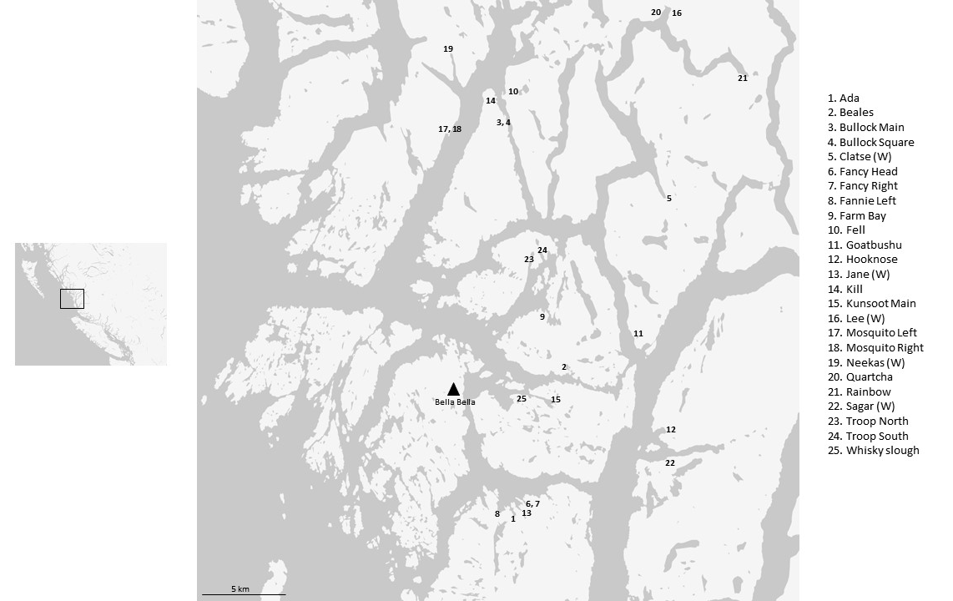
Figure A-1: Map of study sites on the Central Coast examined in this thesis. Sites with waterfalls are indicated by a (W).
Table A-1: Table of streams investigated in this thesis with selected watershed-level variables.

Stream | Stream Magnitude | Catchment Area (km²) | Spawning length (m) | Bankfull width (m) | Falls present? | Mean salmon density, all years on record (kg/m) | Mean salmon density, last 3 years (kg/m)
Ada | 24 | 9.8 | 435 | 11.1 | Y | 17.9 | 23.1
Beales | 9 | 6.4 | 300 | 10.9 | N | 12.1 | 16.5
Bullock Main | 2 | 3.3 | 622 | 10.99 | N | 14.7 | 17.4
Bullock Square | 5 | 2.8 | 296 | 8.4 | N | 2.5 | 2.9
Clatse | 3 | 24.3 | 900 | 22.8 | Y | 42.1 | 67.5
Fancy Head | 3 | 1.6 | 141 | 5.5 | N | 8.1 | 11.3
Fancy Right | 16 | 9.9 | 298 | 4.8 | N | 4.0 | 7.7
Fannie Left | 16 | 16.4 | 1500 | 12.8 | N | 13.6 | 28.0
Farm Bay | 2 | 2.3 | 0 | 6.4 | N | 0.0 | 0.0
Fell | 10 | 7 | 0 | 10.9 | N | 0.0 | 0.0
Goat | 5 | 2.3 | 550 | 7.5 | N | 2.3 | 2.5
Hooknose | 9 | 14.8 | 1800 | 16.9 | N | 5.8 | 7.6
Jane | 5 | 1.3 | 500 | 4.6 | Y | 0.0 | 0.0
Kill | 2 | 0.5 | 1280 | 3.5 | N | 2.6 | 2.8
Kunsoot Main | 3 | 4.9 | 3800 | 13.1 | N | 3.8 | 5.1
Lee | 3 | 11.2 | 700 | 12.4 | N | 13.9 | 19.0
Mosquito Left | 4 | 2.1 | 250 | 5.7 | N | 4.1 | 7.1
Mosquito Right | 8 | 3.1 | 500 | 4 | N | 3.7 | 3.1
Neekas | 23 | 16 | 2100 | 17.7 | Y | 45.8 | 51.0
Quartcha | 6 | 29.4 | 5500 | 21.7 | N | 3.5 | 4.2
Rainbow | 10 | 13.7 | 300 | 15.1 | N | 3.7 | 4.7
Sagar | 8 | 36.6 | 800 | 15.5 | Y | 4.1 | 6.3
Troop North | 2 | 1.6 | 332 | 4.4 | N | 0.3 | 0.0
Troop South | 2 | 1.8 | 489 | 4.1 | N | 0.6 | 0.4
Whisky slough | 3 | 0.819 | 0 | 2 | N | 0.0 | 0.0

Table A-2: Correlation matrix of watershed size measures with salmon density (biomass per m of stream reach) for reference.
Table A-3: Loadings of the four principal components of the ordination in Figure A-3.
The first two principal axes encompass ~76% of the variation.
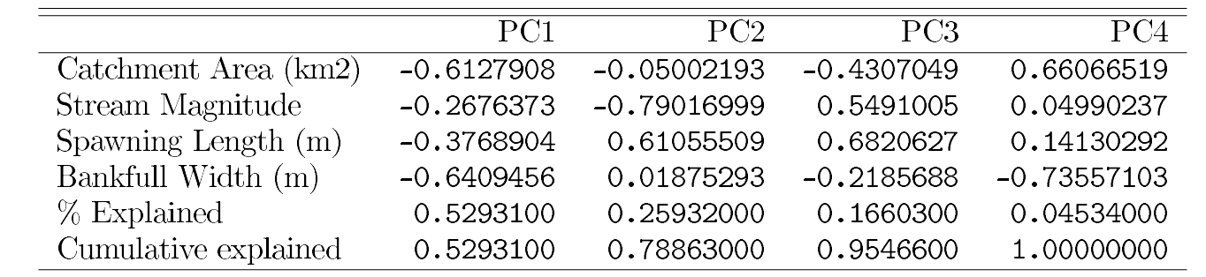

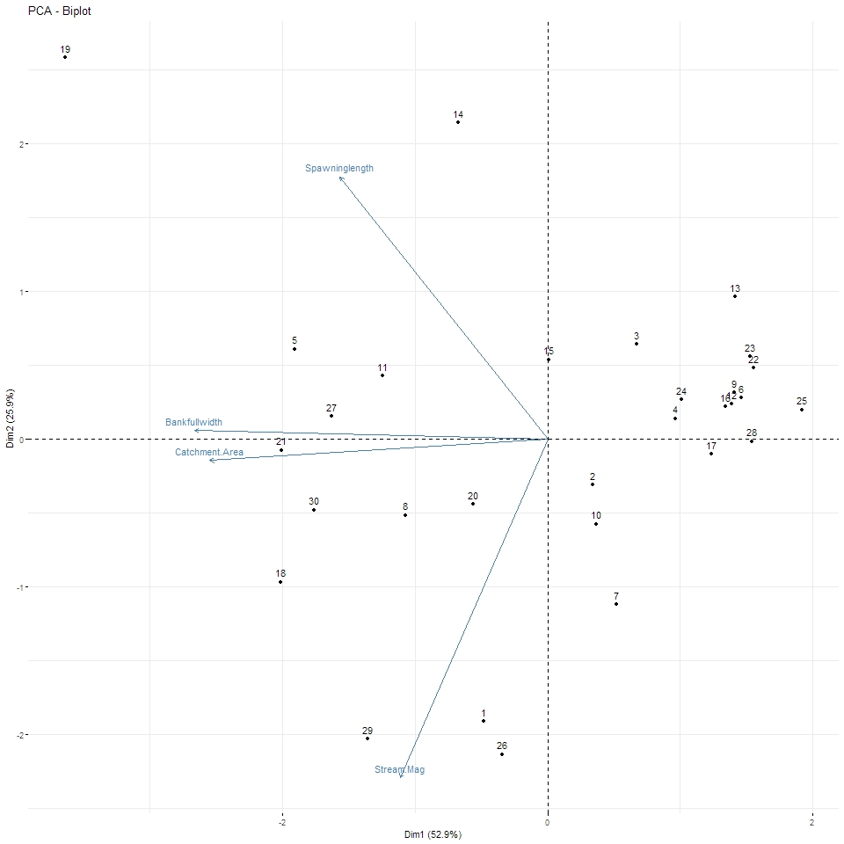
Figure A-2: PCA biplot of four watershed size indices
: catchment area (km²), bankfull width (m), stream magnitude (unitless), and length of spawning reach (m). Together the first two axes account for ~75% of the variation. All variables were scaled prior to ordination.

Salmon Density
This thesis uses a salmon count data set maintained by John Reynold’s lab at Simon Fraser University and the Heiltsuk Integrated Resource Management Department. This data set represents a collaboration between Fisheries and Oceans Canada, the Reynolds’ lab (SFU), and Heiltsuk First Nation, and as of data collection for this thesis (2017) covers years 2002-2016 inclusive. Years 2002-2007 are only included in this dataset as an agglomerated mean of those years (here labeled ‘mean 2002-2007’). Pinks (Oncorhynchus gorbuscha) and Chum (O. keta) where the primary species targeted in these surveys and other salmon species were only included if they were counted by chance; despite this, I’ve opted to include biomass estimates for coho (O. kisutch) and sockeye (O. nerka) in these calculations as these fish were present and hence contribute to SDN loading at these sites.
Temporal averaging: Three sliding scales of temporal averaging were used to measure ‘salmon biomass density’ in this thesis. These were:
- salmon density in the previous year (2016);
- salmon density averaged over the last three years (2014-2016)
- salmon density averaged over all years (2002-2016).
In most cases, for consistency with other literature published by the Reynolds lab I have used the second averaging window (averaged over the previous three years).
Spatial averaging: Indices of ‘salmon density’ were calculated for each site s according to the following equations:
 | $${biomass}_{s} =\sum_{1}^{SP}{{\left(number of salmon counted\right)}_{s}*{(average species mass)}_{sp}}$$ | (1)

where (number of salmon counted) are from the Reynolds lab data and (average species mass) are the species average masses at spawning and pulled from past publications, summed over all salmon species sp from 1 to SP, where SP is the total number of salmon species (n=4). For chum and pink, these averages are for fish measured from Central Coast streams (Hocking & Reynolds, 2011); for Coho and sockeye these are approximations from troll and seine net data (Bigler et al., 1996) (Table B-1)Error! Reference source not found..
The salmon density at site s was then calculated by the equation:
 | $${density}_{s}=\frac{{ biomass}_{s} (kg)}{{length of stream reach}_{s} (m)}$$ | (2)
Where the length of stream reach is the length in meters of salmon-accessible stream.
For each stream considered in this study, time series of salmon densities for each stream s are plotted for reference in Figure B-1and Figure B-2; summed over all sites plotted in Figure B-3Error! Reference source not found., and a histogram of all sites in Figure B-4. Of note are the preponderance of pink and chum salmon, as well as the right-skew distribution where Neekas and Clatse have many more salmon than the other sites. Also of note is the gap in the data between 20 and 40 kg/m between Neekas and Clatse and the rest of the streams.
Choice of density index: Two other density indices were considered. The first adds bankfull width to the density calculation:
density_{s} (SLxBW) | $$\frac{{ biomass}_{s} (kg)}{{length of stream reach}_{s} \left(m\right)*{bankfull width}_{s}(m)}$$ | (3)
where ‘stream bankfull width’ is the mean width of stream s at the stream’s mouth at the approximate period of maximum flow (in the fall).

The second divides instead by the catchment area:
density_{s} (CA) | $$\frac{{biomass}_{s} (kg)}{catchment area ({km}^{2})}$$ | (4)
Where ‘catchment area’ is from Hocking 2011, with missing sites added by Allen Larocque via estimates calculated from watershed data provided by iMAP BC (IMapBC, 2018).
Various of these four spatial density estimates have been used in the literature (Hocking & Reynolds, 2011; Wagner & Reynolds, 2019). These indices are highly correlated (Table B-2), and a PCA was run to further measure their degree of shared variation (Figure B-5).
For this thesis I settle on density per m of stream reach (eq. 2) for conceptual simplicity, consistency with previous and on-going studies, and because initial analysis showed that the ‘stream reach’ index (eq. 2) had the highest correlation with response variables (Chapter 2, 4, 5). Throughout this thesis this is referred to as ‘salmon density’.

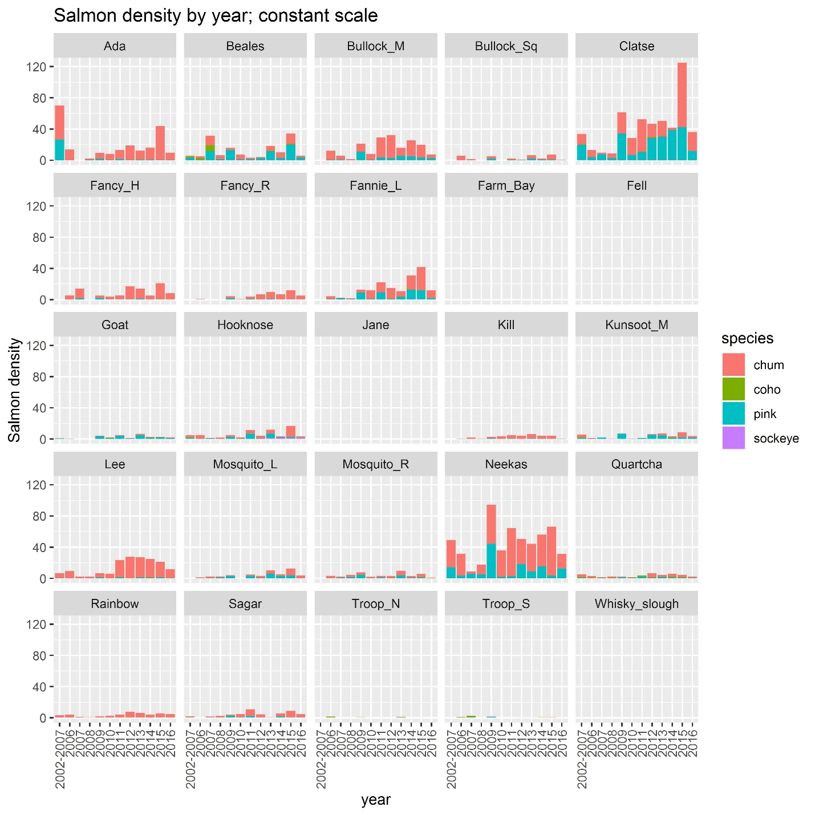
Figure B-1: Salmon density (kg of salmon/m of accessible stream reach) for all streams used in this study.
Y-axis scale is held constant across streams for cross watershed comparison.

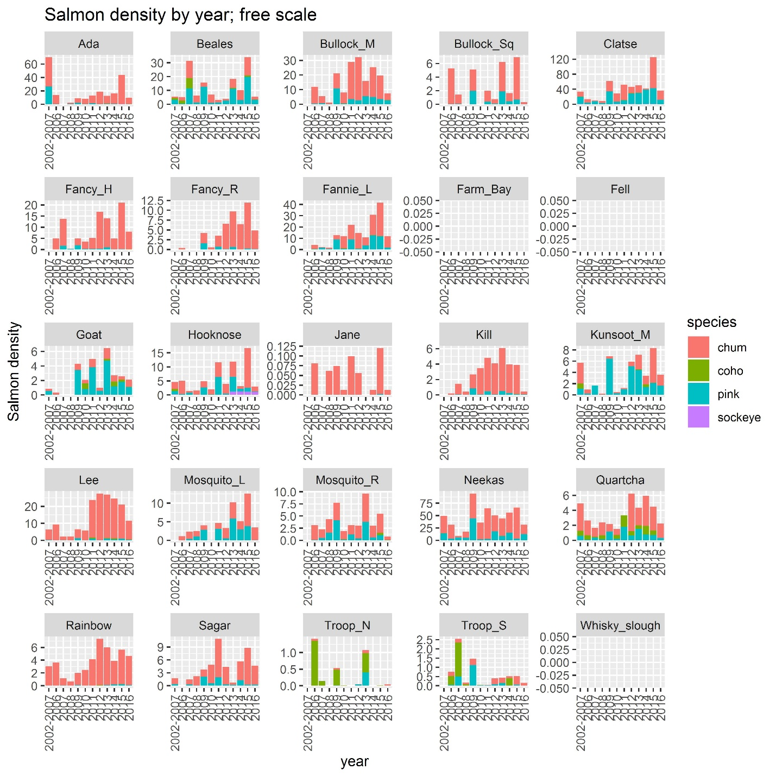
Figure B-2: Salmon density (kg of salmon/m of accessible stream reach) for all streams used in this study.
Y-axis scale dynamic across streams too allow for within-watershed comparison.

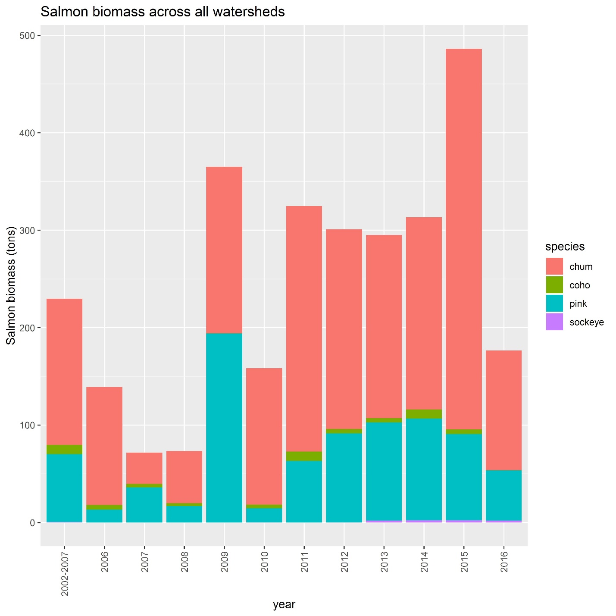
Figure B-3: Salmon biomass (metric tons) by year over all streams used in this thesis.
Four species are present in this region, with chum and pink being most represented.

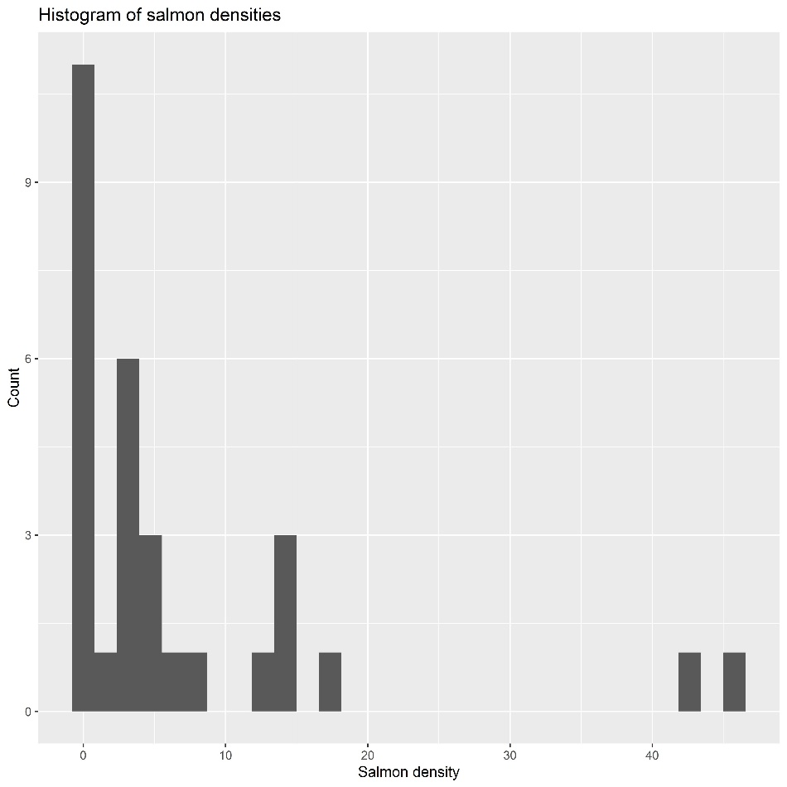
Figure B-4: Histogram of the distribution of salmon density (kg/m) across streams for all years. Note the skew-right distribution and gap between 20 and 40 kg/m (high density streams are Neekas and Clatse).

Table B-1: Average mass at spawning for different salmon species used in salmon density calculations.
Species | Average weight at spawning (kg) | Reference
Chum | 3.1 | (Hocking & Reynolds, 2011)
Pink | 1.05 | (Hocking & Reynolds, 2011)
Coho | 4.5 | Approximate; (Bigler et al., 1996)
Sockeye | 2.7 | Approximate; (Bigler et al., 1996)

Table B-2: Correlation table between salmon-density indices.
a. total salmon biomass (biomass, kg); b. biomass per m of stream reach (density.SL, kg/m); c. biomass / (m of stream reach*m of bankfull width) g/m²); d. biomass / catchment area (kg/km²). All measures are correlated. For most of this thesis density per m of stream reach was used to represent ‘salmon biomass density’.
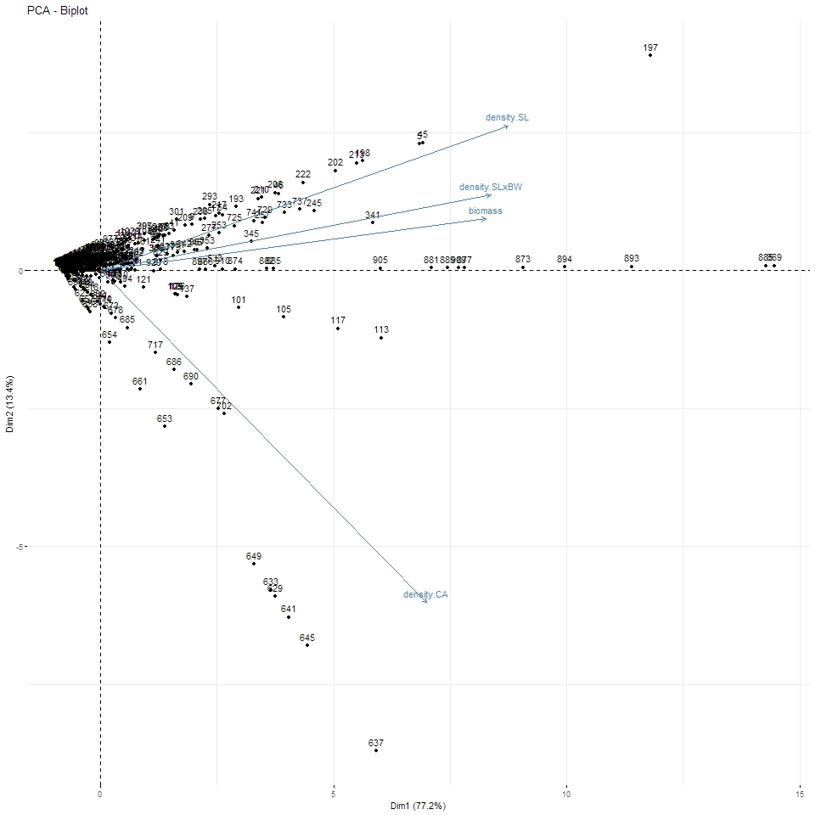
Figure B-5: PCA biplot of density indices.
Salmon biomass, biomass/ stream reach length (SL), and biomass / (stream reach length*bankfull width) are all highly correlated. Density / catchment area (CA) lies along a slightly different axis. All variables were scaled prior to ordination.

Table B-3: Four principal components of biomass and the three density indices.
77% of the variance falls upon the first axis, and 90% on the first two.
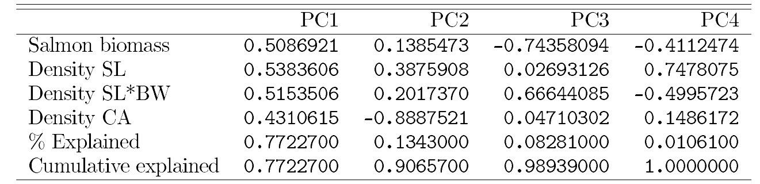

Vegetation summer 2017

Vegetation measures
The goal of the summer measures was to characterize the vegetation community around each soil core. To do this, a nested methodology was used: first, percent cover of moss and herbs were estimated in a small 1 m² square plot around the soil core. Second, shrubs greater than 1m in height were comprehensively measured in a circular plot with radius 5 m. Shrubs were identified to species, and their distance and absolute bearing from the soil core measured. Their volume was approximated as a rectangular prism with measured $h x l x w$. For each individual shrub i, these volumes were combined with distance into a ‘shrub influence index’ measuring the effect of individual shrub i on core j:
$${Shrub influence index}_{ij}=\frac{{shrub volume}_{i}}{{distance to soil core}_{ij}}$$
And these influence indices summed for each species k to determine the influence of each shrub species k on each soil core j:
$${Summed influence index}_{kj}= \sum_{i=1}^{n}{{Shrub influence index}_{ij}}$$
Where n is the number of individuals i of species k in plot j.
Similarly, every tree with circumference > 3 cm in the 5 m radius plot was identified. Species identity, distance, absolute bearing from the soil core, and circumference was measured. For each individual tree i, circumference was combined with distance to create a ‘tree influence index’ measuring the effect of individual tree i on core j:
$${Tree influence index}_{ij}=\frac{{circumference}_{i}}{{distance to soil core}_{ij}}$$
And these influence indices summed for each species k to determine the influence of each tree species k on each soil core j:
$${Summed influence index}_{kj}= \sum_{i=1}^{n}{{Tree influence index}_{ij}}$$
Where n is the number of individuals i in species k in plot j.
The list of all identified species can be found in Table C-1Error! Reference source not found., and heatmaps of species abundance measures can be found in to Figure C-1 to Figure C-4. Also visualized are species traits (soil nutrient regime (SNR) and mycorrhizal guild), which are taken from Indicator Plants of British Columbia (Klinka et al., 1989) and the FungalRoot database (Soudzilovskaia et al., 2020).

Dimension reduction (PCA)
To simplify interpretation and allow for use of these data as explanatory variables in downstream analyses, principal components analysis (PCA) was used to reduce the dimensionality of species abundance data. For each species group measurement (moss percent cover, herb percent cover, shrub influence index, and tree influence index) the lowest 10% of variables were removed based on low variance (Poos & Jackson, 2012) and PCA performed on the remaining variables using the R package PCAtools (Blighe & Lun, 2020). Thimbleberry was removed as despite being observed at a single site (Neekas below falls) and it was heavily weighted in initial PCAs. Unscaled rather than scaled variables were used as we were interested in the absolute influence of each species on the soil cores, not the relative influences.
The loadings on the first two axes of each PCA are visualized in Figure C-5 to Figure C-8, and were interpreted as : moss – PCA1: lanky moss (negative), PCA2: step moss (negative); herbs and ferns – PCA1: false-lily-of-the-valley (positive) and deer fern and salal (negative), PCA2: salal, deer fern, and false-lily-of-the-valley (all negative); shrub influence index – PCA1: salmonberry (positive), PCA2: false azalea and Alaskan blueberry (negative); trees – PCA1: cedar (positive), PCA2: snags (positive) and stumps and Sitka spruce (negative).
Finally, the weights of the first two axes of each PCA for each soil core was extracted and used in downstream analyses.

Table C-1: Species observed and identified in this thesis
, organized by growth form (“Type”). Soil nutrient regime (SNR) values are derived from Klinka et al. 1989, and “Mycorrhizal Guild” from Soudzilovskaia et al. 2020.
Latin name | Common name | Type | SNR | Mycorrhizal Guild
Brachythecium frigidum | Golden short capsuled moss | Moss | NA | NA
Buckiella undulata | Wavy moss | Moss | NA | NA
Dicranum fuscescens | Dusky moss | Moss | 1 | NA
Eurhynchium praelongum | Slender moss | Moss | NA | NA
Hookeria lucens | Clear moss | Moss | 1 | NA
Huperzia selago | Fir club moss | Moss | 1 | NM-AM
Hylocomium splendens | Step moss | Moss | 1 | NA
Kindbergia oregana | Orgeon-beak moss | Moss | NA | NA
Plagiomnium insigne | Badge moss | Moss | 3 | NA
Plagiothecium undulatum | Flat moss | Moss | 1 | NA
Pleurozium schreberi | Feather moss | Moss | 1 | NA
Polytrichum commune | Haircap moss | Moss | NA | NA
Rhizomnium glabrescens | Fan moss | Moss | 2 | NA
Rhytidiadelphus loreus | Lanky moss | Moss | 1 | NA
Rhytidiadelphus squarrosus | Bent leaf moss | Moss | NA | NA
Sphagnum rubellum | Red sphagnum moss | Moss | NA | NA
Sphagnum squarrosum | Shaggy sphagnum moss | Moss | NA | NA
Ulota obtusiuscula | Carpet moss | Moss | NA | NA
Conocephalum conicum | Snake liverwort | Liverwort | 3 | AM
Pellia neesiana | Ring pellia | Liverwort | 3 | AM
Plagiochila porelloides | Cedar shake liverwort | Liverwort | 2 | NA
Circaea alpina | Enchanter's nightshade | Herb | 2 | AM
Clintonia uniflora | Queen's cup | Herb | 1 | AM
Coptis aspleniifolia | Fern-leaf goldthread | Herb | 1 | AM
Cornus canadensis | Bunchberry | Herb | 1 | AM
Listera caurina | Twayblade | Herb | 2 | OM
Maianthemum dilatatum | False-lily-of-the-valley | Herb | 3 | AM
Poa sp. | Grass | Herb | NA | NA
Prenanthes alata | Rattlesnake root | Herb | 3 | AM
Rubus pedatus | Five-leaf bramble | Herb | 1 | AM
Rubus ursinus | Trailing blackberry | Herb | 2 | AM
Sagittaria latifolia | Arrowhead | Herb | NA | NA
Streptopus amplexifolius | Clasping twisted stalk | Herb | 3 | AM
Tiarella trifoliata | Foam flower | Herb | 3 | AM
Veratrum eschscholtzii | Indian hellbore | Herb | 3 | AM
Viola glabella | Violet | Herb | 3 | AM
Athyrium filix-femina | Lady fern | Fern | 3 | AM
Blechnum spicant | Deer fern | Fern | 1 | AM
Dryopteris expansa | Spiny wood fern | Fern | 2 | AM
Gymnocarpium dryopteris | Oak fern | Fern | 3 | AM
Phegopteris connectilis | Beech fern | Fern | 3 | AM
Pityrogramma triangularis | Goldenback fern | Fern | NA | NA
Polystichum munitum | Sword fern | Fern | 3 | AM
Pteridium aquilinum | Bracken fern | Fern | NA | AM
Gaultheria shallon | Salal | Shrub | 1 | ErM
Ledum groenlandicum | Labrador Tea | Shrub | 1 | ErM
Lonicera involucrata | Black twinberry | Shrub | 3 | AM
Lysichitum americanum | Skunk cabbage | Shrub | 3 | uncertain
Oplopanax horridus | Devil's club | Shrub | 3 | AM
Rhododendron menziesii | False Azalea | Shrub | 1 | ErM
Ribes bracteosum | Stink Current | Shrub | 3 | AM
Rubus parviflorus | Thimbleberry | Shrub | 3 | AM
Rubus spectabilis | Salmonberry | Shrub | 3 | AM
Sambucus racemosa | Red elderberry | Shrub | 3 | AM
Vaccinium alaskaense | Alaskan blueberry | Shrub | 1 | ErM
Vaccinium ovalifolium | Oval-Leaf blueberry | Shrub | 1 | ErM
Vaccinium parvifolium | Red huckleberry | Shrub | 1 | ErM
Abies amabilis | Amabilis fir | Tree | NA | EcM
Alnus rubra | Alder | Tree | 3 | EcM
Picea sitchensis | Sitka spruce | Tree | 3 | EcM
Thuja plicata | Cedar | Tree | NA | AM
Tsuga heterophylla | Western hemlock | Tree | NA | EcM

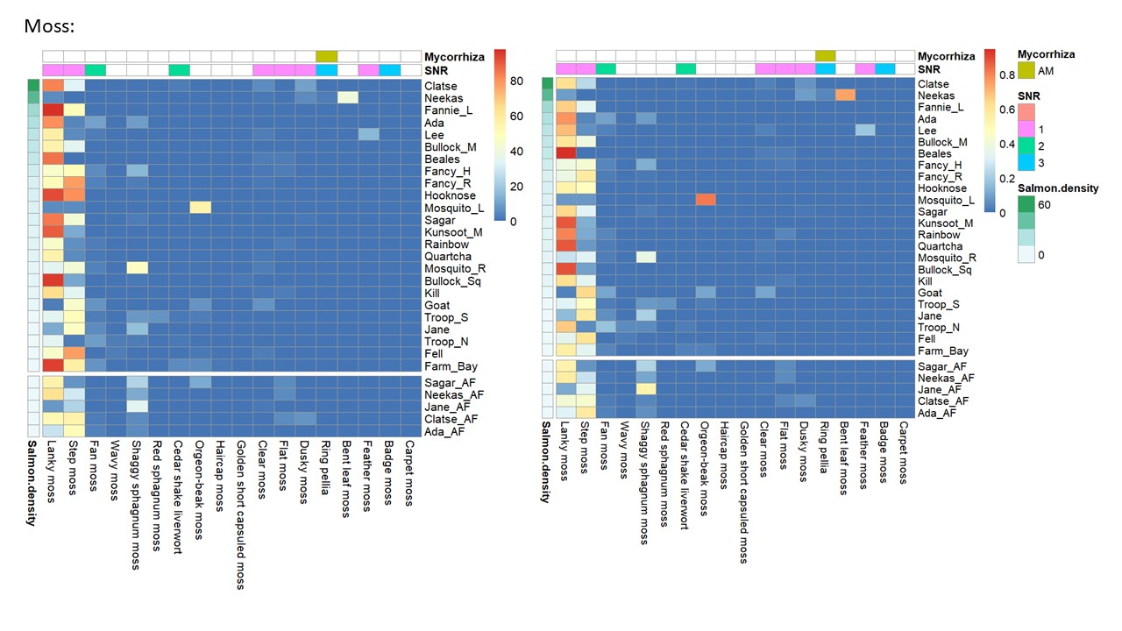
Figure C-1: Heatmap of observed moss percent cover by watershed
, in order of increasing salmon density. Sites above waterfalls are in the lower facet of each heatmap. Raw values are in the left-hand plot, and as a proportion of measured species within each watershed on the right. Values displayed are the mean across plots (n=2) within each watershed. For each species, corresponding SNR and mycorrhizal guild traits are displayed on top bars.

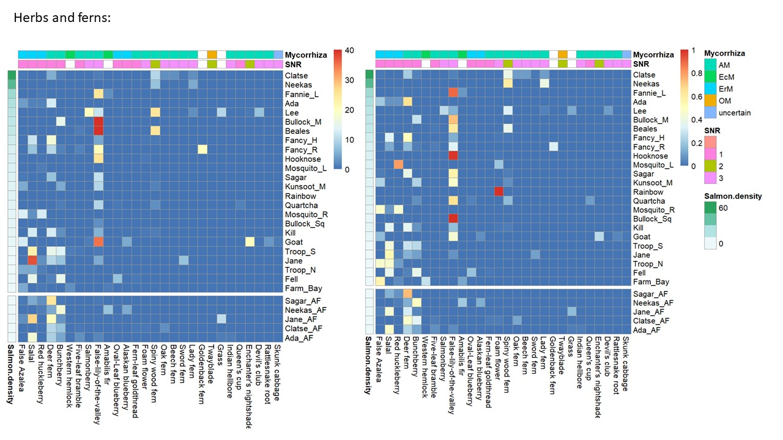
Figure C-2: Heatmap of observed herb and fern percent cover by watershed
, in order of increasing salmon density. Sites above waterfalls are in the lower facet of each heatmap. Raw values are in the left-hand plot, and as a proportion of measured species within each watershed on the right. Values displayed are the mean across plots (n=2) within each watershed. For each species, corresponding SNR and mycorrhizal guild traits are displayed on top bars.
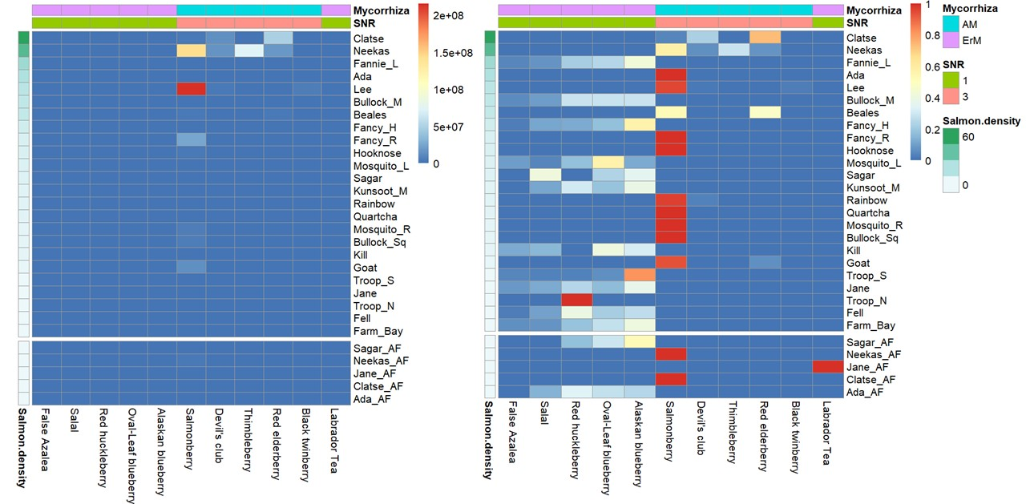
Figure C-3: Heatmap of observed shrub volume by watershed
, in order of increasing salmon density. Sites above waterfalls are in the lower facet of each heatmap. Raw values are in the left-hand plot, and as a proportion of measured species within each watershed on the right. Values displayed are the mean across plots (n=2) within each watershed. For each species, corresponding SNR and mycorrhizal guild traits are displayed on top bars.
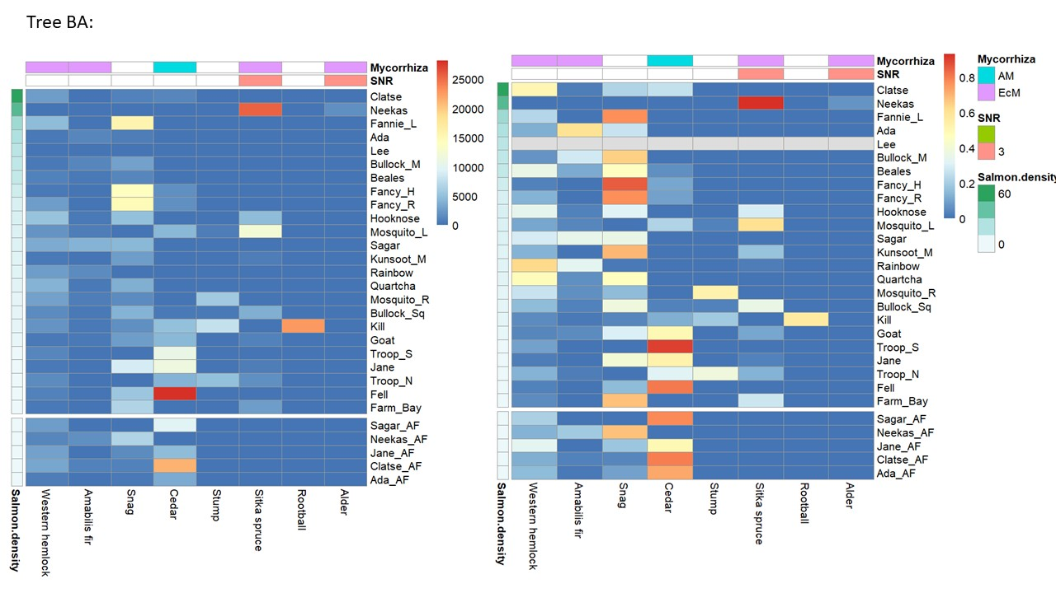
Figure C-4: Heatmap of observed tree basal area by watershed
, in order of increasing salmon density. Sites above waterfalls are in the lower facet of each heatmap. Raw values are in the left-hand plot, and as a proportion of measured species within each watershed on the right. Values displayed are the mean across plots (n=2) within each watershed. For each species, corresponding SNR and mycorrhizal guild traits are displayed on top bars.
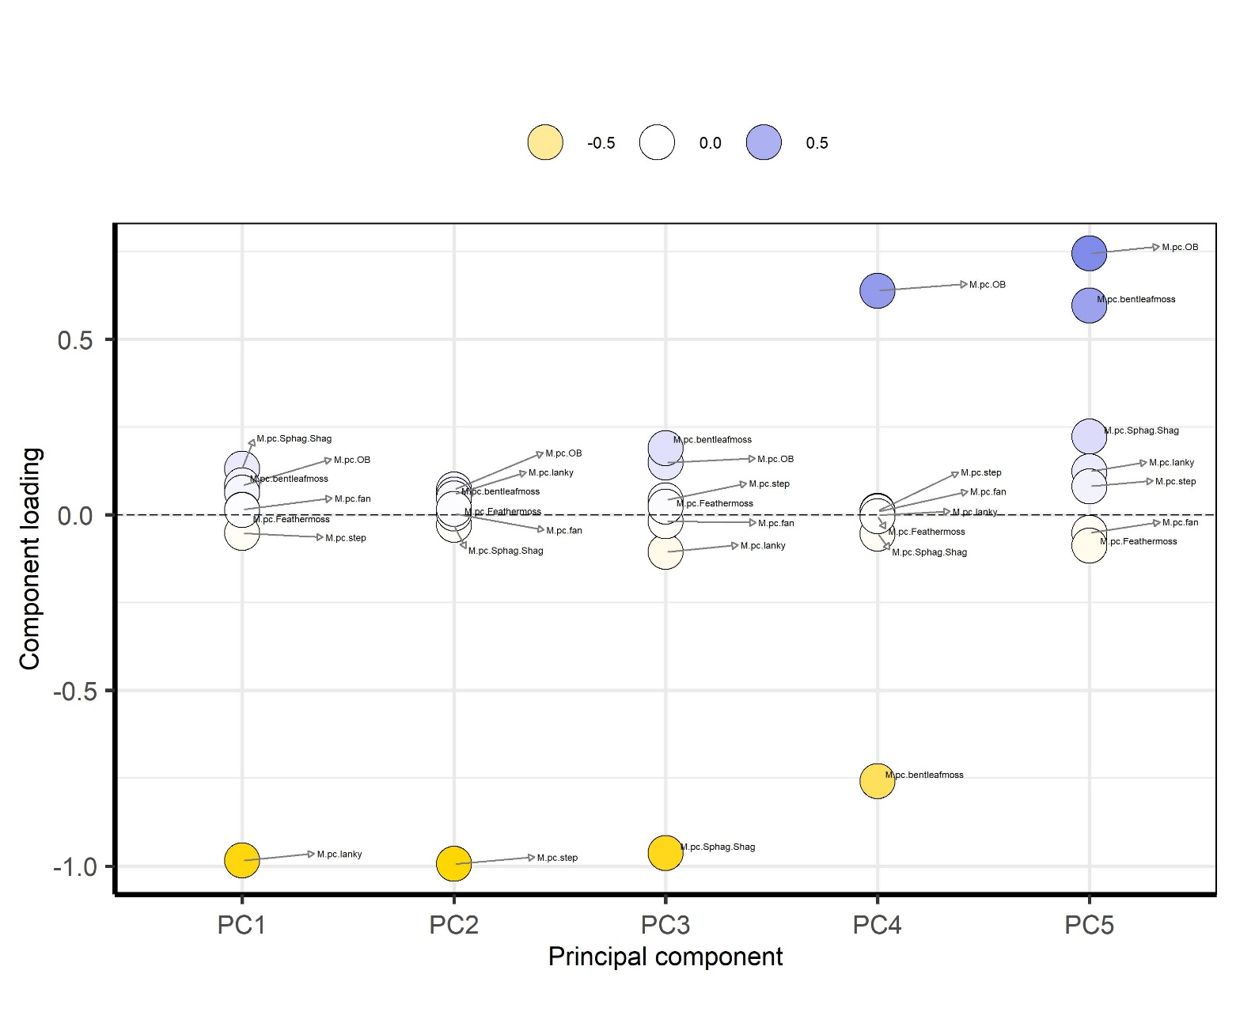
Figure C-5: PCA loadings for moss.
The first axis (42% of variation) corresponds primarily to lanky moss and the second axis (41% of variation) to step moss.

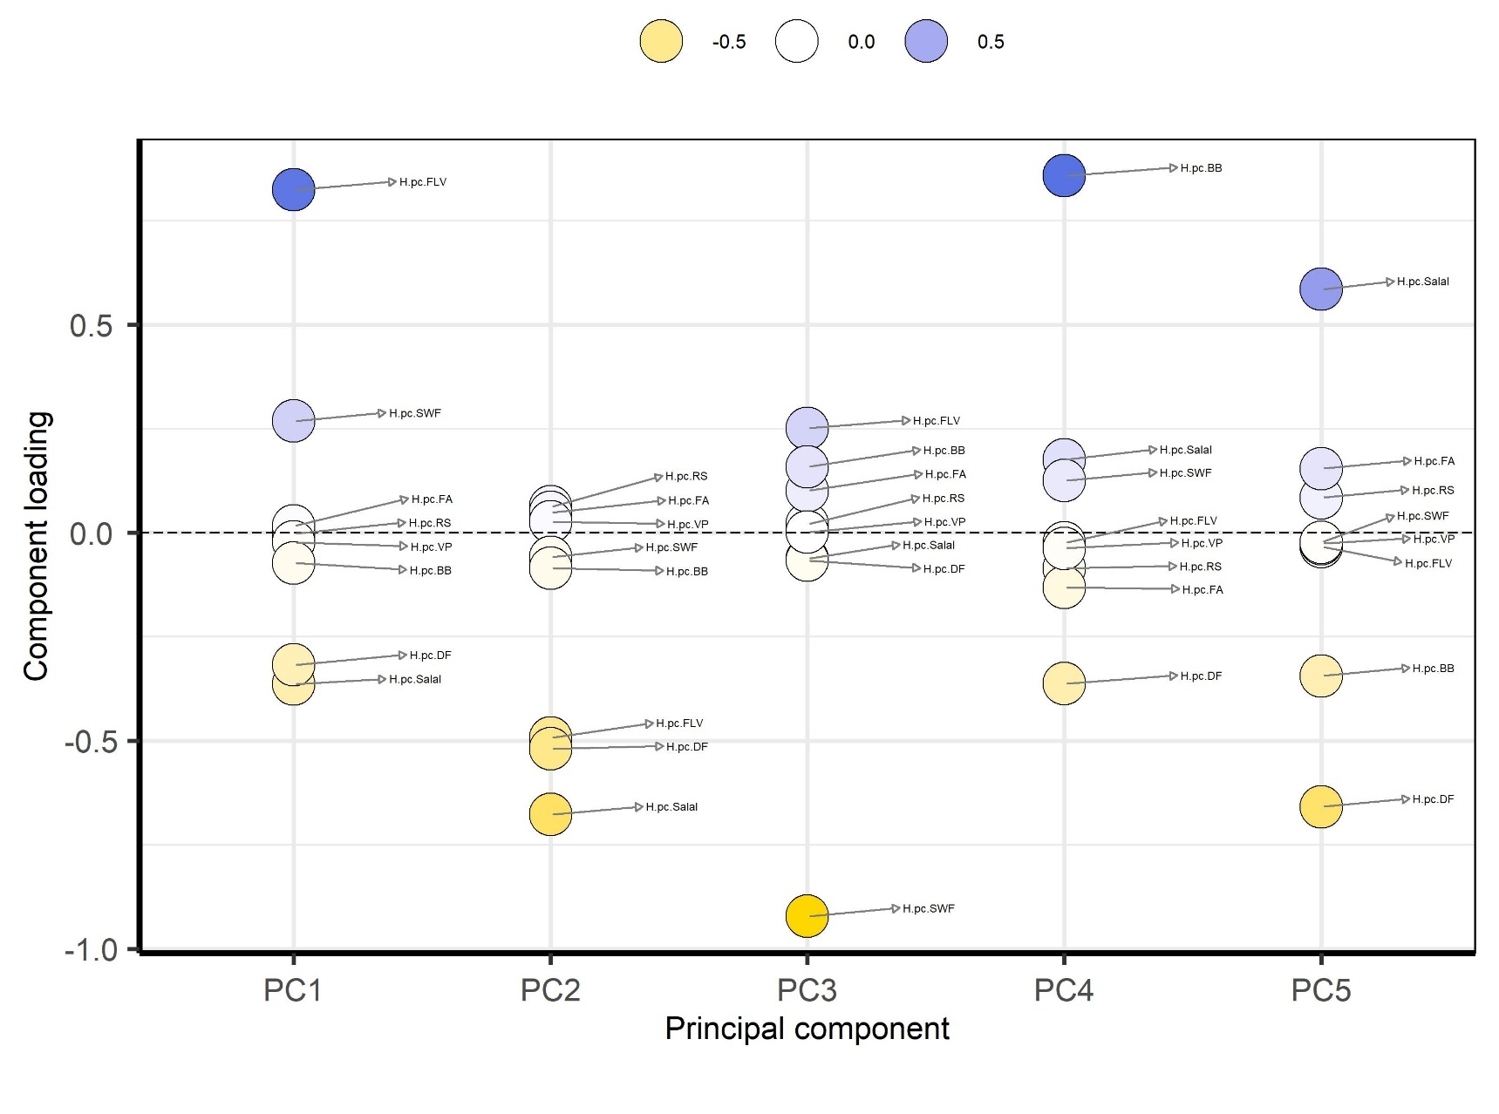
Figure C-6: PCA loadings for herbs.
The first axis (35% of variation) consists primarily of false-lily-of-the-valley (positive) and deer fern and salal (negative). The second axis (18% of variation) consists of salal, deer fern, and false-lily-of-the-valley (negative).

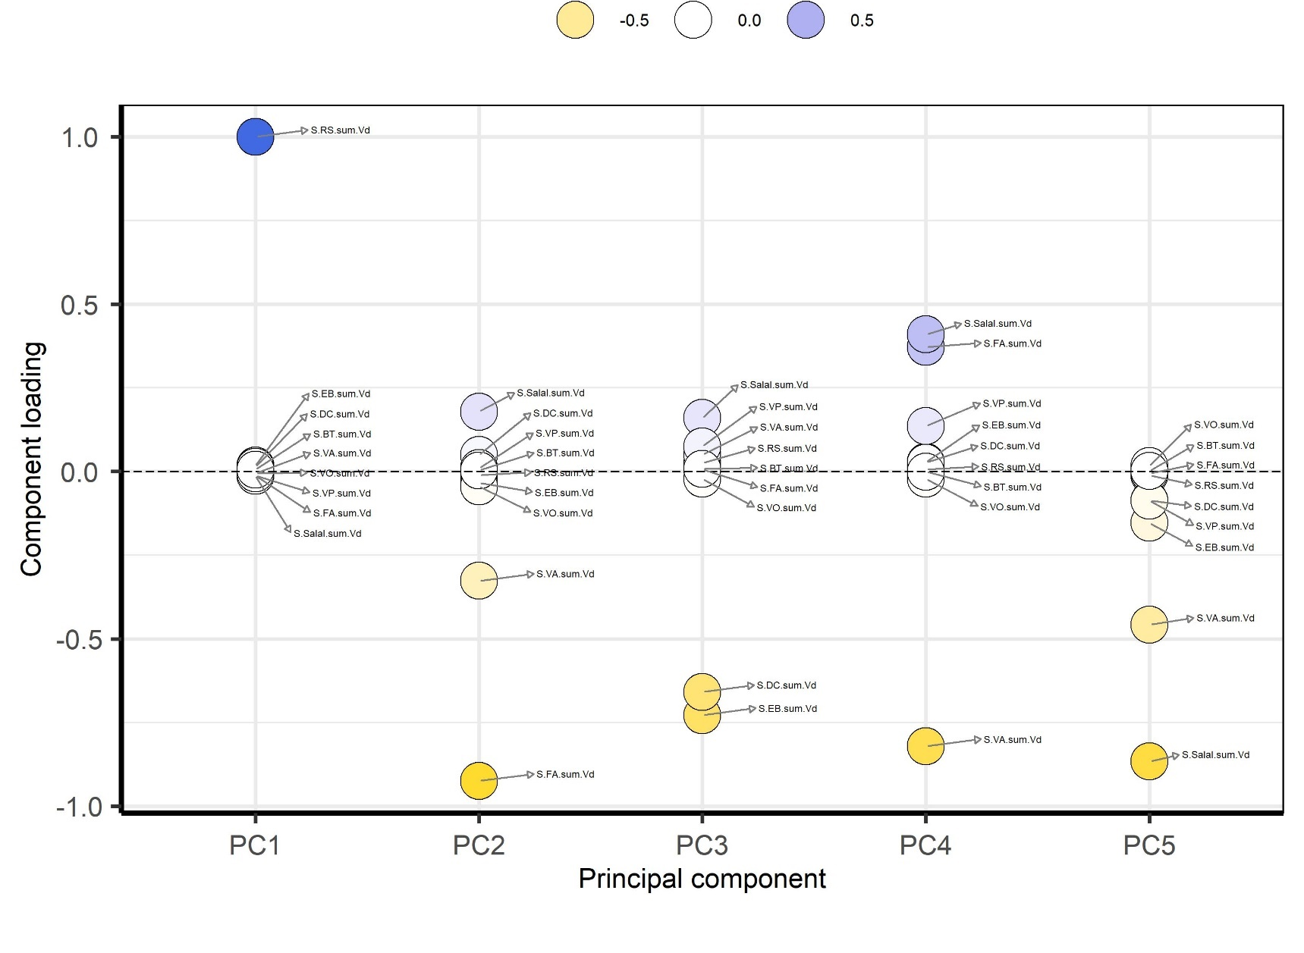
Figure C-7: PCA loadings for the shrub influence index.
The first axis (90% of variation) consists mostly of salmonberry (positive) and the second axis (3% of variation) to false azalea and Alaskan blueberry (negative).
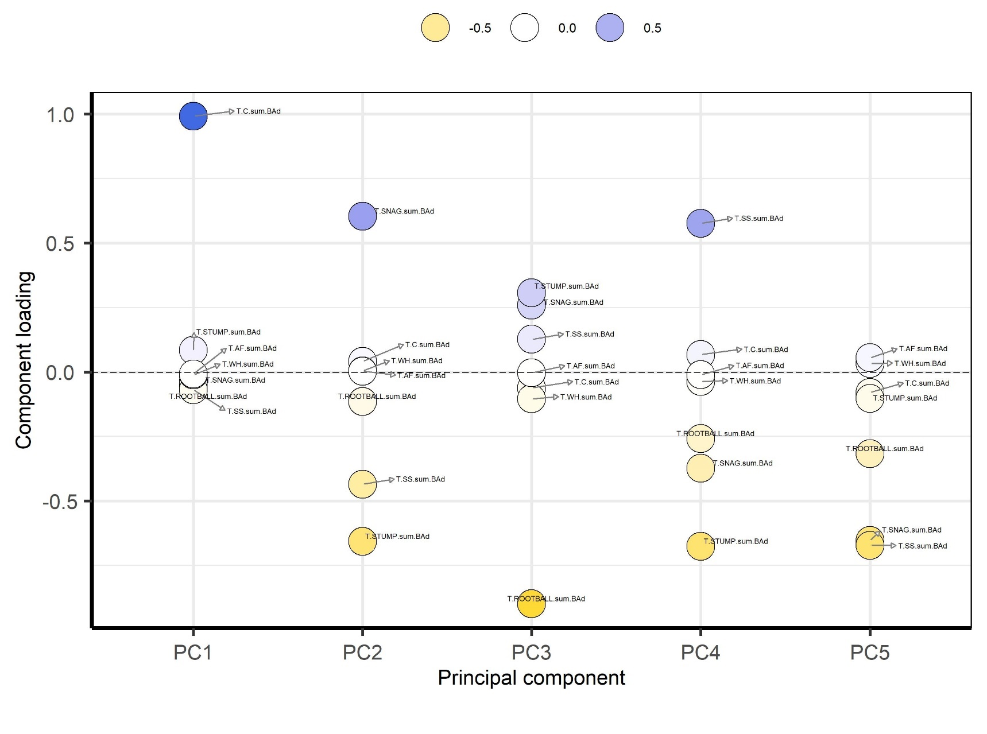
Figure C-8: PCA loadings for tree influence index.
The first axis (38% of variation) consists of cedar (positive), and the second axis (18% of variation) a combination of snags (positive) and stumps and Sitka spruce (negative).

Vegetation Autumn 2017
The goal of the autumn measures was to characterize the vegetation community around each sporocarp sample. This characterization had to be done rapidly due to time constraints during field work as sampling was conducted alongside fall fish counts by the Heiltsuk Integrated Resource Management Department and the Reynolds lab. To do this, a 5m-radius circular vegetation plot was measured centered on the fungal sporocarp sample, and percent cover of moss, herb, shrub, and tree species were visually estimated by Allen Larocque. For use as response variables in downstream analyses, the dimensions of these data were reduced via principal components analysis (PCA).

Dimensionality reduction (PCA):
For each species group measurement (moss, herb, shrub, and tree percent cover) the lowest 10% of variables were removed based on low variance (Poos & Jackson, 2012) and PCA performed on the remaining variables using the R package PCAtools (Blighe & Lun, 2020). Unscaled rather than scaled variables were used as we were interested in the absolute influence of each species on sporocarp and surrounding soil, not the relative influences.
The loadings on the first two axes of each PCA are visualized in Figure C-9 to Figure C-12, and were interpreted as : 1.) moss: PC1 42% variance explained, positive - Lanky moss (Rhytidiadelphus loreus); PC2 25% variance explained, negative - step moss (Hylocomium splendens); 2.) herbs: PC1 35.5% variance explained, positive - deer fern (Struthiopteris spicant), negative – spiny wood fern (Dryopteris expansa); PC2 29% variance explained, positive – spiny wood fern and deer fern, negative – bunchberry (Cornus canadensis); 3.) shrubs: PC1 34.7% variance explained, positive – Alaskan blueberry (Vaccinuium alaskansae); PC2 27.6% of variation, positive - salal (Gaultheria shallon) and false azalea (Rhododendron menziesii), and negative - salmonberry (Rubus spectabilis). 4.) trees: PC1 56% variance explained, positive – Sitka spruce (Picea sitchensis), negative - Western hemlock (Tsuga heterophylla); PC2 22.6% variance explained, positive – amabilis fir (Abies amabilis); negative – Western red cedar (Thuja plicata). Finally, the weights of the first two axes of each PCA for each soil core was extracted and used in downstream analyses.

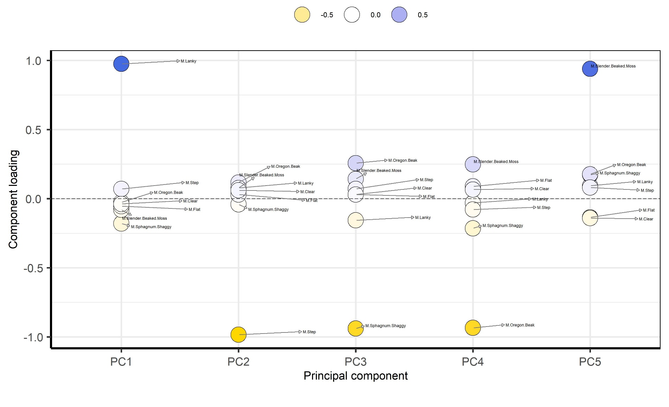
Figure C-9: PCA loadings for moss, fall 2017.
The first axis (42% of variation) corresponds primarily to lanky moss and the second axis (25% of variation) to step moss.
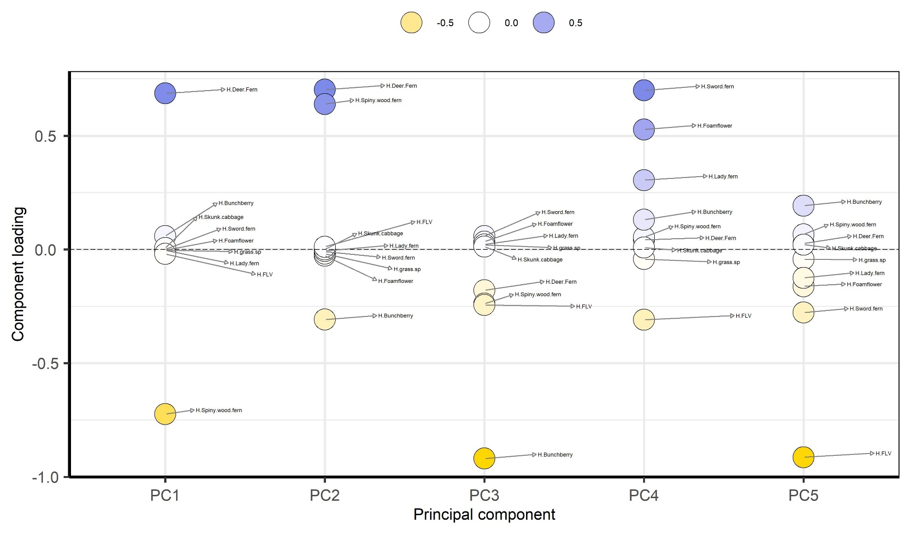
Figure C-10: PCA loadings for herbs, fall 2017.
The first axis (35.5% of variation) corresponds primarily to deer fern (positive) and spiny wood fern (negative) and the second axis (29% of variation) to both deer fern and spiny wood fern together (positive) and bunchberry (negative).
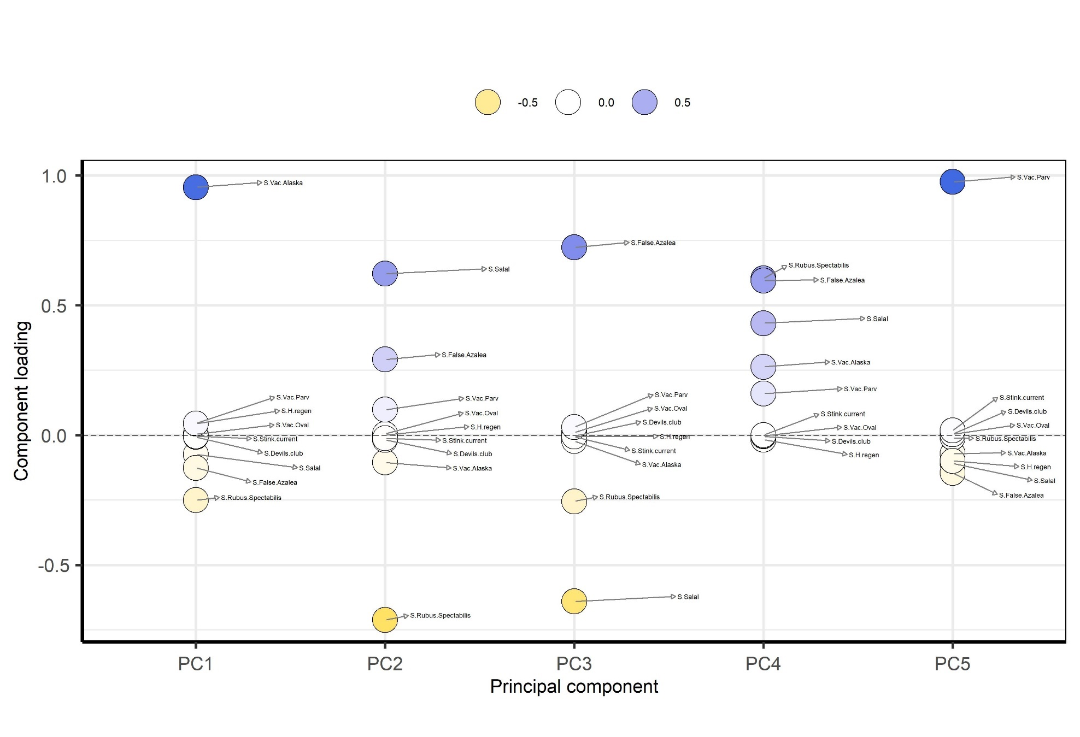
Figure C-11: PCA loadings for shrubs, fall 2017.
The first axis (34.7% of variation) corresponds primarily to Vaccinium alaskensae (positive) and the second axis (27.6% of variation) to salal and false azalea (positive) and salmonberry (negative).

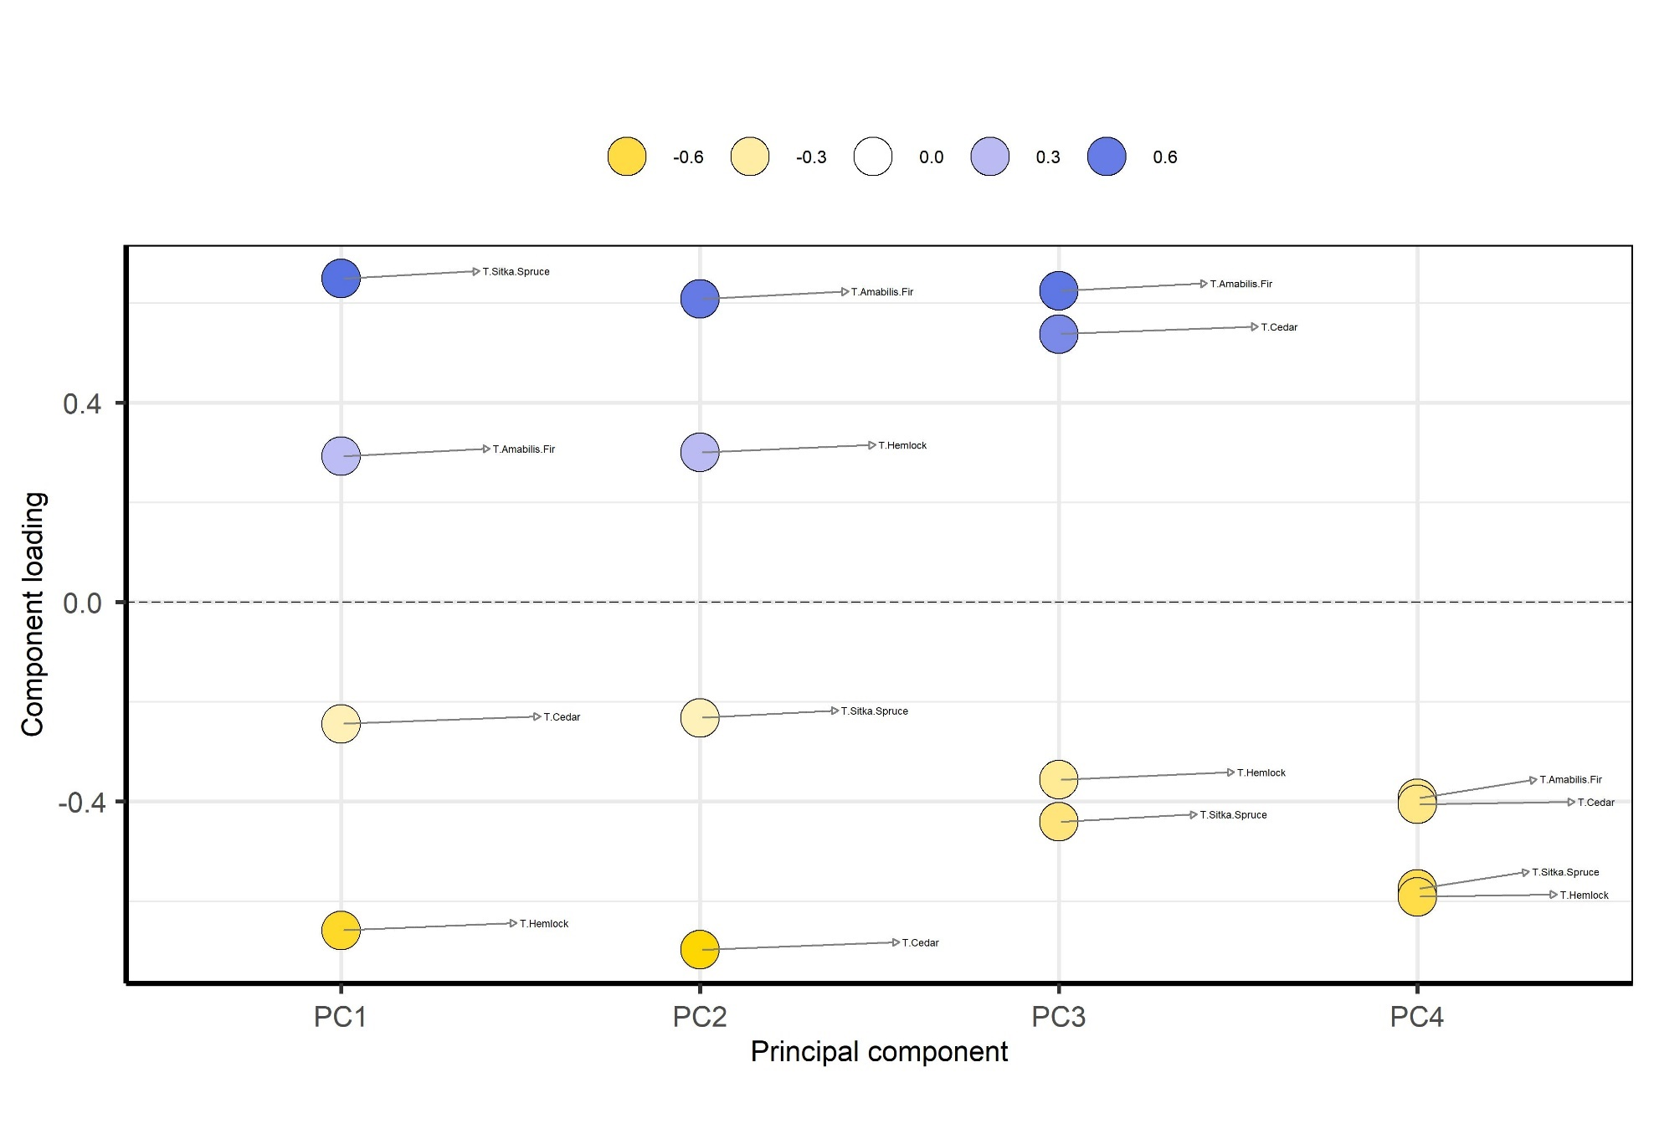
Figure C-12: PCA loadings for trees, fall 2017.
The first axis (56% of variation) corresponds primarily to Sitka spruce (positive) and hemlock (negative) and the second axis (22.6% of variation) to amabilis fir (positive) and cedar (negative). Alder was excluded from this analysis as it occurred at only two sites.

Nutrient Addition Calculations
Drake et al. performed an addition of ¹⁵N plus a modified Hoagland solution to mimic the decomposition of a dead salmon (Drake et al., 2006). Here I perform a similar experiment, but mimicking a pink salmon (~1.5 kg average mass) to match the dominant salmon type on the central coast, instead of a chum salmon (~7.5 kg average mass) which dominates the Washington State site studied by Drake. The 1.5 kg mass average for the Central Coast was taken from the supplementary material of (Hocking & Reynolds, 2011).
Nutrients as a percentage of carcass mass above taken from Drake 2006. Target grams of each nutrient was calculated by:
$$\left(proportion of nutrient\right)*1500g=Target mass (g)$$
Table D-1 shows the compound salts used in this study and Drake 2005, their molar masses and the mass ratio of each constituent element in the compound.
Ratios are simply:
$$\frac{Total molar mass of target nutrient in compound}{molar mass of compound}$$
Tradeoffs had to be made to reach target element masses since each salt has a companion ion (Table D-3). In order I prioritized: 1. Nitrogen; 2. Phosphorus; 3. Potassium; 4. Magnesium. This results in a solution with approximately 30X as much sulphur as desired and 11X as much calcium. For treatments using ¹⁵N the calculations are slightly different due to the heavier nature of the nitrogen (calculations not shown).

Table D-1: Nutrients, their molar masses and their proportion by mass of a salmon carcass.
The final column is total mass in grams needed to mimic a 1.5 kg salmon.
Nutrient | Molar mass | Proportion of a carcass of each nutrient (Drake 2005) | Total target g of each nutrient given 1.5kg salmon
N | 14 | 0.025 | 37.5
P | 31 | 0.0043 | 6.45
K | 39 | 0.0014 | 2.1
Mg | 24.3 | 0.0003 | 0.45
S | 32 | 0.001 | 1.5
Ca | 40 | 0.0005 | 0.75
15N, 10 atom% | 14.104 | 0.025 | 37.5

Table D-2: Compound salts used in Drake 2006 and in this study.
Elemental ratio by mass is the sum total mass of the element in question/ whole compound.
 |  | Elemental Ratio by mass
Compound | Molar Mass of Compound | N | P | K | Mg | S | Ca | H | O | Sum
(NH4)₂SO₄ (₁₅N) | 132.34 | 0.21 | 0 | 0 | 0 | 0.24 | 0 | 0.06 | 0.48 | 1
(NH4)₂SO₄ | 132.14 | 0.21 | 0 | 0 | 0 | 0.24 | 0 | 0.06 | 0.48 | 1
Ca(HPO₄)²⁻ | 136 | 0 | 0.22 | 0 | 0 | 0 | 0.29 | 0.007 | 0.47 | 1
K₂SO₄ | 174 | 0 | 0 | 0.45 | 0 | 0.18 | 0 | 0 | 0.37 | 1
MgSO₄ | 120.3 | 0 | 0 | 0 | 0.20 | 0.26 | 0 | 0 | 0.53 | 1

Table D-3: Amount of each compound added.
 |  |  | Implied (g)
Procedure | mass added (g) | compound | N | P | K | Mg | S | Ca | H | O | sum
1. Meet nitrogen target | 176.92 | (NH4)₂SO₄ | 37.5 | 0 | 0 | 0 | 42.84 | 0 | 10. | 85.68 | 176.74
2. Add P | 28.30 | Ca(HPO₄)²⁻ | 0 | 6.45 | 0 | 0 | 0 | 8.32 | 0.20 | 13.31 | 28.29
3. Add K | 4.68 | K₂SO₄ | 0 | 0 | 2.1 | 0 | 0.86 | 0 | 0 | 1.72 | 4.68
4. Add Mg | 2.22 | MgSO₄ | 0 | 0 | 0 | 0.45 | 0.59 | 0 | 0 | 1.18 | 2.22
 |  | Total | 37.5 | 6.45 | 2.1 | 0.45 | 44.29 | 8.32 | 10.91 | 101.9 | 211.9
 |  | Proportion of desired | 1 | 1 | 1 | 1 | 29.53 | 11.0
 |  | Number of mols added | 2.67 | 0.20 | 0.05 | 0.018 | 1.38 | 0.20 | 10.91 | 6.37

